UNITED  NATIONS |  |  | 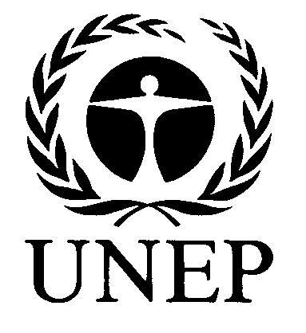 | 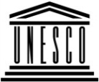 | 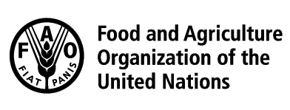 | 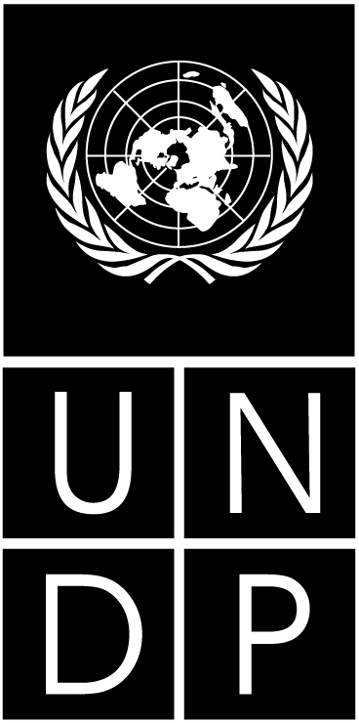 |  | BES
 |  |  |  |  |  |  | IPBES/5/INF/13
 |  | Intergovernmental Science-Policy Platform on Biodiversity and Ecosystem Services |  |  |  |  | Distr.: General  23 December 2016  English only
Plenary of the Intergovernmental Science-Policy
Platform on Biodiversity and Ecosystem Services
Fifth session
Bonn, Germany, 7–10 March 2017
Item 6 (d) of the provisional agenda*
Work programme of the Platform: methodological
assessment regarding the diverse conceptualization of
multiple values of nature and its benefits

Progress report on the integration of the diverse conceptualization of multiple values in ongoing assessments (deliverable 3 (d))
Note by the secretariat
- In section V of decision IPBES-4/1, the Plenary of the Intergovernmental Science-Policy Platform on Biodiversity and Ecosystem Services (IPBES) welcomed the preliminary guide on the conceptualization of values of biodiversity and nature’s benefits to people (IPBES/4/INF/13) and approved the scoping report on the methodological assessment regarding the diverse conceptualization of multiple values of nature and its benefits, including biodiversity and ecosystem functions and services (deliverable 3 (d)), set out in annex VI to the decision and reproduced in document IPBES/5/INF/12. In the same decision, the Plenary decided to consider the undertaking of the assessment at its fifth session. Further information is set out in the note by the secretariat on considerations pertaining to the undertaking of two thematic assessments and one methodological assessment (IPBES/5/6).
- In the same decision, the Plenary also requested the Multidisciplinary Expert Panel to nominate a set of experts – two per Platform assessment – to ensure, in collaboration with the Panel, that values and valuation were incorporated appropriately into all IPBES assessments. The annex to the present note sets out information on progress made by the expert group in its work and on its future activities. It is presented without formal editing.

Annex
Integration of the diverse conceptualization of multiple values in ongoing assessments (deliverable 3 (d))
I. The expert group on values
- At its eight meeting, the Multidisciplinary Expert Panel (MEP) approved the final list of members of the expert group values. Candidates were selected as a subset of those experts that were part of the group of authors drafting the guide on multiple values. Furthermore, regional and gender representation, the interdisciplinarity of the background of candidates as well as their involvement in IPBES assessments were considered. The appendix to this document sets out the list of 15 members. The group was led by Brigitte Baptiste (member of the MEP), Unai Pascual (member of the MEP), and György Pataki until Mr. Pataki resigned from the MEP on 31 October 2016. It is now led by Brigitte Baptiste and Unai Pascual. Robert Watson and Diego Pacheco (Bureau members) are overseeing the progress of the expert group on behalf of the Bureau. Furthermore, it was agreed to maintain collaboration with experts from the expert group that prepared the preliminary guide on the conceptualization of values of biodiversity and nature’s benefits to people (hereafter called the guide on values).
- The technical support unit (TSU) for the IPBES work on values is hosted by the Ecosystems and Sustainability Research Institute of the National Autonomous University of Mexico
(IIES-UNAM). The Bureau had accepted the offer to host the TSU conveyed by the IPBES focal point for Mexico, the National Commission for Knowledge and Use of Biodiversity (CONABIO) on 13 May 2016. The Deutsche Gesellschaft für Internationale Zusammenarbeit (GIZ) GmbH provides EUR 20,000 per year for a two-year period as financial support for a technical position at the TSU (June 2016 to May 2018). The TSU consists of Patricia Balvanera (head of the TSU) and David González (project manager). The TSU has been providing support to the IPBES work on values since 30 May 2016.
- At its eighth meeting, the MEP endorsed a work plan for the expert group, setting out specific activities to implement its mandate to ensure that values and valuation were appropriately taken into account in all IPBES assessments. The activities comprise support by the expert group to:
  - The appropriate consideration of values in on-going IPBES assessments;
  - The appropriate consideration of values in other deliverables of IPBES, in particular those related to indigenous and local knowledge, and scenarios and models; and
  - The development of the preliminary guide on values into an easily accessible online resource.
II. Support provided to the integration of values and valuation into IPBES assessments
A. Workshops and working sessions
- A workshop on relational values was held from 30 May to 1 June 2016 in San Sebastian, Spain. The workshop was organized in a joint effort by the United Nations Educational. Scientific and Cultural Organization (UNESCO) and the Basque Centre for Climate Change (BC3), with financial support provided by the Ministry of Environment of Japan. 24 experts, including members of the Multidisciplinary Expert Panel, co-chairs of the global assessment of biodiversity and ecosystem services as well as experts working on the regional assessments of biodiversity and ecosystem services and other IPBES deliverables. The objective of the workshop was to strengthen the understanding and use of the concept of relational values, in line with the conceptual framework, within IPBES. The workshop also addressed the implications of using the concept of relational values for the development of the IPBES classification of nature’s contributions to people.
- Workshops and working sessions to support the integration of values in the four regional assessments have been held with financial support from the Swedish International Development Cooperation Agency through SwedBio. The workshops were facilitated by members of the expert group on values, assisted by authors of the guide on values. The following workshops and working sessions were held:
  - A workshop for the Africa regional assessment, from 6 to 7 September 2016, in El Jadida, Morocco, in the context of the African Congress for Conservation Biology. The workshop was organized in a joint effort by the Council for Scientific and Industrial Research of South Africa (CSIR), the African TSU and the TSU for values. 27 participants from 14 different countries participated in the workshop;
  - A working session for the Europe and Central Asia regional assessment, on 8 September 2016 in Zadar, Croatia, in the context of an additional second author meeting for this assessment. The workshop was organized in a joint effort by the TSU for the Europe and Central Asia assessment and the TSU for values;
  - A workshop for the Americas assessment, from 16 to 17 of October 2016 in Cali, Colombia, back-to-back with the Latin American and Caribbean Ecosystem Services Partnership Conference. The workshop was organized in a joint effort by the Humboldt Institute, the TSU for the Americas assessment and the TSU for values. A total of 28 participants from 9 different countries participated in the workshop;
  - A workshop for the Asia Pacific assessment, from 10 to 11 of November 2016 in Dehradun, India. The workshop was organized in a joint effort by the Wildlife Institute of India, the TSU for the Asia Pacific assessment and the TSU for values. A total of 26 participants from 11 different countries participated in the workshop.
B. Support to assessment expert groups during other meetings
- Representatives of the expert group and TSU for values as well as authors of the guide on values attended the first author meeting of the global assessment (15-19 August 2016, Bonn, Germany), and the joint second author meeting of the regional assessments and the land degradation and restoration assessment (22-26 August 2016, Bonn, Germany).
- During the first author meeting of the global assessment, the TSU organized two meetings with a total participation of 21 experts from all chapters to promote the use of the guide on values for the integration of the multiple conceptualizations of values in the assessment. The meetings resulted in a set of key questions and topics related to the multiple conceptualizations of values to be addressed within the global assessment.
- During the joint second author meeting for the regional assessments and the land degradation and restoration assessment, members of the expert group on values worked with assessment authors to integrate multiple conceptualizations of values in the different chapters of the assessments. Next steps in this regard were developed during two cross-assessment chapter sessions for experts working on chapters 2 of the regional assessments and chapter 5 of the land degradation and restoration assessment.
III. Promotion of the use of the guide on values
- Members of the expert group on values supported by the TSU have undertaken the following activities to promote the use of the guide:
  - A webinar entitled ‘The multiple values of nature, of its benefits to people and of its contribution to a good quality of life. The IPBES values guide’ held on 9 August 2016 in collaboration with the TSU for capacity building. Patricia Balvanera, head of the TSU for values and member of the expert group, delivered the webinar. The webinar is available at: www.ipbes.net/webinars;
  - The submission of a paper, summarizing the guide, to the journal Current Opinion in Environmental Sustainability titled ‘Valuing nature’s contributions to people: The IPBES approach’. The paper has been accepted and will be available in volume 23 of the journal in the course of December 2016. The paper was prepared through a collaboration of a number of authors of the guide, led by Unai Pascual and coordinated by the TSU;
  - A presentation on ‘Multiple values of nature: A vision from IPBES’ delivered by Patricia Balvanera to the Latin America & Caribbean Ecosystem Services Partnership Conference in Cali, Colombia;
  - A side event for the thirteenth meeting of the Conference of the Parties to the Convention on Biological Diversity (CBD COP 13) titled ‘Multiple approaches to valuing nature: the work of IPBES on diverse values and its echo in practice’, organized jointly by the United Nations University, GIZ and the TSU for values. The event presented the conceptual basis of the IPBES guide on values, brought together related initiatives on alternative or pluralistic ways to value nature, nature’s benefits to people and their contribution to a good quality of life, presented examples and highlighted ways in which the guide can be used in practice, and highlighted the relevance of the guide to mainstreaming biodiversity;
  - A poster, prepared by the TSU entitled ‘The values of nature’s contributions to people’, showcased during the 3rd Science for Biodiversity Forum that was held in the margins of CBD COP 13.
IV. Next steps in supporting the integration of values and valuation into IPBES assessments
- The expert group on values, supported by its TSU, will continue to provide support to the integration of values and valuation into ongoing IPBES assessments, in particular the global assessment, until completion of the global assessment, in 2018-19, funding permitting. It is suggested that the expert group will undertake the following activities:
  - Guide the work of the TSU in turning the guide on values into an online web-tool. The tool will make the guide easily accessible to the authors of the on-going assessments as well as to a wider audience. The tool will be developed in close collaboration with the expert group on policy support tools and methodologies (deliverable 4(c));
  - Organize, in collaboration with the management committee of the global assessment, a workshop on multiple values to support the integration of values and valuation into the global assessment. The workshop will be facilitated by members of the expert group on values and is planned to be held in the first half of 2017;
  - Coordinate, until the finalization of these assessments, a liaison group of assessment experts across chapters 2 of the regional assessments and chapter 5 of the land degradation and restoration assessment;
  - Collaborate with the task force on knowledge and data in the identification and provision of support to assessment experts in the use of a set of socio-economic indicators. These indicators will support assessment experts in addressing in their work all aspects of the IPBES conceptual framework. This activity will include the organization of a workshop (first half of 2017) and the coordination of relevant experts (until the finalization of the global assessment).
- The expert group will report on its progress to the Plenary at its sixth and seventh sessions.

Appendix
List of experts for the expert group on values
(second phase of deliverable 3(d))
Role | Name | Gender | Country | Regions
Bureau Member | Diego Pacheco | M | Bolivia | LAC
Bureau Member | Robert Watson | M | United Kingdom | WEOG
Chair | Brigitte Baptiste | F | Colombia | LAC
Chair | Unai Pascual | M | Spain | WEOG
Expert | Esra Basak | F | Turkey | WEOG
Expert | Eszter Kelemen | F | Hungary | EE
Expert | Aroha Mead | F | New Zealand | WEOG
Expert | Patrick O'Farrell | M | South Africa | AF
Expert | György Pataki | M | Hungary | EE
Expert | Susan Preston | F | Canada | WEOG
Expert | Suneetha Subramanian | F | India | AP
Expert | Heidi Wittmer | F | Germany | WEOG
Expert | Nobuyuki Yagi | M | Japan | AP
Expert / Head of the TSU | Patricia Balvanera | F | Mexico | LAC
TSU on values Project manager | David González | M

* IPBES/5/1/Rev.1.

