UNITED  NATIONS |  |  |  |  |  | 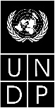 |  | BES
 |  |  |  |  |  |  | IPBES/4/INF/1/Rev.1
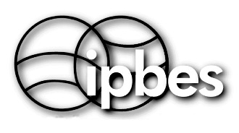 |  | Intergovernmental Science-Policy Platform on Biodiversity and Ecosystem Services |  |  |  |  | Distr.: General  16 February 2017  English only
Plenary of the Intergovernmental Science-Policy
Platform on Biodiversity and Ecosystem Services
Fourth session
Kuala Lumpur, 22–28 February 2016
Item 5 (a) of the provisional agenda*
Work programme of the Platform: thematic
assessment on pollinators, pollination and food production
Thematic assessment on pollinators, pollination and food production (deliverable 3 (a))
Note by the secretariat
- In section IV of its decision IPBES-2/5, the Plenary of the Intergovernmental Science-Policy Platform on Biodiversity and Ecosystem Services (IPBES) approved the undertaking of a thematic assessment on pollinators, pollination and food production for consideration by the Plenary at its fourth session, as outlined in the scoping report set out in annex V to that decision.
- In accordance with the decision, the thematic assessment was undertaken and a report on the assessment, comprising a summary for policymakers and a set of individual chapters and their executive summaries, was produced by an expert group according to the procedures for the preparation of the Platform’s deliverables for consideration by the Plenary at its fourth session.
- In section IV of decision IPBES-4/1, the Plenary approved the summary for policymakers as set out in annex II to that decision and accepted the individual chapters and their executive summaries (IPBES/4/INF/1), with the understanding that the chapters would be revised after the fourth session as document IPBES/4/INF/1/Rev.1 to reflect the summary for policymakers as approved.
- A laid-out version of the final thematic assessment on pollinators, pollination and food production (including a foreword, statements from key partners, a preface and acknowledgments, the summary for policymakers, the revised individual chapters and their executive summaries and annexes setting out a glossary and lists of acronyms, authors, review editors and expert reviewers) will be posted on the IPBES website. The final set of chapters and their executive summaries is available at http://www.ipbes.net/sites/default/files/downloads/pdf/pollination_chapters_final.pdf. It is presented without formal editing.

* IPBES/4/1.

