UNITED  NATIONS |  |  |  |  | 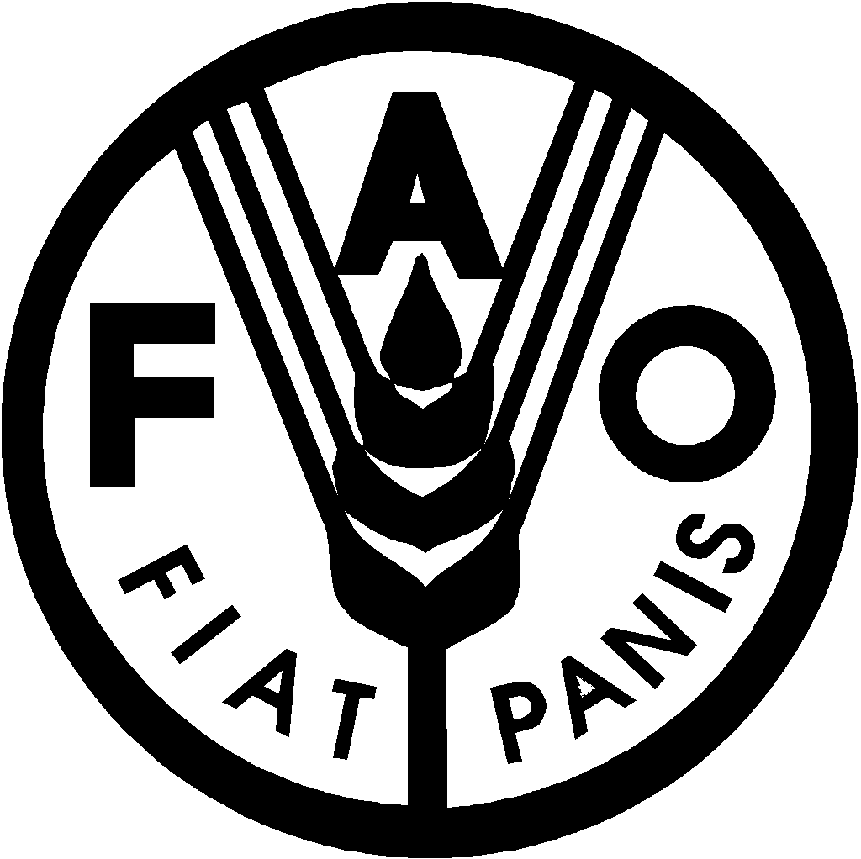 | 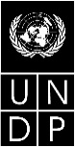 |  |  | BES
 |  |  |  |  |  |  |  | IPBES/4/3/Corr.1
 |  | Intergovernmental Science-Policy Platform on Biodiversity and Ecosystem Services |  |  |  |  |  | Distr.: General  21 January 2016  Original: English
Plenary of the Intergovernmental Science-Policy
Platform on Biodiversity and Ecosystem Services
Fourth session
Kuala Lumpur, 22–28 February 2016

Item 5 (a) of the provisional agenda*
Work programme of the Platform: thematic assessment on pollinators, pollination and food production
Summary for policymakers of the thematic assessment on pollinators, pollination and food production (deliverable 3 (a))
Note by the secretariat
Corrigendum
1. Figure SPM.1: Global diversity of wild and managed pollinators
Replace figure SPM.1 (page 6) with figure SPM.1 below
2. Page 9
At the end of section A, insert figure SPM.3 below
3. Figure SPM.6: The International Union for Conservation of Nature (IUCN) Red List status of wild pollinator taxa
Replace figure SPM.6 (page 14) with figure SPM.6 below

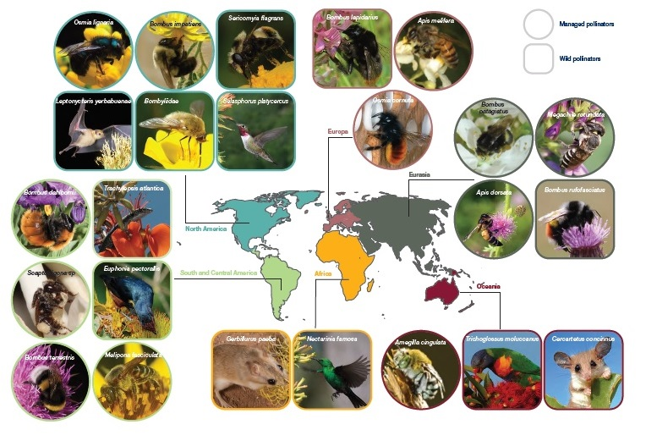
Figure SPM.1: Global diversity of wild and managed pollinators. Examples provided here are purely illustrative and chosen to reflect the wide variety of animal pollinators found regionally.

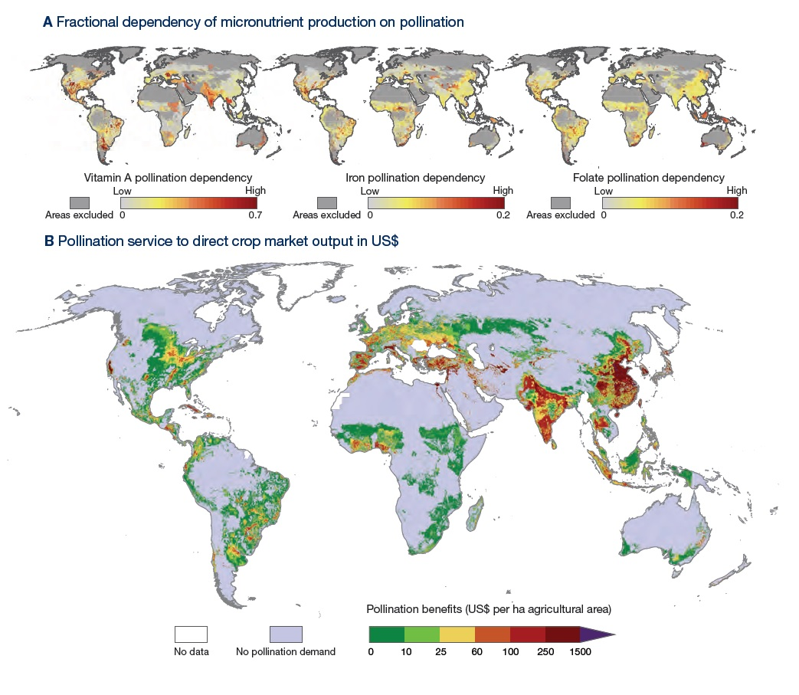
Figure SPM.3: (A) Fractional dependency of micronutrient production on pollination. This represents the proportion of production that is dependent on pollination for (a) vitamin A, (b) iron, and (c) folate. Based on Chaplin-Kramer R. et al. (2014).(B) Global map of pollination service to direct crop market output in terms of US$ per hectare of added production on a 5’ by 5’ latitude longitude grid. Benefits are given as US$ for the year 2000 and have been corrected for inflation (to the year 2009) and for purchasing power parities. Analyses used country-specific FAO-data on production prices and production quantities and on the pollination dependency ratio of the crop. Based on Lautenbach et al. (2012).

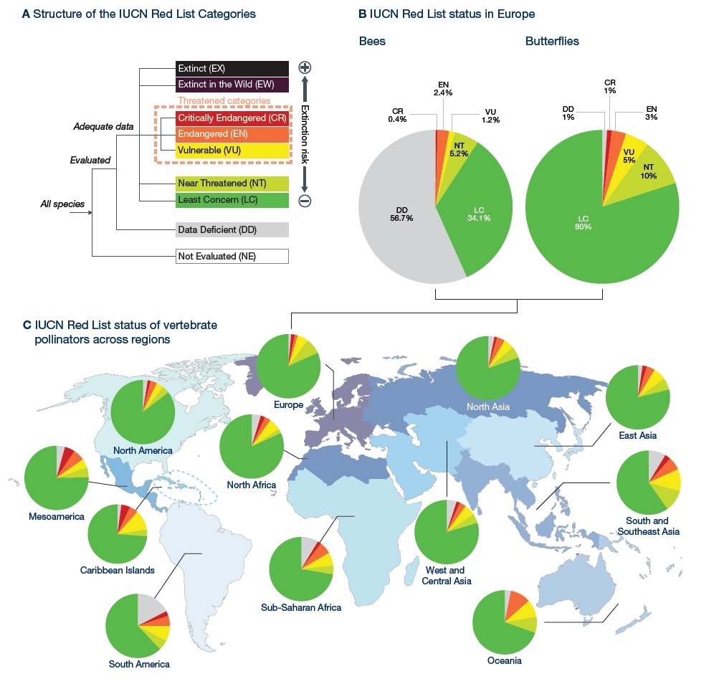
Figure SPM.6: The International Union for Conservation of Nature (IUCN) Red List status of wild pollinator taxa. (A) The IUCN Red List relative risk categories: EX= extinct; EW = extinct in the wild; CR = critically endangered; EN = endangered; VU = vulnerable; NT = near threatened; LC = least concern; DD = data deficient; NE = not evaluated. (B) Red List status of European bees and butterflies. (C) Red List status of vertebrate pollinators (including mammals and birds) across IUCN regions.

* IPBES/4/1.
Chaplin-Kramer R. et al. (2014) “Global malnutrition overlaps with pollinator-dependent micronutrient production.” Proc. R. Soc. B 281: 2014.1799.
Lautenbach S. et al. (2012) “Spatial and temporal trends of global pollination benefit.” PLoS ONE 7: e35954.
This map replicates the original country and territory assignments to geographical regions used by the IUCN during their assessment process. Further details are available from: http://www.iucnredlist.org/technical-documents/data-organization/countries-by-regions.

