November 23rd 2021

IPBES Secretariat
10th floor, Platz der Vereinten Nationen 1,
53113 Bonn,
Germany

Dear IPBES Secretariat,

We hereby nominate the following representative of our organization to as our focal point:

Dr. Anna Metaxas
Dalhousie University
1355 Oxford Street
PO Box 15000
Halifax, Nova Scotia
Canada B3H 4R2
Email: Metaxas@dal.ca
Phone: (902) 494-3021
Website: www.annametaxas.com

Kind regards,
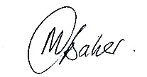
Dr Maria Baker (On behalf of the DOSI Executive)
University of Southampton
Waterfront Campus
European Way
Southamton
SO14 3ZH
UK

