UNITED  NATIONS |  |  | 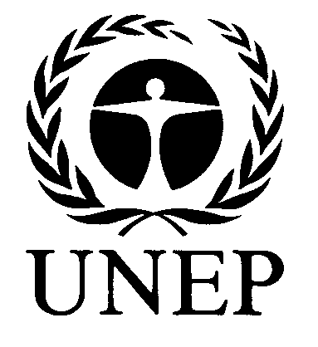 |  |  | 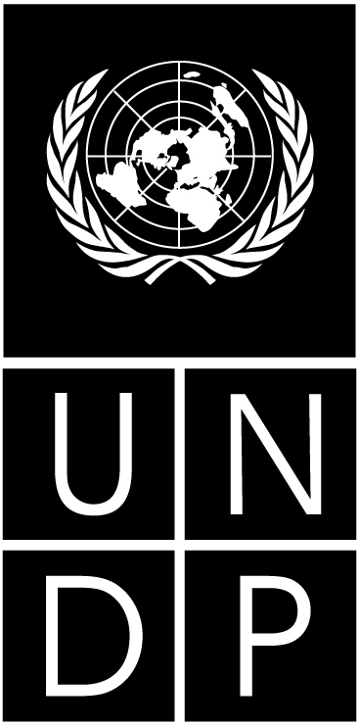 |  |  | BES
 |  |  |  |  |  |  |  | IPBES/3/INF/18
 |  | Intergovernmental Science-Policy Platform on Biodiversity and Ecosystem Services |  |  |  |  |  | Distr.: General  28 November 2014  Original: English
Plenary of the Intergovernmental Science-Policy
Platform on Biodiversity and Ecosystem Services
Third session
Bonn, Germany, 12–17 January 2015
Item 5 (c) of the provisional agenda*
Initial work programme of the Platform: scoping documents for regional assessments, land degradation and restoration and the conceptualization of values
Information on the scoping process for a thematic assessment of land degradation and restoration (deliverable 3 (b) (i))
Note by the secretariat
In its decision IPBES-2/5, the Plenary of the Intergovernmental Science-Policy Platform on Biodiversity and Ecosystem Services approved the initiation of scoping for a thematic assessment of land degradation and restoration. The resulting scoping report (IPBES/3/7) was developed by a time-bound and task-specific expert group in accordance with the institutional arrangements for the implementation of the work programme set out in annex I to decision IPBES-2/5 and in accordance with the procedures for the preparation of the Platform’s deliverables set out in decision IPBES-2/3. The expert group met once in Beijing from 9 to 11 September 2014, thanks to generous in-kind support received from China. The annex to the present note provides information on the composition and work of the expert group. It is presented without formal editing.
Annex
I. Composition of the expert group
- A time-bound and task-specific expert group of 35 experts was selected from a total of 235 nominations received from governments and other relevant stakeholders. The selection process was performed by members of the Multidisciplinary Expert Panel, with advice from Bureau members, together reviewing all nominations that had been submitted, based on examination of nomination templates and CVs for each nominee. Selections were made on the basis of excellence and relevance of candidates’ expertise with respect to relevant areas of the work programme. Once selected on merit, further selection was focused on balancing disciplinary, regional and gender diversity, as well as sectorial aspects (i.e. 80 per cent of selected experts from governments and 20 per cent from non-governmental stakeholders).
- The group selected included 20percent of experts from Africa, 20 percent from Asia Pacific, 14 percent from Eastern Europe, 20 percent from Latin America and the Caribbean and 23 percent from Western European and Others Groups, with 77 percent nominations made by governments and 23 percent by non-governmental stakeholders, and an overall male to female ratio of 66 to 34. The composition of the expert group is presented in the appendix hereto.
II. Process followed
- The meeting was chaired by Ann Bartuska (Multidisciplinary Expert Panel, MEP) in accordance with the institutional arrangements for the implementation of the work programme. Günay Erpul (MEP) and Jay Ram Adhikari (Bureau ) were in attendance. The group first discussed and agreed, in plenary, on the scope, rationale and utility and on the chapter outline of the thematic assessment on land degradation and restoration. It then worked alternately in break out groups and in plenary sessions to discuss the content of each chapter. A final plenary meeting reviewed all aspects of the content of the scoping report. The expert group finalised the document by email, with support from the secretariat.
Appendix
List of experts selected for scoping an assessment on land degradation and restoration
Name | Affiliation | Nominating Country or Organisation
Abbas, Mohamed | Ministry of Water Resources and Electricity | Sudan
Arabi, Mourad | Institut National de recherche forestière (INRF) | Algeria
Argaw Denboba, Mekuria | Addis Ababa University | Ethiopia
Barger, Nichole | University of Colorado | United States of America
Bolashvili, Nana | Ivane Javakhishvili Tbilisi State University | Georgia
Chapela, Gonzalo | Universidad Autonoma Chapingo | Mexico
Čustović, Hamid | Faculty of Agricultural and Food Sciences, University of Sarajevo | Bosnia and Herzegovina
Davies, Jocelyn | Commonwealth Scientific and Industrial Research Organisation (CSIRO) | Australia
Dolisca, Frito | State University of Haiti | Haiti
El-Bana, Magdy | University of Suez Canal and Port Said | Egypt
Gardner, Toby | Stockholm Environment Institute | Sweden
Gutierrrez-Espeleta, Edgar E. | University of Costa Rica | Costa Rica
Ishikawa, Mikiko | Cho University | Japan
Karim, Md Saiful | Faculty of Law, Queensland University of Technology | Australia
Kohler, Florent | Université de Tours | France
Madenoglu, Sevinc | Ministry of Food Agriculture and Livestock Soil Fertilizer and Water Resources Research Institute Ankara | Turkey
Mendes, Isabel Da Silva Ana | University of Lisbon | Portugal
Mohd. Tamin, Noraini | Qatar University | Malaysia
Morris, Joe | Retired, formerly from Cranfield University | United Kingdom of Great Britain and Northern Ireland
Ramirez, Wilson | Alexander von Humboldt Institute | Colombia
Razafy Fara, Lala | Madagascar and West Indian Ocean Programme Office-World Wildlife Fund for Nature (WWF MWIOPO) | Madagascar
Ritsema, Coen | Wageningen University | Netherlands
Rodrigues, Ricardo Ribeiro | Agriculture School-ESALQ - University of Sao Paulo | Brazil
Safriel, Ariel | Hebrew University of Jerusalem | Israel
Thwin, San | Ministry of Environmental Conservation and Forestry Forest | Myanmar (Burma)
Török, Katalin | Centre for Ecological Research | Hungary
Wu, Bo | Institute of Desertification Studies (IDS) Chinese Academy of Forestry (CAF) | China
Aragón, Roxana | Consejo Nacional de Investigaciones Científicas y Técnicas (CONICET) | Instituto de Ecologia Regional, Facultad de Ciencias Naturales, Univ. Nacional de Tucumán, Argentina
Godbole, Archana | Applied Environmental Research Foundation | Applied Environmental Research Foundation
Mirzabaev, Alisher | Center for Development Research, University of Bonn | Center for Development Research (ZEF), University of Bonn
Munoz, Pablo | United Nations University | International Council for Science (ICSU)
Nkonya, Ephraim | Ministry of Agriculture, Tanzania | International Food Policy Research Institute (IFPRI)
Von Maltitz, Graham | Council for Scientific and Industrial Research (CSIR) | UNCCD CST Bureau
Wang, Fei | Institute of Soil and Water Conservation, CAS | Institute of Soil and Water Conservation, CAS and MWR
Zdruli, Pandi | Mediterranean Agronomic Institute of Bari (CIHEAM) | International Centre for Advanced Mediterranean Agronomic Studies (CIHEAM) Mediterranean Agronomic Institute of Bari, Italy

* * IPBES/3/1.

