|  |  |  |
| --- | --- | --- |
| **UNITED NATIONS** |  | **EP** |
|  |  | **IPBES**/2/12 |
| Description: EP | **United Nations Environment  Programme** | Distr.: General 23 September 2013  Original: English |

Plenary of the Intergovernmental Science-Policy   
Platform on Biodiversity and Ecosystem Services

Second session

Antalya, Turkey, 9–14 December 2013

Item 7 (a) of the provisional agenda[1]*

Communications and stakeholder engagement:  
communications and outreach strategy

Draft communication strategy

Note by the secretariat

I. Background

1. It has been recognized in previous meetings of the Intergovernmental Science-Policy Platform on Biodiversity and Ecosystem Services that the Platform’s ability to strengthen the science-policy interface will depend to a considerable degree on its communication activities. This will pose a particular challenge, given the complexity of the Platform itself and of the scientific and policy issues that it addresses and given the need to create a dialogue on these issues with multiple stakeholders at multiple scales.
2. To date, joint communication activities on the Platform have been undertaken by the United Nations Environment Programme (UNEP) in coordination with the United Nations Educational, Scientific and Cultural Organization (UNESCO), the Food and Agriculture Organization of the United Nations (FAO) and the United Nations Development Programme (UNDP). United Nations organizations have also provided individual communication efforts*.* Basic tools are now in place to engage with all the Platform’s target audiences and have been helpful in securing the interest of a base audience that is familiar with the Platform. Based on the findings of coverage monitoring, the Platform has reasonable press but, as it starts its activities, it is critical that a robust communication strategy be developed in order to build a good level of trust in the Platform from the outset and to mitigate future communication crises. It is also vital to ensure a better evaluation of the actual communication needs and expectations of all stakeholder groups of prime relevance to the Platform, to ensure its success and cost‑effectiveness.
3. Recognizing that it is critical to adopt a solid communication strategy as the Platform starts its work, the Bureau, at its first meeting, held in Bergen, Norway, in June 2013, agreed to establish a communication subcommittee chaired by one of the vice-chairs to advance the process of developing a communication strategy.
4. The principles, guidelines and framework for the Platform’s communications (see sect. II) have therefore been updated on the basis of the draft communication strategy for the start-up of the Platform and for its initial work programme that was presented as an information document (UNEP/IPBES.MI/2/INF/4) at the second session of the plenary meeting to determine modalities and institutional arrangements for an intergovernmental science‑policy platform on biodiversity and ecosystem services, held in Panama City in 2012. The present note is designed, therefore, to provide a framework for the Platform’s communications, comprising principles and guidelines that would serve as the founding document for all communication strategies to come and as a basis for briefing potential partners and contractors.
5. A process to develop the first communication strategy for the Platform, which would include a needs assessment, a consultation designed to harness best practices and an identification of potential external partners or strategic partners to shape the first communication strategy for the Platform, is also proposed in section II.G below. The strategy will be designed to support the work programme as agreed by the Plenary at its second session, will be aligned with the stakeholder engagement strategy and will cater for potential strategic partnerships in the field of communications. There is also a need for the Plenary formally to endorse the Platform’s logo, which is presented in annex III.
6. A proposed yearly corporate communication budget for the implementation of the strategy is also set out in section II.G below.
7. The substance of the present note was reviewed by members of the Bureau at its second meeting, held in Cape Town, South Africa, on 31 August and 1 September 2013. Comments received during that meeting were incorporated in the document before its finalization and submission to the Plenary at its second session.
8. The draft communication strategy should be considered also in the context of the draft stakeholder engagement strategy for the implementation of the Platform’s work programme (IBPES/2/13) and the guidance on the development of strategic partnerships (IPBES/2/14).

II. Principles, guidelines and framework for the Platform’s communications

A. Introduction

1. The success of the Platform will depend to a considerable degree on its communication activities. They will ensure general support for the Platform itself, secure engagement from relevant stakeholders in its work, ensure maximum dissemination of the Platform’s products and support resource mobilization efforts.
2. This poses a particular challenge, given the complexity of the Platform itself and of the scientific and policy issues that it addresses, and given the need to create a dialogue on these issues with multiple stakeholders at multiple scales.
3. As the Platform starts its activities, it is critical that a robust communication strategy be developed in order to build a good level of trust in the Platform from the largest audience possible and to prevent and, where necessary, mitigate future communication crises. It is also vital to ensure a better evaluation of the actual communication needs and expectations of all stakeholder groups of prime relevance to the Platform so as to ensure its success and cost‑effectiveness.
4. The Platform’s communication should:

(a) Be in line with the Platform’s operating principles and institutional arrangements;

(b) Be innovative;

(c) Build on best practices and lessons learned by other organizations and initiatives, including those outside the United Nations system and working in the humanitarian and development fields.

1. The Platform’s communication work should be appropriately funded and allow for support from external communication and media professionals.
2. The present note is designed to provide the principles, guidelines and framework for the Platform’s communications, guiding the development of communication strategies supporting the Platform’s work in its different processes and in the delivery of its successive work programmes.

B. Objectives of the Platform’s communication

1. The main objectives of the strategy are the following:

(a) The Platform builds upon and adds value to ongoing efforts for biodiversity and ecosystem services to be recognized as key to human well-being and sustainable development, with a particular focus on developing countries and countries with economies in transition and the general public worldwide;

(b) The Platform is positioned and identified by all relevant stakeholders, including the media and the general public, as a platform that adds value to the work already undertaken in the field of biodiversity and ecosystem services to support policymaking;

(c) The Platform is recognized as a credible, relevant, independent and legitimate platform that produces policy-relevant (but not prescriptive) knowledge products and builds capacity to strengthen the use of biodiversity and ecosystem services and knowledge in decision-making;

(d) Opportunities are widely publicized among relevant stakeholders for their full engagement in the Platform, to contribute to its work and impact, in support of the stakeholder engagement strategy;

(e) Tools are provided to support the operation of the Platform as a whole as well as the activities of and coordination between its different bodies and organs.

C. Key audiences

1. The Platform will be of interest to the wide range of stakeholders involved in the fields of biodiversity conservation and natural resource management and development, at all levels. It is expected that these stakeholders will act both as contributors to and end-users of the Platform.
2. The Platform’s stakeholder engagement strategy contributes towards defining these stakeholders and proposes the following definition in the context of the implementation of the work programme. Stakeholders are institutions, organizations or groups that could:

(a) Contribute to the activities of the work programme through their experience, expertise, knowledge, data and information;

(b) Benefit from the outcomes of the work programme;

(c) Encourage, facilitate and support the participation of relevant individuals in the Platform’s activities.

1. Annex I to the present note provides the current list of types of actors that should be engaged in the Platform in keeping with the stakeholder engagement strategy.
2. In the context of the Platform’s communications, and when designing specific activities, this definition should:

(a) Be broadened to include stakeholders having a role in the Platform’s decision-making processes;

(b) Make a distinction between a general audience seeking basic information from the Platform, on the one hand, and, on the other, audiences familiar with its operation, who are more closely involved in the Platform’s activities or should be more engaged with its processes and outputs;

(c) Include the general public and the media as a well-defined and specific audience for the Platform’s communications.

1. The following list of type of stakeholders can also serve as a basis for the definition of the Platform’s audiences.

1. Primary audiences

(a) Decision-makers in the field of biodiversity and ecosystem services at all levels;

(b) Ministries of the environment, energy, industry, planning, finance, foreign affairs, agriculture, et cetera, from the local to the international level, negotiators at the Platform’s plenary meetings;

(c) Relevant multilateral environmental agreements and their constituencies, secretariats and chairs of scientific advisory bodies: the Convention on Biological Diversity, the Convention on Wetlands of International Importance Especially as Waterfowl Habitat (Ramsar Convention), the Convention on International Trade in Endangered Species of Wild Fauna and Flora (CITES), the Convention on the Conservation of Migratory Species of Wild Animals, the United Nations Convention to Combat Desertification in Countries Experiencing Serious Drought and/or Desertification, Particularly in Africa, the World Heritage Convention and the International Treaty on Plant Genetic Resources for Food and Agriculture;

(d) United Nations bodies related to biodiversity and ecosystem services: UNEP, UNESCO, FAO, UNDP and other entities with a role in addressing the links between ecosystem services, human well-being and development;

(e) International and regional scientific organizations working in the field of biodiversity and ecosystem services;

(f) Other relevant stakeholders involved in the management of natural resources, including non-governmental and intergovernmental organizations, the scientific community, the public and private production sector, indigenous people, local communities and others.

2. Secondary audiences

(a) Potential donors;

(b) The media;

(c) The general public, including young people and women.

1. Ultimately, fluid groupings – such as the combination of general audiences and those familiar with the operations of the Platform or the bundling of various actors depending on their role in respect of the Platform’s work – will have to be used. The groupings will be defined according to each specific communication objective and to the tailoring of specific messages (see sect. D below). For example:

(a) The same general message on the Platform’s added value and role can be shared among all categories of stakeholders who are not familiar with the operations of the Platform;

(b) When considering the engagement of scientific experts in the Platform’s assessments, specific messages will be developed and will target the scientific community at the relevant scale;

(c) When detailed information on the upcoming meeting of the Plenary is being shared, negotiators in government and observers, independently of the type of organization that they represent, will be targeted more specifically.

1. The groupings and messages will also be refined in the light of discussions on stakeholder engagement on the proposed needs analysis, including analysis of the scale at which they work, languages, et cetera

D. Key messages

1. Specific messages along the following lines will be developed in the implementation of the Platform’s communication strategy:

(a) Building on what is already in the public domain and trying to form partnerships with other organizations or initiatives, to explain what biodiversity and ecosystem services are, why they are important for human well-being and what is threatening them, as well as the role of science and policy in understanding and managing the threats and how an improved science-policy interface can help;

(b) Why the Platform has been set up, how it adds value to the current landscape of initiatives on biodiversity and ecosystem services and how it can support decisions to address the loss of biodiversity and degradation of ecosystem services;

(c) Key messages relating to the Platform’s work programme: how the Platform operates (its four functions, overall approach and governance, and the mandate for each of its specific bodies), and under which principles;

(d) How various stakeholders can be involved in the Platform’s work: how to learn more about the Platform, how to be engaged at the decision-making level, how to contribute to its programme of work, et cetera;

(e) How various stakeholders can benefit from the Platform’s activities (for example on capacity-building, networking opportunities and learning opportunities);

(f) Raising awareness of the Platform’s key products, following an approach targeted at specific audiences: what these key products are, how they were developed (including highlighting uncertainties around the scientific information), what their major conclusions are, and how they can be used, and ensuring that the products are readily available to interested parties (relating, for example, to issues of format, content, language and tone, et cetera);

(g) Sharing of specific information to ensure smooth participation in and preparation for meetings of the Plenary and other meetings (information on venue and dates, documents to be presented and logistics, et cetera).

E. Principles to be followed in the Platform’s communication strategy and activity design

1. Given the nature of the Platform and the experience of other relevant initiatives, the following principles are likely to be important in conveying information about the Platform’s work:

(a) The Platform’s communication approach and activities will at all times be aligned with its operating principles and institutional arrangements;

(b) The communication strategy should be innovative and build on best practices and lessons learned by other organizations and initiatives, including those outside the United Nations system and working in the humanitarian and development fields;

(c) The communication strategy should emphasize transparency and provide rapid and evidence-based responses to emerging communication issues which are of relevance to stakeholders;

(d) Communication activities should be timely and appropriate when information is shared in the public domain, but they should also be reactive in response to questions or criticism;

(e) The appropriate communication of scientific uncertainties will be critical for recognition of the Platform’s independence, legitimacy and credibility. In the case of assessments, this can be achieved by ensuring that the full range of views or the specific language in which a scientific finding has been made is reflected appropriately or by explaining the Platform’s processes and methodologies for conducting global and regional assessments. Indeed, the Platform should provide a context to guide the interpretation of its reports and to ensure that audiences have unbiased information about it. In the case of policy support tools, the methodology used and limitations of models, for example, should also be clearly communicated;

(f) Information should be shared in a policy-relevant but not a policy-prescriptive manner. It is an essential quality of the Platform’s work that messaging and reports should remain policy‑neutral and maintain scientific balance;

(g) Whenever appropriate and possible, communication work should build upon and strengthen existing communication initiatives in relevant fields;

(h) The Platform’s communication activities should support the stakeholder engagement strategy for the implementation of the work programme and wider stakeholder engagement in the overall work of the Platform;

(i) Specific emphasis should be placed on the use of different languages and on the scale of the activities in order appropriately to communicate with the full range of the Platform’s stakeholders;

(j) The Platform’s communication activities should be integrated and targeted;

(k) The Platform’s communication must consider making use of strategic partners;

(l) The Platform’s communication activities should also allow for support from external communication and media professionals.

F. Implementation set-up

1. Roles and responsibility for the design and implementation of successive Platform communication strategies and implementation plans based on these guidelines and framework should be clearly identified.
2. In doing so, the role of the following bodies or groups should be considered:

(a) The Plenary, which is the decision-making body of the Platform and should adopt a framework and guidelines for the development of communication strategies for the Platform;

(b) The Bureau, in accordance with its agreed functions;

(c) The Multidisciplinary Expert Panel, in accordance with its agreed functions;

(d) The secretariat, in particular the Executive Secretary supported by a dedicated communication and stakeholder engagement programme officer and a programme assistant;

(e) Key representatives of other bodies of the Platform, such as the chair of a working group, if established; lead authors for scientific reports; and national focal points, who may be involved in communication activities and asked to speak on behalf of the Platform under terms agreed by the Plenary.

1. Clear coordinating (between the various organs of the Platform), reporting and decision‑making processes to decide on communication issues (including at times when a rapid response to urgent queries or to criticism is needed) should be developed. Rules and procedures could be developed to this end that would also clarify specific roles and responsibilities for all parties involved.
2. Guidelines on who can speak on behalf of the Platform under different circumstances should be developed, by, for example, maintaining a list of authorized people adopted by the Bureau or the Plenary. Briefings containing consistent key messages should be made available to support their work.

G. Actions to develop successive communication strategies and implementation plans for the Platform

1. This present note aims to provide principles, guidelines and a framework for the Platform’s communications and for guiding the development of communication strategies supporting the work of the Platform in its different processes and in the delivery of its successive work programmes.
2. The following process is proposed for the development of the first strategy once the Plenary has agreed on a framework and guidelines for the Platform’s communication as well as on a budget for the Platform’s communication activities:

(a) A needs analysis for all of the Platform’s key audiences is organized;

(b) A quick analysis of existing communication initiatives that the Platform could build upon, strengthen and complement is undertaken;

(c) The secretariat could be entrusted with drafting a strategy under the supervision of the Bureau and specific guidance from the Multidisciplinary Expert Panel on communicating scientific issues and engaging with the scientific and technical communities;

(d) In doing so, specific attention could be given to making use of strategic partners, and making provision for the use of external communication agencies or media experts in the delivery of the activities;

(e) A process to gather best practices and lessons learned by other organizations or initiatives, including outside the United Nations system and working in the humanitarian and development fields, should be facilitated. Inputs from relevant organizations should be invited on the draft strategy.

1. Annex II, which sets out a wide range of indicative activities that could be undertaken as part of these strategies, could be used to support this work.

H. Monitoring and evaluation

1. A simple yet effective monitoring and evaluation system for the Platform’s communication activities should be put in place. This monitoring and evaluation should include assessment of the effectiveness and efficiency of the strategy measured at key audience level.

G. Indicative maximum annual budget for the corporate communication activities of the Platform

(United States dollars)

|  |  |  |
| --- | --- | --- |
| *Item* | *Comments* | *Annual  budget* |
| Web and social media support | Hosting, technical management, maintenance and support to content management | 45 000 |
| Audiovisual support | Interviews, public service announcements, curtain raiser, photography, clips, in appropriate languages | 160 000 |
| Media support | For organization of media events, development of the media briefs and kits, press conferences, et cetera | 70 000 |
| Printed communication and outreach material, excluding official reports and documents | Printing of leaflets, banners, posters, fact sheets in six United Nations languages, as appropriate | 90 000 |
| **Total** |  | **365 000** |

Annex I

List of types of actors that should be engaged in the Platform in accordance with the draft stakeholder engagement strategy

1. The range of stakeholders involved in supporting the implementation of the work programme may include, but is not limited to (in alphabetical order, categories may overlap):

(a) Academic education communities;

(b) Businesses and industries (including small and medium-sized enterprises, investors, financial organizations and trade organizations);

(c) Consumer organizations;

(d) Foundations and trust funds;

(e) Government officers and agencies and organizations working in relevant fields such as environment, development, planning, investment and finance, health, agriculture, et cetera;

(f) Humanitarian and development organizations (in such domains as social justice, equity);

(g) Indigenous peoples and indigenous communities;

(h) Intergovernmental organizations working in relevant fields;

(i) Landowners;

(j) Local authorities;

(k) Local communities;

(l) Media and communication (e.g., mass media, social media, translators for different audiences);

(m) Multilateral environmental agreements;

(n) Non-governmental organizations working in relevant fields;

(o) Networks and secretariats of relevant initiatives working in relevant fields such as the Sub-Global Assessment Network;

(p) Non-profit organizations working in relevant fields;

(q) Organizations related to agriculture, aquaculture, fisheries (e.g., farmers, fishermen, herders, foresters);

(r) Scientific and technological communities;

(s) United Nations agencies or programmes;

(t) Women;

(u) Workers and unions;

(v) Young people and children.

1. Additional criteria might also be considered:

(a) The scale at which they are working on biodiversity- and ecosystem-related issues;

(b) The language that they use.

Annex II

List of potential activities to be conducted as part of a communication strategy for the Platform

1. This is an indicative list of activities that can be conducted to implement the Platform’s communication strategies to be developed in support of the work of the Platform. All the elements of the communication mix will have to be undertaken in an integrated and synergetic manner.
2. To reach a wide audience, translations of the key elements of the communication mix will be made available in all six official languages of the United Nations, and in any additional language as necessary, and as detailed below. Attention will also be paid to format, vocabulary and tone used, accessibility, et cetera
3. Partnerships with key institutions and networking processes will also have to be established as part of the stakeholder engagement strategy to ensure that information and products related to the Platform are shared with appropriate audiences and that feedback from these communities can be received by the Platform, beyond the creation of a formal system for stakeholders to engage with the Plenary.

A. Branding

1. A full graphic design policy as well as branding standards will be developed for the Platform. They will include guidance on the use of the logos of United Nations partners in conjunction with the Platform logo, in accordance with the decision made regarding the United Nations collaborative partnership arrangement with the Platform.
2. The need for rebranding and the design of a new logo could be discussed.

B. Online services

1. Platform website

1. The structure, functions and content of the website should evolve according to the Platform’s work and its communication needs. Going forward, it should focus more on the delivery of the Platform’s work programme, on opportunities to contribute to that work and on the Platform’s products, including through the following modalities:

(a) It should provide links to any online tool established by the Platform, such as a dynamic catalogue of assessments, a platform for submitting local and national assessments for peer‑review, potential intranet to provide access to data as part of the Platform’s capacity-building activities, et cetera;

(b) It could also support e-learning activities, using multimedia resources such as CD‑ROMs and YouTube training, as set out below;

(c) To better reach out to the general public and the media, more information could be provided on the basics of biodiversity and ecosystem services and their linkages with human well-being, through articles, fact sheets, short clips, monthly features and interviews with experts, a highlight of the month feature, and other news items;

(d) It could also provide a collaborative working space to support the work of the various groups under the Platform;

(e) The website should enable stakeholders to share their views and analysis of the Platform (forum, opinion pieces, video interviews, articles, links to their websites, et cetera);

(f) A subscription page to the newsletters and a list of stakeholders involved in the Platform should be made available;

(g) A media kit should be made available on the website;

(h) Attention should be given to ensuring ease of access, downloading and printing to facilitate information‑sharing with people living in areas with low internet connection speeds;

(i) A specific focus will be placed on communicating the Platform’s activities at different scales (for example, by publishing and maintaining lists of activities undertaken at specific levels).

2. Newsletter

1. The contact database for the Platform newsletter should be continuously updated and the newsletter sent regularly, based on a needs analysis.

3. Wikipedia page

1. The Platform’s Wikipedia page should be updated regularly.

4. E-mail

1. The secretariat’s e-mail address will be used as its primary contact modality.

5. Social networks

1. The full use of social networks should be encouraged to support the Platform’s communications, given their cost‑effectiveness.
2. The Platform’s Twitter account should be maintained to support outreach efforts; a Facebook page could be set up to engage with a wider audience; and YouTube could be used for posting all the audiovisual material developed for the Platform that can then be embedded on the website but could also feature material from other relevant initiatives and serve as a platform for capacity-building, through online short courses on assessment, presentation of the Platform’s other products, et cetera

6. Presentations

1. Professional and visually appealing presentations will be developed to raise awareness and understanding of the Platform, for use by all people representing the Platform at external events:

(a) Their look and feel will be adapted in case of rebranding;

(b) They should be made available in relevant languages;

(c) A briefing note with key messages should be prepared for speakers delivering the presentation.

7. Dissemination materials

1. The Platform’s printed material should be strategically produced based on needs assessments to help raise the visibility of the process and understanding of its purpose and objectives:

(a) Proposed material should include banners, posters and leaflets;

(b) Simple language versions of fact sheets should also be produced in relevant languages;

(c) Targeted fact sheets should be developed for specific audiences (including a general fact sheet on the Platform and what it does, and key principles of its work; on the development of its products for the general public; on the benefits of engaging with the Platform as a stakeholder; and also specific fact sheets for various stakeholders, et cetera);

(d) Key messages and briefing documents could also be developed and shared with partners, relevant institutions and the media to ensure consistency in messaging and information;

(e) Multi-media CD-ROMs targeting specific audiences, including for assessment practitioners, including tools, methodologies and capacity-building materials, or targeting policymakers, presenting the Platform’s products that are available to them, policymaking tools, et cetera;

(f) Materials should be made available in digital format and for downloading from the website for wider distribution.

8. Promotional products

1. Branded promotional products could be produced for delegates attending meetings (such as notepads, pens, USB keys, et cetera) and for distribution to a wider audience at targeted events (key rings, T-shirts, stickers and bags, for example).

9. Platform products

1. Products of the Platform (such as assessment reports, documents on policy-support tools, a common framework for assessments) will be branded, formatted and made available on the website for easy downloading in relevant languages.
2. A limited number will also be made available in printed version to reach out to the widest audience possible. Their format, language and tone should be adapted to the targeted audiences (for example, a long assessment report could have a separate policymakers’ executive summary, a general public information sheet, and other elements).

10. Audiovisual material

1. Curtain-raisers could be developed for meetings of the Plenary and to present the Platform at relevant events. In addition, public service announcements and less elaborate interviews with the Platform’s high‑profile stakeholders (conducted in relevant languages and with a wide geographical representation) could be developed, to help spread the message to a wider audience through the media and the Platform’s website.
2. Short video clips on biodiversity ecosystem services and the links with human well-being could be developed and distributed to inform the general public, including young people; alternatively, existing clips developed by other initiatives could be used and presented at external events, with the authorization of the owners. At the same time, short clips on the Platform’s activities (such as capacity-building workshops or assessment work) could also be produced, in order to demonstrate through real examples what the Platform does and how.

### 11. Events and outreach

1. Platform events will be publicized; there will also be a calendar of events at which to spread the Platform’s messages and to engage with stakeholders. Stakeholders and relevant organizations should be invited to populate these calendars.
2. The briefing notes, digital slide presentations, audiovisual productions, other materials for dissemination and promotional items can be used at these events. Stakeholders will be invited to contribute ideas to further such events on the calendar via the website. Special launches should be organized for key Platform products and potential training measures. In that context, the calendar of Platform-related events should be disseminated over partner networks, such as through the biodiversity updates put out by the International Institute for Sustainable Development (IISD).
3. A transportable publicity booth (including a television to project audiovisual material and stands for printed material) could be produced in order to increase the visibility of the Platform at external events, such as the meetings of biodiversity-related multilateral environmental agreements. Efforts should be made to ensure that there is coverage of the Plenary and other relevant meetings by IISD or equivalent bodies. In addition, side events should be organized at the Platform’s meetings for stakeholders to engage with participants of the Plenary and to present or discuss topics of interest.

12. Media work

1. Media briefings should be organized, taking into account regional spread and the use of appropriate languages. To that end, media-packs should be prepared in a number of different languages and press releases should also be produced in various languages to share information about the Platform’s key activities and products. Press conferences should be organized as needed to share information about those key activities and products.
2. Public service announcements and television appearances by key stakeholders should be widely broadcast, to ensure that they reach as extensive an audience as possible. Regular articles should be prepared for policy, scientific, non-governmental and youth-oriented publications and also for the general public press, and online bulletins and newsletters should be developed in order to reach out to all relevant audiences.

Annex III

Logo

The following logo has been prepared for the Platform:

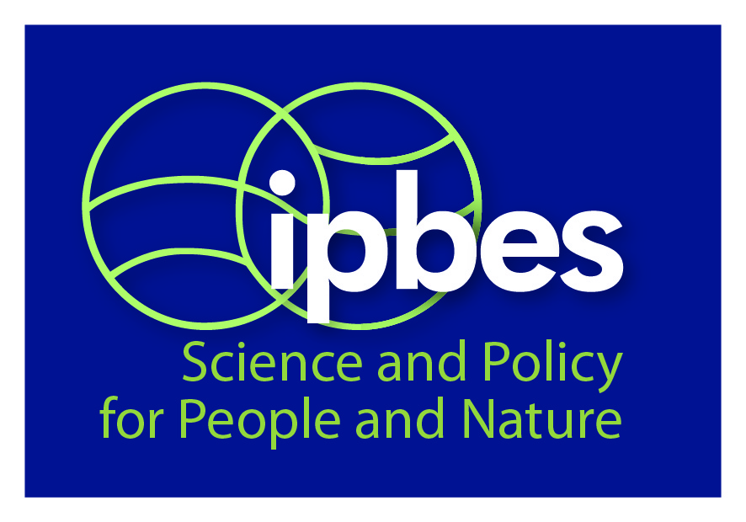

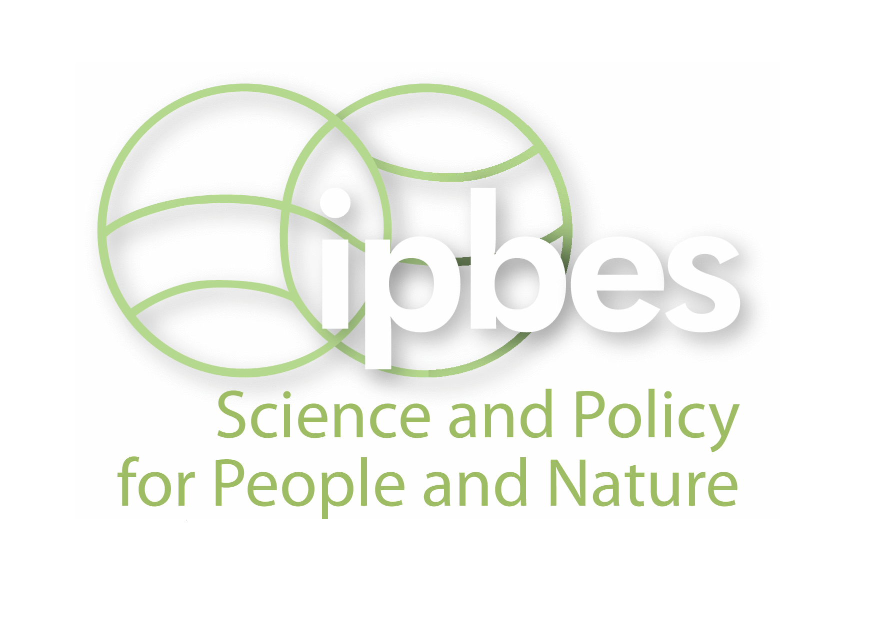

The Platform logo and its catch-line, “Science and Policy for People and Nature”, are to be used on all official Platform documents and communication materials. The logo may be used with or without the catch-line, on a dark blue or white background, as appropriate. A comprehensive policy for the use of the logo and overall graphic design and branding standards will be developed for the Platform.

|  |  |  |
| --- | --- | --- |
|  |  |  |

1. * IPBES/2/1.