UNITED  NATIONS |  |  |  |  | 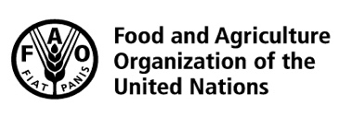 |  |  | BES
 |  |  |  |  |  |  | IPBES/6/15/Add.5
 |  | Intergovernmental Science-Policy Platform on Biodiversity and Ecosystem Services |  |  |  |  | Distr.: General  23 April 2018  Original: English
Plenary of the Intergovernmental Science-Policy
Platform on Biodiversity and Ecosystem Services

Sixth session
Medellin, Colombia, 18–24 March 2018
Report of the Plenary of the Intergovernmental Science-Policy Platform on Biodiversity and Ecosystem Services on the work of its sixth session
Addendum
At its sixth session, in its decision IPBES-6/1, section V, paragraph 1, the Plenary of the Intergovernmental Science-Policy Platform on Biodiversity and Ecosystem Services (IPBES) approved the summary for policymakers of the thematic assessment of land degradation and restoration as set out in the annex to the present addendum.

Annex
Summary for policymakers of the thematic assessment report on land degradation and restoration of the Intergovernmental
Science-Policy Platform on Biodiversity and Ecosystem Services
Authors:
Robert Scholes (co-chair, South Africa), Luca Montanarella (co-chair, Italy/FAO).
Anastasia Brainich (IPBES); Nichole Barger (United States of America), Ben ten Brink (the Netherlands), Matthew Cantele (United States of America), Barend Erasmus (South Africa), Judith Fisher (Australia), Toby Gardner (United Kingdom of Great Britain and Northern Ireland/Sweden), Timothy G. Holland (Canada); Florent Kohler (Brazil, France), Janne S. Kotiaho (Finland), Graham Von Maltitz (South Africa), Grace Nangendo (Uganda), Ram Pandit (Nepal), John Parrotta (United States of America), Matthew D. Potts (United States of America), Stephen Prince (United States of America), Mahesh Sankaran (India), Louise Willemen (the Netherlands).
Suggested citation:
IPBES (2018): Summary for policymakers of the thematic assessment report on land degradation and restoration of the Intergovernmental Science-Policy Platform on Biodiversity and Ecosystem Services. R. Scholes, L. Montanarella, A. Brainich, N. Barger, B. ten Brink, M. Cantele, B. Erasmus, J. Fisher, T. Gardner, T. G. Holland, F. Kohler, J. S. Kotiaho, G. Von Maltitz, G. Nangendo, R. Pandit,
J. Parrotta, M. D. Potts, S. Prince, M. Sankaran and L. Willemen (eds.). IPBES secretariat, Bonn, Germany. [ ] pages.
Members of the management committee who provided guidance for the production of this assessment: Günay Erpul, Yi Huang, Marie Roué, Leng Guan Saw (Multidisciplinary Expert Panel), Fundisile G. Mketeni, Rashad Z. O. Allahverdiyev (Bureau).

I. Key messages
A. Land degradation is a pervasive, systemic phenomenon: it occurs in all parts of the terrestrial world and can take many forms
Combating land degradation and restoring degraded land is an urgent priority to protect the biodiversity and ecosystem services vital to all life on Earth and to ensure human well-being
A1. Currently, degradation of the Earth’s land surface through human activities is negatively impacting the well-being of at least 3.2 billion people, pushing the planet towards a sixth mass species extinction, and costing more than 10 per cent of the annual global gross product in loss of biodiversity and ecosystem services. Loss of ecosystem services through land degradation has reached high levels in many parts of the world, resulting in negative impacts that challenge the coping capacity of human ingenuity. Groups in situations of vulnerability feel the greatest negative effects of land degradation, and often experience them first. These groups also see the greatest benefits from avoiding, reducing and reversing land degradation (Figure SPM.1). The main direct drivers of land degradation and associated biodiversity loss are expansion of crop and grazing lands into native vegetation, unsustainable agricultural and forestry practices, climate change, and, in specific areas, urban expansion, infrastructure development and extractive industry.
A2. Investing in avoiding land degradation and the restoration of degraded land makes sound economic sense; the benefits generally by far exceed the cost. Land degradation contributes to the decline and eventual extinction of species and the loss of ecosystem services to humanity, making avoidance, reduction and reversal of land degradation essential for human
well-being. Short-term gains from unsustainable land management often turn into long-term losses, making the initial avoidance of land degradation an optimal and cost-effective strategy. Studies from Asia and Africa indicate that the cost of inaction in the face of land degradation is at least three times higher than the cost of action. On average, the benefits of restoration are 10 times higher than the costs, estimated across nine different biomes. While challenging, the benefits of restoration include, but are not limited to, increased employment, increased business spending, improved gender equity, increased local investment in education and improved livelihoods.
A3. Timely action to avoid, reduce and reverse land degradation can increase food and water security, can contribute substantially to the adaptation and mitigation of climate change and could contribute to the avoidance of conflict and migration. This is especially important considering the projected 4 billion people that will be living in drylands in 2050. Inherent feedbacks between the Earth’s land systems, climate and human societies mean that efforts to address land degradation and restore land have multiplicative benefits. Land restoration and reduced and avoided degradation that increases carbon storage or avoids greenhouse gas emissions in global forests, wetlands, grasslands and croplands could provide more than one third of the most cost-effective greenhouse gas mitigation activities required by 2030 to keep global warming to below 2°C. By 2050, land degradation and climate change together are predicted to reduce crop yields by an average of 10 per cent globally and up to 50 per cent in certain regions. Decreasing land productivity, among other factors, makes societies, particularly on drylands, vulnerable to socioeconomic instability. In dryland areas, years with extreme low rainfall have been associated with an increase of up to 45 per cent in violent conflict. Every 5 per cent loss of gross domestic product (GDP), itself partly caused by degradation, is associated with a 12 per cent increase in the likelihood of violent conflict. Land degradation and climate change are likely to force 50 to 700 million people to migrate by 2050.

Figure SPM.1
Land degradation is a pervasive, systemic phenomenon: it occurs in all parts of the terrestrial world and can take many forms. Successful examples of restoration can also be found in all ecosystems
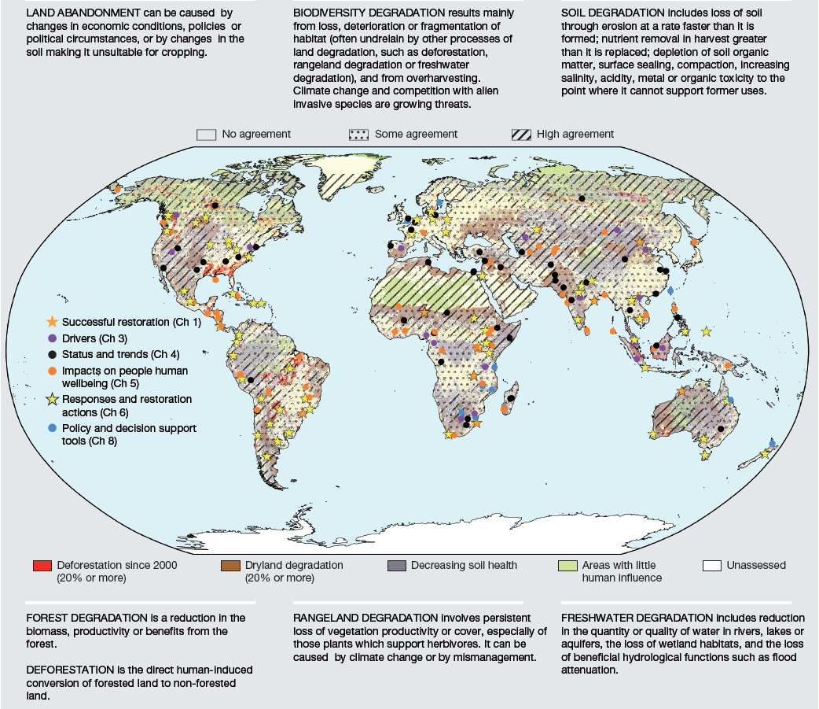
Source: The degradation background map combines a deforestation map by Hansen et al (2013), a drylands degradation map by Zika and Erb (2009), a cropland degradation map by Cherlet et al (2013) and a wilderness map by Watson et al (2016). It is overlaid by a map of agreement and disagreement between different data sources within a degradation type, adapted from Gibbs and Salmon (2015). For further explanation on the metrics and methodology for Figure SPM. 1, see supporting material Appendix 1.1 available from https://www.ipbes.net/supporting-material-e-appendices-assessments.
A4. Avoiding, reducing and reversing land degradation is essential for meeting the Sustainable Development Goals contained in Agenda 2030 (Figure SPM.2). Due to the delay between starting restoration and seeing the full benefits, the window, while still open for limiting land degradation to a level that does not endanger the achievement of the Sustainable Development Goals, is estimated to close over the next decade. The area of non-degraded land is progressively shrinking at the global scale, while land requirements for a range of competing uses continue to grow. Food, energy, water and livelihood security, as well as the good physical and mental health of individuals and societies, are in whole or in part a product of nature and are negatively impacted by land degradation processes. In addition, land degradation causes biodiversity loss and reduction of nature´s contributions to people, erodes cultural identity and, in some cases, leads to loss of the knowledge and practices that could help halt and reverse land degradation. Full achievement of the Sustainable Development Goals contained in the 2030 Agenda for Sustainable Development is likely to only be possible through urgent, concerted and effective action to avoid and reduce land degradation and promote restoration.
Figure SPM.2
Avoiding, reducing and reversing land degradation is essential for reaching the majority of the Sustainable Development Goals and would deliver co-benefits for nearly all of them
The graphic presents the results of a survey of 13 coordinating lead authors of this assessment, who were asked to synthesize findings of the chapters in order to evaluate the relevance of efforts to address land degradation and restoration for targets of each Sustainable Development Goal, as well as the extent to which addressing land degradation would have a positive or negative impact on progress towards each Sustainable Development Goal. The vertical axis indicates the percentage of experts who believed halting land degradation and restoring degraded land to be relevant to the achievement of that Goal. The green colours indicate the degree to which the targets are synergistic with progress to address land degradation: dark green means all targets are aligned, while lighter green boxes indicate areas where there may be trade-offs between targets and efforts to address land degradation and restoration. In none of the cases was the relationship between efforts to address land degradation and meeting the Sustainable Development Goals judged to be more conflictual than synergistic.
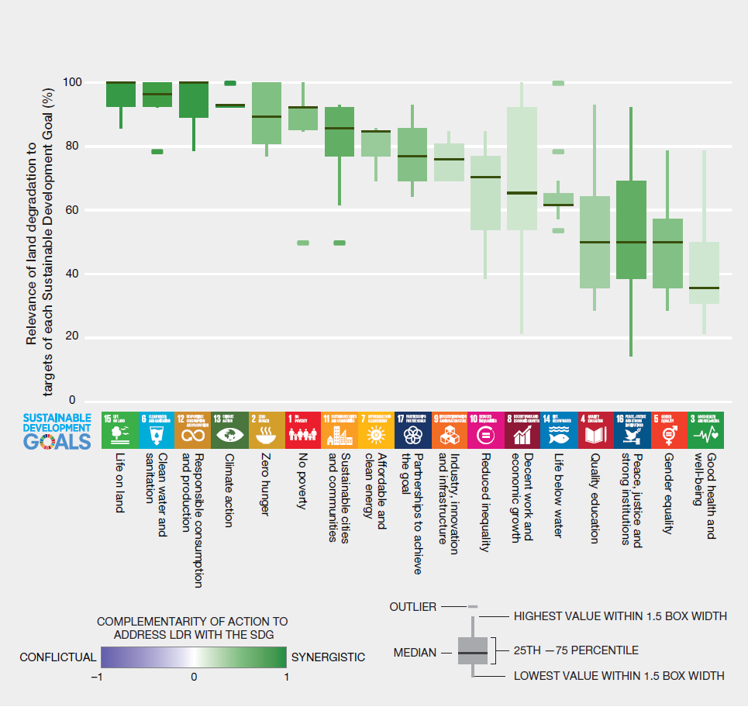

B. Unless urgent and concerted action is taken, land degradation will worsen in the face of population growth, unprecedented consumption, an increasingly globalized economy and climate change
B1. Widespread lack of awareness of land degradation as a problem is a major barrier to action. Perceptions of human-environment relationships have a strong influence on the design and implementation of land management policies. Land degradation is often not recognized as an unintended consequence of economic development. Even when the link between land degradation and economic development is recognized, the consequences of land degradation may not be given due consideration, which may result in lack of action. Appreciation of the challenges posed by land degradation is further undermined by the fact that negative impacts can be highly variable and localized in nature, and are often strongly shaped by distant, indirect drivers. Land degradation and thus loss of biodiversity and ecosystem services is the most pervasive, systemic phenomenon with
far-reaching negative consequences for human well-being worldwide, including by exacerbating food and water insecurity and climate change. Thus, raising awareness of the drivers and consequences of land degradation is essential for moving from high-level policy goals to implementation at the national and local levels.
B2. High consumption lifestyles in more developed economies, combined with rising consumption in developing and emerging economies, are the dominant factors driving land degradation globally. The ultimate driver of land degradation is high and rising per capita consumption, amplified by continued population growth in many parts of the world. Increases in consumption often follow the opening up of new economic opportunities that lower the costs of
land-based resources for consumers, leading to a rise in demand. New economic opportunities often arise from increased access to growing regional and global markets, and from technological developments, which increase production capacity. Without adequate regulation, these factors could drive unsustainable levels of agricultural expansion, natural resource and mineral extraction, and urbanization. The widespread failure of policies and institutions to enforce and incentivize sustainable practices and internalize the long-term economic costs of unsustainable production has meant that the exploitation of natural resources typically leads to greater levels of land degradation. Tackling land degradation thus requires systemic change on a macroeconomic level, including a concerted effort to improve the sustainability of both production systems and consumer lifestyles, while simultaneously working to foster a socioeconomic environment conducive to low population growth rates and per capita consumption.
B3. The full impact of consumption choices on land degradation worldwide is not often visible due to the distances that can separate many consumers and producers. Land degradation is often the result of social, political, industrial and economic changes in other parts of the world, with effects that may involve a lag of months or years. These disconnections mean that many of the actors who benefit from the overexploitation of natural resources are among the least affected by the direct negative impacts of land degradation, and therefore have the least incentive to take action. The fact that regional and local land-use decisions are so strongly influenced by distant drivers can also undermine the effectiveness of local- and regional-scale governance interventions. Market integration may also mean that local governance interventions can result in both positive and negative rebound effects elsewhere, for example, through sustainable investment strategies or the displacement of land uses where environmental enforcement is weaker.
B4. Institutional, policy and governance responses to address land degradation are often reactive and fragmented, and fail to address the ultimate causes of degradation. National and international policy and governance responses to land degradation are often focused on mitigating damage already caused. Most policies directed at addressing land degradation are fragmented and target specific, visible drivers of degradation within specific sectors of the economy, in isolation from other drivers. Land degradation is rarely, if ever, the result of a single cause and can thus only be addressed through the simultaneous and coordinated use of diverse policy instruments and responses at the institutional, governance, community and individual levels.
B5. Land degradation is a major contributor to climate change, while climate change can exacerbate the impacts of land degradation and reduce the viability of some options for avoiding, reducing and reversing land degradation. The impact of almost all direct drivers of land degradation will be worsened by climate change. These include, among others, accelerated soil erosion on degraded lands as a result of more extreme weather events, increased risk of forest fires and changes in the distribution of invasive species, pests and pathogens. Sustainable land management and land restoration can assist climate change mitigation and adaptation. Long-established land management and restoration practices may no longer be viable in the face of climate change. Notwithstanding this risk, nature-based climate mitigation and adaptation actions remain promising.
B6. Rapid expansion and unsustainable management of croplands and grazing lands is the most extensive global direct driver of land degradation. Croplands and grazing lands now cover more than one third of the Earth´s land surface, with recent clearance of native habitats, including forests, being concentrated in some of the most species-rich ecosystems on the planet. Intensified
land-management systems have greatly increased crop and livestock yields in many areas of the world, but, when inappropriately managed, can result in high levels of land degradation, including soil erosion, fertility loss, excessive ground and surface water extraction, salinization, and eutrophication of aquatic systems. Increasing demand for food and biofuels will likely lead to a continued increase in nutrient and chemical inputs and a shift towards industrialized livestock production systems, with pesticide and fertilizer use expected to double by 2050. Proven management practices currently exist to avoid and reduce degradation of existing croplands and grazing lands, including sustainable intensification, conservation agriculture, agroecological practices, agroforestry, grazing pressure management and silvopastoral management. Avoidance of further agricultural expansion into native habitats can be achieved through yield increases, shifts towards less land-degrading diets, such as those with more vegetables, and reductions in food loss and waste.
C. The implementation of known, proven actions to combat land degradation and thereby transform the lives of millions of people across the planet will become more difficult and costly over time. An urgent step change in effort is needed to prevent irreversible land degradation and accelerate the implementation of restoration measures
C1. Existing multilateral environmental agreements provide a platform of unprecedented scope and ambition for action to avoid and reduce land degradation and promote restoration. The United Nations Convention to Combat Desertification in Those Countries Experiencing Serious Drought and/or Desertification, Particularly in Africa, the United Nations Framework Convention on Climate Change, the Convention on Biological Diversity, the Convention on Wetlands of International Importance especially as Waterfowl Habitat (Ramsar Convention), the 2030 Agenda for Sustainable Development and its Sustainable Development Goals and other agreements all have provisions to avoid, reduce and reverse land degradation. These have found a focus in target 15.3 of the Sustainable Development Goals, taking into account, among others, the scientific conceptual framework for land degradation neutrality. However, greater commitment and effective cooperation in using and implementing these established mechanisms at the national and local levels are vital to enable these major international agreements to create a world with no net land degradation, no loss of biodiversity and improved human well-being.
C2. More relevant, credible and accessible information is needed to allow decision makers, land managers, and purchasers of goods to improve the long-term stewardship of land and sustainability of natural resource use. Effective monitoring strategies, verification systems and adequate baseline data—on both socioeconomic and biophysical variables—provide critical information on how to accelerate efforts to avoid, reduce and reverse land degradation and conserve biodiversity. Land managers, including indigenous peoples and local communities, as well as experts and other knowledge holders, all have key roles to play in the design, implementation and evaluation of more sustainable land management practices. Given the complexity of global supply chains, better and more open-access information on the impacts of traded commodities is needed to support decisions, manage risk and guide investments that promote more sustainable commodity production systems and more sustainable lifestyle choices, within the framework of international commitments and in accordance with national legislation at the appropriate level. These would also allow consumers throughout supply chains to make better-informed commodity choices that reward responsible management practices, and raise awareness about the implications of their choices.
C3. Coordinated policy agendas that simultaneously encourage more sustainable production and consumption practices of land-based commodities are required to avoid, reduce and reverse land degradation. Achieving policy reform for sustainable land management requires a step change in how the design and implementation of more sustainable consumption and production policies are aligned across different sectors, including between departments and ministries. Key policy agendas requiring greater alignment include food, energy, water, climate, health, rural, urban and industrial development. The chances of success are improved by close coordination, sharing of information and knowledge, adoption of specific policy instruments for both regulatory and incentive-based measures, and capacity-building that supports a whole supply chain approach to avoiding, reducing and reversing land degradation. Success in these goals is highly dependent on creating enabling conditions for more sustainable land management, which include policies that confer and protect individual and collective land tenure and property rights, in accordance with national legislation at the appropriate level, empower indigenous peoples and local communities, and recognize the role of indigenous and local knowledge and practices for sustainable land management. Efforts are also needed to improve institutional competencies at the national and international levels.
C4. Eliminating perverse incentives that promote degradation and devising positive incentives that reward the adoption of sustainable land management practices are required to avoid, reduce and reverse land degradation. Positive incentives for sustainable land management could include strengthened regulations that ensure that the environmental, social and economic costs of unsustainable land use and production practices are reflected in prices. Perverse incentives include subsidies that reward unsustainable land use and production. Voluntary or regulation-based incentive mechanisms for safeguarding biodiversity and ecosystem services can help avoid, reduce and reverse land degradation. Such mechanisms include both market and non-market based approaches. Examples of market-based approaches include credit lines, insurance policies and future contracts that reward adoption of more sustainable land management practices, payments for ecosystem services and conservation tenders, as applied in some countries. Examples of non-market based approaches include joint mitigation and adaptation mechanisms, justice-based initiatives and ecosystem-based adaptation and integrated water co-management schemes.
C5. Landscape-wide approaches that integrate the development of agricultural, forest, energy, water and infrastructure agendas, all informed by the best available knowledge and experience, are required to avoid, reduce and reverse land degradation. There is no
one-size-fits-all approach to sustainable land management. Achieving success requires selecting from the full toolkit of approaches that have been effectively implemented in different biophysical, social, economic and political settings. Such a toolkit includes a wide range of low-impact farming, pastoral, forest management and urban design practices based on scientific, indigenous and local knowledge systems. Integrating different practices into landscape-scale planning, including local-level sustainable finance and business practices, can reduce the impacts of degradation and enhance the resilience of both ecosystems and rural livelihoods. Participatory planning and monitoring, based on, among others, land capabilities that include local institutions and land users and are supported by multiple knowledge and value systems, are more likely to result in agreement among stakeholders and the effective implementation and monitoring of integrated land management plans
C6. Responses to reduce environmental impacts of urbanization not only address the problems associated with urban land degradation, but can also significantly improve quality of life while simultaneously contributing to climate change mitigation and adaptation. Proven approaches include urban planning, replanting with native species, green infrastructure development, remediation of contaminated and sealed soils, and wastewater treatment and river channel restoration. - Landscape-level and ecosystem-based approaches that use, among others, restoration and sustainable land management techniques to enhance the provision of ecosystem services have proven effective in reducing flood risk and improving water quality for urban populations.

II. Background to the key messages
A. Land degradation is a pervasive, systemic phenomenon: it occurs in all parts of the terrestrial world and can take many forms
Combating land degradation and restoring degraded land is an urgent priority to protect the biodiversity and ecosystem services vital to all life on Earth and to ensure human well-being
Box SPM.1
For the purposes of this assessment, “land degradation” is defined as the many human-caused processes that drive the decline or loss in biodiversity, ecosystem functions or ecosystem services in any terrestrial and associated aquatic ecosystems. “Degraded land” is defined as the state of land which results from the persistent decline or loss in biodiversity and ecosystem functions and services that cannot fully recover unaided within decadal time scales. “Degraded land” takes many forms: in some cases, all biodiversity, ecosystem functions and services are adversely affected; in others, only some aspects are negatively affected while others have been increased. Transforming natural ecosystems into human-oriented production ecosystems—for instance agriculture or managed forests—often creates benefits to society but simultaneously can result in losses of biodiversity and some ecosystem services. Valuing and balancing these trade-offs is a challenge for society as a whole (Figure SPM.3; Figure SPM.10).
“Restoration” is defined as any intentional activity that initiates or accelerates the recovery of an ecosystem from a degraded state. “Rehabilitation” is used to refer to restoration activities that may fall short of fully restoring the biotic community to its pre-degradation state {1.1, 2.2.1.1}.

Figure SPM.3
Human transformation of natural ecosystems and trade-offs among ecosystem services and biodiversity
This figure shows the trade-offs among ecosystem services and biodiversity with land use intensification, using food production as an example. In this specific example, as food production increases, there is a decrease in other ecosystem services and biodiversity (illustrated by reduced bars) as compared to the undegraded state. In extreme cases, land has been degraded to the point of abandonment (right panel), thus providing less of all ecosystems services. This pattern generally applies to all ecosystems and land-use types. Deciding whether trade-offs among land-use types are negative or beneficial depends on values and priorities, and is therefore part of the
socio-political decision-making process. Evidence suggests there are few, if any, beneficiaries from extreme degradation and the permanent loss of function and services.
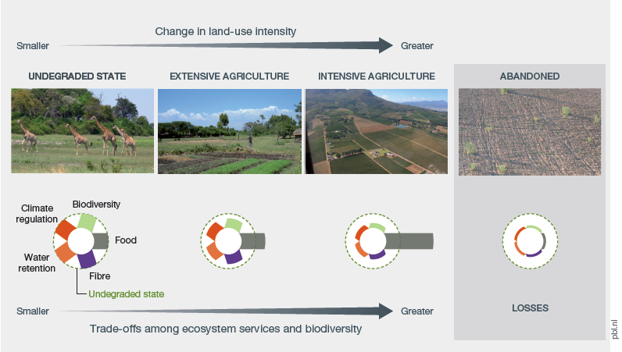
Source: Adapted from Van der Esch et al. (2017).

Box SPM.2
Indigenous and local knowledge consists of bodies of social-ecological knowledge developed and held by local communities, some of which have interacted with a given ecosystem for a very long time. Indigenous and local knowledge includes practices and beliefs about relationships of living beings, including humans, with one another and their environment. This knowledge evolves continuously through interaction of experiences and different types of knowledge, and can provide information, methods, theory and practice for sustainable management that has been tested through application and experimentation in real-world situations, by many people, over a wide range of conditions. Indigenous and local knowledge aids in avoiding, reducing and reversing land degradation and in sustainable land management to reduce degradation and improve restoration by offering different ways of thinking about people’s relationship to nature {1.3.1, 2.2.2.1} (Figure SPM.4) and alternative land management systems {1.3.1.2, 1.3.1.4, 1.4.3.1, 1.4.8.2, 2.2.2.2, 2.3.2.1, 6.3.1, 6.3.2.3, 6.4.2.4} and by promoting good governance {1.3.1.5, 2.2.2.3}.

Figure SPM.4
This figure was developed by senior knowledge holders of the Ngan’gi set of Aboriginal languages, in collaboration with the Commonwealth Scientific and Industrial Research Organisation, and shows the depth and detail of their understanding of the land. This detailed knowledge can assist to prevent degradation and restore landscapes, and is representative of indigenous peoples and local communities worldwide. For ease of readability this figure has been cropped to show a portion of the full year's seasonal knowledge of the Nauiyu Nambiyu community in Daly River, Northern Territory, Australia.
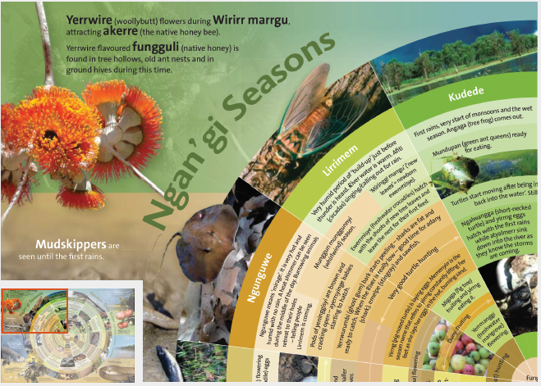
- Less than one quarter of the Earth’s land surface remains free from substantial human impacts (established but incomplete). Transformation and degradation of various types and intensity are causing predominantly negative impacts on biodiversity and ecosystem functions on the other three quarters (well established) (Figure SPM.5). Ecosystems affected by land degradation (including, for example, some areas that have been transformed to agricultural systems and urban areas) mainly include forests, rangelands and wetlands. Wetlands are particularly degraded, with 87 per cent lost globally in the last 300 years, and 54 per cent since 1900 {4.2.5, 4.2.6.2, 4.3.2.1, 4.3.4}. Land degradation, including transformation to urban areas and to intensive agricultural systems involving high use of chemicals, frequently leads to eutrophication of water bodies by fertilizers, to toxic effects of pesticides on non-target species, and to erosion). The extent of transformation in developed countries is large, even though the rate of transformation has slowed or even reversed in recent decades. In developing countries, the extent of transformation is lower, but the rate of transformation remains high. In the future, most degradation and especially transformation is forecasted to occur in Central and South America, sub-Saharan Africa and Asia, which have the largest remaining amount of land suitable for agriculture (well established). By 2050, it is estimated that less than 10 per cent of the Earth’s land surface will remain substantially free of direct human impact. Most of this remnant will be found in deserts, mountainous areas, tundra and polar systems that are unsuitable for human use or settlement (well established) {7.2.2, 7.3}.
Figure SPM.5
Status, trend and extent of direct drivers of land degradation across subregions globally
This report is based on expert opinions from the 28 authors working on the assessment with a wide range of land degradation and regional experience. Three or more experts contributed to each cell unless denoted by an asterisk (*), which indicates two expert opinions. Data was not reported when fewer than two experts contributed to the scoring, which is denoted by the grey cells. Within each region, the impacts on biodiversity and ecosystem services in managed systems (i.e., grazing land, croplands and agroforestry, and native forest and tree plantation) were evaluated relative to well-managed production systems of that type, rather than relative to their initial untransformed state, which often existed in the distant past (Figure SPM.10). The five land degradation drivers of
non-timber natural resource extraction, extractive industry and energy development, infrastructure, industry, and urbanization, fire regime change and introduction of invasive species were evaluated relative to the inferred state of biodiversity and ecosystem services in the absence of human disturbance (Box 1.1, 2.1). Experts scored changes in biodiversity and ecosystem services separately. In the analysis, however, the scores of biodiversity and ecosystem services were highly correlated (range = 0.70-0.98). Consequently, changes in biodiversity and ecosystem services are reported as one integrated score. Trends in land degradation from 2005 to 2015 due to specific drivers are shown by the angle of the arrows. The time period 2005–2015 was chosen to identify more recent trends in land degradation. Within the agricultural production drivers, the extent of land affected by the degradation driver is expressed as a percentage of the total land area of that land use type. The extent of land affected by the degradation driver of the remaining five drivers is expressed as the total land area of the subregion. For further explanation on the metrics and methodology for Figure SPM. 5, see supporting material Appendix 1.2 available from https://www.ipbes.net/supporting-material-e-appendices-assessments.
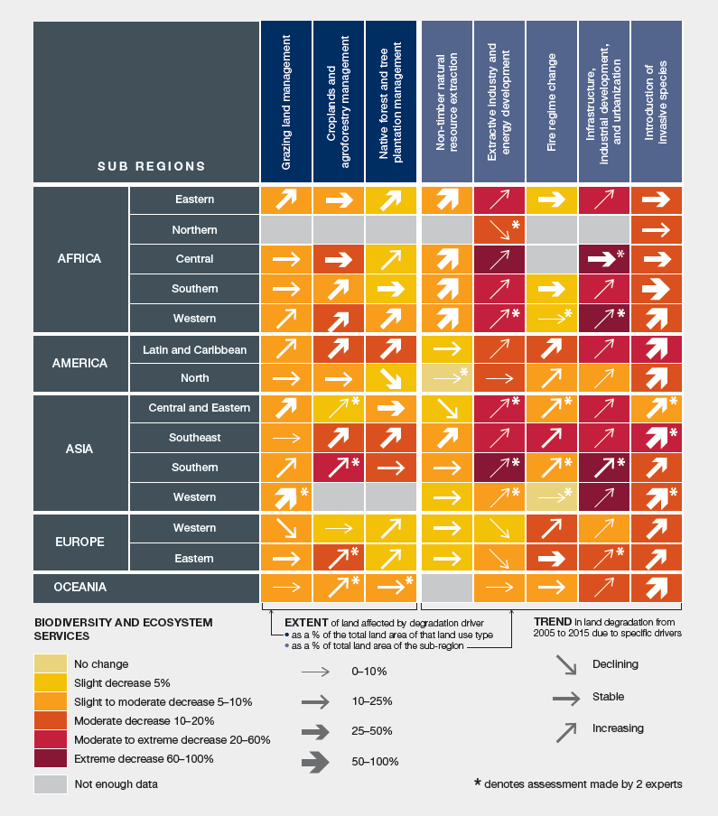
- Habitat loss through transformation and the decline in suitability of the remaining habitat through degradation are the leading causes of biodiversity loss (well established) {4.2.9} (Figure SPM.6). Between 1970 and 2012, the index of the average population size of wild terrestrial vertebrate species declined by 38 per cent and that of freshwater vertebrate species by 81 per cent (established but incomplete) {4.2.9, 7.2.2}. Species extinction rates are currently hundreds to thousands of times above the long-term rate of species turnover (established but incomplete) {4.2.9.1, 7.2.2}. There is a body of evidence suggesting a positive association between diversity, especially functional biodiversity, ecosystem functions and resilience to disturbance (established but incomplete) {4.2.9.3}.
Figure SPM.6
Projected loss in global biodiversity by 2050 under a range of scenarios (shared socioeconomic pathways, SSP1, 2 and 3, plus a variant of SSP2 which includes a decline in plant productivity. Biodiversity is expressed as mean species abundance (MSA), a measure of the size of populations of wild organisms as a percentage of their inferred abundance in their natural state (% MSA)
The SSP1 scenario describes a world with high economic growth, low population growth, medium to fast technology change, emphasis on environmental protection and international cooperation, high globalization of trade, low meat consumption and waste of food, strict land-use regulation (e.g., protected areas) and high improvement of crop yield and livestock production efficiency.
The SSP2 scenario is a “middle-of-road” scenario, with medium economic and population growth, technological change, globalization of trade, meat consumption and waste of food, moderate land-use regulation and medium improvement of crop yield and livestock production efficiency. It represents a continuation of the trends observed in recent decades.
The SSP3 scenario describes a world with low economic growth, high population growth, less technological change, little environmental protection, reduced international cooperation, low globalization of trade, high meat consumption and waste of food, low land-use regulation (e.g., protected areas) and low improvement of crop yield and livestock production efficiency. The SSP2 “productivity decline scenario” makes the same socioeconomic assumptions as SSP2 but takes into account the impact of a persistent decline in biomass and crop yields as observed at particular locations in the last decades, as a result of unsustainable land management.
The left panels show the effects of land use transformation, while the right panels include land
degradation-induced productivity loss. By 2010, 34 per cent of global biodiversity indexed in this way had already been lost. Biodiversity loss is projected to reach 38–46 per cent by 2050. The global loss in the
middle-of-the-road scenario - SSP2 with productivity decline - projects a future loss of around 10 per cent by 2050. This is equivalent to a complete loss of the original biodiversity of an area about 1.5 times the size of the United States of America. The strongest drivers of biodiversity loss to date have been agriculture, followed by forestry, infrastructure, urban encroachment and climate change. In the period 2010–2050, climate change, crop agriculture and infrastructure development are expected to be the drivers of biodiversity loss with the greatest projected increase {7.2.2.1}.
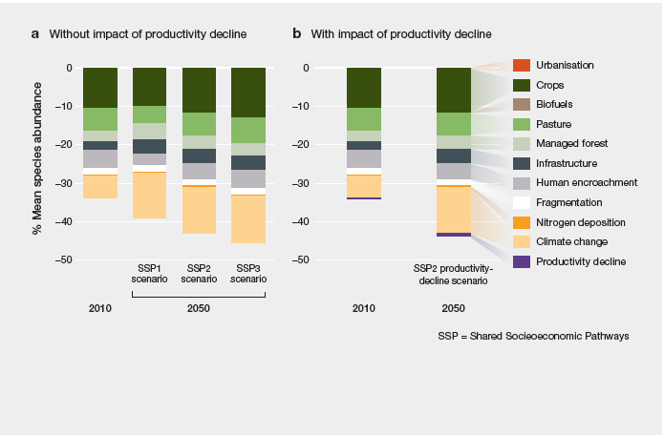
Source: Adapted from Van der Esch et al. (2017).
- Land degradation has already had a pronounced impact on ecosystem functions worldwide (well established). Net primary productivity of ecosystem biomass and of agriculture is presently lower than it would have been under natural state on 23 per cent of the global terrestrial area, amounting to a 5 per cent reduction in total global net primary productivity (established but incomplete) {4.2.3.2, 4.2.9.3}. Over the past two centuries, soil organic carbon, an indicator of soil health, has seen an estimated 8 per cent loss globally (176 gigatons of carbon (Gt C)) from land conversion and unsustainable land management practices (established but incomplete) {4.2.3.1, 7.2.1} (Figure SPM.7). Projections to 2050 predict further losses of 36 Gt C from soils, particularly in
sub-Saharan Africa {7.2.1.1}. These future losses are projected to come from the expansion of agricultural land into natural areas (16 Gt C), degradation due to inappropriate land management
(11 Gt C) and the draining and burning of peatlands (9 Gt C) and melting of permafrost (established but incomplete) {4.2.3, 7.2.1.1}.
Figure SPM.7
Human activity has changed the surface of the planet in profound and far-reaching ways
Panel (a) shows the degree to which humans have appropriated production of biomass. In some cases, particularly areas of intensive agriculture, human use is equivalent to 100 per cent of the total biomass that would have been produced by plant natural conditions (darker blue). Panel (b) shows the decline in soil organic carbon, an indicator of soil degradation (decline in red, increase in blue), relative to an estimated historical condition that predates anthropogenic land use. Panel (c) shows the parts of the land surface that can be considered as “wilderness”. The areas shown in green are wilderness in the sense that ecological and evolutionary processes operate there with minimal human disturbance. In the remaining three quarters of the Earth’s surface, natural processes are impaired by human activities to a significant degree. Panel (d) shows (in purple) the levels of species loss, estimated for all species groups, relative to the originally-present species composition.
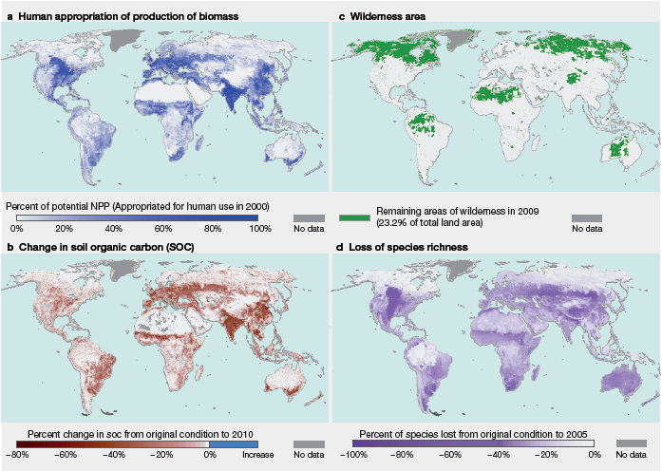
- Land degradation adversely affects human well-being through the loss of biodiversity and ecosystem services, which has reached critical levels in many parts of the world (well established). In many contexts, land degradation negatively impacts food and water security, as well as human health and safety {1.3.1, 1.3.2, 1.4.4, 5.3.2, 5.4, 5.6, 5.8.2}. Degradation-driven losses in agricultural production—through erosion, soil fertility loss, salinization and other processes—constitute a risk to food security {4.2.1–4.2.3, 4.3.3, 5.3.2.3, 5.3.2.4}. Soil fertility loss is caused by three main processes: soil acidification, salinization and waterlogging {4.2.1, 4.2.2}. By 2050, land degradation and climate change together are predicted to reduce crop yields by an average of 10 per cent globally and up to 50 per cent in certain regions {5.3.2.6}. Although important advances have been made in reducing global food insecurity in the past decade, there are still nearly 800 million people worldwide without access to adequate nutrition {4.2.5.1, 5.3.3.1}. Land degradation impairs water security through a reduction in the reliability, quantity and quality of water flows {5.8.2}. Degradation of catchment and aquatic ecosystems, combined with increasing water abstraction and pollution by human activities, have contributed to deterioration in water quality and supply, such that four fifths of the world’s population now live in areas where there is a threat to water security {4.2.4.3, 4.2.5.1, 5.8.1}.
- Transformation of natural ecosystems to human use-dominated ecosystems can increase the risk of novel diseases such as Ebola, monkeypox and Marburg virus, some of which have become global health threats, by bringing people into more frequent contact with pathogens capable of transferring from wild to human hosts (established but incomplete) {5.4.1, 5.4.2, 5.4.3}. Modifications in hydrological regimes affect the prevalence of pathogens and vectors that spread disease {2.2.2.4, 4.2.7, 5.4.1}. Land degradation generally increases the number of people directly exposed to hazardous air, water and land pollution, particularly in developing countries, with the worst-off countries recording rates of pollution-related loss of life higher than those in wealthy countries (established but incomplete) {5.4.4; Figure 5.8}. Land degradation generally harms psychological well-being by reducing benefits to mental balance, attention, inspiration and healing (established but incomplete) {5.4.6, 5.9.1}. Land degradation has particularly negative impacts on the mental health and spiritual well-being of indigenous peoples and local communities {1.3.1.2}. Finally, land degradation, especially in coastal and riparian areas, increases the risk of storm damage, flooding and landslides, with high socioeconomic costs and human losses {1.3.3, 5.5.1}. With around 10 per cent of the world’s population living in coastal zones less than 10 metres above the mean sea level—currently more than 700 million people, expected to increase to more than 1 billion by 2050—the economic and human risks associated with loss of coastal wetlands are substantial {5.5.1, 5.5.3}.
- Land degradation negatively affects the cultural identity of some communities, particularly indigenous peoples and local communities, and erodes their traditional knowledge and management systems (well established). An individual's or society's relationship to land shapes identity, traditions and values, as well as spiritual beliefs and moral frameworks {1.2, 1.3.1, 1.3.2, 1.4.3, 2.2.2.1, 5.4.6, 5.9.1, 5.9.2}. There is a strong co-occurrence between linguistic diversity (a proxy for cultural diversity) and biological diversity (Figure SPM.8). Though difficult to quantify, many indigenous peoples and local communities consider land degradation to cause pronounced loss of their cultural identity and indigenous and local knowledge (well established) {1.3.2, 1.4.3, 1.4.6, 1.4.8, 2.2.2.3, 5.9.2.3}, manifested, for instance, in the abandonment of sacred places and rituals (established but incomplete) {5.9.2.1}. Land degradation causes a loss of sense of place and of spiritual connection to the land, in indigenous peoples and local communities (established but incomplete) {2.2.3.1}, as well as in urban residents living far from the affected areas (well established) {5.9.1}.
Figure SPM.8
Cultural diversity and biodiversity are spatially associated
This map shows patterns in cultural diversity, using language diversity as a proxy indicator, and patterns in biodiversity, using mammal and bird species richness as a proxy indicator. Language diversity is measured as the geographic concentration of the points of origin of each unique language. Biodiversity is represented by the total species richness of mammals and birds. Areas with darker colour are more biodiverse, while the colour spectrum from green to magenta represents increasing language diversity. Many indigenous peoples and local communities consider land degradation to cause pronounced loss of their cultural identity.
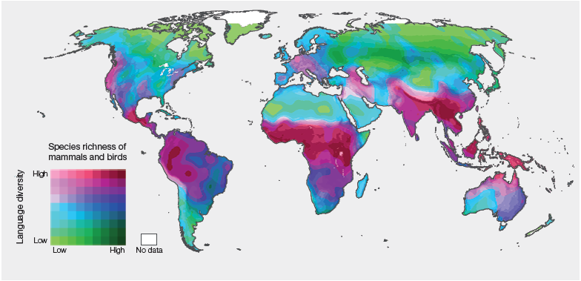
- Alienation of indigenous peoples and local communities from the land often leads to the irreversible loss of accumulated knowledge on how to manage land. In most cases, land management practices based on indigenous and local knowledge have proven to be sustainable over long time periods and offer alternative models to the currently dominant human-nature relationship {1.2.1, 1.3.1, 1.3.2.2, 14.1.1, 1.4.3.1, 1.4.8.2, 2.3.2; 5.3.3.1}. The model for human-nature relationships offered by indigenous and local knowledge holders is based on relational ethics rather than on technological progress or economic growth {2.3.1.2}. In parallel, novel concepts, such as “Ecological Solidarity”, “Mother Earth Rights”, “Living Well” and “Systems of Life”, are being adopted by different countries, concepts that acknowledge that humans and ecosystems not only interact, but are also interdependent {2.2.1.3; 2.2.2.1; 2.2.2.2.}. This cognitive framing of human integration with nature is likely to create a collective sense of duty at various spatial and political scales to protect and restore land and to recognize the obligation to balance current needs with those of future generations {1.3, 1.4.1.2, 1.4.6.3, 1.4.7.3, 2.2.4.3, 2.3.2.2}.
- Land degradation-associated changes in ecosystem services can exacerbate income inequality since the negative impacts fall disproportionately on people in vulnerable situations, including women, indigenous peoples and local communities, and lower-income groups (well established). Although land degradation exists in both developed and developing parts of the world, it tends to have the strongest negative impacts on the well-being of people in vulnerable situations and of those living in economically poor areas {5.2.1, 5.2.2} (Figure SPM.9). People living in more marginal environments are usually poorer than the national average {5.2.1}. They are particularly dependent on the ecosystem services for disaster risk reduction that are lost through land degradation, and recover more slowly following natural disasters {5.2.2.1, 5.5.2, 5.5.3}. The effect of agricultural soil loss on poverty at the national level can be enormous; negative impacts of land degradation as large as 5 per cent of total GDP have been observed {5.2}. In many countries, lower-income groups are on average more dependent on the agricultural sector than the population as a whole; in addition, the land they have access to is often of lower productivity than average {2.2.2.3, 5.2.1}. In lower-income countries, losses in the agricultural sector are 2.5 times more important to the income of individuals at the lower end of the income distribution than are losses in other parts of the economy {5.2}. In addition, people in vulnerable situations have fewer financial resources to invest in technologies, for instance, in agriculture or sanitation, to mitigate the negative impacts of degradation {1.3.2.2, 1.4.8.2, 5.2.2.2}. Land degradation also reduces the availability of wild-harvested goods that serve as buffers for vulnerable households in times of hardship {3.3.4, 5.2.2.1}. The poor also rely more than average on ecosystem-derived fuels, such as wood, charcoal and dung, to meet their energy needs {5.7.2.1}. Land degradation creates higher labour demands on fuelwood-dependent households, generating an additional labour burden that often falls disproportionately on women {5.2.3.2, 5.7.2.1}. The negative impact of land degradation on ecosystem services frequently acts in concert with other stressors, such as socioeconomic change, climate variability, political instability and inefficient or ineffective institutions {3.4, 3.6.2.1, 5.6.1.1}. The combined result is decreased livelihood security among the most vulnerable members of society {2.2.2.3}.
Figure SPM.9
Land degradation affects countries of all income levels and at all levels of human development
Some of the most degraded areas in the world, such as Western Europe and parts of Australia, are also the high GDP countries. However, the negative impacts of land degradation on human well-being are likely to be more pronounced in locations where degradation overlaps with poverty, low institutional capacity and weak social safety nets. In this map, countries are coloured according to their Human Development Index (HDI) score, while loss of soil organic carbon relative to estimated original condition (one indicator of land degradation) is illustrated by the lightness or darkness of each pixel. HDI is a composite statistic that is commonly used to indicate human development based on data on education, life expectancy and per capita income. Change in soil organic carbon is modelled relative to estimated quantities prior to anthropogenic land use and land cover change.
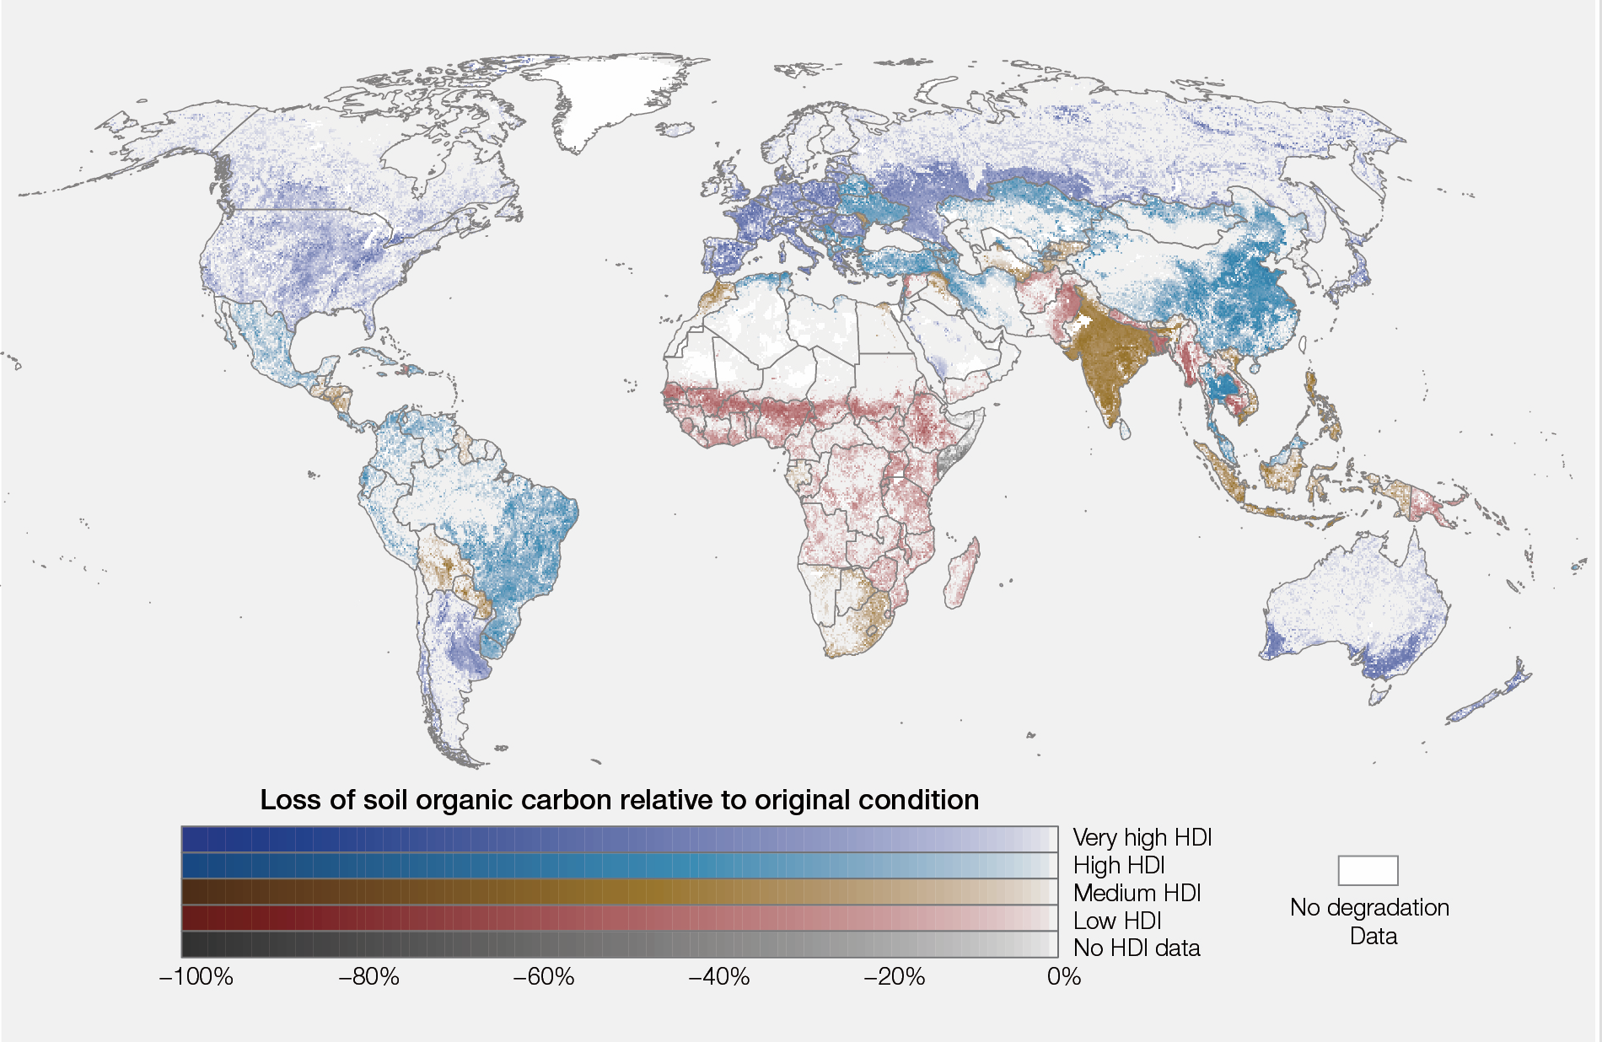
Source: Data on soil organic carbon from Van der Esch et al. (2017) and Stoorvogel et al. (2017).
- The economic benefits of sustainable land management practices and/or restoration actions to avoid, reduce and reverse land degradation have been shown to exceed their costs in many places (established but incomplete), but their overall effectiveness is context-dependent (well established). A variety of sustainable land management practices, such as agroforestry, soil and water conservation techniques and river-channel restoration, have been shown to be effective in avoiding, reducing and reversing land degradation in both rural and urban settings (well established) {1.2.2, 1.3, 1.4, 2.2.3.1, 4.2.6.2, 6.3.1, 6.3.2}. Such practices and restoration actions generally produce positive results, but their effectiveness depends on the degree to which they address the nature, extent and severity of underlying drivers and processes of degradation, and the biophysical, social, economic and political settings in which they are implemented {1.2.1, 1.3.2.2, 1.3.3.1, 3.5, 5.2.3.3, 6.3, 6.4}. For example, land management practices based on indigenous and local knowledge, and community-based natural resource management systems, have been effective in avoiding and reversing land degradation in many regions {1.3.1.1, 1.3.2.3, 1.4.3.2, 1.4.7.2, 1.4.8.2, 2.2.2.1, 2.2.2.2, 5.3.3.1, 6.3.1, 6.3.2, 6.4.1.2, 6.4.2.2, 6.4.2.4, 6.4.3, 8.3.1}. For instance, recent advances in valuing ecosystem services, as well as the non-market benefits of ecological restoration and subsequent incorporation of such values in benefit-cost analyses of restoration projects, with socially-appropriate discount rates, show that restoration investments are economically beneficial. Across biomes, at the global level the benefits of restoration are estimated to exceed the costs by an average margin of 10 to 1 {6.4.2.3} (established but incomplete). In several Asian and African countries, the cost of inaction has been estimated to be 3.8 to 5 times higher than the estimated costs to avoid land degradation {5.2.3.4}.
- Desertification currently affects more than 2.7 billion people and can contribute to migration (well established). Desertification is defined as land degradation in arid, semi-arid and dry sub-humid areas (collectively called drylands) because of human activities and climatic variations. Inhabited drylands cover 24 per cent of the Earth’s surface and are home to 38 per cent of the world’s population, with especially pastoralists and smallholder farmers tending to be disproportionately poor and vulnerable to changes in the natural resource base {5.6.1.3, 5.6.2.2, 4.2.6.2}. For example, in
sub-Saharan Africa, half of the total population, but three quarters of the poor, live in drylands {5.2.1}. Populations in drylands are projected to increase by 43 per cent—from 2.7 billion in 2010 to 4.0 billion in 2050—amplifying the impact of people on dryland landscapes {7.2.4.1}. Drylands are particularly susceptible to land degradation when one or more of the following features are present: low-productivity ecosystems; easily degradable soils; highly variable temperature and rainfall; and dense and rapidly growing populations of economically marginalized populations (well established) {3.3.1.2, 7.2.1, 7.2.3, 7.2.4, 7.2.5, 7.3.1}. These interrelated characteristics contribute to high rates of poverty and limit the capacity of populations to develop local mechanisms for coping with increasingly severe episodic or chronic deficits of food, water, energy and physical security (well established) {3.6, 7.1, 7.2.3, 7.3.1}. For example, degradation in drylands is one reason why grain yields in sub-Saharan Africa failed to increase between 1960 and 2005, despite increases in all other world regions. Land degradation acts in concert with other socioeconomic stressors to result in increased local or regional violent conflict and out-migration from severely degraded areas (established but incomplete) {5.6.1.2, 5.6.1.3}. When the rainfall is less than a tenth of its expected value, an increase of up to 45 per cent in communal conflict has been observed {5.6.1.3}, while a 5 per cent decline in gross domestic product has been associated with a 12 per cent increase in violent conflict {5.6.1.2}. By 2050, 50 to 700 million people are projected to have migrated as a result of the combination of climate change and land degradation. Migrants can come into conflict with prior residents of the areas into which they move, especially if the destinations also have a fully used or degraded resource base {5.6.2}.
- The capacity of rangelands to support livestock will continue to diminish in the future, due to both land degradation and loss of rangeland area. The increased use of intensive livestock production systems with high off-site impacts increases the risk of degradation in other ecosystems (established but incomplete). Global demand for livestock products is projected to double between 2000 and 2050, while competition for land between livestock grazing and other land uses, such as cropping, mining and human settlements, continues to increase (well established) {3.3.1.1, 4.3.2}. In many of the world’s rangelands, livestock stocking levels are at or above the land’s capacity to sustain animal production in the long term, leading to overgrazing and long-term declines in plant and animal production {1.4.7, 3.3.1.1, 4.3.2.2}. In extreme cases, changing land condition has led to a reduction of up to 90 per cent in the ability of rangelands to support large herbivores {4.2.6.2}. The impacts have been particularly pronounced in drylands, where 69 per cent of global livestock production occurs and livestock production is often the only viable agricultural activity {3.3.1, 4.2.6.2, 4.3.2.2}. Reduction in the productivity of the livestock sector negatively impacts the livelihoods of 1.3 billion people, including 600 million poor smallholder farmers {5.2}.
- A response to the growing demand for animal protein but declining livestock production on rangelands has been the increased use of intensive “landless” livestock production systems. These systems have driven the expansion of croplands dedicated to animal feed production, which currently amount to 30 per cent of all croplands. Increased demand for animal feed is met by increased crop production per unit of land, displacement of food crops and/or conversion of natural lands to croplands {3.3.2.2}. Only 26 per cent of ruminants are currently raised fully on rangeland systems, with the rest partly or fully raised on agricultural crops or crop residue for at least part of their lifespan. An estimated 76–79 per cent of poultry and pork are fully raised in intensive systems {3.3.2}. While intensive livestock systems often reduce greenhouse gas emissions per unit of protein produced, they can have multiple negative indirect and off-site impacts on ecosystem services if not properly managed {2.2.1.3}, including the transformation of natural ecosystems into feed-producing croplands. The waste streams from intensive production systems can result in air pollution, water contamination, human health impacts and eutrophication of freshwater ecosystems {4.3.2.2, 5.4.4, 5.8.2.2}.
- Avoiding, reducing and reversing land degradation can contribute substantially to adaptation to and mitigation of climate change, but land-based climate adaptation and mitigation strategies must be implemented with care if unintended negative impacts on biodiversity and ecosystem services are to be avoided (well established). Between 2000 and 2009, land degradation was responsible for annual global emissions of 3.6–4.4 billion tonnes of CO₂ (established but incomplete) {4.2.3.2}. The main processes include deforestation and forest degradation, the drying and burning of peatlands, and the decline of carbon content in many cultivated soils and rangelands as a result of excessive disturbance and insufficient return of organic matter to the soil {4.2.3, 4.3.4}. Climate change will be an increasingly important driver of land degradation throughout the twenty-first century {3.4, 4.2.8, 7.2.5}. Changes in temperature and rainfall patterns will result in range shifts and in some cases extinction of species, causing a modification in both the composition and functioning of ecosystems, not necessarily constituting degradation {3.4, 7.2.2}. In mountainous and high latitude regions, permafrost melt and glacier retreat will result in mass land movements such as landslides and surface subsidence, and increased greenhouse gas emissions {3.4.1, 4.2.3.3, 4.2.6.4}. In forests, the likelihood of wildfires, pest and disease outbreaks increases in scenarios where droughts and hot spells are projected to be more frequent {3.4.5}.
- Many sustainable land management practices yield net climate benefits (well established). Actions to avoid, reduce and reverse land degradation can provide more than one third of the most
cost-effective climate mitigation needed to keep global warming under 2°C by 2030 (established but incomplete) {4.2.3, 4.2.8}. These approaches and practices include, among others, agroecology, conservation measures, agroforestry and some integrated animal and crop production systems that promote soil organic matter accumulation and nutrient cycling, restoration of degraded forests, rangelands and wetlands, and measures that enhance soil carbon storage in managed landscapes such as reduced or no-till farming practices, cover crops, green manures or intercropping {1.3, 4.2.3, 4.2.8.8, 4.3.4, 6.3.1.1, 6.3.1.2, 6.3.1.3, 6.3.2.3}. However, some activities aimed at climate mitigation, when not appropriately implemented, can have the unintended consequence of increasing the risk of land degradation and biodiversity loss, either directly or indirectly, through, for instance: increased herbicides and pesticides use; afforestation by monoculture plantation on previously non-forest habitats; expansion of bioenergy crops into lands formerly under natural vegetation; net displacement of croplands into natural vegetation as a result of increasing competition for land between food and bioenergy crops; and excessive fire protection in landscapes with an evolutionary history of fire (well established) {1.4.3, 3.3.7.2, 3.5, 4.2.6.5, 5.3.2.5, 7.2.2, 7.2.5.2, 7.2.6}.
B. Unless urgent and concerted action is taken, land degradation will continue to accelerate in the face of continued population growth, unprecedented consumption, an increasingly globalized economy and climate change
- Quantifying land degradation and its reversal through restoration requires assessments of both the geographic extent and severity of damage against a reference state (well established). A range of national and international policies, notably Aichi Biodiversity Target 15 of the Strategic Plan for Biodiversity 2011–2020, call for the quantification of land degradation and its reversal. Lack of consensus over baselines and what types of change constitute degradation has resulted in inconsistent estimates of the extent and severity of land degradation {1.1, 2.2.1.1–2.2.1.3, 4.1.4, 4.1.6, 7.13}, and thus to differing interpretations of the consequences of degradation for human well-being and to differences in interpreting and measuring progress towards Aichi Target 15. There are several options for agreeing on a reference state {1.1, 2.2.1.1, 4.1.4, Box 1.1, Box 2.1, Table 4.2}. Reference states related to the natural state of the ecosystem may be harder to define than those based on the current state, but are comparable and fair across countries at different stages of development. If, on the other hand, the baseline is set to a recent ecosystem state, countries that transformed their ecosystems centuries ago are able, in practice, to assume much less ambitious restoration measures than countries that began transformation in the past few decades. Other approaches, such as land degradation neutrality, which relates to target 15.3 of the Sustainable Development Goals, are addressed from an agreed point in time, and detailed guidelines have been developed regarding how neutrality can be monitored and assessed (Figure SPM.10) {2.2.1.1}.
Figure SPM.10
Land degradation can occur either through a loss of biodiversity, ecosystem functions or services, without a change in land cover class or use (1), or by the transformation to a derived ecosystem type such as the conversion of natural cover to a crop field (2), delivering a different spectrum of benefits, but also typically involving loss of biodiversity and reduction of some ecosystem functions and services
The transformed ecosystem can also be degraded with respect to the new social expectations associated with that land use (3). Degraded natural ecosystems can also be transformed to another ecosystem (4), or restored towards their original natural state, either completely or partially (“rehabilitated”) (5). Degraded transformed ecosystems can be rehabilitated towards a less degraded state, with respect to the expectation for a deliberately modified landscape (6). Both degraded and undegraded transformed lands can, under many circumstances, be restored or rehabilitated towards their original natural state (7 and 8). Success in achieving the aspirational goal of land degradation neutrality by 2030 in Sustainable Development Goal 15 may be measured based on whether biodiversity, ecosystem functions and services are stable or increasing in each of the focal ecosystems compared to their state in 2015.
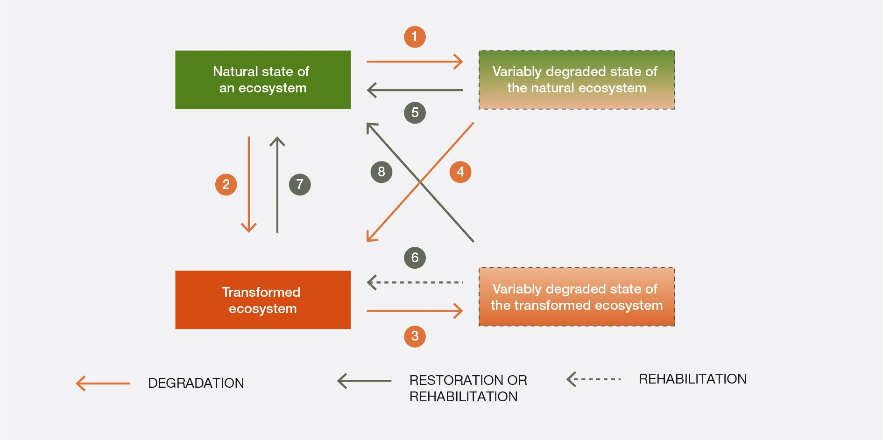
- High and rising per capita consumption is a major factor underpinning increasing degradation in many parts of the world (well established). The current unsustainably high rate of transformation of land and consumption of land-based resources has two underlying drivers: the first is the massive increase in human population over the past two centuries; and the second is the even larger increase in per capita consumption rates of many resources {4.3.2.2, 7.1.5}. The future global population, if multiplied by a per capita consumption rate similar to that currently enjoyed in the developed world, will greatly exceed the global capacity to deliver food, energy and other land-based resources {7.2.3, 7.3.1}. While the global population growth rate is declining, especially in developed countries, it remains high in large parts of the developing world and in some developed countries due to migration {7.1.5.1}. Measures to address population growth across the world and associated changes in consumption patterns can deliver significant and lasting environmental and social benefits, including improved access to education, voluntary family planning and gender equality (well established); improved access to social welfare to support ageing populations (established but incomplete); and rethinking the role of subsidies that may be further stimulating population growth in many more developed nations {2.2.4.2, 2.3.1.4}. Measures to reduce per capita consumption of land-derived goods, especially in places where it is above the global average, include, among others, the encouragement of recycling and reuse, the reduction of loss and waste and the increase in public awareness of the land degradation impacts of consumption patterns {2.3.2, 2.3.1.4, 3.3.2.2, 5.3.1.1}.
- Per capita consumption remains high in developed economies, while in emerging and developing economies it is growing rapidly {3.6.2, 3.6.3}. Many far-reaching changes in how land is used and managed result from responses to economic drivers, such as a shift in demand for a particular commodity or improved market access, mediated by institutional and political settings (established but incomplete) {1.2.1, 1.3.1.1, 1.3.1.5, 1.3.2.2, 1.3.3.1, 1.3.3.3, 2.2.1.3, 2.2.3.3, 2.2.4.3, 3.6.3, 3.6.4, 6.4.2.3}. Weak institutions and poorly-enforced regulations, including those related to land rights and access to natural resources, can lead to overexploitation, exacerbating the effect of rising consumption and population growth on land degradation {1.3.1.2, 1.3.1.4, 3.6.2, 8.3.2.1}.
- Local-scale land degradation is often the result of social, political and economic processes in other parts of the world, with effects that may involve a lag of months or years (established but incomplete). Demand for food imports is increasing across much of the world {3.6.4}. This high dependency on imports means that between one quarter and one half of the environmental impacts of consumption—be they CO₂ emissions, chemical pollutants, biodiversity loss or the depletion of freshwater resources—are felt in parts of the world other than where the consumption occurs {3.6.4, 5.8.1.1} (Figure SPM.11). On average, a country’s use of non-domestic natural resources is about three times larger than the physical volume of goods traded by that country {3.6.4}. The costs imposed by land degradation are felt disproportionately by low-income nations, the same nations that are increasingly depended upon for the provision of raw materials and agricultural commodities to the rest of the world (established but incomplete) {3.6.4}. The globalized nature of many commodity supply chains can elevate the relative importance of global-scale factors such as trade agreements, market prices and exchange rates as potential drivers of local land degradation {3.6.4}; it also amplifies the influence of international consumers and investors over that of national and regional governments and individual producers {2.2.3, 3.6.2.2}, and underscores the critical importance of global actors, including multinational companies and financial institutions, in advancing sustainability everywhere {1.3.1.1, 1.3.2.2, 2.2.3.2, 3.6.4, 6.4.2.3, 6.4.2.4}. Increased market integration combined with rising global demand for land-based commodities can have the effect of offsetting the benefits of increased productivity, resulting in continued pressure to clear remaining areas of native vegetation {3.6.4}.
- The increasing separation and spatial disconnection between consumers and the ecosystems that produce the food and other commodities they depend upon has resulted in a growing lack of awareness and understanding of the implications of consumption choices for land degradation by these consumers (established but incomplete). The prices of most internationally traded land-based commodities do not reflect the environmental and social externalities associated with the production, transportation and processing of those commodities (well established) {2.2.1.5, 6.4.2.3}. Internalizing and appropriately regulating the environmental and social costs of traded commodities, while also avoiding market distortions, such as protectionist policies and subsidies, that prevent a more accurate reflection of the environmental and social costs of traded commodities, could help boost demand for low-impact products {2.3.2, 3.6.2.3, 6.4.1}. However, incentives to encourage the production of more sustainably produced land-based commodities are often low or non-existent, as retail, consumer goods and trading companies often operate with low margins and are reluctant to lose market share {2.2.3.3, 6.4.2.3}.
- Land degradation is almost always the result of multiple interacting causes (well established). Human activities that are the direct causes of land degradation are ultimately determined by multiple underlying causes, including economic, demographic, technological, institutional and cultural drivers (well established) {Figure 1.2; 1.2.1, 1.2.2, 1.3.3.1, 1.4.8.1, 2.2.1.3, 3.6.1, 3.6.2.1, 5.2.2.2, 5.2.2.3, 7.3, 8.3.3–8.3.6, 8.4.1}. Overly simplified single-factor explanations for land degradation overlook such complexities and, as a result, are generally misleading. Similarly, restoration practices are also generally shaped by multiple drivers {1.3.1–1.3.3, 6.4.2, 8.2.2, 8.3.6, 8.4.2}. For example, increasing agricultural productivity—one of the most widespread recommendations to address land degradation—can reduce pressure on remaining areas of native vegetation, but only if strict conditions are met, including the adoption of sustainable land management practices and protection of areas of native vegetation, to prevent the result being an expansion of agricultural lands instead (unresolved) {3.6.3}.
- Extreme poverty, combined with resource scarcity and inequitable access to resources, can contribute to land degradation and unsustainable levels of natural resource use, but is rarely the major underlying cause of either (well established). Single-factor explanations, such as extreme poverty, fail to address the multiplicity of underlying causes that typically lead to unsustainable
land-use practices {5.2.2.2}. In many impoverished rural areas, these underlying causes typically include disputes over land rights, poor access to markets and financial credit, insufficient investment in research and development, sector-focused development plans that pay no attention to other sectors, and weak governance institutions (well established) {1.3.1.1, 1.3.1.4, 3.6.3, 5.2.2.2, 5.2.2.3, 6.4.3–6.4.5, 8.4}. Local land-use practices that degrade land have to be interpreted in the context of wider national policies and integration with regional and global markets {2.2.2.3, 5.2.2.2}. Sustainable land use often depends on collective action by communities {2.2.2.2, 2.2.3.1, 2.3.2.1, 5.2.2.3}. There is mounting evidence of the effectiveness of community-based approaches for the management of common pool environmental resources and the benefit of multi-stakeholder-led approaches for building long-term socioecological resilience {1.3.1.1, 1.3.1.5, 1.3.2.2, 2.2.2.3, 5.2.2.3, 6.4.2.4, 6.4.5, 8.3.2, 8.3.4}. However, developing the social networks to support collective action without substantial support from public, private or civil society actors is made very difficult by pervasive problems of land insecurity, household poverty and low levels of individual education and empowerment {2.2.2.3}.
Figure SPM.11
Illustration of the biodiversity impacts of international trade in 2000
This figure shows the top net exporters (orange) and importers (blue) of biodiversity impacts associated with international commodity trade. Dots are scaled to the total number of threatened species associated with the exports or imports of that particular country. The biodiversity footprint methodology used in this analysis uses a high-resolution input-output economic model that traces the commodities whose production is associated with threatened biodiversity, through several intermediate trade and transportation steps, to the country of final consumption. As is standard in all consumption-based accounting analyses, imported goods that are used and embodied in exported goods from the same country are not included in the consumption account for that country, but in the account of the country of final consumption. The underlying model, which links the Eora global trade database to the International Union for Conservation of Nature (IUCN) Red List of Threatened Species, tracks 18,000 species through more than 5 billion supply chains linking 15,000 sectors across 189 countries. The faint black lines illustrate a representative sample of biodiversity-implicated trade flows. This figure is intended to be illustrative, and the pattern of embedded biodiversity impacts of international trade in imports and exports changes year-on-year with changes in the dynamics of the global economy.
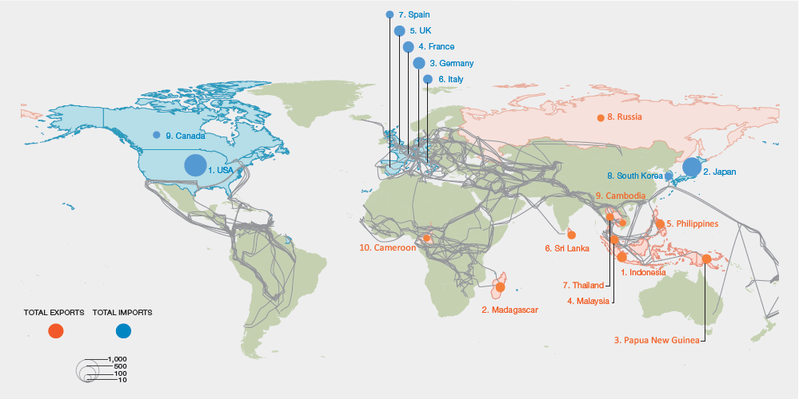
Source: Based on data from Lenzen et al. (2012).
- Institutional, policy and governance responses to address land degradation have in many cases proven inadequate, since they are often insufficiently comprehensive or fail to address ultimate causes (established but incomplete). National policy responses to land degradation are typically focused on short-term and local-level drivers and are often insufficiently resourced, including with skills, knowledge, technology, finance and institutional capacity {6.3.1, 6.3.2, 6.4.4, 6.5}. Attempted solutions are often incremental and reactive, focused on mitigating damage rather than proactively focused on avoiding initial harm. They are frequently poorly coordinated across the various sectors and ministries that share responsibility for the use of land and natural resources, and are often regionally uncoordinated and not sustained between different political dynamics such as electoral cycles {2.2.4, 2.3.1, 3.5, 8.3.4}. Effectiveness of land degradation and restoration policies is often further undermined by corruption, which erodes financial resources and confounds evaluation processes by inflating successes and omitting failures {3.6.2.1, 8.3.1.1}. Tackling corruption is enormously challenging, as practices are deeply rooted in local economy, history and culture {1.3.2.2, 3.6.1, 3.6.2.1, 6.4.5}. Addressing the multiple causality of land degradation—within the context of simultaneously trying to meet global goals for food, water, energy, climate stability and biodiversity protection—requires holistic policy responses that transcend narrowly-defined jurisdictions and policy agendas and put in place the enabling conditions necessary for long-term change {1.3.1.4, 2.2.4.3, 3.5, 6.3.2.4, 6.4.2.6, 6.4.3, 8.4}.
- Avoiding land degradation is always preferable to attempting post-degradation restoration. Notwithstanding long-term benefits, restoration of degraded land is often slow and has high upfront costs, with both cost and difficulty increasing as degradation becomes more severe, extensive and protracted (well established). Restoration of degraded land depends upon a series of interdependent biophysical processes, many of which develop over decadal or centennial timescales, including: the arrival, establishment, growth and reproduction of recolonizing species; the formation of soil from parent materials; the rebuilding of soil carbon and nutrient pools; the recovery of hydrological functions such as infiltration and water retention; and the reestablishment of biotic interactions among species {1.3.3, 4.2.1, 4.2.2, 6.3.1.5, 6.3.2.3, 6.3.2.4}. In situations of severe land degradation, the unaided natural recovery of native species and biophysical processes may not be possible within realistic timeframes {4.1.3}. As ecosystem function is progressively impaired and biotic populations decline and disappear, the capacity of an ecosystem to self-restore becomes increasingly restricted. This is because key functional types of organisms are no longer present, populations become too small to sustain themselves, biotic interactions including competition, predation and pollination are lost, the environment becomes hostile to the establishment of new propagules or too distant from sources of replenishment to allow recolonization, and reserves of soil organic matter and nutrients, water-retention capacity and propagules become depleted {1.3.3.2, 1.4.3.1, 4.2.1–4.2.3, 6.3.1.5, 6.3.2.3, 6.3.2.4}. Inappropriate restoration techniques can further exacerbate land degradation. An example is the planting of trees where they did not historically occur (afforestation), which can have a similar impact as deforestation, including the reduction of biodiversity and disruption of water, energy and nutrient cycles {3.5}. Implemented appropriately, however, restoration can rehabilitate many ecosystem functions and services {5.2.3, 6.3.2}. Although it is expensive, restoration is typically more cost-effective than accepting the permanent loss of those functions and services {6.4.2.3}.
- Strong two-way interactions between climate change and land degradation mean that the two issues are best addressed in a coordinated way (well established). Cultivation of crops, livestock management and land-use change are all substantial contributors of human-induced greenhouse gas emissions, amounting together to approximately one quarter of global emissions, with
degradation-related emissions accounting for a large part of that quarter {4.2.8}. Deforestation alone contributes approximately 10 per cent of all human-induced greenhouse gas emissions, and can further alter the climate through changes in surface reflectivity and the generation of dust particles {4.2.8}. Land-based activities to mitigate the effects of climate change can have positive or negative effects on land degradation, depending on where and how they are implemented (well established) {6.3.1.1, 6.3.2.3, 7.2.5, 7.2.6}. For example, indiscriminate tree planting in previously non-forested habitats such as grasslands and savannas for the purpose of carbon sequestration and more widespread use of bioenergy crops to mitigate climate change could constitute forms of land degradation from the perspectives of loss of biodiversity, loss of food production and loss of water yield. Establishment of species-diverse, sustainably managed plantations on degraded land could restore ecological function, protect undegraded land by providing alternative sources of products, and help secure livelihoods {3.5, 7.2.6}.
- Climate change threatens to become an increasingly important driver of land degradation throughout the twenty-first century, exacerbating both the extent and severity of land degradation as well as reducing the effectiveness and sustainability of restoration options {3.4}. Climate change can have a direct effect on agricultural yields, through changes in the means and extremes of temperature, precipitation and CO₂ concentrations, as well as on species distributions and population dynamics, for instance, pest species {3.4.1, 3.4.2, 3.4.4, 4.2.8, 7.2.6}. However, the greatest effects of climate change on land is likely to come from interactions with other degradation drivers {3.4.5}.
Long-established sustainable land management and restoration practices may no longer be viable under future climatic regimes in the places where they were developed, requiring rapid adaptation and innovation, but also opening new opportunities {3.5}.
C. The implementation of known, proven actions to combat land degradation and thereby transform the lives of millions of people across the planet will become more difficult and costly over time. An urgent step change in effort is needed to prevent irreversible land degradation and accelerate the implementation of restoration measures
- World views influence the way individuals, communities and societies manage the environment (well established) (Figure SPM.12). If prevailing world views result in land degradation, then promoting alternative world views can foster the shifts in individual and societies’ beliefs, values and norms required for effective and enduring action to avoid, reduce and reverse land degradation (well established) {1.3.1, 1.3.2.1, 1.3.2.3, 2.1.2, 2.3.2.2; Figure 2.1}. Education has an important role to play, empowering decision makers with knowledge on the extent, location, severity and trend of land degradation to enable them to choose and implement adequate response actions and to avoid transgressing tipping points beyond which restoration is difficult and costly {7.3.2, 8.2.1}.
Figure SPM.12
Perceptions are organized into a hierarchy of concepts dependent on collective systems of knowledge, norms, values and beliefs, which in turn guide cultural, governance and land management practices, as well as resource use and consumer behaviours. Taken together, these elements constitute a world view. When dominant or mainstream perceptions and concepts have an undesired impact on nature and its contributions to people, promoting alternative perceptions and concepts may transform practices towards more desired impacts. Policies defending new concepts and associated practices are expected by civil society, as environmental degradation affects human well-being.
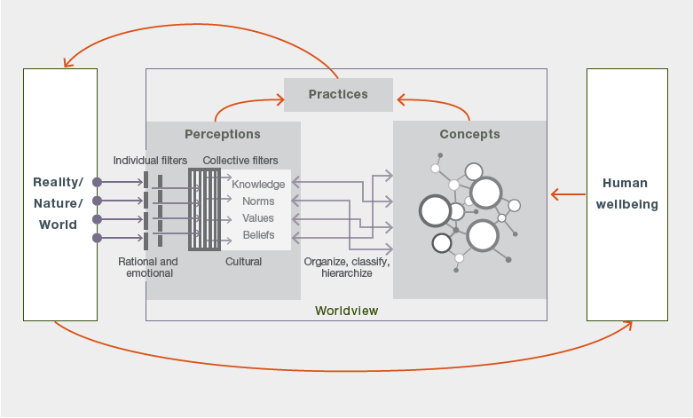
- Education and awareness-raising at the individual level, especially among consumers, is also of great importance to expose the environmental impacts associated with the full chain of production, transportation and, ultimately, waste management related to consumer products and services (well established) {2.2.1.3, 2.3.2.2, 6.4.2.4}. Internalizing the environmental costs of the production of food, clothing and other goods into prices is likely to stimulate demand for lower-impact products {2.2.1.5, 2.3.2.1, 6.4.2.4}. There is significant potential to build on current efforts to promote more land-friendly production and consumption choices through information and awareness-raising, as experimented with in some countries through voluntary eco-labelling, certification and corporate social responsibility (established but incomplete) {6.4.2.4}. Civil society has a major role to play in this shift towards increased awareness and understanding of the consequences of consumer choices {2.3.2, 2.3.2.2}.
- Information systems—including for baseline assessment, land-use planning, monitoring, verification and reporting —are needed to support the sustainable and adaptive long-term stewardship of land (well established). We now have at our disposal a greater range of approaches, tools and actions for understanding and acting upon land degradation than at any other time in human history {6.3.2, 6.4.2–6.4.4}. Most of the current decision-support tools focus on assessing the biophysical state of the land; more-integrated tools are under development that combine socioeconomic and biophysical variables and are needed to capture social-ecological interactions and impacts {8.2, 8.3.5}. Recent years have seen new information technologies, including remote-sensing capabilities, mobile applications, open-access data and decision-support platforms, to inform
decision-making and monitor the effectiveness of efforts to avoid, reduce and reverse land degradation, yet they are not commonly used {8.2.3}. Concerted multidisciplinary and cross-sectoral efforts to improve the conceptual, technical and operational harmonization of inputs and outputs of different decision support systems could lead to a substantial improvement in evidence-based decision-making {8.2.3}. Since local resource users are often the first to experience ecosystem changes and the impacts of land degradation, monitoring programmes and the design of restoration management plans can benefit from participatory approaches involving local ecosystem experts, including indigenous and local knowledge holders, working together with scientific experts {1.3.1.4, 1.3.3.2, 2.2.2, 8.3.5}.
- Efforts to address land degradation and biodiversity loss require a multifaceted response (well established). Adopting holistic policy responses to the multiple causes of land degradation requires transcending institutional, governance and sectoral boundaries to create the enabling conditions necessary for long-term change (established but incomplete) {Figure 1.2; 1.2, 1.3, 2.2.4.3, 6.4.1, 6.4.2, 6.4.3, 6.5, 8.4} (Table SPM.1). Integrated approaches that harmonize sectoral development policies can reduce land degradation, enhance the resilience of rural livelihoods and minimize environment-development trade-offs (established but incomplete) {1.2, 1.3.2, 6.4.2.3, 6.4.3, 8.4.3}. Participatory planning and monitoring, in addition to land capability and condition assessments that include local institutions and land users and incorporate both scientific and indigenous and local knowledge, are more likely to result in agreement among stakeholders on the nature of integrated use of landscapes and in monitoring of the effectiveness of land-use plans {1.3, 2.2.2.2, 2.2.2.4, 6.3.1.1, 6.3.1.2, 6.4.2.4, 6.4.3, 6.4.5, 8.3.4, 8.3.5}. Since financial resources, technical capacities and skill and knowledge gaps often constrain response options (established but incomplete) {6.4.4, 6.5} (Table SPM.3), there is a need to develop capacities for sustainable land management and associated information systems, particularly in developing countries that are prone to and most affected by land degradation. This may involve, for example, appropriate measures to enhance sharing of indigenous and local knowledge that has been effective in addressing land degradation problems in certain contexts (established but incomplete) {1.2.1, 1.3.1.2, 1.3.3.2, 1.3.3.7, 2.2.2.1, 6.4.2.2, 6.4.2.3}.
- Strategies and actions to combat land degradation that are well aligned with other decision-making areas can more effectively address multiple environmental and social challenges, while unlocking the potential to harness synergies (well established) (Table SPM.2). Institutional coordination, multi-stakeholder engagement and the development of governance structures that bridge different government functions, types of knowledge, sectors and stakeholder groups (including consumers) are a prerequisite for reducing trade-offs, enhancing alignment and harnessing synergies among decision-making areas {1.3.1.5, 2.2.1.3, 2.2.4.3, 6.4.2, 6.4.3, 8.4.2, 8.4.3}. For example, national-level decisions seeking to ensure availability of adequate food through reduction of land degradation would be more effective if they considered the impacts of the selected strategies on achievement of policy goals regarding, for instance, water, energy and shelter provision for the growing population at other scales {2.2.1.3, 8.4.2}. Effective means for enhancing such coordination and collaboration include the engagement of scientists with leaders in government, business and civil society to develop the knowledge, tools and practices necessary to integrate
social-ecological interactions into decision-making {1.3.2.1, 2.3.2.2, 6.4.3, 6.4.4, 8.2.3}, and
cross-disciplinary and multi-actor collaboration in research, restoration planning and implementation {6.4.2.3, 6,4,3, 8.2.3}.
- Sound decision-making by landowners, communities, governments and private investors can be achieved through more inclusive analyses of the short-, medium- and long-term costs and benefits of avoiding and reversing land degradation (established but incomplete). Most current economic analyses only consider financial or private benefits while overlooking biodiversity,
non-market ecosystem services, public values and intergenerational benefits, among others. Furthermore, they often apply inappropriately high discount rates, which favour investments in land uses and management practices promising short-term gains over those with long-term benefits {2.2.3.1, 2.2.3.3, 2.3.1.2, 2.3.2.2, 6.4.2.3, 8.3.4}. Thus, the inclusion of a full range of market and
non-market benefits and costs using socially appropriate discount rates in decision-making processes could help to avoid or reverse land degradation. Fulfilling national and subnational aspirations, such as land degradation neutrality aspirations, and attaining restoration goals can be achieved by creating incentives that encourage landowners, land managers and investors to recognize the public values of non-degraded land {1.3.1.1, 2.2.3.2, 2.2.3.3, 2.3.1.2, 6.4.2.3}.

Table SPM.1
Responses to address land degradation, their impacts and outcomes for biodiversity and ecosystem services
Sustainable land management practices and restoration, supported by coordinated policies, institutions, governance arrangements, better informed consumer demand and corporate social responsibility, can lead to significant improvements in land condition, reduce biodiversity loss and enhance the provision of environmental services essential for the future survival and well-being of the growing numbers of people adversely affected by land degradation.
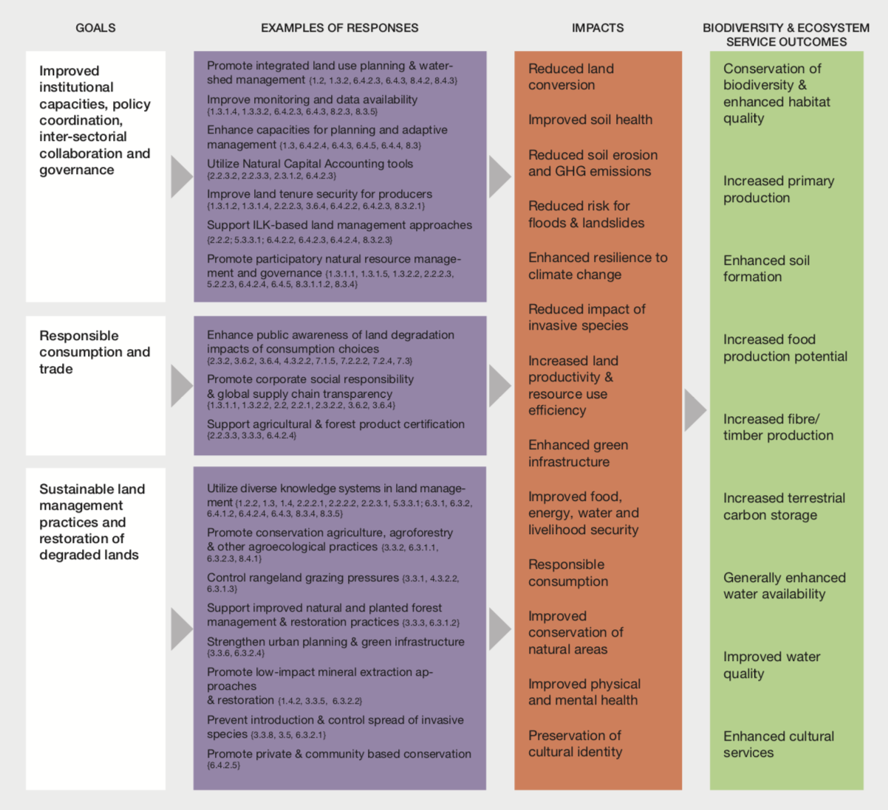

Table SPM.2
Aspirations for addressing land degradation and possible actions and pathways
The appropriateness and relevance of different aspirations varies from place to place, depending on regional and national contexts. The lists of actions are indicative, non-exhaustive and non-exclusive.
Aspirations | Possible actions and pathways
Safeguarded biodiversity | Greater protection of biodiversity through enlarged and more effective protected area systems, halting conversion of natural land, large-scale restoration of degraded land, biodiversity offsetting where land transformation is unavoidable
Low-consumption lifestyles | Lower per-capita consumption patterns, including the adoption of less  land-degrading diets, such as more vegetable-based diets, and low- and  renewable-energy-based housing, transportation and industrial systems
Global human population at  near-zero growth | Improving gender equality and moving towards improved access to education, voluntary family-planning, and social-welfare for ageing populations
Circular economy | Reduced food loss and waste, sustainable waste and sanitation management systems, reuse and recycling of materials
Low-input production systems and resource management | More land-, energy-, water-, and material-efficient and low-emission production systems for food, fiber, bioenergy, mining, and other commodities
Sustainable land management | Sustainable land management practices in croplands, rangelands, forestry, water systems, human settlements, and their surrounding landscapes, specifically directed at avoiding, reducing and reversing land degradation

- Strengthening institutional competencies can enhance the effectiveness of policy instruments designed to avoid, reduce and reverse land degradation (established but incomplete). There exist various market and non-market mechanisms to mitigate land degradation and to promote land restoration. Market mechanisms may include, among others, financial and economic instruments, payments for ecosystem services, farm subsidies, conservation tenders and biodiversity offsets. Effective implementation of such instruments requires institutional capacities and context-specific governance mechanisms {1.3.1.1, 1.3.2.2, 2.2.1.5, 6.4.2.3, 8.3.1, 8.3.3, 8.3.6}. However, the more markets are used to finance the restoration of complex ecosystems, the more institutional capacity and regulations are needed to ensure and safeguard the restoration outcomes {8.3.3}. For example, increasing agricultural productivity to minimize pressure on remaining areas of native vegetation is more likely to be effective where market demand for agricultural products is relatively inelastic to price change, and strong regulatory measures or other limits to expansion are in place (unresolved) {3.6.3}. Examples of non-market based approaches include joint mitigation and adaptation mechanisms, justice-based initiatives, ecosystem-based adaptation and integrated water
co-management schemes. Building an adequate set of institutional competencies and appropriate governance mechanisms—based on the monitoring of response impacts and adaptive management—is crucial for the design, selection and implementation of effective policy instruments to avoid, reduce and reverse land degradation {1.3, 3.5, 6.4.2.4, 6.4.3, 6.4.5, 8.3}. In most countries, the design and implementation of national policies addressing land degradation is constrained by a lack of
national-level information on ecosystems and their contribution to economic development {8.3.3, 6.4.2.3}. A shift in decision-making focus from narrowly-defined analysis based on affordability and effectiveness to an approach that includes the consideration of social acceptability and environmental sustainability would help to achieve desired outcomes of response actions {1.3.1.1, 2.3.1.2, 2.3.2.2, 6.4.2.3, 8.2.2}.
- Secure land tenure, property and land-use rights, vested in individuals and/or communities, in accordance with national legislation at the appropriate level, are enabling conditions for actions to prevent land degradation and biodiversity loss and restore degraded lands (well established). The customary practices and knowledge used by indigenous peoples and within local communities can be effective for conserving biodiversity and avoiding, reducing and reversing land degradation {1.3.1.5, 2.2.2.1, 2.2.2.2, 5.3.3.1, 6.3.1, 6.3.2}. The continued viability of such practices is supported by, among other things, secure land tenure, property and land-use rights in accordance with national legislation at the appropriate level {1.3.1.2, 1.3.1.4, 6.4.2.2–6.4.2.4}. This can be achieved by formalizing customary practices and local knowledge, which requires adequate institutional competencies within communities for participation in decision-making and responsible governance of land and natural resources, taking into account the voluntary guidelines on the responsible governance of tenure of land, fisheries and forests in the context of national food security, and in line with human rights principles {1.3.1.5, 2.2.2.3, 5.2.2.3, 5.3.3.1, 6.4.2.2, 6.4.2.3, 6.4.2.4, 8.3.2.1, 8.3.2.3}.
- A wide range of practices already exists to avoid, reduce and reverse land degradation in many ecosystems and urban areas and reduce the impacts of many land degradation drivers (well established). Degradation of agricultural lands can be avoided or reversed through many
well-tested practices and techniques, both traditional and modern. On croplands, these include, for example, reducing soil loss and improving soil quality/soil health, the use of salt-tolerant crops, agroforestry and agroecological practices, conservation agriculture and integrated crop and livestock and forestry systems (well established) {2.2.3.1, 6.3.1.1, 6.3.2.4, 6.3.2.5, 7.2.3}. On rangelands, they include: land capability and condition assessments and monitoring; grazing pressure management; pasture and forage crop improvement; silvopastoral management; and ecologically-sound weed and pest management (well established) {6.3.1.3}. The maintenance of appropriate fire regimes, and the reinstatement or development of local livestock management practices and institutions in rangelands with traditional grazing, have proven effective in many dryland regions (established but incomplete) {4.3.2.2, 6.3.1.3}. A variety of passive or active forest management and restoration techniques have been successfully used to conserve biodiversity and avoid forest degradation, while yielding multiple economic, social and environmental benefits (well established) {6.3.1.2}—although adoption of more sustainable forest production systems continues to be slow {3.5, 5.3.2, 6.3.1.2}. Proven approaches to avoid, reduce and reverse land degradation in urban areas include urban planning, replanting with native species, green infrastructure development, remediation of contaminated and sealed soils, and wastewater treatment and river channel restoration {6.3.1.4, 6.3.2.4}.
- Combating land degradation resulting from invasive species involves identification and monitoring of invasion pathways and the adoption of eradication and control measures (mechanical, cultural, biological and chemical) (well established) {3.5, 6.3.2.1}. Responses to land degradation from mineral resource extraction include on-site management of mining wastes (soils and water), reclamation of mine site topography, conservation and early replacement of topsoil, and restoration and rehabilitation measures to recreate functioning grassland, forest, wetland and other ecosystems (well established) {1.4.2, 6.3.2.2}. Effective responses to avoid, reduce and reverse wetland degradation include: controlling point and diffuse pollution sources; adopting integrated land and water management strategies {6.3.2.4}; and restoring wetland hydrology, biodiversity and ecosystem functions through restoration and rehabilitation measures, such as constructed wetlands (well established) {1.4.1; Box 2.3; 6.3.1.5, 6.3.2.4}. Similarly, effective responses to improve water quality include soil and water conservation practices, controlling pollution sources and purification (and where appropriate desalination) of wastewater (established but incomplete) {6.3.2.4}.
- Major, transformative changes in consumption patterns, demographic growth, technology and business models can contribute to avoid, reduce and reverse land degradation and achieve food, energy, water and livelihood security for all, while mitigating and adapting to climate change and halting biodiversity loss (well established). No mid-century scenarios examined in this assessment simultaneously met the global goals for the avoidance of land degradation, limiting of climate change and halting of biodiversity loss given the accelerating growing demand for food, energy, fibre, timber, housing, infrastructure and water. The projected unprecedented growth in consumption, demography and technology will roughly quadruple the global economy in the first half of the twenty-first century {7.2.2.2}. Under these conditions, only transformative changes both within and across all sectors would be sufficient to meet the goals (established but incomplete) {3.6.2.1, 7.2, 7.3}. Adjustments towards lower consumption lifestyles in developed and emerging economies may include changes in food—particularly reductions in meat-intensive diets and in the consumption of water-, energy-, material- and space-intensive goods and services {7.2.2.2, 7.2.4, 7.3}. Adjustments to production systems may be achieved by sustainable improvements in agricultural productivity, in combination with strong environmental protection and social safeguards to avoid the environmental and social externalities of intensive production systems and damaging rebound effects {1.3.1.1, 1.3.2.2, 3.6.3}. Particular care is needed to ensure that increased demand for bioenergy does not exacerbate land degradation by replacing land previously used for food crops and driving agricultural land expansion {5.3.2.5, 7.2.6}. Finally, various interventions in infrastructure and information may improve the efficiency with which consumers use food, water and energy to and further their reuse, recycling and their reduction of waste {7.2.2, 7.2.4, 7.3}.
- The IPBES thematic assessment on land degradation and restoration provides clear evidence for the urgent need to address the unprecedented loss of ecosystem functions and services vital to all life on Earth. Existing international agreements and conventions, such as the United Nations Convention to Combat Desertification, the United Nations Framework Convention on Climate Change and its associated agreements, the Convention on Biological Diversity, and the Ramsar Convention, already provide a range of mechanisms to support national and international responses to land degradation and can benefit greatly from the multidisciplinary knowledge base provided by this assessment (Box SPM.3).
Box SPM.3
United Nations Convention to Combat Desertification
Land degradation in drylands is a reality affecting millions of people, and results from a combination of local, regional and global causes (well established). The diminishing capacity of dryland systems to support the needs of the populations of humans and other organisms that live there is widespread and demonstrated {1.4.7, 4.2.6.2, 4.3.2.2, 6.4}. The emerging view of dryland degradation—as primarily human-induced and the consequence of processes at the local, national, regional and global scales—differs substantively from earlier concepts of desertification, such as of the inexorable advance of deserts into formerly productive lands. It implies that the responsibility for addressing the underlying drivers of dryland degradation is found locally, nationally, regionally and globally. For instance, the achievement of land degradation neutrality by 2030 will only be achieved by a strong deviation from current trends and world views (well established) {2.2.1.3, 4.2.6.2, 6.2.1, 6.4.2.2, 6.5}.
Convention on Biological Diversity
Land degradation is accompanied, in almost all cases, by a reduction in the populations of wild organisms, and frequently by a loss of species (well established) {3.4.1, 3.4.2, 3.4.4, 4.2.7, 4.2.9, 4.3, 7.2.2}. Losses occur not only at the species level but also in genetic diversity of individual species. The distribution of declines is not geographically uniform; losses are greater in some land cover and land use types than in others: croplands, pastures and urban areas have the greatest decreases compared with undisturbed and recovering ecosystems. The main causes of biodiversity loss are habitat loss and fragmentation, overexploitation of species by humans, pollution and the impact of invasive species and diseases of wild organisms {4.2.6.3, 4.2.6.4, 4.2.7} (Figure SPM.13). The type and intensity of degradation drivers determines the magnitude of biodiversity loss, as well as options for restoration. Restoration of vegetation cover following degradation is possible and often successful, but seldom attains, within decades, the pre-degradation levels of ecosystem function or compositional biological diversity {1.4.2}.
Figure SPM.13
The most common drivers of biodiversity loss among some animal taxa
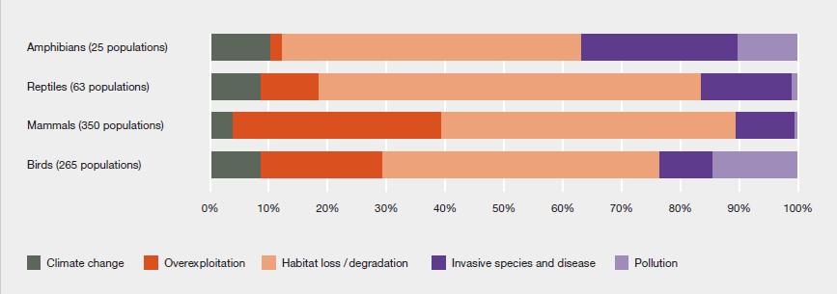
Note: Data includes 703 populations from the Living Planet Report (WWF, 2016).
United Nations Framework Convention on Climate Change and its associated agreements
Climate change is already contributing to land degradation, and will be an increasingly important driver of land degradation throughout the twenty-first century {3.4, 4.2.3, 4.2.6.1, 4.2.6.2, 4.2.8, 6.3.1.1, 6.3.2.3}. Moreover, the strength of land ecosystem-based carbon sinks, the stability of soil carbon stocks and the ecosystem-based adaptive capacity are weakened by degradation {4.2.3.2}. Avoiding land degradation or restoring degraded land usually, but not always, helps to mitigate and adapt to climate change {1.4.3, 7.2.6}. Tapping into the potential of land-based climate change mitigation and adaptation requires strong protection measures, sustainable management and the development of agricultural and natural production systems that combine high yields and close-to-natural soil organic carbon levels as promoted by, among others, the Global Soil Partnership for Food Security and Climate Change Adaptation and Mitigation and the 4 per 1000 initiative (established but incomplete) {7.2.1.2, 7.2.5, 7.2.6}. Such agricultural systems can have positive or negative effects on land degradation, depending on where and how they are practiced (established but incomplete) {4.2.3, 4.2.8, 6.3.1.1, 6.3.2.3}. Implementation of land-based climate mitigation actions that require more land than is available for restoration would exacerbate land degradation by displacing existing food or fibre crops or natural ecosystems.
Ramsar Convention
Despite comprising a small fraction of the global land area, wetlands provide a disproportionately large amount of critical ecosystem services, particularly those associated with the filtration and supply of fresh water and coastal protection (well established) {1.4.1, 4.2.3.3, 4.2.5.2} (Figure SPM.14). Wetlands also have high biodiversity importance, including being critical habitat for many migratory species. Treating wetlands as natural infrastructure can help meet a wide range of policy objectives, such as water and food security, as well as climate change mitigation and adaptation {6.3.1.5}. Restored wetlands recover most of their ecosystem services and functions within 50 to 100 years, providing a wide range of benefits for both biodiversity and human well-being {4.5.2.5, 5.4.4}. Considering the role of wetlands in freshwater catchments, river basins and coastal zones, future wetland restoration efforts could be greatly enhanced by the development of indicators and restoration targets aimed at evaluating and recovering the range of interactions between organisms and their abiotic environment {6.3.1.5}.
Figure SPM.14
The Wetland Extent Trends (WET) index representing the trends in natural wetland extent per region relative to 1970
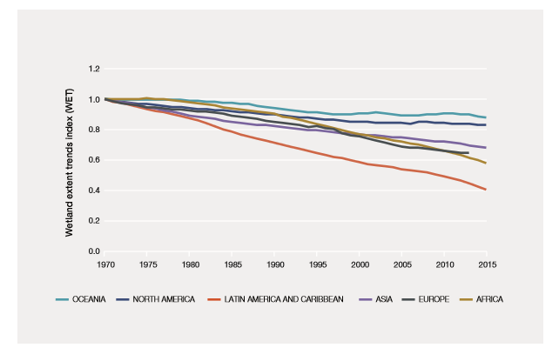
Source: Based on Ramsar Convention secretariat and UNEP-WCMC (2017) and Dixon et al. (2016).

Table SPM.3
Critical gaps in knowledge and understanding of land degradation and restoration
The summary for policymakers of this assessment represents the current state of knowledge regarding the biophysical, social and economic consequences and drivers of land degradation and restoration as well as approaches for avoiding, reducing and reversing land degradation. The research areas listed below represent the highest priorities identified by the assessment team to further enable evidence-based decisions regarding land degradation and restoration.
The evidence base required to address land degradation | Priority gaps in each area of knowledge
What are the consequences of land degradation for biodiversity, ecosystem functioning, natures contributions to people, and human well-being? | Methods to effectively monitor and map changes in different forms of degradation over time and at relevant spatial scales and resolutions
 | Spatial and temporal patterns of, and changes in, soil health
 | Consequences of land degradation on freshwater and coastal ecosystems, including mangroves and seagrass systems
 | Consequences of land degradation for physical and mental health and spiritual well-being
 | Consequences of land degradation for infectious disease prevalence and transmission
 | The potential for land degradation to exacerbate climate change
What are the causes of land degradation? | The social and environmental consequences of interactions between climate change and land degradation drivers, including for efforts to avoid land degradation and restore degraded land
 | Linkages between land degradation and restoration and distant social, economic and political processes
 | Interactions among land degradation, poverty, climate change and the risk of conflict and of migration
What are the key factors that can facilitate efforts to avoid, reduce and reverse land degradation? | Effectiveness of mechanisms for raising awareness and influencing the behaviour of actors across all stages of supply chains in ways that may improve the sustainability of internationally traded commodities
 | The relative importance of various enabling conditions for avoiding, reducing and reversing land degradation in different social, cultural, economic and governance contexts, including regarding technical capacities, technologies, data and information access, knowledge-sharing, decision support tools and institutional competencies
 | Methods for integrating conventional science and indigenous and local knowledge, in order to achieve a more broadly-based understanding of the causes and consequences of land degradation, its progression over time (including future projections) and potential solutions
 | Methods and tools for achieving a more inclusive understanding of the short, medium and long-term monetary and non-monetary implications of various approaches to the restoration of degraded land
What needs to be done to avoid, reduce and reverse land degradation, and what is the effectiveness of different approaches available? | Interactions amongst policies and land and resource-management practices to address different Sustainable Development Goals and other multilateral agreements, and the consequences of these efforts for land degradation and restoration outcomes
 | Methods for internalizing the environmental and social costs of unsustainable production practices into commodity prices, and the allocation of such costs to different stages of production, processing and consumption in the life cycle of a product
 | Evaluation of the effectiveness of different policy instruments designed to avoid, reduce and reverse land degradation, including legal, regulatory, social and economic instruments, for both environmental and social outcomes
 | Spatially-explicit multi-model scenarios of change in biodiversity and ecosystem services and the implications of these scenarios for achieving progress towards multilateral agreements, including land degradation neutrality at the national level

Appendix
Communication of the degree of confidence
In this assessment, the degree of confidence in each main finding is based on the quantity and quality of evidence and the level of agreement regarding that evidence (Figure SPM.A1). The evidence includes data, theory, models and expert judgement. Further details of the approach are documented in the note by the secretariat on the information on work related to the guide on the production of assessments (IPBES/6/INF/17).
The summary terms to describe the evidence are:
- Well established: comprehensive meta-analysis or other synthesis or multiple independent studies that agree.
- Established but incomplete: general agreement although only a limited number of studies exist; no comprehensive synthesis and/or the studies that exist address the question imprecisely.
- Unresolved: multiple independent studies exist but conclusions do not agree.
- Inconclusive: limited evidence, recognizing major knowledge gaps.
Figure SPM.A1
The four-box model for the qualitative communication of confidence.
Confidence increases towards the top-right corner as suggested by the increasing strength of shading.
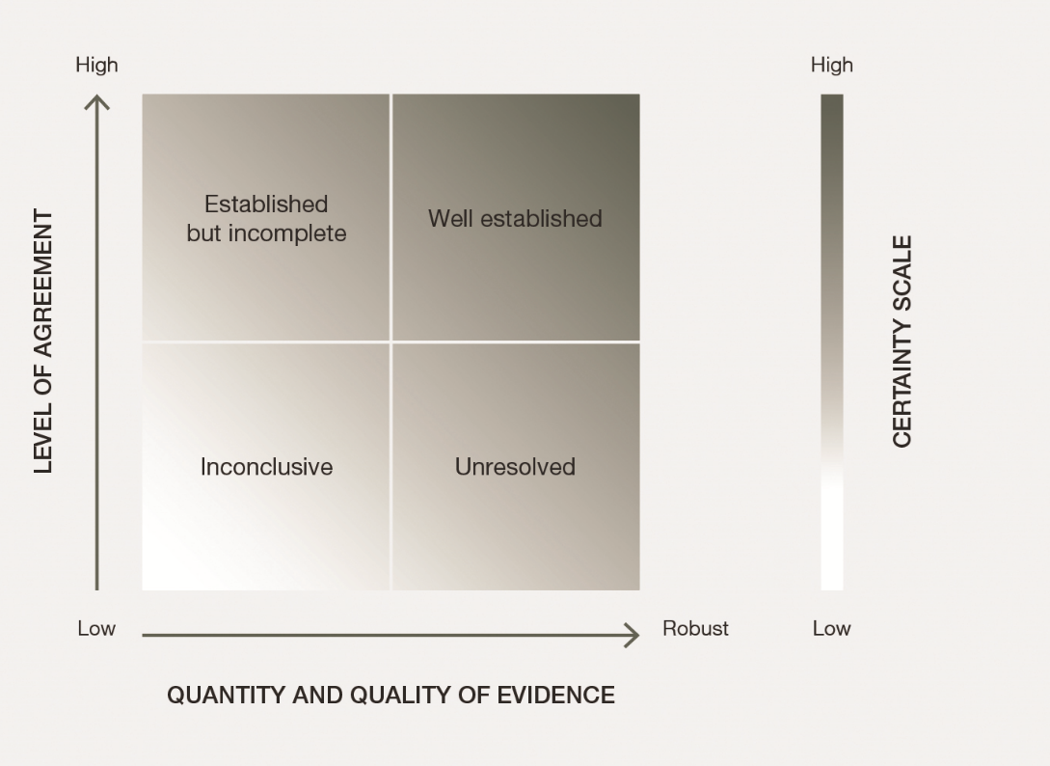
Source: IPBES, 2016.

Authors are listed with, in parenthesis, their country of citizenship, or countries of citizenship separated by a comma when they have several; and, following a slash, their country of affiliation, if different from citizenship, or their organization if they belong to an international organization: Name of expert (nationality 1, nationality 2/affiliation). The countries or organizations having nominated these experts are listed on the IPBES website.
Hansen, M. C., Potapov, P. V., Moore, R., Hancher, M., Turubanova, S. A., Tyukavina, A., Thau, D., Stehman, S. V., Goetz, S. J., Loveland, T. R., Kommareddy, A., Egorov, A., Chini, L., Justice, C. O., and Townshend, J. R. G. (2013). High-resolution global maps of 21st-century forest cover change. Science, 342, (6160), 850–853. DOI: 10.1126/science.1244693.
Zika, M and Erb, K.H. (2009) The global loss of net primary production resulting from human-induced soil degradation in drylands. Ecological Economics, 69 (2), 310-319. DOI: 10.1016/j.ecolecon.2009.06.014.
Cherlet, M., Ivits-Wasser, E., Sommer, S., Toth, G., Jones, A., Montanarella, L., and Belward, A. (2013). Land productivity dynamics in Europe: Towards a valuation of land degradation in the EU. EUR 26500. DOI: 10.2788/70673.
Watson, J. E. M., Shanahan, D. F., Di Marco, M., Allan, J., Laurance, W. F., Sanderson, E. W., Mackey, B., and Venter, O. (2016). Catastrophic Declines in Wilderness Areas Undermine Global Environment Targets. Current Biology, 26 (21), 2929–2934. DOI: 10.1016/j.cub.2016.08.049.
Gibbs, H. K., and Salmon, J. M. (2015). Mapping the world’s degraded lands. Applied Geography, 57, 12–21. DOI: 10.1016/j.apgeog.2014.11.024.
Van der Esch, S., ten Brink, B., Stehfest, E., Bakkenes, M., Sewell, A., Bouwman, A., Meijer, J., Westhoek, H., and van den Berg, M. (2017). Exploring future changes in land use and land condition and the impacts on food, water, climate change and biodiversity: Scenarios for the UNCCD Global Land Outlook. The Hague: PBL Netherlands Environmental Assessment Agency. Retrieved from http://www.pbl.nl/sites/default/files/cms/publicaties/pbl-2017-exploring-future-changes-in-land-use-and-land-condition-2076.pdf.
Woodward, E., Marrfurra McTaggart, P., Yawulminy, M., Ariuu, C., Daning, D., Kamarrama, K., Ngulfundi, B., Warrumburr, M., and Wawul, M. (2009). Ngan’gi Seasons, Nauiyu - Daly River, Northern Territory, Australia. Darwin, CSIRO Sustainable Ecosystems.
For an explanation of confidence terms, see appendix.
Van der Esch, S., ten Brink, B., Stehfest, E., Bakkenes, M., Sewell, A., Bouwman, A., Meijer, J., Westhoek, H., and van den Berg, M. (2017). Exploring future changes in land use and land condition and the impacts on food, water, climate change and biodiversity: Scenarios for the UNCCD Global Land Outlook. The Hague: PBL Netherlands Environmental Assessment Agency. Retrieved from http://www.pbl.nl/sites/default/files/cms/publicaties/pbl-2017-exploring-future-changes-in-land-use-and-land-condition-2076.pdf.
Haberl, H., Erb, K-H., Krausmann, F., Gaube, V., Bondeau, A., Plutzar, C., Gingrich, S., Lucht, W., and Fischer-Kowalski, M. (2007). Quantifying and mapping the human appropriation of net primary production in Earth’s terrestrial ecosystems. PNAS, 104 (31), 12942–12947. DOI: 10.1073/pnas.0704243104.
Van der Esch, S., ten Brink, B., Stehfest, E., Bakkenes, M., Sewell, A., Bouwman, A., Meijer, J., Westhoek, H., and van den Berg, M. (2017). Exploring future changes in land use and land condition and the impacts on food, water, climate change and biodiversity: Scenarios for the UNCCD Global Land Outlook. The Hague: PBL Netherlands Environmental Assessment Agency. Retrieved from http://www.pbl.nl/sites/default/files/cms/publicaties/pbl-2017-exploring-future-changes-in-land-use-and-land-condition-2076.pdf.
Stoorvogel, J. J., Bakkenes, M., Temme, A. J., Batjes, N. H., and Ten Brink, B. J. (2017). S‐World: A Global Soil Map for Environmental Modelling. Land Degradation and Development, 28 (1), 22–33. DOI: 10.1002/ldr.2656.
Watson, J. E. M., Shanahan, D. F., Di Marco, M., Allan, J., Laurance, W. F., Sanderson, E. W., Mackey, B., and Venter, O. (2016). Catastrophic Declines in Wilderness Areas Undermine Global Environment Targets. Current Biology, 26 (21), 2929–2934. DOI: 10.1016/j.cub.2016.08.049.
Newbold, T., Hudson, L. N., Arnell, A. P., Contu, S., De Palma, A., Ferrier, S., Hill, S. L. L., Hoskins, A. J., Lysenko, I., Phillips, H. R. P., Burton, V. J., Chng, C. W. T., Emerson, S., Gao, D., P (2016). Has land use pushed terrestrial biodiversity beyond the planetary boundary? A global assessment. Science, 353(6296), 288–291. DOI: 10.1126/science.aaf2201.
The definition that follows is for the purpose of this assessment only: water security is used to mean the ability to access sufficient quantities of clean water to maintain adequate standards of food and goods production, sanitation and health care and for preserving ecosystems.
Hammarström, H., Forkel, R., and Haspelmath, M. (2017). Glottolog 3.0. Max Planck Institute for the Science of Human History. Retrieved from http://glottolog.org.
Jenkins, C. N., Pimm, S. L., and Joppa, L. N. (2013). Global patterns of terrestrial vertebrate diversity and conservation. PNAS, 110(28), E2602–E2610. DOI: 10.1073/pnas.1302251110.
Ecological solidarity first appeared in France’s Law on National Parks and was adopted in France’s Law for the Restoration of Biodiversity, Nature and Landscapes (Law No. 2016-1087 of 8 August 2016); the legislation of the Plurinational State of Bolivia (Law No. 071, of Mother Earth Rights, and Law No. 300, the Framework Law of Mother Earth and Integral Development for Living Well); and the Constitution of Ecuador {2.2.1.3}. For more examples, see 2.2.2.
United Nations Development Programme (2015). Human Development Data (1990–2015) Retrieved from http://hdr.undp.org/en/data.
Van der Esch, S., ten Brink, B., Stehfest, E., Bakkenes, M., Sewell, A., Bouwman, A., Meijer, J., Westhoek, H., and van den Berg, M. (2017). Exploring future changes in land use and land condition and the impacts on food, water, climate change and biodiversity: Scenarios for the UNCCD Global Land Outlook. The Hague: PBL Netherlands Environmental Assessment Agency. Retrieved from http://www.pbl.nl/sites/default/files/cms/publicaties/pbl-2017-exploring-future-changes-in-land-use-and-land-condition-2076.pdf.
Stoorvogel, J. J., Bakkenes, M., Temme, A. J., Batjes, N. H., and ten Brink, B. J. (2017). S‐World: A Global Soil Map for Environmental Modelling. Land Degradation and Development, 28 (1), 22–33. DOI: 10.1002/ldr.2656.
Lenzen, M., Moran, D., Kanemoto, K., Foran, B., Lobefaro, L., and Geschke, A. (2012). International trade drives biodiversity threats in developing nations. Nature, 486, 109–112. DOI: 10.1038/nature11145.
Many ecosystems require fire to remain healthy and safe. The frequency and type of fire used depends on the circumstances and intent, which may use managed burns or simulate natural ignition and spread {3.3.7, 4.2.6.3}.
WWF. (2016). Living Planet Report 2016. Risk and resilience in a new era. Gland, Switzerland: WWF International. Retrieved from http://wwf.panda.org/about_our_earth/all_publications/lpr_2016/.
Ramsar Convention secretariat and UNEP-WCMC (2017). Wetland Extent Trends (WET) Index - 2017 Update. Technical Update 2017. Gland, Switzerland: Ramsar Convention secretariat.
Dixon, M. J. R., Loh, J., Davidson, N. C., Beltrame, C., Freeman, R., Walpole, M. (2016). Tracking global change in ecosystem area: The Wetland Extent Trends Index. Biological Conservation, 193, 27–35. DOI: 10.1016/j.biocon.2015.10.023.
IPBES, Summary for policymakers of the assessment report of the Intergovernmental Science-Policy Platform on Biodiversity and Ecosystem Services on pollinators, pollination and food production. S.G. Potts, V. L. Imperatriz-Fonseca, H. T. Ngo, J. C. Biesmeijer, T. D. Breeze, L. V. Dicks, L. A. Garibaldi, R. Hill, J. Settele, A. J. Vanbergen, M. A. Aizen, S. A. Cunningham, C. Eardley, B. M. Freitas, N. Gallai, P. G. Kevan, A. Kovács-Hostyánszki, P. K. Kwapong, J. Li, X. Li, D. J. Martins, G. Nates-Parra, J. S. Pettis, R. Rader, and B. F. Viana (eds.)., secretariat of the Intergovernmental Science-Policy Platform on Biodiversity and Ecosystem Services, Bonn, Germany, 2016. Available from www.ipbes.net/sites/default/files/downloads/pdf/spm_deliverable_3a_pollination_20170222.pdf.

