UNITED  NATIONS | 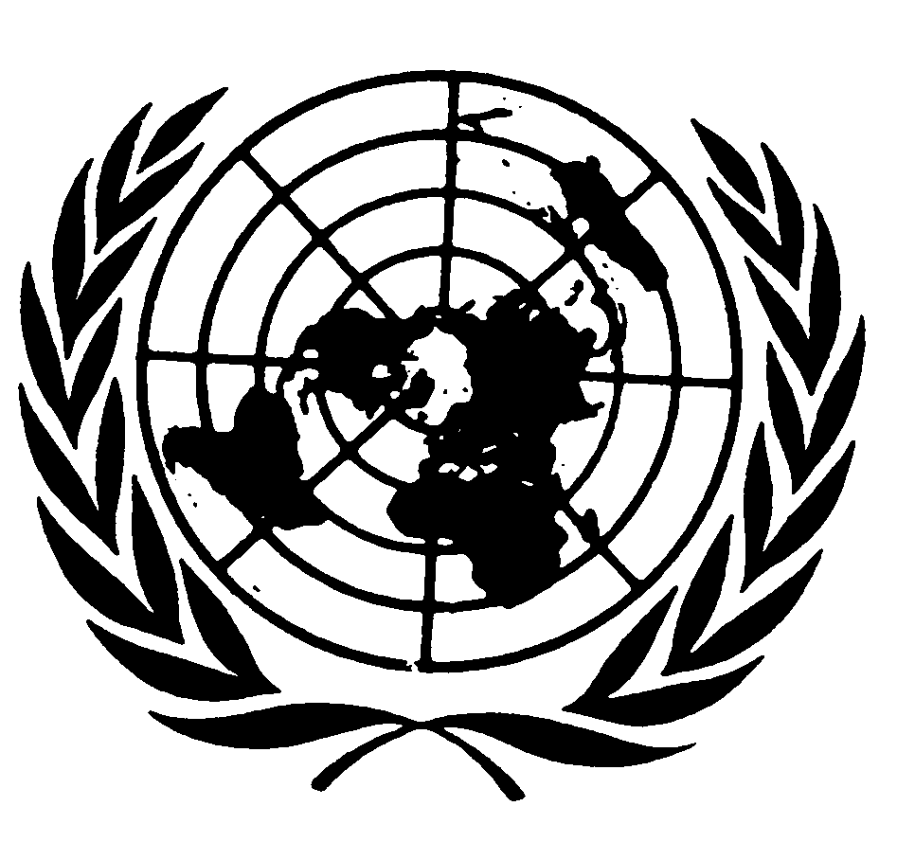 |  | 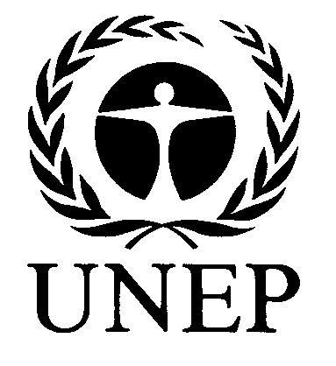 | 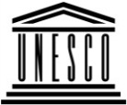 | 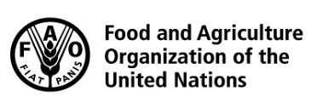 | 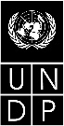 |  | BES
 |  |  |  |  |  |  | IPBES/6/INF/13
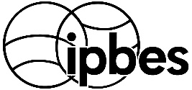 |  | Intergovernmental Science-Policy Platform on Biodiversity and Ecosystem Services |  |  |  |  | Distr.: General  19 January 2018  English only
Plenary of the Intergovernmental Science-Policy
Platform on Biodiversity and Ecosystem Services
Sixth session
Medellin, Colombia, 18–24 March 2018
Item 5 of the provisional agenda*
Report of the Executive Secretary on the implementation
of the first work programme for the period 2014–2018
Information on work related to indigenous and local knowledge (deliverable 1 (c))
Note by the secretariat
- In section III of decision IPBES-5/1, the Plenary of the Intergovernmental Science-Policy Platform on Biodiversity and Ecosystem Services (IPBES) approved the approach to recognizing and working with indigenous and local knowledge set out in annex II to the decision, and requested the Multidisciplinary Expert Panel, supported by the task force on indigenous and local knowledge, to implement the approach. Since the adoption of decision IPBES-5/1, work on indigenous and local knowledge has focused on the implementation of the indigenous and local knowledge approach.
- The annex to the present note, which is presented without formal editing, sets out information on progress to date in the work related to indigenous and local knowledge, including the implementation of the indigenous and local knowledge approach in the context of the IPBES global assessment of biodiversity and ecosystem services, progress in the development of methodological guidance for the approach and arrangements supporting the implementation of the approach.

Annex
Information on work related to indigenous and local knowledge
I. Context
- With decision IPBES-5/1 the Plenary:
  - Approved the approach to recognizing and working with indigenous and local knowledge (set out in annex II to decision IPBES-5/1) and requested the Multidisciplinary Expert Panel, supported by the task force on indigenous and local knowledge, to implement it;
  - Invited indigenous peoples and local communities and their representatives, as well as experts on indigenous and local knowledge, to engage in the activities described in the approach, in particular through the participatory mechanism;
  - Invited Governments, stakeholders, strategic partners and others to support activities that mobilize indigenous and local knowledge where such knowledge is needed but not available in readily available formats and that increase the capacity of indigenous peoples and local communities to engage in and benefit from the Platform; and
  - Requested the Executive Secretary to make the arrangements necessary to implement the approach, including arrangements for the establishment of the participatory mechanism, subject to the availability of resources.
- Following up on this decision, the work on indigenous and local knowledge has focused on the implementation of the indigenous and local knowledge approach.
- At the 9th meeting of the MEP and Bureau (June 2017), progress made on the implementation of the indigenous and local knowledge approach was reported, reflecting on the discussions and outcomes from the 6th meeting of the indigenous and local knowledge task force, held in May 2017 in Pereira, Colombia. The Bureau and MEP invited the task force to submit at their 10th meeting a draft methodological guidance for the implementation of the approach as well as a further developed proposal for the governance supporting the implementation of the approach.
- At the 10th meeting of the MEP and Bureau (October 2017), further progress was reported. This included implementing the following aspects of the approach, described in more detail in the following sections: a) Implementation of the indigenous and local knowledge approach in the context of the Global Assessment; b) Development of methodological guidance for the indigenous and local knowledge approach; and c) Arrangements supporting the implementation of the indigenous and local knowledge approach. The Bureau and MEP noted some overlap between the proposed “facilitation, management and support” group and the task force; and that the functions of both should be clearly delineated; and noted progress made in the development of a proposal for institutional arrangements supporting the implementation of the indigenous and local knowledge approach.
II. Implementation of the agreed approach to recognising and working with indigenous and local knowledge in IPBES
A. Implementation of the Indigenous and Local Knowledge approach in the context of the Global Assessment
- After the approval of the IPBES approach to working with indigenous and local knowledge (section III of decision IPBES-5/1, and annex II to the decision), the Global Assessment devised steps to implement the indigenous and local knowledge approach, which were presented at the ninth meeting of the MEP and Bureau (June 2017). These concrete plans included a series of consultations that would take place either online or face-to-face with varying objectives.
- The indigenous and local knowledge liaison group within the Global Assessment, through one of its members Zsolt Molnár (Coordinating Lead Author Chapter 2 of the Global Assessment), organized a meeting of the Global Assessment indigenous and local knowledge liaison group (Budapest, Hungary 31 March to 02 April 2017). The objectives of this meeting were to discuss the process for the inclusion of indigenous and local knowledge into the Global Assessment, in addition to the planning and preparation of the upcoming consultations.
- Subsequently, Eduardo Brondizio, co-chair of the Global Assessment, together with the indigenous and local knowledge liaison group and advised by the IPBES indigenous and local knowledge task force, launched the Indigenous and Local Knowledge Call for Contributions from 25 July to 15 September 2017 in three languages (English, French and Spanish). There were 220 submissions received in response to that first call (English: 174, French: 14, and Spanish 32), which was extended until 20 December 2017.
- Contributions received through the Indigenous and Local Knowledge Call for Contributions mostly consist of research and conference papers (case study/conceptual/review), books and book chapters. Other submissions include synthesis reports, PhD dissertations, websites, videos, and newspaper articles. A large number of names of experts and organizations were also submitted.
- A series of face-to-face indigenous and local knowledge consultations have also been held:
  - Side Event at the 16th session of the United Nations Permanent Forum on Indigenous Issues (New York, USA, 24 April – 03 May 2017): Operationalization strategy for advancing Indigenous and Local Knowledge and Practices (Indigenous and Local Knowledge) in the IPBES Global Assessment;
  - Session at the 40th Annual Conference of the Society of Ethnobiology (Montreal, Canada, 10 – 13 May 2017): The IPBES Global Assessment of Biodiversity and Ecosystems Services: Calling upon the contribution of Ethnobiology. Both were reported on during the last (9th) meeting of the MEP and Bureau;
  - Dialogue on Human Rights and Biodiversity Conservation (Eldoret, Kenya,
20 – 23 November 2017). The co-organizers of this workshop were SwedBio at Stockholm Resilience Centre, Forest Peoples Programme, and Natural Justice, with local hosts Chepkitale Indigenous Peoples Development Project. This was an opportunity to consult on issues related to Chapters 2, 3, 5, and 6 involving the links between IPLCs and protected areas (PAs), protected area governance, and human rights. Participating IPBES authors gave presentations, engaged in dialogue discussions and carried out individual interviews with key indigenous participants. A report with the IPBES meeting outcomes has been made available to IPBES authors;
  - A dialogue held in the context of the 10th meeting of the Ad Hoc Open-ended Working Group on Article 8(j) and Related Provisions of the Convention on Biological Diversity (CBD) (Montreal, Canada, 09 December 2017). The IPBES secretariat worked with the CBD, International Indigenous Forum on Biodiversity (IIFB), Indigenous Women's Biodiversity Network (IWBN), International Indigenous Forum on Biodiversity and Ecosystem Services (IIF BES), and the Forest Peoples Programme (FPP) on co-organizing this full-day dialogue, which focused on key issues for indigenous and local communities in the Global Assessment. A report of the meeting outcomes has been made available to IPBES authors.
B. Progress regarding the development of methodological guidance for the IPBES indigenous and local knowledge approach
- The 6th meeting of the indigenous and local knowledge task force (8 – 11 May 2017, Colombia), discussed the IPBES indigenous and local knowledge approach, focusing on next steps for its operationalization. It was agreed that further methodological guidance was needed to operationalize the requirements for respectfully working with indigenous knowledge and indigenous knowledge holders, including on how to work with FPIC principles.
- Concerns included how to take into account indigenous and local knowledge holder values within the approach, and how to account for these using FPIC principles. Participants also highlighted that a concerted effort would be needed to educate indigenous participants about their rights, about the IPBES assessment process, and about how data will be stored and synthesized, in order for indigenous and local knowledge holders to be ‘informed’ before giving their consent. Definitions of indigenous peoples were also discussed.
- In line with this guidance, the TSU on indigenous and local knowledge subsequently further analysed the indigenous and local knowledge approach, and the comments of the task force. A review of other methodological documents produced by international bodies aiming to work respectfully and effectively with indigenous peoples was also carried out by the TSU.
- A comprehensive outline for the Methodological Guidance was subsequently drafted, discussed at the 10th meeting of the MEP (October 2017), and shared with the task force for comments, and text was developed for some of its sections (see Appendix 1). The methodological guidance aims to address all four phases of the Assessment process, as well as to propose ways to work towards many of the aims of the other thematic areas of IPBES: knowledge and data, policy support tools and methodologies, and capacity-building.
C. Arrangements supporting the implementation of the indigenous and local knowledge approach
- The participatory mechanism on indigenous and local knowledge is one of the main mechanisms supporting the implementation of the indigenous and local knowledge approach. The Bureau and the MEP, at their 10th meetings (October 2017) considered an initial governance structure, reproduced in appendix II, to implement the approach and a set of steps to establish it. This governance will be further developed and considered by MEP and Bureau in 2018, and could form part of the consultations on possible institutional arrangements for the second work programme, and would be presented, in this context, to the Plenary.
- The proposed initial governance structure of the participatory mechanism consists of a “Facilitation, Management and Support” Group, hereafter called “the Group”, including 24 members as follows:
  - Seven IPLC representatives drawn from the seven IPLC regions: under the UN Permanent Forum on Indigenous Issues, the seven socio-cultural regional groupings of IPLCs are: Africa; Asia; Central and South America and the Caribbean; The Arctic; Eastern Europe, Russian Federation, Central Asia and Transcaucasia; North America; The Pacific;
  - Five strategic partners, representing a larger set of organizations with direct involvement with IPLCs and others with IPLC interests. These five partners would be represented by their respective resource person on the Group;
  - Eight indigenous and local knowledge experts representing relevant expert groups and task forces within IPBES; and
  - Two members of the Bureau and two members of the MEP acting as co-chairs. Technical support to the Group would be provided by the secretariat, through its TSU on indigenous and local knowledge.
- To establish this “Facilitation, Management and Support” Group, the following process could be followed:
  - The Chair of IPBES would invite the seven IPLC regions to name one representative each, to serve for a term of three years, renewable once;
  - An open call for expressions of interest for strategic partner organizations would be launched and five organizations would be selected by MEP and Bureau to be represented on the Group for a possible term of three years, renewable once; and
  - A set of eight indigenous and local knowledge experts would be selected by MEP and Bureau from ongoing assessments (from the Global Assessment and any assessments launched subsequently), task forces and possibly from other expert groups.
- Once established, this Group would support the implementation of the indigenous and local knowledge approach, providing strategic advice, supporting the work with strategic activities by the IPLCs and selected strategic partners, and coordinating the strategic outreach to further catalyze broader levels of engagements, mainly through open calls for contributions to targeted activities.
- The consultations planned for 2018 on a second work programme may address whether adjustments are necessary to the focus and scope of the task forces established for the first work programme, including the task force on indigenous and local knowledge (see document IPBES/6/11 on the development of a second work programme). The proposal for a “Facilitation, Management and Support” Group of the participatory mechanism could be considered in this context and, following further consideration by the MEP and Bureau, be submitted for consideration by the Plenary, in the context of institutional arrangements for the implementation of the second work programme.

Appendix I
Outline of the methodological guidance for the IPBES indigenous and local knowledge approach
A. Introduction
- Background to additional methodological guidance
Background to additional methodological guidance needed on how to engage with indigenous peoples and indigenous knowledge
- Key areas of focus
Brief introduction to key areas of focus, as specified in Decision IPBES-5/1:
  - Online surveys and web-based consultations
  - Face-to-face consultations with representative networks and organizations
  - Specific and localized forms of consultations with ILK holders
  - Synthesis and analysis of ILK knowledge, information and data
  - Outreach and information sharing
B. Free prior and informed consent (FPIC) and best practice
- Background to FPIC
Definitions for free, prior, informed and consent, and brief history
- Elements of effective consultations with ILK Holders
  - ILK holder rights within the process
  - Considerations of time, effort, and budget
C. IPBES approach and free prior and informed consent (FPIC)
- What ILK holders need to know for ‘informed’ consent
Discussion of all of the aspects of IPBES that ILK holders should understand before ‘informed’ consent can be given, including aims, methods, and ILK holder rights
D. Methodological guidance for the IPBES assessments’ four phases
- Phase 1: Scoping
  - How to reach out to IPLC networks
  - Selection and facilitation of indigenous participants
  - How to engage effectively with indigenous peoples during face-to-face dialogues
  - Improving the chances of successful online review
  - Developing indicators that reflect ILK holder concerns
- Phase 2: Synthesizing
Methods and key considerations for:
- Developing a set of practices to help manage ILK evidence and data that will be collected in the assessments
- Working with existing written documents or data containing ILK, including data and cases from other IPBES assessments and related reports and meta-analysis and data from international research centres and institutions and relevant regional centres;
- Working with indigenous and local knowledge manifested in forms such as ritual, ceremonial, oral, dance, song and visual manifestations, including symbols, documentaries and artwork
- Local dialogue workshops with ILK holders which aim to gather knowledge directly
- Longer-term capacity building with ILK holders to support regular community level monitoring and self-assessment schemes that address issues relevant to IPBES
- Phase 3: Reviewing
Key methodological considerations for facilitating ILK holder participation in document reviews through web-based interactions and face-to-face dialogue meetings
- Phase 4: Knowledge sharing
Methodological considerations on how to share information with ILK holders and raise awareness of IPBES products and reports.
E. Knowledge and data
Noting that the above methodological guidance will work towards the main aims of knowledge and data in relation to ILK:
- How to identify ILK experts and manage evidence and data: Identify; in coordination with indigenous and local knowledge holders, indigenous and local knowledge experts and experts on indigenous and local knowledge; a set of practices to help manage evidence and data that will be collected in the assessments;
- Access to and management of available sources of ILK: Facilitate, as appropriate, via the IPBES web-based infrastructure, the access to and management of available sources of indigenous and local knowledge, both for internal use in developing assessments and for decision makers and scholars drawing on the work of IPBES to support their own work, in line with relevant standards and conventions;
- Mobilization of ILK collection: Promote and catalyse the mobilization of indigenous and local knowledge, as appropriate, where such knowledge does not exist in readily available formats in ways that reflect the concepts of parallel validation or co-production processes, with the support of appropriate partners, focusing on gaps that emerge during each phase of an assessment.
- Developing indicators, units of analysis and classifying units of analysis and natures gifts to people: Take into account appropriately those aspects relevant to indigenous and local knowledge and indigenous peoples and local communities in the list of indicators, classifications of units of analysis and classification of nature’s contributions to people including ecosystem services and nature’s gifts.
F. Policy support tools and methodologies
Noting that the above described methodological guidance will work towards the goals for Policy Support Tools and Methodologies:
- Develop tools and methods: Identify, describe and facilitate the use of relevant tools and methods for implementing the four phases of the proposed approach. Where such tools and methods still need to be developed, IPBES will promote and catalyse their development with appropriate partners;
- Policy responses, decision-making processes: Ensure that policy responses, decision-making instruments and processes relevant to indigenous and local knowledge and indigenous peoples and local communities are reflected in IPBES assessments.
G. Capacity-building
Noting that the above described methodological guidance will work towards the IPBES goals for capacity-building:
- Identify, prioritize and build capacity: Identify, prioritize and build capacity critical to its implementation, within the means available, through, for example, training workshops and webinars on the approaches to and procedures for recognizing and working with indigenous and local knowledge in assessments or participation in the fellowship programme; and
- Promote and catalyse capacity building activities: Promote and catalyse the undertaking of capacity-building activities in support of broader capacity-building needs involving, among other mechanisms, strategic partnerships where such needs go beyond the means of IPBES. In this context, the participatory mechanism could strengthen the ability of indigenous peoples and local communities to take part in, contribute to, and benefit from IPBES deliverables.

Appendix II
Arrangements establishing the participatory mechanism
- The following arrangements were considered by Bureau and MEP at their 10th meetings (October 2017), and will be further developed in 2018.
- The following objectives of the participatory mechanism derive from the agreed ILK approach (decision IPBES-5/1, section III, and annex II to the decision) and include, inter alia, the following:
  - support the IPBES work programme by linking with strategic partners to build capacity of indigenous peoples and local communities to engage in IPBES;
  - mobilize indigenous and local knowledge in formats accessible to IPBES;
  - ensure processes are in place for giving back to indigenous peoples and local communities through sharing knowledge and insights gained through assessments;
  - promote dialogue with various networks, relevant experts and policymakers to allow participation in all four phases of the assessment process, including both web-based consultations and dialogue workshops;
  - assist in development of policy support tools and methodologies which have special reference and/or significance to IPLCs;
  - create opportunities for shared learning through dedicated discussion forums on the web-based platform and/or face-to face meeting as appropriate.
- To facilitate, manage and support the participatory mechanism, a “Facilitation, Management and Support” Group (see Figure 1) would be established, including:
  - seven IPLC representatives drawn from the seven IPLC regions: under the UN Permanent Forum on Indigenous Issues the seven socio-cultural regional groupings of IPLCs are: Africa; Asia; Central and South America and the Caribbean; The Arctic; Eastern Europe, Russian Federation, Central Asia and Transcaucasia; North America; The Pacific;
  - five strategic partners represented by a resource person: organizations with direct involvement with IPLCs and others with IPLC interests; and
  - twelve ILK experts representing relevant expert groups and task forces within IPBES, as well as representatives of the Bureau, MEP and of the secretariat (including its TSU).
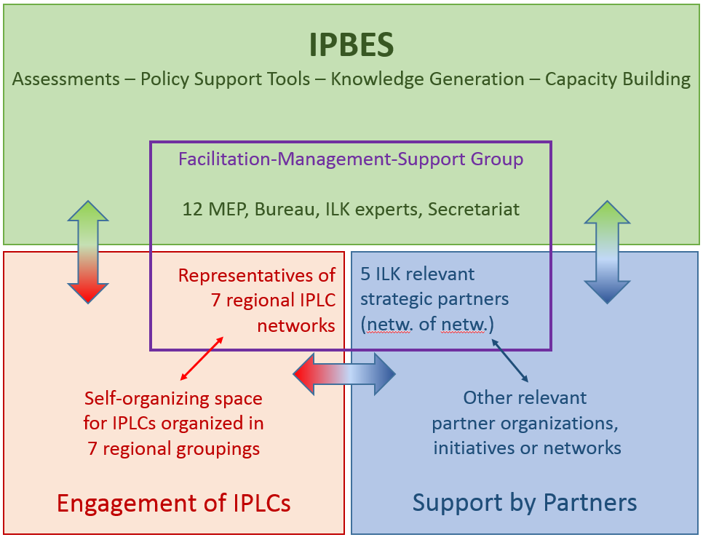
Figure 1: Structure of the proposed “Facilitation, Management and Support Group” governing the participatory mechanism; the arrows indicate joint activities such as dialogue workshops, knowledge mobilization, capacity building and shared learning, in support of and/or drawing from IPBES assessments and other products (e.g. policy support tools).
- To establish this “Facilitation, Management and Support” Group, it is suggested that:
  - The Chair of IPBES invite the seven IPLC regions to name seven representatives, one from each of their regions for a term of a suggested length of 3 years (renewable once);
  - An open call for interest of expression for strategic partner organizations be launched and MEP and Bureau select five appropriate organizations as representatives of this larger set of organizations for a term of a suggested length of 3 years (renewable once); and
  - The ILK experts be drawn from ongoing assessments (from the global assessment and possibly other subsequently launched assessments), the task forces (capacity building, ILK and knowledge and data) and possibly from other expert groups.
- The “Facilitation, Management and Support” Group would be chaired by two members each of the MEP and Bureau. Technical support to the group would continue to be provided by the secretariat (and its TSU on ILK).
- Once established, this group would support implementation of the ILK approach, providing strategic advice, supporting the work with strategic activities by the IPLCs and selected strategic partners, as well as coordinating the strategic outreach to further catalyze broader levels of engagements, mainly through open call to contributions to targeted activities.
- Collaborative activities would be further defined for the four phases of any assessment cycle to implement the ILK approach, as follows:
  - Phase 1 – Scoping:
    - Building capacity on IPBES processes and the value of getting engaged;
    - Promoting nominations of ILK experts to IPBES call for nomination for the scoping expert group;
    - Supporting the face-to-face dialogue meeting scoping the assessment by reaching out to IPLC networks to get input to scoping;
    - Supporting the online review of the scoping document by amplifying its reach, including through group reviews among IPLCs and strategic partners;
  - Phase 2 – Mobilization of data and information:
    - Building capacity on IPBES processes and the value of getting engaged;
    - Promoting nominations of ILK experts to IPBES call for nomination for the assessment expert group;
    - Supporting the call for contributions to gather evidence in response to the questions elaborated during the scoping phase by:
      - Mobilizing knowledge that is available to partners, organizations and networks of the participatory mechanism;
      - Where such knowledge is not available: Supporting the mobilization of knowledge from IPLCs 1) short-term by facilitating local dialogue workshops gathering knowledge, and 2) longer-term by building capacity and supporting regular community level monitoring and
self-assessment schemes that address issues relevant to IPBES;
  - Phase 3 – Engagement in reviews:
    - Facilitating group reviews of first order drafts, second order drafts, and summaries for policymakers in support of the regular web-based review phases of the assessments;
    - Supporting face-to-face dialogue meetings aimed at in-depth reviews of specific issues of interest to the assessment by reaching out to IPLC networks to get inputs to in-depth review
  - Phase 4 – Sharing knowledge and insights:
    - supporting sharing knowledge and insights gained through an assessment, e.g. by developing IPLC-appropriate educational material, undertaking capacity building workshops, training trainers, organizing discussions
(face to face / e-learning), etc.
- An ILK web portal would be developed in support of the participatory mechanism.

* IPBES/6/1.

