UNITED  NATIONS | 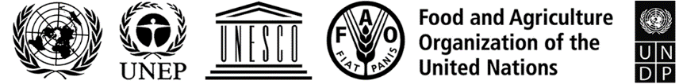 |  |  | BES
 |  |  | IPBES/9/1*
 |  | Intergovernmental Science-Policy  Platform on Biodiversity and  Ecosystem Services | Distr.: General  14 October 2021  Original: English
Plenary of the Intergovernmental Science-Policy
Platform on Biodiversity and Ecosystem Services
Ninth session
Bonn, Germany, 3–9 July 2022
Provisional agenda
- Opening of the session.
- Organizational matters:
  - Adoption of the agenda and organization of work;
  - Status of the membership of the Platform;
  - Election of officers.
- Admission of observers.
- Credentials of representatives.
- Report of the Executive Secretary on progress in the implementation of the rolling work programme up to 2030.
- Financial and budgetary arrangements for the Platform.
- Assessing knowledge:
  - Thematic assessment of the sustainable use of wild species;
  - Methodological assessment regarding the diverse conceptualization of multiple values of nature and its benefits, including biodiversity and ecosystem functions and services;
  - Scoping report for a methodological assessment of the impact and dependence of business on biodiversity and nature’s contributions to people;
  - Engagement with the Intergovernmental Panel on Climate Change.
- Building capacity, strengthening knowledge foundations and supporting policy:
  - Work programme deliverables and task force workplans;
  - Nature futures framework prepared by the task force on scenarios and models.
- Improving the effectiveness of the Platform.
- Requests, input and suggestions for additional elements of the rolling work programme of the Platform up to 2030.
- Organization of the Plenary; dates and venues of future sessions of the Plenary.
- Institutional arrangements: United Nations collaborative partnership arrangement for the work of the Platform and its secretariat.
- Adoption of the decisions and the report of the session.
- Closure of the session.

* Reissued for technical reasons on 3 December 2021.

