UNITED  NATIONS | 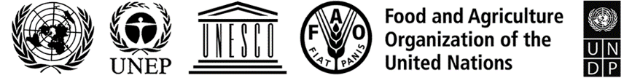 |  |  | BES
 |  |  | IPBES/9/14/Add.2
 |  | Intergovernmental Science-Policy  Platform on Biodiversity and  Ecosystem Services | Distr.: General  1 August 2022  Original: English
Plenary of the Intergovernmental Science-Policy
Platform on Biodiversity and Ecosystem Services
Ninth session
Bonn, Germany, 3–9 July 2022
Report of the Plenary of the Intergovernmental Science-Policy Platform on Biodiversity and Ecosystem Services on the work of its ninth session
Addendum
Summary for policymakers of the methodological assessment regarding the diverse conceptualization of multiple values of nature and its benefits, including biodiversity and ecosystem functions and services (assessment of the diverse values and valuation of nature)
At its ninth session, in decision IPBES-9/1, section II, paragraph 4, the Plenary of the Intergovernmental Science-Policy Platform on Biodiversity and Ecosystem Services approved the summary for policymakers of the methodological assessment regarding the diverse conceptualization of multiple values of nature and its benefits, including biodiversity and ecosystem functions and services (assessment of the diverse values and valuation of nature), as set out in the annex to the present addendum.

Annex
Summary for policymakers of the methodological assessment regarding the diverse conceptualization of multiple values of nature and its benefits, including biodiversity and ecosystem functions and services (assessment of the diverse values and valuation of nature)
Authors
Unai Pascual (Spain/Switzerland), Patricia Balvanera (Mexico), Michael Christie (United Kingdom of Great Britain and Northern Ireland), Brigitte Baptiste (Colombia), David González-Jiménez (IPBES), Christopher B. Anderson (Argentina, United States of America/Argentina), Simone Athayde (Brazil/United States of America), David N. Barton (Norway), Rebecca Chaplin-Kramer (United States of America), Sander Jacobs (Belgium), Eszter Kelemen (Hungary), Ritesh Kumar (India/Wetlands International), Elena Lazos (Mexico), Adrian Martin (United Kingdom of Great Britain and Northern Ireland), Tuyeni H. Mwampamba (United Republic of Tanzania/Mexico), Barbara Nakangu (Uganda), Patrick O’Farrell (South Africa), Christopher M. Raymond (Australia, Netherlands/Sweden, Finland), Suneetha M. Subramanian (India/United Nations University Institute for the Advanced Study of Sustainability), Mette Termansen (Denmark), Meine van Noordwijk (Netherlands/Indonesia), Arild Vatn (Norway).

Members of the management committee who provided guidance for the preparation of this assessment

Bibiana Vilá, Antonio Díaz-de-León, Chimere Diaw, Mersudin Avdibegovic, Julia Marton-Lefevre, Rashad Allahverdiyev.

Disclaimer

The designations employed and the presentation of material on the maps used in the present report do not imply the expression of any opinion whatsoever on the part of the Intergovernmental Science-Policy Platform on Biodiversity and Ecosystem Services concerning the legal status of any country, territory, city or area or of its authorities, or concerning the delimitation of its frontiers or boundaries. These maps have been prepared for the sole purpose of facilitating the assessment of the broad biogeographical areas represented therein.

KEY MESSAGES
The assessment of the diverse values and valuation of nature of the Intergovernmental Science-Policy Platform on Biodiversity and Ecosystem Services (IPBES) provides guidance to navigate pathways for reconciling people’s good quality of life with life on Earth and advancing the intertwined economic, social and environmental dimensions of sustainable development in a balanced manner (figure SPM.1). It includes an understanding of the relations between different world-views and values, a values typology, guidelines for designing and implementing valuation methods and processes, and for embedding the diverse values of nature into decision-making and policymaking.
The assessment also highlights key capacities for working with multiple values to leverage transformative change across different stakeholders and institutions. Nature is understood by IPBES and by the assessment in an inclusive way, encompassing multiple perspectives and understandings of the natural world, such as biodiversity and the perspectives of indigenous peoples and local communities who use and embody concepts like Mother Earth. In addition, the assessment of the diverse values and valuation of nature is expected to contribute to achieving the 2050 Vision for Biodiversity, the 2030 Agenda for Sustainable Development and the future post-2020 global biodiversity framework, towards just and sustainable futures.
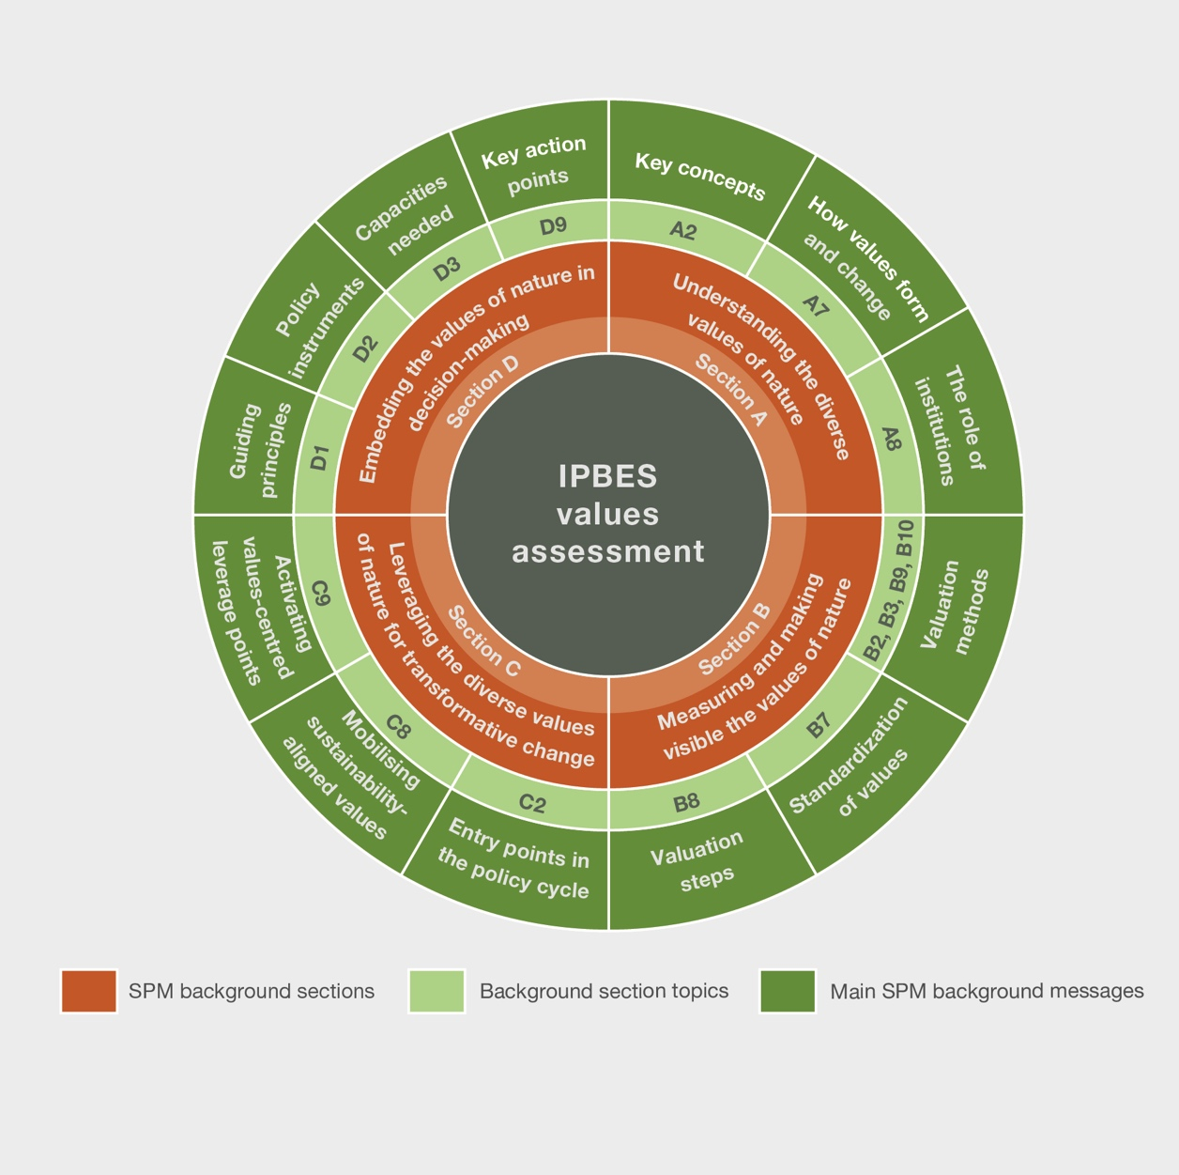
Figure SPM.1. The values assessment wheel. The assessment of the diverse values and valuation of nature provides guidance on the diverse values of nature and how to integrate them into decision-making. Figure SPM.1 illustrates the structure of the background section, by showing the main section themes and how they are linked to specific issues and background messages.
KM1. The causes of the global biodiversity crisis and the opportunities to address them are tightly linked to the ways in which nature is valued in political and economic decisions at all levels {A4, A9, C1, C7, C8}.
Unprecedented climate change and decline of biodiversity are affecting ecosystem functioning and negatively impacting people’s quality of life. An important driver of the global decline of biodiversity is the unsustainable use of nature, including persistent inequalities between and within countries, emanating from predominant political and economic decisions based on a narrow set of values (e.g., prioritizing nature’s values as traded in markets). Simultaneously, access to and distribution of the benefits from nature’s many contributions to people are highly inequitable., Yet, a consolidated global consensus reflected by the 2030 Agenda for Sustainable Development and the 2050 Vision for Biodiversity has established a shared vision of prosperity for people and the planet. Achieving this vision depends on system-wide transformative change that incorporates the diverse values of nature and is aligned with the mutually supportive goals of justice and sustainability and their intertwined economic, social and environmental dimensions.
KM2. Despite the diversity of nature’s values, most policymaking approaches have prioritized a narrow set of values at the expense of both nature and society, as well as of future generations, and have often ignored values associated with indigenous peoples’ and local communities’ world-views {A4, A8, A9, B10, C1, C3}.
People perceive, experience and interact with nature in many ways. This results in different understandings of the role that nature plays as the foundation of people's lives and in contributing to their quality of life, leading to a diverse range of values related to nature. However, policymaking largely disregards the multiple ways in which nature matters to people in that it often prioritizes a narrow set of nature’s values.
For example, the predominant focus on supporting short-term profit and economic growth typically relies on macroeconomic indicators like gross domestic product. Such indicators generally consider only those values of nature reflected through markets and therefore do not adequately reflect changes in quality of life. One important reason is that they overlook the non-market values associated with nature’s contributions to people, including the functions, structure, and ecosystem processes upon which life depends. In addition, such indicators do not account for the over-exploitation of nature and its ecosystems and biodiversity and the impact on long-term sustainability. Conservation policies that focus on biodiversity for its own sake may downplay other values and exclude local populations that depend on nature for their livelihoods. The use of a restricted set of values of nature that underpins many development and environmental policies is embedded in and promoted by societal norms and formal rules.
KM3. The diversity of nature’s values in policymaking can be advanced by considering a typology of nature's values that encompasses the richness of people's relationships with nature {A1, A2, A3, A4, A5}.
The values of nature vary greatly across knowledge systems, languages, cultural traditions and environmental contexts. People and nature can be seen as part of holistic and interdependent systems of life, or, in other world-views, considered as separate from one another. Diverse understandings of nature are expressed in different ways (e.g., via symbols, rituals, languages, and data and models).
Given the diversity of world-views, cultures, knowledge systems and disciplines, it is challenging to define nature’s values in a universally practical and acceptable way. A comprehensive typology of the diverse values of nature can help guide decisions that affect nature and its contributions to people in diverse contexts, including economic (e.g., investment, production, consumption), political (e.g., recognition of individual and collective rights and duties) or sociocultural (e.g., forming, maintaining or changing peoples’ sociocultural identities) decisions.
A typology of nature's values (figure SPM.2) requires value perspectives that encompass the richness of people’s relationships with nature, including: (i) world-views, the ways in which people conceive and interact with the world; (ii) knowledge systems, bodies of knowledge, practices and beliefs such as academic, indigenous and local knowledge systems embodied in world-views; (iii) broad values, the moral principles and life goals that guide people-nature interactions; (iv) specific values, judgements regarding the importance of nature in particular contexts, grouped into instrumental values (i.e., means to a desired end often associated with the notion of “ecosystem services”), relational values (i.e., the meaningfulness of human-nature interactions), and intrinsic values (i.e., independent of people as valuers); and (v) value indicators, the quantitative measures and qualitative descriptors used to denote nature’s importance in terms of biophysical, monetary or sociocultural metrics. The values typology helps to promote the use of values that have been underutilized in decision-making.
People conceive of or relate to nature in multiple and often complementary ways: living from, with, in, and as nature. These different ways of relating to nature reflect people’s different world-views. Although this typology may not capture the full range of values linked to various knowledge systems, it can help to understand how certain human-nature relationships can be incorporated into particular policy decisions.
KM4. Valuation processes can be tailored to equitably take into account the values of nature of multiple stakeholders in different decision-making contexts {A5, A6, B1, B6, B8, C2}.
Valuation is an explicit, intentional process in which agreed-upon methods are applied to make visible the diverse values that people hold for nature. The type and quality of information obtained from valuation depend on how, why and by whom valuation processes are designed and implemented. The way valuation is conducted, including the methods chosen, is in part determined by power relations in society, which influence which and whose values of nature are recognized and how equitably the benefits and burdens arising from these decisions are distributed.
Considering the values of multiple individuals, stakeholders and interest groups at scales beyond the individual is an essential part of valuation. One way is to aggregate individual or group values into social values, which can be weighted to account for differences between stakeholders (e.g., income disparities). Another way is to collectively form or express shared social values through deliberative processes, which can help bridge multiple values that are difficult to aggregate (e.g., via talking circles). These are two complementary strategies, yet any strategy to achieve valuation beyond the individual needs to consider challenges of representation, inequity (e.g., within and between generations) and asymmetric power relations (e.g., predominance of certain world-views) among the actors affected.
Furthermore, the following five steps help guide valuations: (i) constructing a legitimate process; (ii) defining the purpose of valuation; (iii) scoping the valuation; (iv) selecting and applying valuation methods; and (v) articulating the values into decision-making. These steps can increase robustness of valuations to inform different decision-making contexts, including in the context of indigenous peoples’ and local communities’ territories.
KM5. More than 50 valuation methods and approaches, originating from diverse disciplines and knowledge systems, are available to date to assess nature’s values; choosing appropriate and complementary methods requires assessing trade-offs between their relevance, robustness and resource requirements {B1, B2, B3, B4, B5, B8, B9, B10}.
There exist many valuation methods and approaches to elicit and assess the diverse values of nature. Valuation methods, originating from diverse disciplines and knowledge systems (including indigenous peoples and local communities), can be grouped into four non-disciplinary “method families” (table SPM.1): (i) nature-based valuation gathers, measures or analyses information about the properties of nature and its contributions to people; (ii) statement-based valuation directly asks people to express their values; (iii) behaviour-based valuation identifies how people value nature by observing their behaviour and practices; and (iv) integrated valuation brings together various types of values assessed with different information sources. Each method family relies on different data sources, different levels and forms of social participation, identifies different value types, and has specific technical and skill requirements and limitations. While the method families help highlight the commonalities of procedures across different valuation traditions, other considerations are needed to fully appreciate the variations of valuation undertaken according to specific knowledge systems, particularly those of indigenous peoples and local communities.
Different valuation approaches have trade-offs between relevance (i.e., salience in terms of the values that can be used in decisions), robustness (i.e., reliable, consistent and socially representative) and resources (i.e., time, financial, technical and human resources). Given the diversity of social, economic and ecological contexts, there is no one-size-fits-all valuation method and available valuation methods may be adapted to address local realities. The use of complementary methods helps to make a wider diversity of values visible, while improving the quality and legitimacy of the information generated to support decisions about nature.
KM6. Despite increasing calls to consider valuation in policy decisions, scientific documentation shows that less than 5 per cent of published valuation studies report its uptake in policy decisions. {B7, C2, C3, C9, D4}.
International initiatives (e.g., the Aichi Biodiversity Targets, The Economics of Ecosystems and Biodiversity; the System of Environmental-Economic Accounting – Ecosystem Accounting; various “inclusive/comprehensive wealth” approaches; United Nations General Assembly resolution 74/224 on harmony with nature) have promoted the integration of the values of nature into national-level policies. Yet, the vast majority of peer-reviewed literature on valuation studies do not document influence on decisions. A majority of countries have not made progress at a rate that would have allowed achievement of Aichi Target 2 by 2020 of integrating biodiversity values into strategies, planning process and accounting, as reported in their national reports to the Convention on Biological Diversity.
The uptake of valuation in Governmental decision-making is more likely when the valuation process is relevant to the different stages of policymaking and when it is sufficiently resourced. Furthermore, documenting the use and impact of valuation knowledge can be improved by iterating studies through the policy cycle. Valuation uptake can also be improved by co-production of valuation knowledge, best practice guidance, standardization of valuation methods where this is suitable, and more use of participatory and deliberative methods that represent indigenous peoples’ and local communities’ values. Gaps in knowledge and capacities are more prevalent in developing countries.
KM7. Achieving sustainable and just futures requires institutions that enable a recognition and integration of the diverse values of nature and nature’s contributions to people {A4, A8, C1, C4, C5, C6, C7, C9}.
Informal social conventions and norms and formal legal rules (i.e., institutions) govern people’s lives and regulate actions by decision makers. In addition, institutions play a crucial role in shaping how nature is valued within and across societies. Institutions influence which values become socially legitimized and which ones are excluded from decision-making. Hence, ensuring greater transparency about which values are embedded in institutions is key to recognizing the values of nature that are at stake in any decision-making context. Enhancing the institutional and technical capacities to monitor and assess nature's contributions to people is also crucial to improve uptake of valuation methods and practices, and enable more transparent and inclusive decision-making processes.
Reforming existing institutions and creating new ones can improve political, economic and social decision-making, mainstreaming the consideration of nature’s diverse values and leading to better outcomes for people and nature. For example, policies giving local people authority in protected area management often result in improvement of people's good quality of life and more effective, long-lasting conservation. Tackling power asymmetries is important because power shapes the extent to which the values held by different actors are considered in decision-making. Institutions that enable more diverse values to be considered have greater potential to avoid or mitigate conflicts, as these often arise from not identifying and anticipating value clashes. Recognizing and respecting the world-views, values and traditional knowledge of indigenous peoples and local communities and the institutions that support their rights, territories or interests allow policies to be more inclusive of how different people live, relate to and value nature, which also translates into better outcomes for people and nature.
KM8. Transformative change needed to address the global biodiversity crisis relies on shifting away from predominant values that currently over-emphasize short term and individual material gains, to nurturing sustainability-aligned values across society {A3, A7, C1, C7, C8, C9}.
Putting sustainability at the heart of decision-making can be supported by redefining “development” and “good quality of life”, and recognizing the multiple ways in which people relate to each other and to nature. Societal goals will need to align more strongly with broad values like justice, stewardship, unity and responsibility, both towards other people and towards nature. This shift in the framing of decision-making can be supported by ensuring that a more balanced range of values are considered in political and economic decisions by (i) reducing the dominance of those broad values that mostly relate to individualism and materialism, whilst mobilizing broad values that are consistent with living in harmony with nature; and (ii) reducing the dominance of specific values to remove the dominance of market-based instrumental values, whilst mobilizing relational, intrinsic and non-market instrumental values.
Balancing and mobilizing values can be facilitated by participatory processes for envisioning alternative futures that are inclusive of diverse world-views, knowledge systems and values. Various pathways can contribute to achieving just and sustainable futures, including, but not limited to, the “green economy”, “degrowth”, “Earth stewardship”, “nature protection” and other pathways arising from diverse world-views and knowledge systems (e.g., living well and other philosophies of good living). All of these sustainability pathways are associated with certain sustainability-aligned values and seek a more diverse valuation of nature as a foundation for reconciling social, economic and ecological dimensions. These and many other pathways from other world-views and knowledge systems (e.g., living well in harmony with Mother Earth, among others) reflect different perspectives on how best to bring about values-based transformative change. However, all are founded on the need to rebalance the range of values shaping individual and collective decisions.
KM9. Working with a combination of four values-based leverage points (i.e., undertaking valuation, embedding values in decision-making, reforming policy and shifting societal goals) may catalyse transformation towards sustainable and just futures {C1, C9}.
Transformative change is more likely to be catalysed through actions that target a combination of values- and valuation-based leverage points. These are: (i) recognizing the diversity of nature’s values through undertaking relevant and robust valuation; (ii) embedding valuation into the different phases of decision-making processes to allow meaningful consideration of nature’s diverse values; (iii) reforming policy in order to realign incentives, rights, and legal regulations with the diverse values of nature and to empower actors to express and act upon their sustainability-aligned values; and (iv) creating spaces to deliberate, develop and shift societal goals and norms attuned to the agreed global objectives of sustainability and justice (figure SPM.7). Activating the latter two deeper leverage points can be facilitated by aligning bottom-up approaches (e.g., empowering civil society via public deliberation) with top-down ones (e.g., changing regulations and policy frameworks).
KM10. Information, resource (i.e., technical and financial) and capacity gaps hinder the inclusion of diverse values of nature in decision-making. Capacity-building and development, and collaborations among a range of societal actors, can help bridge these gaps {D1, D2, D3, D4, D5, D6, D7, D8, D9}.
The transformative changes needed to implement the 2030 Agenda for Sustainable Development, the future post-2020 global biodiversity framework and the 2050 Vision for Biodiversity can be advanced by bridging key knowledge-to-action gaps, which are unequally distributed between the developed and developing regions of the world. Such gaps can be addressed through meaningful, context-specific, inclusive, legitimate, and iterative consideration of the role of diverse values of nature in decisions. Sustainability-aligned values, including those of indigenous peoples and local communities, can guide the design and implementation of transformative policy instruments, cross-sectoral development policies, as well as policy initiatives across scales.
Aligning values with sustainability necessitates addressing conflicting values. This in turn calls for developing the capacities of various types of decision makers to (i) enhance their motivation to recognize and address power and equity asymmetries; (ii) use suitable valuation methods and approaches by enhancing the availability of resources needed (e.g., technical and financial); (iii) foster inclusive social learning that involves different types of knowledge, including traditional knowledge of indigenous peoples and local communities; (iv) negotiate compromises among stakeholders’ different interests and values towards achieving equitable outcomes; (v) improve coherence across sectors and jurisdictional scales; and (vi) increase transparency and accountability in decision-making.
Overcoming knowledge-to-action gaps, such as those related to understanding and addressing power asymmetries among stakeholders and their values, and fitting valuation supply to demand, would advance values-centred, system-wide transformations. Values-centred transformations, through collaborations among the range of societal actors, are relevant to revert the current biodiversity crisis and to build more sustainable and just futures for people and nature.

BACKGROUND MESSAGES
A. Understanding the diverse values of nature.
A1. Over millennia, around the world, people have developed many ways of understanding and connecting with nature, leading to a large diversity of values of nature and its contributions to people (well established).
Many academic disciplines have studied human-nature relationships, leading to multiple conceptualizations of the values of nature (well established) {2.1.1; 2.3.1}. In science and management, the ecosystem services framework has been extensively used to relate different facets of nature to people’s good quality of life. The IPBES framing of nature’s contributions to people aims to more explicitly include values like responsibility, reciprocity and respect for nature, as well as to embrace other knowledge systems that conceive people as part of nature, such as those of indigenous peoples and local communities and emerging movements centred around holistic people-nature wellness (well established) {2.2.1; 2.2.2; 2.2.3.2; 2.3.2.1; 4.4.2; 4.4.3}.
The many ways that people relate to nature, which can be organized into generalized modes of living from, in, with and as nature, also reflect their diverse world-views, knowledge systems, broad and specific values (established but incomplete) {2.3.2}. When people see themselves as living from nature, they emphasize nature’s capacity to provide resources for sustaining livelihoods, needs and wants. As such, a river is valued for the fish it provides for people's consumption. People also may see themselves as living with nature, valuing its life-supporting processes in connection with “other-than-humans”. In this case, the fish in a river are seen as having the right to thrive independently of people’s needs. Living in nature refers to the importance of places as settings for people’s lives, practices, and cultures. Consequently, a riverine landscape is valued as territory that contributes to people’s sense of place and identity. Finally, people may see themselves as part of nature or in terms of living as nature, perceiving it as a physical, mental, and spiritual part of themselves. In this case, a river is valued as sacred or family because it supports relations of kinship and interdependence (well established) {2.2.1; 2.3.2.1}. These interpretations of nature are not mutually exclusive, and one life frame is not inherently better than another. Instead, they may be expressed together in varying combinations over different times and contexts.
A2. Using a typology of the values of nature can provide guidance to decision makers on understanding and engaging with the diverse ways in which people relate to and value nature (well established).
The term “value” conveys multiple ideas associated with goals, principles, priorities, and levels of importance. Therefore, it is challenging to define nature’s values in a universally intelligible and accepted way across cultures and academic traditions (well established) {2.2.3; 2.2.4}. Nevertheless, a core set of concepts can inform a policy-relevant standardized values typology, including the following: world-views, knowledge systems, broad values, specific values and value indicators (figure SPM.2). This typology synthesizes multiple theoretical perspectives on values and can be used by decision makers to consider the multiple understandings and policy implications of the diverse values of nature (well established) (box SPM.1) {2.2.1; 2.2.2; 2.2.3; 2.2.4}. The values typology can help policymakers identify how different types of values can best be handled in different decision-making contexts; for example, when values can be directly compared, overlaid or used in parallel (established but incomplete) {2.2.3.3, 2.4.2.1; 3.3.1.3}. The typology can also be used to (i) make visible otherwise neglected, intangible or detrimental contributions from nature, thereby facilitating a more inclusive and just expression of value; and (ii) build common ground across different stakeholders in support of biodiversity conservation and sustainable use and/or sustainable development by highlighting points of convergence or overlap between value types (established but incomplete) {2.2.3.3}.
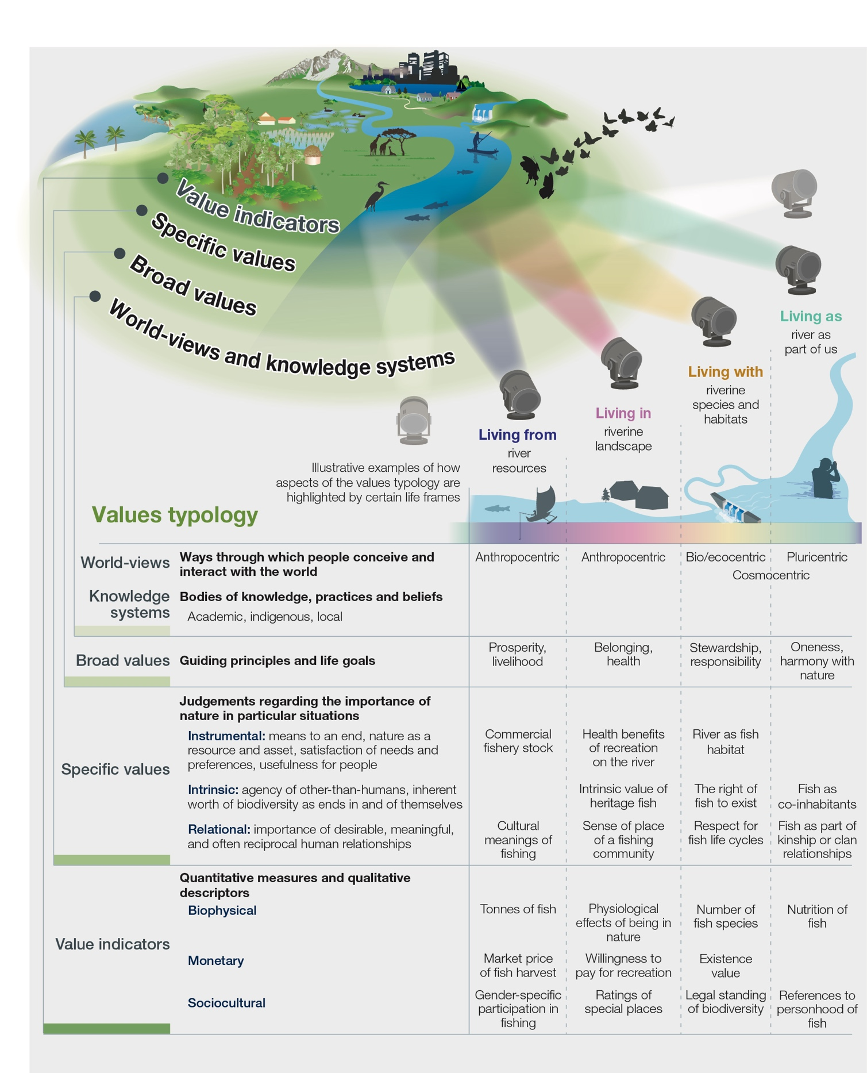
Figure SPM.2. The values assessment typology highlights key concepts and their interrelationships to understand the diverse values of nature. The figure centres on potential foci of value (e.g., agroecosystems, biodiversity, cities, rivers) and concentric circles illustrate different value types and dimensions (world-views, broad and specific values, nature’s contributions to people and value indicators). Life frames are not mutually exclusive; individuals or groups can hold multiple frames. Metaphorically, they are light beams that cut across value categories. Examples are highlighted of some values that might be given prominence in the context of a freshwater ecosystem {2.2; 2.3}.

Box SPM.1. Definitions of key concepts to help understand the diverse values of nature
World-views are like lenses through which people perceive, make sense of and act upon the world. Embedded in cultures and languages, world-views shape people's values in their relationships with other people and with nature. Anthropocentric world-views prioritize people; bio/ecocentric world-views emphasize nature’s inherent value and its evolutionary and ecological processes. An example of the application of a bio/ecocentric world-view in policy is the recognition of the rights of Mother Earth. Pluricentric world-views focus on relationships between humans and other-than-humans, as well as nature’s elements and systemic processes {2.2.1}. Cosmocentric world-views can be understood as bridging bio/ecocentric and pluricentric world-views. They refer to living in harmony with all forms of existence that are considered alive and connected by reciprocal and interdependent relationships {2.2.1}.
Knowledge systems are dynamic bodies of knowledge, practices and beliefs, pertaining to the relationships of living beings, including people, with one another and with nature, embedded in world-views. Scientific knowledge systems entail explicit knowledge derived from applying formal and generalizable methods. Indigenous and local knowledge, which includes traditional knowledge, is highly diverse, grounded in territory and sociocultural identity and is based on different knowledge types (e.g., written, oral, visual, tacit, practical) {2.2.1}.
Broad values are general moral guiding principles and life goals (e.g., freedom, justice, responsibility, harmony with nature, harmony with Mother Earth, health, prosperity) informed by people’s world-views and beliefs. They are often embedded in a society’s institutions (i.e., informal social conventions and norms, and formal legal rules) and can underpin people’s specific values of nature {2.2.3.1}.
Specific values are judgements regarding nature’s importance in particular situations {2.2.3.2}. They can be grouped into instrumental, intrinsic and relational values. Instrumental values relate to things that are a means to a desired end and tend to be associated with nature (e.g., as asset, capital, resources) and its contributions to people. Intrinsic values relate to the values of nature expressed independently of any reference to people as valuers and include entities such as habitats or species that are worth protecting as ends in and of themselves. Relational values refer to the meaningfulness of people-nature interactions, and interactions among people (including across generations) through nature (e.g., sense of place, spirituality, care, reciprocity) {2.2.3}.
Value indicators are quantitative measures and qualitative descriptors that reflect nature’s importance to people. Indicators are generally grouped as biophysical, monetary and sociocultural {2.2.4}.
Life frames of nature’s values allow the organization and communication of the richness of the relationships between people and nature. A set of life frames (e.g., living from, with, in and as nature) can be used to organize and reflect distinct sets of values found in the typology. Life frames are diverse and not mutually exclusive, but help to understand how certain values are highlighted in particular decision-making contexts and can inform the design of integrated valuations {2.3.1; 1.2.3}.
A3. The multiple ways in which people conceive good quality of life are reflected in how they express broad values that shape people’s interactions with nature, such as unity, responsibility, stewardship and justice, which can align with sustainability (well established).
People and nature are interdependent, and understandings of how nature contributes to good quality of life vary across world-views and knowledge systems (e.g., some indigenous peoples and local communities conceive good quality of life as living in harmony with nature or as living in harmony with Mother Earth) (well established) {2.2.1; 2.2.2}. Values form and evolve alongside and in response to changing world-views, beliefs, spiritual and cultural practices and socioeconomic conditions. They also become embedded in a society’s informal social conventions and norms, and formal legal rules. These institutions influence behavioural standards that may inform and strengthen certain specific values (i.e., instrumental, intrinsic and relational values) which in turn reflect the multiple understandings of nature’s role in achieving good quality of life (well established) {2.4.1; 2.5.1}.
The broad values that shape people’s interactions with nature and with each other can align with sustainability when they emphasize principles like unity, responsibility, stewardship and justice (well established) {2.2.3.1; 5.2.2; 5.3.2}. Such “sustainability-aligned values” depend on whether and how they refer to people’s particular relationships with one another or with nature, as expressed by specific values (well established) {5.2.2; 5.3.2}. For example, the broad value of responsibility can be expressed by recognizing and promoting people’s views about how to pursue meaningful relationships with nature or by supporting nature through environmental education (well established) {5.5.4}. Similarly, the broad value of stewardship may be expressed by developing biodiversity management plans that support or align with human communities’ interests (human-human relations like shared goals of a good quality of life) or by enacting care towards nature (e.g., human-nature relations like reducing overconsumption). Likewise, justice can be emphasized by recognizing diverse values in ways that ensure fair decision-making procedures and equitable distribution of nature’s contributions to people or that strengthen environmental legislation (well established) {5.1; 5.3.2; 5.5.1; 2.2.3}.
A4. The complementary objectives of justice and sustainability can be advanced through better recognition and uptake of nature’s diverse values in political, economic and sociocultural decision-making (well established).
Thirteen of the Sustainable Development Goals explicitly call for equitable opportunities and reducing inequalities, including gender equality, youth empowerment, poverty eradication and fair participation of indigenous peoples and local communities (well established) {1.2.4.1}. There is strong evidence that justice, equity and sustainability are mutually supportive (well established) {4.5.2; 4.5.5; 5.1.2.2; 5.2.2.3.1; 5.5.2; 5.5.3; 5.5.4}. For example, the effectiveness and perceived fairness of policies on protected areas can be compromised when they restrict access to nature and undermine local livelihoods, often leading to conflict and exacerbating pre-existing inequalities (well established) {4.5.2}. Conversely, a lack of sustainability can undermine justice. For example, declines in biodiversity reduce options for present and future generations to sustain a good quality of life, thereby compromising the principle of intergenerational equity (well established) {1.2.4.1}. The uptake of a wider diversity of values of nature is a way to advance the integrated global goals of justice and sustainability (well established) {2.1.1; 2.4.1.4}, but economic and social power asymmetries also need to be overcome (box SPM.2).
Box SPM.2. A values perspective on justice and power
Justice is a broad value connected to the principle of fairness, i.e., the fair treatment of people and other-than-human nature, including inter- and intra-generational equity {1.2.4.1; 2.2.3, 3.3.2.3; 5.1}. Achieving justice implies considering its various dimensions, including: (i) recognition justice, acknowledging and respecting different world-views, knowledge systems and values; (ii) procedural justice, making decisions that are legitimate and inclusive for those holding different values; and (iii) distributional justice, ensuring the fair distribution of nature’s contributions to people {1.2.4; 2.4.1.4; 2.4.2.3.1; 3.3.1; 4.5.1}.
Values-centred policies to advance justice involve engaging with and addressing power asymmetries {1.2.4; 2.4.1.4; 5.3.2.3}. Social, economic and political processes shape power relations that constrain access to and control over nature and its contributions to people {2.4.1.4; 4.4.2; 4.4.3.1; 4.5.2; 4.5.3}. Power is exercised through the development of institutions (i.e., informal social conventions and norms, and formal legal rules) that establish the legitimate ways of relating to nature, who decides, whose values count, who can benefit from nature’s contributions and who bears the cost of ecosystem degradation {2.4.1.4; 4.3.1; 4.3.2; 4.3.5}. For example, within the international conservation movement, the multiple values associated with biodiversity conservation have not always been inclusive of the needs of indigenous peoples and local communities and have tended to favour the intrinsic values of biodiversity promoted by other stakeholders. This narrative has often underpinned global and national agendas that marginalize alternative discourses, such as biocultural diversity perspectives that draw on instrumental and relational values of nature {2.4.1.4; 4.4.2.2; 4.5.2; 5.5.4}. Hence, managing the different dimensions of justice allows for the different roles of power asymmetries in shaping people’s relations to (and values of) nature to be dealt with. This can strengthen the representation of values of underrepresented social groups in decisions through ensuring a participatory process {4.5}.
Respect for the different ways of valuing nature is an act of recognition that can advance just decision-making and allow for the mainstreaming of these values into policy {1.2.4; 2.3.2}. For example, recognizing the role of women in the stewardship of nature and overcoming power asymmetries frequently related to gender status can advance the inclusion of the diversity of values in decisions about nature {1.2.4; 2.2.1; 4.5.2; 4.5.3; 4.5.5}.
A5. Incorporation of the diverse values of nature in decisions requires consideration of whether and how values can be directly compared, made compatible, or be considered in parallel (well established).
The diverse values of nature can be measured using a wide range of biophysical, monetary and sociocultural indicators. However, there are challenges to combining different indicators. Values are directly comparable when they are measured using the same metric. For example, cost-benefit analyses of infrastructure and development projects, such as roads, mines or dams, can use a monetary indicator to compare investment costs versus market and non-market economic benefits. Similarly, biophysical measures may be used to compare hectares of habitat lost due to a development project versus hectares restored to offset the loss. Compatible values share features that allow them to be considered together and reveal value trade-offs, even when using different indicators (e.g., spatially overlaying different bundles of nature’s contributions to people measured with biophysical, monetary and sociocultural indicators). Yet, other values cannot be brought together because they are neither comparable nor compatible (i.e., they are incommensurable). For example, while a development project may be assessed on the basis of instrumental values (e.g., in terms of economic benefits, including jobs), it may also affect relational values associated with the loss of sacred sites. While these different values may not be directly comparable, nor made compatible (and hence ranked or compensated for), decisions can still consider them in parallel, such as through respectful deliberative discussions with affected parties (well established) {2.2.3.3; 2.4.2.1; 3.3.1.3}.
A6. The way decision-making considers the values of nature at varying societal scales (e.g., local communities, countries) has implications for how different social groups are represented in decisions (well established).
Decision-making based on social values often involves measuring changes in individuals’ quality of life and aggregating them. It also considers how the resulting positive and negative impacts on good quality of life are distributed across society (well established) {2.4.2.1; 3.3.1.1; 3.3.2.3}. Representing societal values as the sum of individual values is a common approach, such as in cost-benefit analyses, but carries the risk of overlooking values held by minority groups (well established) {2.2.3.2; 2.4.2.1}.
Decision-making based on shared values seeks to have people express their values collectively. Shared values can be formed through long-term communication and socialization processes or through group deliberations. Shared value formation approaches can enhance the legitimacy of decisions in complex, highly uncertain and contested decision-making situations, and where values held at the individual scale cannot be aggregated (well established) {2.4.2.1; 2.5.1; 3.2.2.4; 3.2.2.2; 3.3.2.3}.
Social values, aggregated from individual values, have tended to be used more often in policy decisions than shared values (established but incomplete) {2.4.2.1; 3.2.2.4; 5.3.3}. Aggregation of individual values can inform deliberative processes and vice versa, implying that social and shared values are complementary (established but incomplete) {2.4.2.1}.
A7. Understanding how values are formed, changed and eroded helps policymakers identify options to achieve decision outcomes that better align with sustainability objectives (well established).
Broad values tend to be relatively stable, largely forming in early life stages (e.g., childhood, early adulthood) (well established) {2.5.1}. However, they can be influenced by targeted value formation policies (e.g., education programmes, awareness campaigns) or significant life events (e.g., parenthood) (established but incomplete) {2.5.1; 5.3.2.4}. Broad values tend to change over inter-generational time scales but can shift more rapidly due to major transformations (e.g., demographic shifts, pro-environmental movements) and social-ecological disturbances (e.g., pandemics, natural disasters) (established but incomplete) {2.5}. In contrast, specific values are malleable and can be changed by modifying the contexts that determine their prioritization. For example, environmental management that prioritizes biodiversity as a natural asset (i.e., instrumental value) can be modified by new regulatory procedures. In this way, specific values like meaningful relationships with nature (i.e., relational value) or the worth of species in and of themselves (i.e., intrinsic value) can also be considered (established but incomplete) {2.4.1; 2.4.2; 2.5.1; 5.3.4}.
While values influence individual and collective decisions, other factors like knowledge, beliefs, opportunities, and skills also affect behaviour. The inability to fully explain behaviour based on values is known as the “value-action gap” (well established) {2.4.1; 2.4.2}. Therefore, in addition to forming new values, policies can also ensure that conditions exist for people to prioritize existing but latent sustainability-aligned values (established but incomplete) {2.4.1; 2.5.2; 5.3.4}. Additionally, in the face of value erosion, policies combating linguistic and knowledge extinction can also ameliorate the loss of ways to experience and value nature (well established) {2.2.2; 5.5.4}.
A8. Institutions (i.e., informal social conventions and norms, and formal legal rules) are underpinned by and support certain values in ways that strongly influence whose values count in decisions (well established).
Institutions represent the informal social conventions and norms and formal legal rules that govern people’s lives (well established) {1.2.1; 2.4.1; 2.4.2}. Informal social conventions facilitate coordination among people (e.g., language and measurement scales). Norms and legal rules are underpinned by societal values and enable or constrain human-human and human-nature relations by legitimizing which values are dominant in society and how they should be expressed (well established) {2.4.1.3}. Norms prescribe what should be done under certain conditions; legal rules provide formal sanctions to support dominant values (well established) {2.4.1.3}. Although some norms and legal rules emphasize broad values like responsibility for nature (e.g., local and indigenous institutions for protecting forests and coastal ecosystems, laws for ecosystem protection), others drive negative impacts on nature (e.g., weak regulations to control carbon emissions). Pressure from civil society may have the capacity to change priorities by powerful actors (e.g., investment decisions by pension funds and procurement decisions by the food industry) (well established) {2.2; 2.4.1; 2.4.2; 4.3; 4,4; 5.4; 5.5}.
Promoting changes in any institution can reconfigure how nature’s values are considered in different types of political, economic and sociocultural decision-making {well established} {2.4}. For example, the implementation of more stringent environmental laws has positive impacts on the values that guide economic decisions by corporations and individual consumers when they interact in market transactions. Changes in values across society can also lead to institutional change, such as when organized civil society drives Governments to adopt more stringent environmental laws (established but incomplete) {2.4; 4.2; 4.4; 5.3}. For example, increased public awareness of plastic pollution has activated sustainability-aligned values in citizens that have pressured Governments to ban single-use plastic products. The role of institutions in prioritizing certain (broad and specific) values of nature is evident through locally- and nationally-defined rules, and international trade and environmental agreements (well established) {2.4; 4.3}.
A9. Predominant economic and political decisions have prioritized certain values of nature, particularly market-based instrumental values, often at the expense of non-market instrumental, relational and intrinsic values (well established).
Globally, economic decisions have generally prioritized a narrow suite of instrumental values, particularly those of nature’s material contributions to people that are traded in markets (e.g., food, fibre, energy). These decisions have often ignored the externalities associated with the negative impacts on biodiversity and ecosystems (well established) {2.2; 2.4; 4.3}. Policymakers have the potential to ensure a more balanced consideration of nature’s diverse values, but success in this regard has been limited (well established) {2.4.2.3; 4.5.2; 4.5.5}. Designing institutions that integrate economic, social and environmental policies to foster values inherent in sustainability and justice, that focus up-front on avoiding serious future impacts on nature and nature’s contributions to people and that make people less dependent on economic development may be important strategies to handle the challenges the world faces, taking into account the needs of developing countries to raise living standards (established but incomplete) {2.4.2.3.2}.
B. Measuring and making visible the values of nature

B1. Over 50 different methods to assess nature’s values have been applied in diverse social-ecological contexts around the world (well established).
Valuation is the intentional process to make explicit the values individuals or communities hold about nature, nature’s contributions to people, and human-nature relationships. Valuation is carried out by applying established or agreed-upon valuation procedures (well established) {3.1.1; 4.3; 4.4; 4.5}. A wide portfolio of valuation methods and approaches has been developed during the last four decades from disciplines such as anthropology, biology and economics, as well as from various indigenous and local traditions (well established) {3.2.2; 3.2.3;3.2.4}.
Valuation methods have been applied all around the world (figure SPM.3) (well established) {3.2.1}. Most valuation studies have been undertaken in the Americas, Asia and the Pacific, and Europe and Central Asia, and to a lesser extent in Africa (well established) {3.2.1}. Valuation is more frequently applied in countries with severe threats to their biodiversity and environmental conditions, and where human and financial resources are available (established but incomplete) {3.2.1}.
The number of valuation studies undertaken has increased on average by more than 10 per cent per year over the last four decades (well established) {3.2.1}. More recently (2010–2020) the most prominent focus of valuation studies has been on the status of nature (65 per cent of 1,163 valuation studies reviewed) (well established) {3.3.1.1}, followed by the role of nature for people’s quality of life and social justice (well established) {3.3.1.1} (figure SPM.3). Instrumental values are elicited more often (74 per cent) than relational and intrinsic values (well established) {3.2.3}. The dominant human-nature relationship framing of valuation studies is living from nature (41 per cent), compared to living with, living in and living as nature (established but incomplete) {3.2.3}. Regarding value indicators, biophysical (50 per cent) measures predominate in valuation, followed by monetary and sociocultural indicators (figure SPM.3) (well established) {3.2.3}. Most reported valuations have been performed at the subnational scales (72 per cent), compared to national and global scales, with very few studies dealing with cross-regional or cross-national protected areas (well established) {3.2.1}, or with explicit reference to the territories of indigenous peoples and local communities (well established) {3.2.1}. Regarding ecological contexts, emphasis has been given to the value of nature’s contributions to people from forests (25 per cent), cultivated areas and inland water bodies (well established) {3.2.1}.
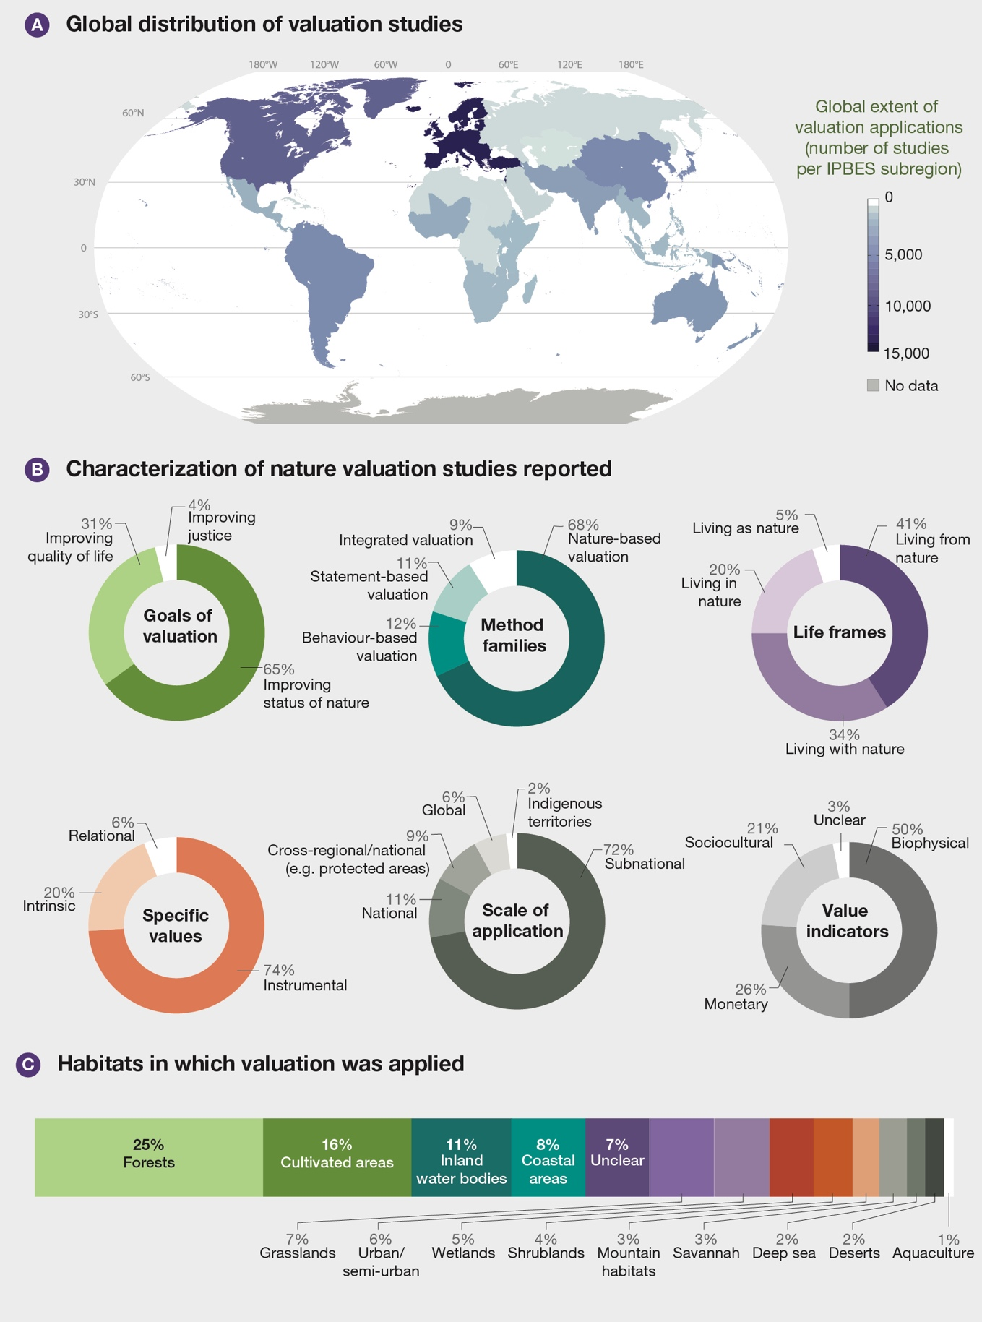
Figure SPM.3. Global distribution and characterization of nature valuation studies reported in the scientific literature. Of the 79,000 studies identified, around 48,000 provided explicit geo-referenced information (depicted in the map). From these, stratified random sampling, based on relevant criteria, was conducted for studies from 2010 to 2020 across all IPBES regions. Then, valuation studies that considered the decision-making purpose were selected for in-depth review {3.2.1}, resulting in 1,163 studies that applied specific valuation methods (used to develop the statistics in the figure). The valuation studies reviewed in depth reveal differences regarding: (i) their primary goal of valuation; (ii) the methodological approach (method family); (iii) the life frame they connect to; (iv) the specific value types they identify and assess; (v) their scale of application; (vi) the value indicators used; and (vii) their application in different ecological contexts, classified according to the IPBES units of analysis {3.2}.
B2. The large portfolio of valuation methods, originating from diverse disciplines and knowledge systems (including indigenous and local knowledge systems), can be grouped into four non-disciplinary method families that consist of nature-based, behaviour-based, statement-based and integrated methods (well established).
Four main methodological groups or “method families” are distilled from the valuation literature based on the source of information about the values of nature (table SPM.1). Nature-based valuation gathers, measures or analyses information about the properties of nature and its contributions to people, and may be used to assess ecological integrity and to identify and quantify nature’s contributions to people (well established) {3.2.2.1}. Statement-based valuation uses people’s expressions of their relations to nature to deduce the importance of nature for people as well as their preferences; it helps understand the different world-views and motivations underlying peoples’ reasons for valuing nature in terms of supporting their quality of life (well established) {3.2.2.2}. Behaviour-based valuation relies on observing what people do and the choices they make. Behaviour-based methods are relatively more robust against potential biases of valuation experts (well established) {3.2.2.3}. Finally, integrated valuation combines different sources of information on nature’s values (well established) {3.2.2.4} and helps elucidate connections between different types of values (well established) {3.1.1; 3.2.2.4}. Rigid application of current method families to valuation practice by indigenous peoples and local communities can risk omitting or misrepresenting cultural and spiritual beliefs integral to their world-views and ways of living (table SPM.1) (established but incomplete) {3.2.4}.
Nature-based valuation methods are most commonly used (68 per cent), followed by statement-based, behaviour-based and integrated valuation methods (figure SPM.3). Combining methods from across the method families can help better inform policy decisions, as the different methods provide complementary information on the diversity of nature’s values that could not be achieved by only using methods from a single method family (well established) {3.2.3; 3.3.1; 3.4}. For instance, integrated modelling can help bring together information on nature’s biophysical impacts (based on nature-based methods) and socioeconomic impacts (based on behaviour-based or statement-based methods) to estimate the costs and benefits of projects or policies affecting nature (well established) {3.2.2; 4.6}. Similarly, multi-criteria analysis allows information about the impacts of alternative policy options on stakeholders’ values regarding nature to be brought together (well established) {3.2.2.4}. Finally, future scenario planning can identify the broad values regarding human-human and human-nature relations embedded in desired future states (established but incomplete) {5.2.2; 5.3.2}. All valuation methods are based on different assumptions about what characterizes the values involved, how they should be expressed and who should participate in the valuation process. Therefore, the choice of method influences the outcome (e.g., whether the focus is on instrumental, relational or intrinsic values) (well established) {2.4.2; 3.3.1}.

Table SPM.1. Overview of the four main valuation method families and their distinctive characteristics. The large portfolio of valuation methods, originating from diverse disciplines and knowledge systems (including indigenous peoples and local communities), can be grouped into four non-disciplinary method families that consist of nature-based, behaviour-based, statement-based and integrated methods. The valuation methods grouped into the different families can assess different types of values of nature and of nature’s contributions to people, using different approaches, with different levels of stakeholder inclusion. Each of the methods is associated with different opportunities and limitations {3.2.3}.
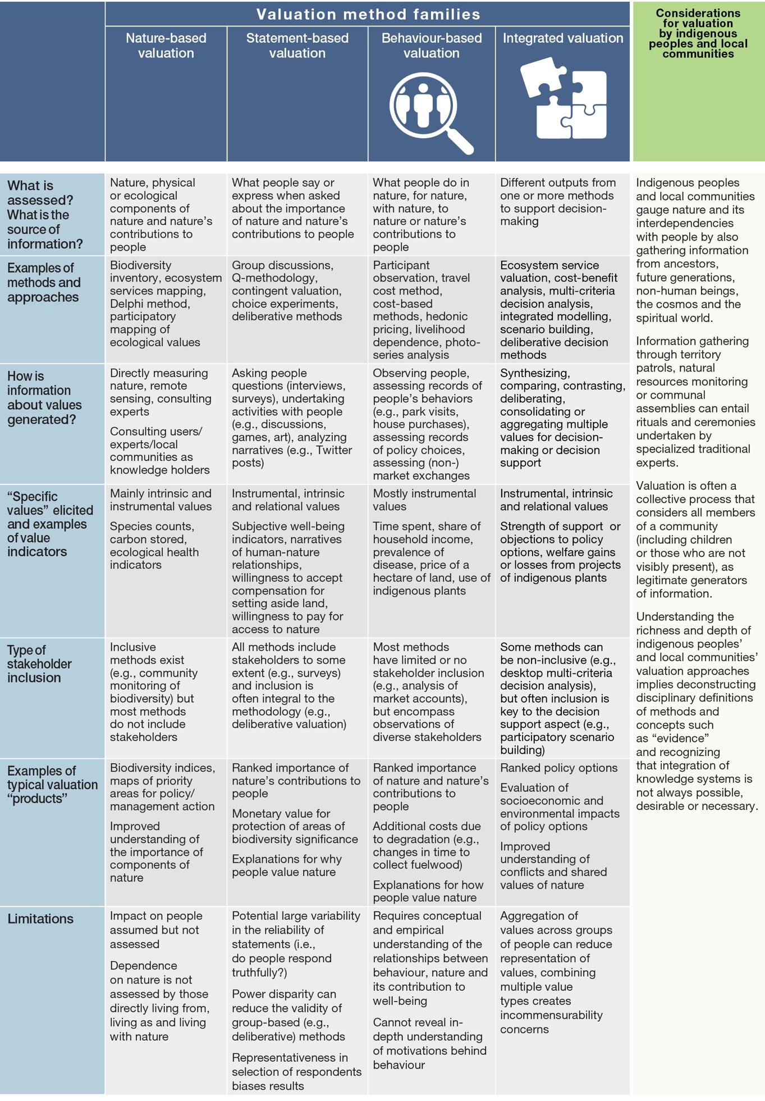
B3. Indigenous peoples and local communities undertake valuation of nature in their places and territories in accordance with their own world-views and applying locally established procedures, which can offer new perspectives to improve and advance valuation processes (established but incomplete).
Valuation in the context of indigenous peoples and local communities aims at supporting collective decisions regarding desirable human-nature relations by generating information about nature, enhancing collective good quality of life, transmitting and generating local ecological knowledge, and reinforcing cultural identities (established but incomplete) {3.2.4; 4.3 4.4; 4.5}. Valuation in these contexts often considers different sources and types of information and is undertaken by diverse expert teams that often include community members, and can imply consultation with ancestors, non-human species, landscapes and spiritual beings (established but incomplete) {3.2.4}. Examples of valuation approaches are patrols of communal territories conducted to monitor attributes of nature, such as soil quality, pasture conditions, or wildlife abundance. Ultimately, findings from valuation are used to make decisions for the collective, such as where to migrate, when to undertake farming activities and what hunting quotas to set (established but incomplete) {3.2.4}.
Valuation by indigenous peoples and local communities is often accompanied by a set of protocols and procedures that are in adherence with their world-views and specific to local contexts (established but incomplete) {3.2.4}. Applying western science concepts and procedures to describe and characterize valuation undertaken by indigenous peoples and local communities risks misrepresenting their world-views and valuation practices, since specific methods cannot be decoupled from their communal world-views, practices and traditions (well established) {3.2.4}. Indigenous perspectives offer opportunities to learn alternative forms of valuation, improve valuation practices, and advance the development of intercultural methods that are based on ethical principles and guidelines (well established) {3.1.1; 3.4.4} such as co-producing valuation and undertaking it with the free, prior and informed consent and full involvement of indigenous peoples and local communities (well established) {3.3.1}.
B4. Different valuation methods and approaches can assess different types of values of nature; however, challenges emerge when comparing different values to inform decision-making (well established).
Most valuation studies (76 per cent of the 1,163 valuation studies reviewed in depth) focus on more than one type of value related to different aspects of nature, its contributions to people and good quality of life. Less than 10 per cent address more than one life frame of nature’s values (i.e., living from, with, in and as nature) (well established) {3.3.1}. Yet, most valuation studies (77 per cent) use one main method or a combination of approaches within the same method family (well established) {3.3.1}. The majority (56 per cent) of valuations do not attempt to bring different values together, but instead use distinct biophysical, monetary and sociocultural indicators. A primary objective of valuation is to allow different but compatible values to be comparable, e.g., to enable prioritization in decision-making. Almost half of the valuation studies that do bring different values together apply methods allowing values to be directly compared (well established) {3.3.1}; the other half compares bundles of values, or uses relative weights based on participants’ or valuation experts’ rankings or deliberation (well established) {3.3.1}. Less than 1 per cent of valuation studies keep values separate (i.e., treat them in parallel in a deliberative process) (well established) {3.3.1}.
Increased plurality in valuation practice currently relies on the use of a wide variety and combination of methods to elicit different types of values of nature and different approaches to dealing with issues of value comparability, compatibility, and representativeness (well established) {3.2.3; 3.3.1; 3.3.4; 3.4.5}.
B5. While meaningful stakeholder participation in valuation is needed to ensure appropriate consideration of their values in decisions, participation at every step of valuation is only found in 1 per cent of valuation studies reviewed (well established).
Participation of stakeholders in valuation helps to gather information, build trust, and achieve procedural justice. Some stakeholder involvement is reported in 44 per cent of valuation studies (well established) {3.2.1}. Participatory valuation approaches are increasingly adopted and implemented across all method families (well established) {3.2.1}. Participation most frequently entails providing data (well established) {3.2.1}. Only 2 per cent of studies consult stakeholders on findings and 1 per cent involve them in every step of the valuation process (well established) {3.2.1}. Approximately half of the studies that engaged with stakeholders report on the diversity of interests at play and on how social representation is attained. Even though valuations have become more participatory over time, the engagement of stakeholders is mostly basic, including stakeholders as data and information providers. Higher levels of participation are found, and are particularly relevant for indigenous peoples and local communities (well established) {3.5}.
Several strategies can enhance stakeholder inclusion in valuation, including engaging participants in their local languages (6 per cent of valuation studies), communicating through diverse media (e.g., verbal and written forms) (3 per cent) and managing group composition and size (1 per cent) (well established) {3.3.2}. When potential representation biases are adequately addressed, participatory approaches generally enhance stakeholders’ perception of the legitimacy of the valuation process, particularly where minority views are included (well established) {3.2.1; 3.2.2; 4.5.3}.
B6. A key challenge when eliciting values at higher social scales is identifying and addressing ways in which access to nature's contributions is inequitably distributed across individuals, groups and generations (well established).
Valuations mostly aim to obtain values at higher social scales beyond the values of individuals and groups (e.g., landscape, country) (well established) {3.3.2.3}. A key challenge in the process of aggregation is how to deal with issues relating to the just distribution of nature’s contributions to people (well established) {3.3.2.3; 4.5.5.2}. The aggregation process can address this problem by using income equity weighting (i.e., applying higher weightings to the values of those in lower income groups), and by adjusting time discounting (i.e., using lower discount rates to place relatively more weight on policy impacts on future generations) (well established) {3.3.2}. The way these income weights and time discount rates are applied, for instance in cost-benefit analysis, has a significant impact on policy and project evaluation results, and thus remains a highly contested issue (well established) {3.3.2.3}. Most valuation studies focus on people living today and do not consider intergenerational equity (well established) {3.3.1.1; 3.3.2.3}. Whilst guidelines are available to consider equity when aggregating impacts on individuals and social groups with diverse socioeconomic conditions, these are rarely used in valuation (5 per cent of studies reviewed) (well established) {3.3.2.3}.
Values at higher social scales can also be elicited using deliberative approaches to form shared values (well established) {2.2.3.3; 2.4.2.1; 3.2.2.4; 5.2.2.1}. Deliberative approaches can contribute to the recognition of diverse values, identities and knowledge (recognition justice), learning, and the inclusion of diverse voices in decision-making processes (procedural justice) (well established) {5.3.2; 5.3.3}. Well-facilitated deliberative approaches can help manage conflicts between stakeholders who may hold unaligned or conflicting values (well established) {2.4.2.1; 2.4.2.2; 2.5.1}. Yet, deliberative approaches are sensitive to which individuals or groups participate and to power imbalances among participants (well established) {2.4.2; 3.2.2.4}.
B7. Standardization procedures in valuation can help increase the uptake of ecosystem accounting into national policies, with due consideration to the ongoing challenges of implementation in decision-making, linking accounting to diverse valuation perspectives and the challenges of measurement and valuation (established, but incomplete).
National ecosystem accounting aims to assess ecosystem services at the national level and to organize the associated data into an agreed statistical framework. This requires employing standardized methods that allow comparisons across countries, sectors, and through time. The System of Environmental-Economic Accounting – Ecosystem Accounting uses biophysical and monetary indicators (“exchange values”, i.e., equivalent to the value of goods and services exchanged in markets) to capture key instrumental values of nature. It provides an international statistical standard to guide the integration of ecosystem extent, condition and physical ecosystem service accounts into national accounts (well established) {4.6}. Standardizing valuation procedures can help the development of national ecosystem accounting, and its uptake in national policies. Ongoing challenges in advancing implementation include (i) the need to move beyond the compilation of accounts to the use of accounting data in applications and decision-making processes; (ii) the need to build links to the discussions of diverse value perspectives; and (iii) the need for further research on several aspects of measurement and valuation, especially the exchange values of ecosystem services (established, but incomplete) {3.2.2; 3.3.4.1; 4.6.4.2}.
B8. Valuation processes can follow five iterative steps to address the trade-offs between the relevance, robustness and resource requirements of valuation methods (established but incomplete).
Clarifying the purpose and scope of valuation helps identify the values of nature at stake and ensure the relevance of the valuation for decision-making. As the choice of valuation method influences the outcome, relevance entails ensuring that different values can be considered. Current valuation practice tends to only elicit those values that can easily be made visible with readily available methods (established but incomplete) {3.3.1; 3.4.3}. Valuation also needs to be robust in order to provide useful information for decision-making. Robust use of methods involves providing reliable and theoretically consistent evidence following a transparent and socially legitimate value elicitation process (well established) {3.3.2}. Since valuation requires employing resources (e.g., time, financial, technical and human resources), their availability determines the feasibility of applying any given valuation method (established but incomplete) {3.3.3}. Addressing the trade-offs between relevance, robustness and resources can be done by following five iterative steps adjusting valuation to the specific decision-making context (figure SPM.4): (i) invest in a legitimate process (well established) {3.4.2; 2.4.2}; (ii) define the purpose and intended use of the valuation outputs (well established) {3.4.3; 5.2}; (iii) establish the boundaries of the valuation scope (well established) {3.4.5; 5.2}; (iv) choose and apply the valuation methods based on the former steps (well established) {5.2; 3.4.5; 2.4.2}; and (v) communicate valuation results, validity, limitations and risks (well established) {3.4.6; 4.2}.
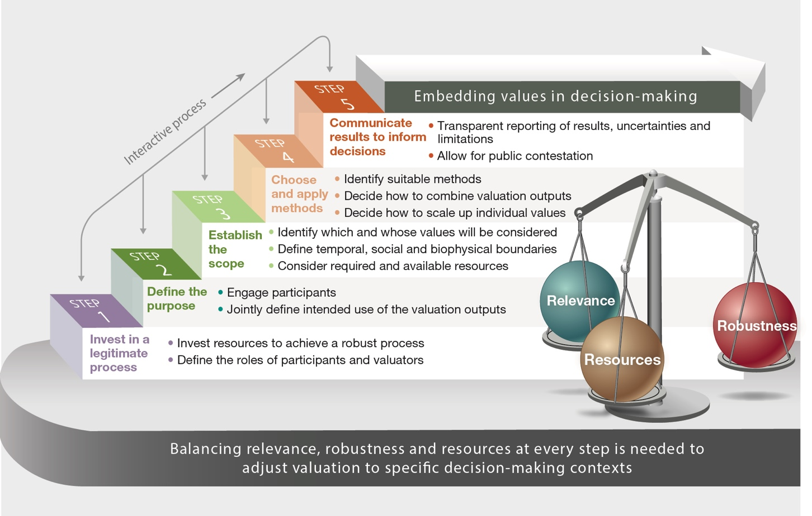
Figure SPM.4. Valuation processes can follow five iterative steps to enhance the quality of valuation outputs for decision-making. At each step, choices need to be made considering the trade-offs in valuation regarding relevance (ensuring that different values can be considered), robustness (reliable and theoretically consistent evidence following a transparent, and socially inclusive and legitimate value elicitation process), and resource requirements (time, financial, technical and human resources) {3.4.1}.
B9. Choosing appropriate valuation methods involves identifying their comparative strengths and weaknesses, particularly by taking into account their relevance, robustness and resource requirements (well established).
Some valuation methods provide highly specific valuation outputs (e.g., biodiversity mapping), while others focus on integrating different types of information about values (e.g., multi-criteria decisions-based methods) (table SPM.2). Highly specialized methods in isolation cannot elicit diverse values, but can be essential for including critical value information with sufficient detail into decision-making processes (established but incomplete) {3.3.4}. Among economic methods, revealed preference methods (in the behaviour-based method family) for example, provide reliable information on values but often only elicit those from a specific group of stakeholders, omit many types of values and are resource intensive, especially in contexts with data scarcity. In contrast, stated preference methods (in the statement-based method family) are generally less reliable and less resource intensive, but are significantly more adaptable to a wide range of stakeholders, value types and decision-making contexts (well established) {3.2.2; 3.3.4}.

Table SPM.2. Valuation methods face trade-offs in terms of their relevance, robustness, and resource requirements (panel A). Relevance involves both the capacity of methods to elicit a diversity of values of nature, including specific and broad values, and their versatility in terms of adapting to different social-ecological contexts. Robust methods provide reliable and fair representations of nature’s values {3.3.2}. Resource requirements for valuation need to balance the costs involved in building up initial capacity (including technical and data sources) and the time and financial costs involved in applying the method. Methods that perform relatively well, based on a synthesis of the relevance, robustness and resources characteristics of valuation methods, are denoted with larger bubbles {3.3.4}. Similar trade-offs point towards complementarities between different economic valuation approaches to embed the values of nature in policymaking (panel B). Such valuation approaches include The Economics of Ecosystems and Biodiversity, the System of Environmental-Economic Accounting – Ecosystem Accounting and “inclusive/comprehensive wealth” approaches {3.3.4}.
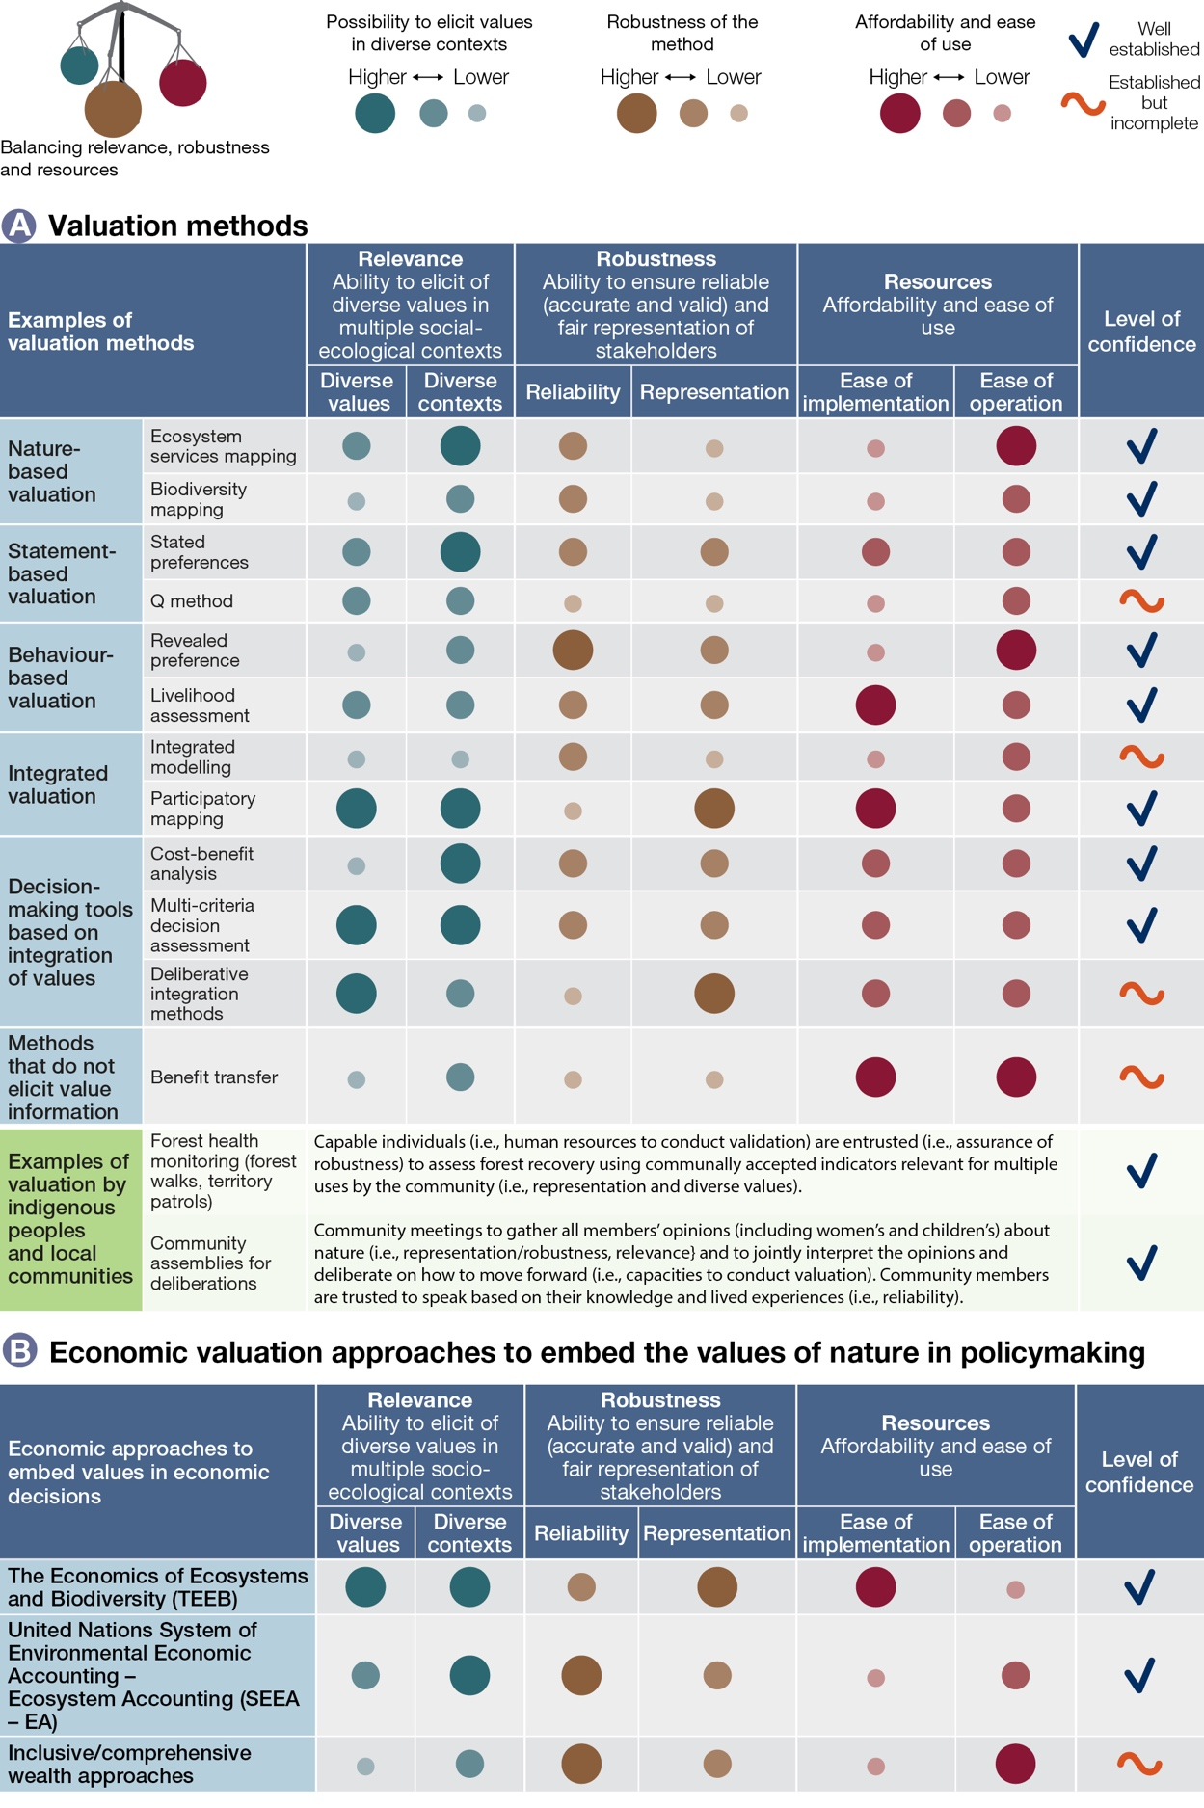
B10. Different economic nature valuation initiatives can complement one another to inform policy decisions (well established).
Economic valuation initiatives have been developed to guide policy but are still in the process of being implemented. The Economics of Ecosystems and Biodiversity (TEEB) provides guidance and examples, mainly at the local level, of how the economic valuation of market and non-market instrumental values of biodiversity (e.g., as economic asset, ecosystem service or benefit flow) can support environmental policies across sectors (e.g., agriculture, forestry, fisheries) (well established) {3.2.2; 6.2.3}. The System of Environmental-Economic Accounting – Ecosystem Accounting (SEEA–EA) provides internationally recognized statistical standards and principles that integrate the physical extent and condition of ecosystems, ecosystem services and their values into national accounting systems (well established) {3.2.2.4; 4.6.4}. The “inclusive/comprehensive wealth” proposals, highlighted in the Dasgupta Review, go beyond standard macroeconomic indicators like gross domestic product, providing comprehensive indicators of sustainable economic development (well established) {2.2.4; 3.3.4; 5.5.2}.
These economic initiatives each have their challenges, but can potentially complement each other’s strengths and weaknesses (table SPM.2). Regarding relevance, TEEB relies mostly on instrumental values of nature, expressed using the “total economic value” framing. SEEA – EA provides guidance for spatially explicit ecosystem accounting that considers the values of ecosystem services and ecosystem assets limited to “exchange values” in order to make them compatible with national accounts (well established) {3.2.2.4; 4.6.4}. Inclusive/comprehensive wealth approaches focus on valuing nature as an asset, combined with other capital assets (e.g., human health, technology and infrastructure) to provide welfare indicators that consider their aggregate long-term changes (well established) {2.2.4; 3.3.4; 5.5.2}. Both TEEB and SEEA – EA can draw on spatial mapping and statistics to prioritize policy interventions where environmental degradation has the most severe impacts (well established) {3.2.2; 4.6.4}. Regarding robustness, SEEA – EA applies United Nations statistical standards for biophysical accounts and internationally accepted statistical principles for monetary accounts. However, it is yet to be implemented in many countries. Inclusive/comprehensive wealth approaches have strong theoretical foundations, but their implementation is impeded in practice by data availability issues (established but incomplete) {3.3.4}. Regarding resources, SEEA – EA and inclusive/comprehensive wealth approaches have relatively high set up costs, given their high technical and data requirements. However, once capacity and infrastructure are developed, their resource needs may decrease significantly, allowing for their continuous implementation (established but incomplete) {3.3.4; 4.6.4}.
C. Leveraging the diverse values of nature for transformative change towards sustainability.

C1. Transformative change towards sustainability can be facilitated through policies designed to incorporate sustainability-aligned values into established social conventions, norms and legal rules that shape human-nature relations (well established).
The current dependency of political and economic decisions on a narrow set of nature’s diverse values underpins the global biodiversity crisis. Incorporating a wider set of values and perspectives into policy design and implementation can address the negative effects of people’s actions on nature (well established) {1.3; 4.3, 4.7; 6.2.3; 6.5}. However, reverting human impact on biodiversity would require a more systemic, transformative change (i.e., “a fundamental, system-wide reorganization across technological, economic and social factors, including paradigms, goals and values”). Such change can be supported by creating conditions that nurture sustainability-aligned values (e.g., mobilizing values of stewardship through tenure reforms that reconnect indigenous peoples and local communities to their territories), as well as by moderating those values that underpin biodiversity loss and ecosystem degradation (well established) {5.2.2; 5.3.2; 5.3.3}. These conditions involve significant transformations of established norms and legal rules that currently promote a restricted set of instrumental values associated with short-term economic profits and political gains. Such transformative change is more likely to occur when institutional change is widely supported by and arises from local levels (well established) {2.4.2; 4.7; 5.4.2}.
C2. Valuation can support policymaking across the different stages of the policy cycle (well established).
Valuation can support policymaking across the different stages of the policy cycle, especially when it considers diverse knowledge systems (well established) {3.2.1.2; 4.6} (figure SPM.5). It can be used in policymaking to: (i) help set agendas and support commitment to agreed goals; (ii) provide technical assistance for policy formulation and design, such as agreeing on the alternatives under consideration or designing economic incentives; (iii) aid policy adoption and agreements about the means of implementation, such as assessing cost-effectiveness of different alternatives for policy action; (iv) monitor to support in-course adjustments to implementation measures or justification for continued budget allocations; and (v) undertake retrospective policy evaluation. The five steps of valuation (figure SPM.4) can be applied at each stage in the policy cycle to increase the likelihood of policy uptake.
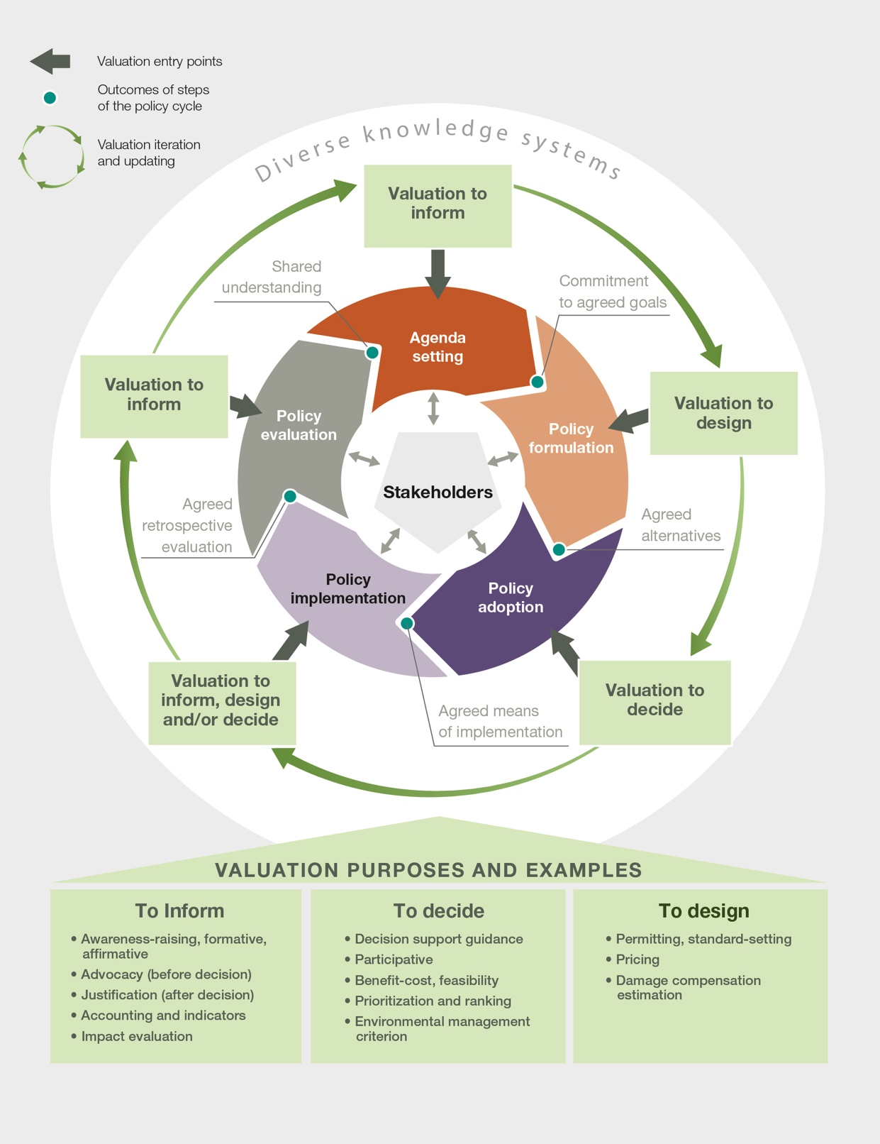
Figure SPM.5. Valuation activities can support different informative, decision-making and policy design purposes by providing different types of knowledge to policymakers and stakeholders throughout the policy cycle.
C3. Despite the significant increase in valuation studies over the last 30 years, less than 5 per cent report the uptake of valuation in decision-making (well established).
Over the past few decades, a wide range of valuation methods and approaches have been developed, refined and tested in different social-ecological contexts. A majority of countries have not made progress at a rate that would have allowed achievement of Aichi Target 2 by 2020 of integrating biodiversity values into strategies, planning process and accounting, as reported in their national reports to the Convention on Biological Diversity (well established) {2.1.2; 4.6.4.1}. Only a very small share of peer-reviewed studies actually report uptake by decision makers, including Governments (well established) {4.6}. Valuation studies with decision support or policy design purposes are more likely to document valuation uptake than those with informative purposes (figure SPM.5) (well established) {4.6.3}. Economic-based valuations are not taken up significantly more often than valuations using non-monetary indicators (well established) {4.6.3}. Key barriers inhibiting the uptake of valuation in public policy decisions include limited reliability of studies for decision-making (well established) {3.3.2}, limited technical capacity and institutional gaps that undermine the ability to monitor and assess the social, economic and environmental benefits provided by nature, as well as overlooking values in decision-making (well established) {4.5; 4.6.2; 4.7}.
C4. More equitable and sustainable policy outcomes are more likely to be achieved when decision-making processes recognize and balance the representation of the diverse values of nature and address social and economic power asymmetries among actors (established but incomplete).
Valuation studies often present a diversity of stakeholder perspectives based on aspects such as age, gender, position and power relations (43 per cent of the 1,163 valuation studies reviewed in depth) and are able to characterize various broad and specific values associated with different life frames (well established) {3.3.2; 3.2.4}. However, only a small fraction of valuation studies (0.6 per cent) explicitly report on measures to account for power asymmetries within the valuation process itself (well established) {3.3.2}. Where decision-making occurs in the context of highly asymmetrical power relations, recognizing the marginalization of certain world-views and knowledge systems and respecting values among indigenous peoples and local communities are associated with increased forest cover and species populations, enhanced delivery of ecosystem services, and improved livelihoods (well established) {2.4.1; 4.4, 4.5.2; 4.5.3; 4.5.4}. Improving information about the values of nature as well as strengthening and developing different capacities at all levels of interventions are key to balancing power imbalances, improving the outcomes of negotiations, and achieving more just and sustainable results (well established) {6.5.1}.
Power asymmetries are often found between those who articulate instrumental values for and against large development and infrastructure projects. For example, dams are often proposed for their market-based instrumental values (including electricity to urban consumers, irrigation water for agriculture, and jobs), while the relational and instrumental values of those directly affected by the project (e.g., loss of farming and fishing livelihoods and ways of life) are often excluded due to power asymmetries. Social movements have sought to shift this imbalance through resistance, litigation and protest (well-established) {4.5.5}. Addressing these power asymmetries by recognizing the diversity of values through participatory assessments can lead to more equitable distribution of project costs and benefits (well established) {4.5.5}.
In biodiversity conservation, community involvement that allows for the prioritization of local values leads to social outcomes being perceived as fairer, often enhancing programme sustainability and consequently social-ecological outcomes (well established) {4.5.2}. Here again power asymmetries among local stakeholders can be addressed to improve decision outcomes, such as through co-management of protected areas and co-design of payments for ecosystem services programmes to protect forests (established but incomplete) {4.5.2; 4.5.3}. Whose values are included in conservation decisions is a key consideration since it influences the outcomes of decisions; for example, relational and instrumental values held by indigenous peoples and local communities are often underrepresented and enter the decision process late in protected area decisions mostly driven by intrinsic values, generally resulting in mistrust and less effective conservation (well established) {4.5.2}. Payments for ecosystem service programmes with substantive community engagement in defining the land management problem or that adapt to local demands over time are better able to align values among diverse stakeholders and achieve better conservation and social outcomes (established but incomplete) {4.5.3}.
C5. Recognizing and respecting indigenous and local knowledge and their associated diversity of values is necessary to achieve outcomes that are respectful of different ways of living (established but incomplete).
There is increasing recognition of the need to bridge between knowledge systems, including those of indigenous peoples and local communities, to support policies related to, for example, development, biodiversity conservation, sustainable use of biodiversity, and climate change mitigation (well established) {2.2.3}. Better understanding of the indigenous and local knowledge and its associated diversity of values requires going beyond dominant epistemologies and world-views, including efforts to decolonize perspectives in order to recognize other ways of seeing, knowing and doing, as those that belong to indigenous peoples and local communities (well established) {3.2.1, 3.2.4.1; 4.4.2} Considering place-based values in decision-making can lead to more equitable and sustainable outcomes (well established) {2.2.3; 3.2.4; 4.4.2; 4.4.3; 4.4.4; 4.5.2; 4.5.3; 4.5.4; 4.6.4; 4.6.7}. For example, in agroecosystems, recognizing and giving credence to the knowledge and values of smallholders, including women, are key to co-designing initiatives that ensure food security and the sustainable use and conservation of agrobiodiversity by farming communities (established but incomplete) {2.2.1; 4.4.4}.
C6. Ignoring, excluding or marginalizing local values often leads to socio-environmental conflicts linked to value clashes, especially in the context of power asymmetries, which undermine the effectiveness of environmental policies (established but incomplete).
Socio-environmental conflicts often result from decisions that exclude some groups’ values, especially those of indigenous peoples and local communities who can be directly connected with and dependent on nature and who bear a disproportionate burden from changes in rights to access or use of nature (well established) {4.5.2; 4.5.3; 4.5.5}. For example, many infrastructure and development projects, such as mining, have led to prolonged conflicts between indigenous peoples and local communities and external actors. Such cases often result in court battles and other forms of protest against perceived environmental injustices; these battles and protests threaten local values through degradation or loss of locally valued ecosystems (well established) {2.2.3.2; 2.4.2; 4.5.5}.
Ignoring or marginalizing local values in the design and management of conservation activities, including protected areas and payments for ecosystem service programmes, can also leave a legacy of mistrust or resentment that is difficult to repair and can provoke local protest and even sabotage, jeopardising conservation outcomes over time (established but incomplete) {4.5.2; 4.5.3}. Conflicts can be avoided or more easily resolved when policy goals are aligned with local instrumental and relational values (well established) {4.5.2}. However, when the values of different actors or groups clash, conflicts may be unavoidable. In such cases, dialogue and transparent deliberative approaches can help make explicit the values underlying the conflict and through consideration of the different values actors may be able to reconcile their values and develop a shared vision of what a successful programme might look like (established but incomplete) {3.2.1; 5.5.6}.
C7. Pathways towards sustainability and justice hinge on the inclusion of a diverse range of nature’s values (established but incomplete).
Future scenario planning and development studies deal with values in different ways. Out of 460 scenarios reviewed, 53 per cent of them explicitly articulate values, especially when co-developed with stakeholders, 42 per cent of them mention values but do not assess them explicitly, and 53 per cent of them perform some kind of valuation without reflecting on underpinning values (well established) {5.2.2}. The majority of scenario studies are driven by instrumental values (94 per cent), either solely (60 per cent) or in combination with other types of values (34 per cent) (well established) {5.2.2}.
Scenarios can be grouped according to their potential to achieve the Sustainable Development Goals and to the relative importance of broad and specific instrumental, relational and intrinsic values in those scenarios. The types of scenarios that are most likely to achieve sustainable and just futures (i.e., global sustainable development and regional sustainability scenarios) typically have a strong societal focus, have high regard for both the values of nature’s material and non-material contributions to people, consider a range of instrumental, relational and intrinsic values, and emphasize the diversity of life choices and social-ecological resilience (established but incomplete) {5.2.2}. Those types of scenarios that are focused on material accumulation, economic growth and individual benefit and only emphasize a narrow range of instrumental values (i.e., inequality, regional competition, breakdown, business as usual, and economic optimism scenarios) incorporate only a narrow suite of Sustainable Development Goals and thus have the least sustainability potential (well established) {2.2.3; 2.4.2; 4.3; 5.2.2; 5.5.6}.
Various pathways can contribute to achieving just and sustainable futures, including, but not limited to, the “green economy”, “degrowth”, “Earth stewardship”, and “nature protection” and other pathways arising from diverse world-views and knowledge systems (e.g., living well and other philosophies of good living) (box SPM.3). All of these sustainability pathways are associated with certain sustainability-aligned values and seek a more diverse valuation of nature as a foundation for reconciling social, economic and ecological dimensions (well established) {2.2.3; 5.5}. No single path is likely to be universally accepted as superior, and there is no feasible agenda to resolve all conflicts or trade-offs among these pathways. Hence, constructive dialogue between these and other possible pathways, based on transparency and recognition of the diversity of values underlying their different positions, would be crucial to achieve transformative change towards sustainability (established but incomplete) {5.3.3; 5.5; 6.3.3}.
Box SPM.3. Pathways that contribute to just and sustainable futures prioritize distinct underlying values of nature
A pathway to transformation is a strategy for getting to a desired future based on a recognizable body of sustainability thinking and practice {5.5.1}. Among the many potential pathways to more sustainable futures, for example, the “green economy” pathway emphasizes the primacy of reform of economic institutions, technologies and performance metrics {5.5.2}.The “degrowth” pathway emphasizes strategies that reduce the material throughput of society, protecting human well-being through equitable distribution of material wealth rather than growth, reducing energy and resource consumption in the most industrialized countries as a means to achieve inter- and intra-generational equity and good quality of life for all {5.5.3}. The “Earth stewardship” pathway emphasizes local sovereignty and agrarian reform, solidarity, and the promotion of biocultural practices {5.5.4}. The “nature protection” pathway emphasizes protecting biodiversity for its own sake and expanding protected area networks {5.5.5}. These pathways pay attention to some form of social justice, especially between generations. The nature protection pathway considers justice as a separate goal to saving biodiversity, whilst the other pathways see justice and sustainability as interdependent. These four pathways emphasize different social justice principles, such as the utilitarian approach to maximising aggregated benefits (green economy), consumption thresholds (degrowth), strengthening rights and empowerment (Earth stewardship) and safeguarding option values (nature protection) {5.5.2; 5.5.3; 5.5.4; 5.5.5.}.
All the pathways reveal diverse ideas about what constitute sustainability-aligned values {5.5.1; 5.5.6}. The green economy is underpinned by prioritization of nature’s instrumental values, emphasizing the role of nature as an asset that supports people’s good quality of life {5.5.2}. Degrowth is underpinned by values of sufficiency and egalitarianism for shaping people’s balance with nature {5.5.3}. Earth stewardship is underpinned by relational values linked to biocultural diversity, alongside broad values like unity and reciprocity among people and between people and nature {2.2.3; 5.5.4; 6.3.3}. Nature protection is underpinned by intrinsic values of nature, particularly concerned with the inadequacies of an instrumental basis for protection {5.5.5} (figure SPM.6). There are many other pathways referring to other world-views and knowledge systems found throughout the world, including those based on the fulfilment of a collective good quality of life (mostly based on non-anthropocentric world-views) (box SPM.6) {5.5.4; 2.2.1; 2.2.3}.
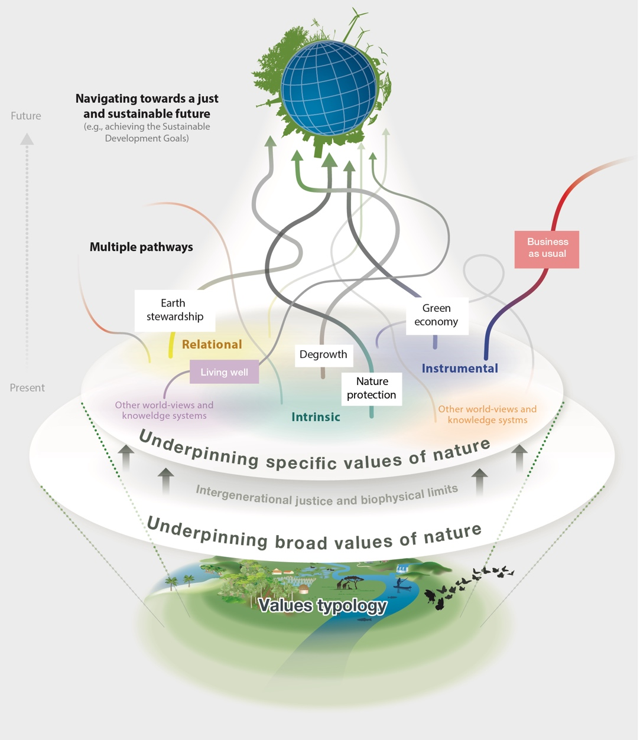
Figure SPM.6. The diversity of values of nature underpins multiple pathways towards sustainability. There are alternative pathways to achieving the Sustainable Development Goals, supported by different coalitions of stakeholders, responding to different contexts and needs, and being adjusted as they are operationalized. For example, a green economy pathway currently has the greatest traction among many business and government stakeholders, but this is contested by alternative pathways, supported by coalitions that emphasize, for example, degrowth, Earth stewardship, and nature protection. Alternative pathways are underpinned by different broad and specific values of nature. There are many pathways related to other world-views and knowledge systems. Some broad values are shared by all pathways, including the imperative to do justice to future generations, and lead to synergies among pathways. Yet, other broad values are contested and can lead to conflicts across pathways, for example, between those which emphasize economic growth as linked to prosperity versus those that value sufficiency and a more relational basis for living well {5.5}. Although living well is an important concept, the evidence used to produce this figure did not review this pathway in particular.
C8. Mobilizing sustainability-aligned values involves empowering civil society and changing societal structures and institutions (well established).
Holding sustainability-aligned values is necessary but insufficient to ensure pro-environmental behaviour. Besides motivation, people also need the capabilities and opportunities to act. Therefore, the integration of diverse values into decision-making or the mobilization of existing sustainability-aligned values can be supported by governance structures that create opportunities to give voice to and act upon these values, including public deliberation and citizen engagement (well established) {5.3.4}.
Mobilizing sustainability-aligned values implies empowering and informing civil society through appropriate societal structures and institutions. However, consumers may be impeded from acting upon their pro-environmental values due to market pricing, lack of available purchase options, or competing social norms favouring unsustainable consumption options (well established) {5.3.4}. Likewise, producers may be constrained by sectoral policies, market prices, the need to maximize short-term shareholder profits or to contribute to predominant sociopolitical goals like economic growth (well established) {2.4.2; 4.5.4}. To overcome such value-action barriers, international cooperation can be mobilized and institutions can be designed or transformed, as appropriate, to support sustainable and fair global value chains, at all levels (established but incomplete) {4.5.4}.
Creating public and private standards and certification schemes associated with single commodity value chain initiatives has had limited achievement of intended social and ecological objectives, but there is some evidence that they are changing the behaviour of the private sector (e.g., agricultural businesses) and leading to voluntary certification schemes that go beyond single commodities (established but incomplete) {4.3.3; 4.5.4}. However, if not designed in line with relevant international rules and implemented with local input, these programmes may leave smallholders behind, with undesired social, environmental, and economic consequences (established but incomplete) {4.5.4}. Furthermore, there are efforts to reform institutions associated with biodiversity conservation that allow indigenous peoples and local communities to develop their own conservation models (established but incomplete) {5.4.2; 5.5.4}.
C9. Transformative change towards more sustainable and just futures relies on a combination of actions that target different values-centred leverage points, in particular (i) undertaking valuation that recognizes the diverse values of nature; (ii) embedding valuation into decision-making; (iii) reforming policies and regulations to internalize nature’s values; and (iv) shifting underlying societal norms and goals (established but incomplete).
Transformative (i.e., system-wide and fundamental) change can be supported by relevant and robust valuation but also local to global institutional change and changes to societal-level norms and goals, to align with global sustainability and justice objectives (well established) {2.4.1; 2.4.2; 5.4.2; 5.4.3; 5.3.3} (figure SPM.7).
Transformative change is more likely to occur when these deep leverage points (i.e., norms and goals) are activated, with the potential to bring change across all spheres in society. Deep leverage points include both the formation and mobilization of sustainability-aligned values (e.g., caring for nature) and shifting societal goals and norms (e.g., shifting the notion of good quality of life linked to material consumption growth, to that derived from sufficiency in contexts of over-consumption) (well established) {5.2.2; 5.3.2; 5.3.4}. Governance systems can enable people to form, utilize and maintain sustainability-aligned values that are currently hard to express or act upon, to reduce the dominance of values associated with materialism and individualism, and to balance market and non-market instrumental, relational and intrinsic values (well established) {2.4.1.3; 2.5.2; 5.3.2; 5.3.4}. Shifting societal goals towards sustainability and justice would in turn require changing paradigms about how to pursue a meaningful life, moving towards visions of good quality of life and development that are aligned with more respectful relationships among humans and towards nature (well established) {5.5}. These deeper leverage points may only be activated by changing social structures and institutional arrangements (well established) {2.4.1; 2.4.2; 2.5.2}. For example, favourable institutional conditions can be promoted that empower civil society to advocate for more sustainable and just future visions, and societal pressure can stimulate institutions to accept those visions (e.g., via public deliberation) (established but incomplete) {5.3.3}.
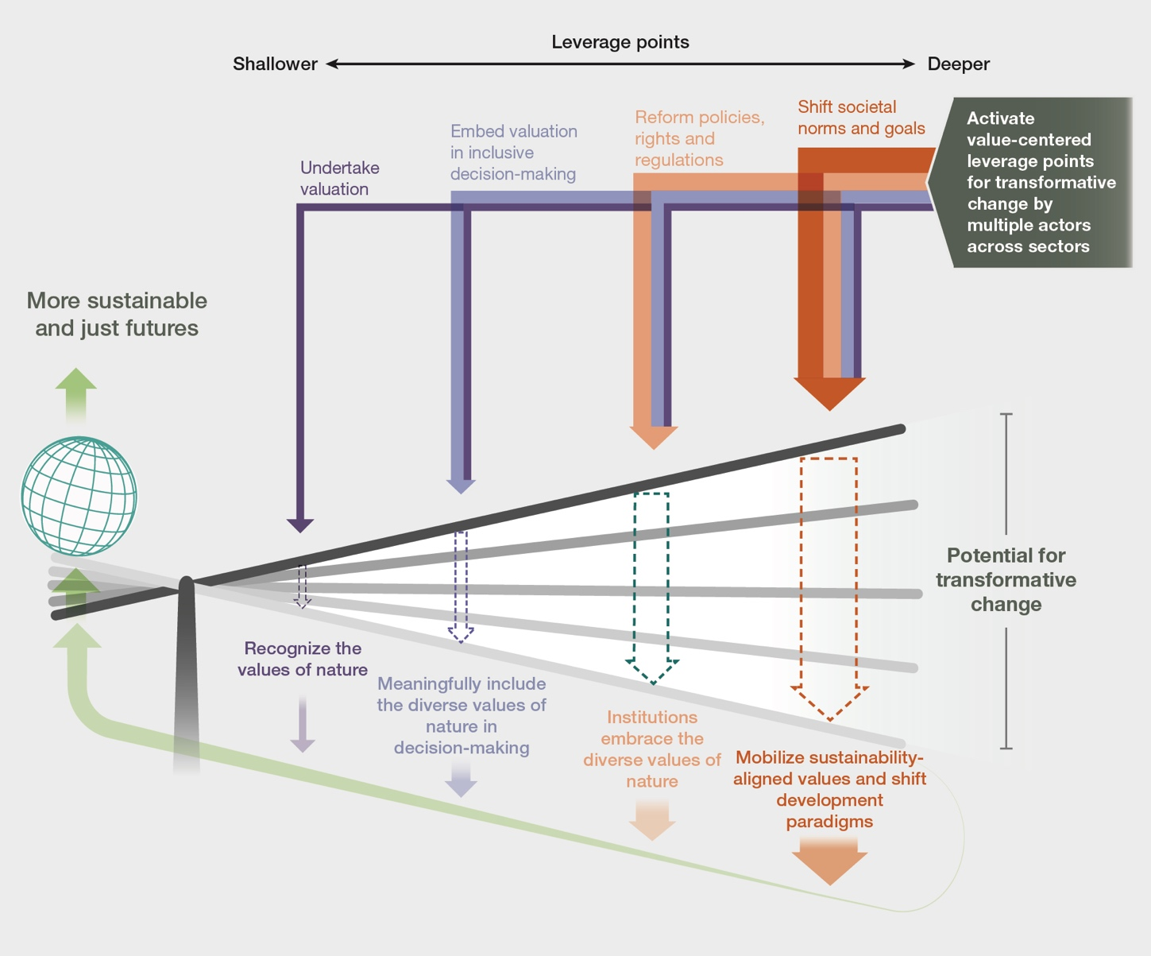
Figure SPM.7. A set of values-centred leverage points can help create the necessary conditions for activating transformative change towards more sustainable and just futures. Leveraging transformative change would be based on the combination of various societal-level actions: (i) recognizing the diversity of nature’s values through undertaking relevant and robust valuation; (ii) embedding values in decision-making; (iii) reforming policies and stimulating institutional change; and (iv) shifting societal-level norms and goals to support sustainability-aligned values across sectors. When actions, including policy interventions, focus on activating deeper leverage points (towards the right of the lever), transformative change is more likely to occur {1.3}.
D. Embedding the values of nature for transformative decision-making for sustainability.

D1. Decision-making that fosters sustainability transitions can be advanced by following six interrelated values-centred guidelines: contextualization, design, representation, engagement, legitimization and reflection (established but incomplete).
Six interrelated values-centred guidelines can be followed to embed nature’s diverse values in decision-making that promotes sustainability pathways across scales and involve a wide range of social actors (box SPM.4). These guiding principles apply to all the stages of the policy cycle (from setting agendas to evaluating policies) and can be summarized as follows (established but incomplete) {6.5}:
- Contextualize the decision-making process by recognizing the diverse world-views and values of nature that underpin different social-ecological contexts.
- Design decision-making processes considering the conditions and functions of ecosystems and biodiversity, the capacities, knowledge and perspectives of stakeholders through participatory, empowering, deliberative and conflict management approaches.
- Represent meaningfully and respectfully the diverse world-views, broad and specific values held by stakeholders, rights-holders and knowledge-holders involved in decisions about nature.
- Engage interactively with specific actors to promote dialogue, long-term collaboration and co-creation of solutions to conserve and sustainably use nature.
- Legitimize decisions and their impacts by instilling a sense of co-ownership over the valuation process and its results by all actors who take part in nature management.
- Reflect to ensure that decisions impacting nature and its contributions to people are aligned with the values and actions that can foster transformative change towards sustainability.
Box SPM.4. Operationalizing the six guidelines to embed nature’s values into environmental decisions: an example from Canada
The Canadian Nuclear Waste Management Organization has addressed the lack of public support for scientifically designed waste disposal options with reduced impacts on society and biodiversity and induced deep transformations in decision-making. Over a 20-year period, the organization has promoted opportunities for collaboration, co-learning, and reflection with indigenous knowledge holders. Public consultation processes helped contextualize the local knowledge and value systems and weave them with scientific knowledge and technical expertise. Decision-making processes at the disposal sites were then designed in an open and transparent way, assessing environmental, social and economic impacts, as well as involving the voluntarily expressed interest of local community members. Stakeholder engagement was promoted through an independent advisory body, including indigenous elders and youths from across Canada. In all these steps, different stakeholders’ world-views, knowledge and values about nature were voiced and represented, leading to improved public support and legitimacy, and a lasting impact on institutional structures and the policy process {6.3.1.2}.
D2. Environmental policy instruments and policy support tools are more likely to foster transformative change for sustainability and justice when they are aligned with nature’s diverse values (well established).
Policy instruments can foster transformative change when: (i) a diversity of specific values (i.e., instrumental, relational and intrinsic values) is considered in their design and implementation; (ii) they address one or more direct or indirect drivers of biodiversity loss; (iii) they mobilize sustainability-aligned values through institutional change; (iv) they promote capacities to embed nature’s values into decisions; and (v) they are integrative and adaptive enough to bridge across world-views, values, sectors and scales (established but incomplete) {6.2.3; 6.2.4}.
Achieving transformative change is therefore more likely when a broader diversity of nature’s values is incorporated into policy instruments and policy support tools (established but incomplete) {6.2.3.2}. Using a combination of policy instruments can also lead to a more diverse representation of nature’s values and hence increased potential to propel system-wide transformations (well established) {6.2; 6.3} (table SPM.3). Whilst economic and legal-regulatory approaches are among the most frequently used environmental policy instruments, only a few of them (e.g., elimination of harmful subsidies, such as tax exemptions to large-scale fisheries) are likely to trigger transformative change (table SPM.3) (well established) {6.2}. Sociocultural, customary and rights-based instruments (e.g., locally co-managed fisheries) are less common, but have more potential to support systemic transformations (established but incomplete) {6.2.2; 6.2.3; 6.3.1}.
Different rights-based approaches have been found to incorporate the diverse values of nature into local and national laws and constitutions (e.g., rights to a healthy environment, rights of nature, rights of Mother Earth, rights of specific entities like rivers, lakes, mountains). These are inspired by indigenous peoples and local communities and can make the case for biodiversity by stimulating institutional change in accordance with national laws and international principles of national sovereignty over natural resources (well established) {2.2.3.1; 4.4.3; 6.2.2.2}.
A policy instrument’s transformative potential is partly dependent on how it is designed and implemented. For instance, aligning payments for ecosystem service programmes with the values of ecosystem service providers in ways that yield fair distribution of costs and benefits can strengthen sustainability-aligned values (well established) {4.3.4; 4.5.3; 5.3.2.3; 5.3.2.4; 6.2.2.1}.
Table SPM.3. Potential of environmental policy instruments to support transformative change towards more sustainable and just futures by representing diverse values. A selection of environmental policy instruments (37 from the IPBES catalogue and previous assessments) was assessed regarding five key criteria required for transformative governance (columns in the centre). The table shows: (i) the strengths and weaknesses of different policy instruments; (ii) the scales at which they can be implemented; and (iii) the type of stakeholders that are most commonly responsible for their implementation (columns to the right). Larger circles denote that a given instrument can better meet each transformative criterion {6.2}.
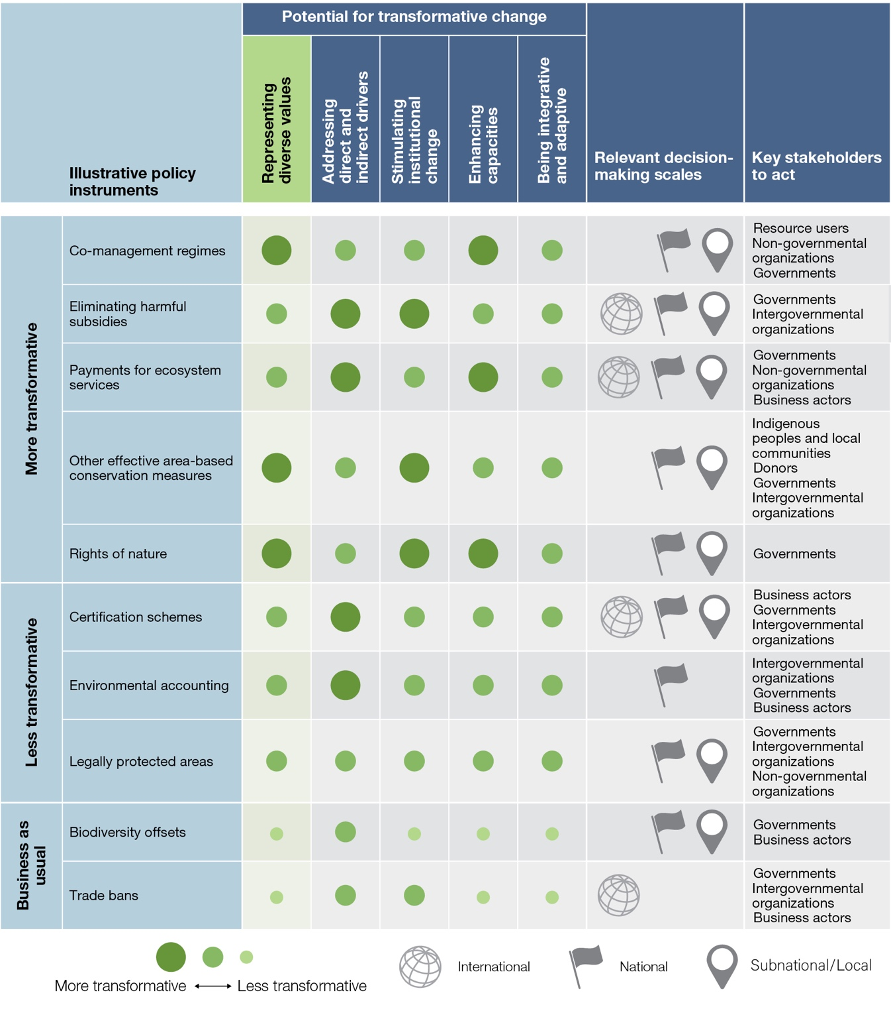
D3. Enhancing the capacities of decision makers to address conflicting or contradictory values can facilitate the consideration of the diverse values of nature in policy decisions (established but incomplete).
Fostering the following capacities of decision makers can help embed the diverse values of nature into decisions (table SPM.4): (i) motivational capacities to raise awareness of, and desire to, consider diverse values in decisions and to mobilize sustainability-aligned values and attitudes towards nature (established but incomplete) {6.4}; (ii) analytical capacities to enhance the ability of selecting and using suitable tools to gather and synthesize information on nature’s values (well established) {6.4}; (iii) bridging capacities to facilitate learning and reflection across diverse value perspectives (established but incomplete) {6.4}; (iv) negotiation capacities to represent one’s own interests, make compromises, and accept the views of others when managing trade-offs (established but incomplete) {6.4}; (v) social networking capacities to coordinate across scales and different social groups, managing expectations and risks in an adaptive way (established but incomplete) {6.4}; and (vi) governance capacities for making accountable, transparent, participatory and law-abiding decisions (established but incomplete) {6.4} (box SPM.5).
Table SPM.4. Capacities of decision makers required to foster the consideration and embedding of the diverse values of nature in policy decisions. Different stakeholders require strengthening different capacities. The larger bubbles highlight larger capacity needs. 85 capacity needs grouped into the six categories were identified and ranked through a consultation process involving experts across the chapters of the assessment of the diverse values and valuation of nature. While all stakeholders need capacity development in almost all capacity dimensions, some of them have more resources to act {6.4.4}.
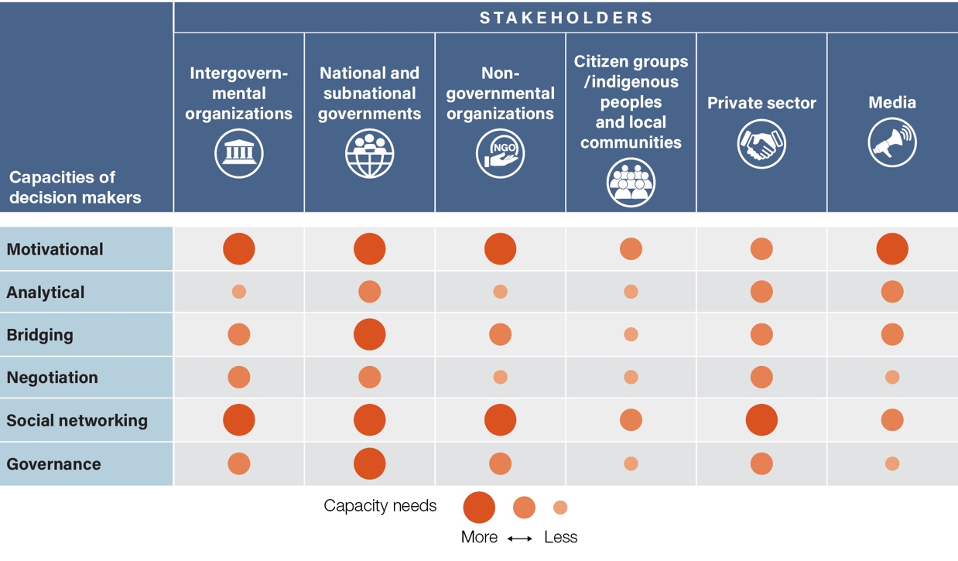

Box SPM.5. Capacity development needs to integrate diverse values in conservation decisions: an example from Japan
At the Kabukuri Marsh Ramsar Site, located in Northern Honshu in Japan, antagonistic value perspectives of local farmers and conservationists were addressed to allow collaborative management of winter-flooded rice paddies. The Japanese Association for Wild Geese Protection, an organization with strong bridging capacities, initiated a social learning process to balance multiple land use objectives that allowed trust-building and increased the motivational capacities of farmers and other stakeholders, including non-governmental organizations, local and national government authorities, and researchers. This helped to design activities that were mutually beneficial for the wild geese and local livelihoods. The process was able to mobilize the analytical capacities by learning from different knowledge systems. Negotiation capacities were enabled to balance local stakeholders’ socioeconomic and nature conservation goals. Social networking capacities led to connections with other actors in the agricultural value chain (i.e., processors, retailers and consumers) leading to a premium market for sustainably produced rice. Finally, the governance capacity of local decision makers led to the designation of the Kabukuri-Marsh as a Ramsar Site, a Wetland of International Importance {6.3.2; 6.5.3}.
D4. Key knowledge and operationalization gaps limit opportunities to effectively embed nature’s diverse values in decision-making (well established).
Specific knowledge gaps regarding values and valuation limit the quantity and quality of evidence that would be required to foster transformative decision-making (table SPM.5). Evidence is sparse on: (i) valuation approaches used by indigenous peoples and local communities (well established) {2.2; 3.2.4; 6.4.3}; (ii) how inequalities among sociodemographic groups (e.g., different gender groups and generations) affect value expression in decision-making (well established) {2.6}; (iii) how and which form of valuation leads to better outcomes for people and for nature (well established) {4.5; 4.6; 4.7.1; 6.4.3.5}; and (iv) embedding robust valuation and its uptake in policy (well established) {4.6; 6.2; 6.3}. Operationalization gaps highlight the obstacles to embedding nature’s values in decision-making in support of transformative change. Both knowledge and operationalization gaps have hindered the uptake of valuation into decisions (established but incomplete) {4.2.4; 4.3.1; 4.3.2; 4.6.2; 6.4.2;}.
Knowledge and operationalization gaps arise fundamentally from a lack of context-specific knowledge (e.g., limits to assessing trade-offs among values), resources (e.g., financial and technical deficits to undertake valuation) or capacities (e.g., lack of ability to implement context-specific valuation) across different actors involved in the policy cycle (well established) {2.3.1; 4.4; 4.6; 6.4; 3.4.4; 6.4}.
Knowledge and operationalization gaps are widespread but more prevalent in developing countries (established but incomplete) {3.3.3; 4.6.4; 5.2.1}. Comprehensive overviews of valuation requirements (e.g., capacities, data, resources, technologies), and how these vary across decision-making contexts are scarce (well established) (3.3.3). To overcome these gaps, policymakers may consider them and support the development of specific capacities of key stakeholders, drawing on available context-specific expertise (e.g., understanding of the different world-views of local stakeholders).
Table SPM.5. Categories of knowledge and operationalization gaps that hinder the effective embedding of nature's diverse values in decision-making. Information on gaps was collected and synthesized across all the chapters of the assessment of the diverse values and valuation of nature. For each gap category (left column) the most pressing issues (right column) are highlighted {6.4.2; 6.4.3}.
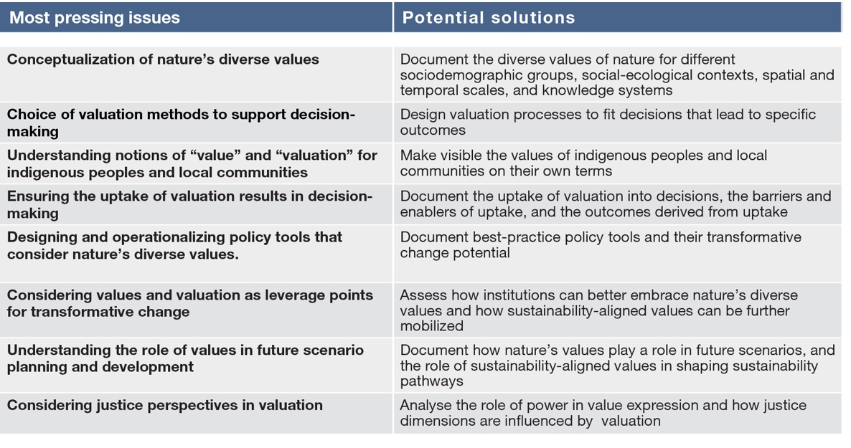
D5. The values held and expressed by indigenous peoples and local communities can inspire environmental governance models in different social-ecological contexts (established but incomplete).
Sustainability-aligned values held and expressed by many indigenous peoples and local communities have inspired other societies around the world, and the incorporation of these values into laws and regulations (box SPM.6). These values can be adopted at different scales and administrative levels, including, for instance, large-scale territorial governance. Collaborative governance and co-design of management plans and policies offer opportunities to make use of indigenous and local knowledge in the design and implementation of sustainable alternatives. For example, indigenous peoples have co-designed community-based sustainable use and conservation areas, and also taken part in the governance of protected areas (established but incomplete) {4.4.2; 4.4.2.2; 4.4.3.2; 4.5; 5.3.4.2}. Values held by a wide range of communities and organized civil society groups, such as youth social movements, have also been incorporated in development agendas and policies across scales (established but incomplete) {2.2.1; 2.2.3}. Developing ‘bridging’ and ‘governance’ capacities can aid the translation of indigenous and local values into laws and regulations that could mobilize society’s sustainability-aligned values (established but incomplete) {4.4.3.2; 6.3.1}.
Addressing the loss of indigenous peoples’ and local communities’ languages, knowledge and values can be aided by establishing alliances with economic, social and political actors, to help reduce vulnerabilities posed by the loss of biocultural diversity (established but incomplete) {2.2.2; 2.3.2; 2.2.4; 4.4.4; 6.3.1; 6.3.2; 6.4.2.2.3}. Alliances between civil society organizations and networks of indigenous peoples and local communities have promoted the recognition and incorporation of values and knowledge associated with local food systems and agrobiodiversity by national institutions, to address food security problems (established but incomplete) {4.4.4}.
Box SPM.6. Opportunities and challenges for integrating indigenous and local values in policy contexts: an example from the South American Andes
Philosophies of good living are associated with ideas of collective good quality of life among people and nature, and are closely associated with the world-views, languages and knowledge systems of many indigenous (and non-indigenous) communities {1.5.2; 2.2.1; 2.2.2; 2.2.3.1; 2.2.4.1}. For example, the notion of vivir bien or buen vivir (good living) is rooted in indigenous Andean world-views and languages (sumak kawsay in Kichwa, and suma qamaña in Aymara), and illustrates pathways for linking collective good quality of life and nature’s values with policy decisions {1.5.2; 2.2.3}. In some Andean communities, values embedded in buen vivir philosophies have historically been part of territorial management plans. Those values have been institutionalized in the constitutions of Ecuador and the Plurinational State of Bolivia and other national policies. They have also been expressed in intercultural educational policies and have inspired global rights-of-nature policies protecting rivers, ecosystems and species {2.2.4.1; 5.5.4}. Yet, embedding such values in policymaking across scales also entails challenges. For example, these values and principles may be used as propaganda rather than genuinely fostering transformative change. Even if vivir bien or buen vivir bien is a constitutional principle, it can be used to legitimize status-quo governmental development agendas {4.4.3}. Ethical and transparent involvement of indigenous peoples and local communities can guide transformative policies {4.4.3; 6.4}.
D6. Balancing perspectives on nature’s values across sectoral policies can enhance coherence among policy instruments needed for sustainability (well established).
Sectoral policies often lack coherence among them and rarely consider the full suite of nature’s values in their respective implementation plans and development narratives. This is in part due to the failure to fully recognize social-ecological interactions in different contexts, thus hindering the achievement of the Sustainable Development Goals (established but incomplete) {4.3; 6.3; 6.5}. For instance, food security policies often overlook issues of cultural identities linked to food, dietary diversity and relationships to environmental health. Consequently, these policies may promote agricultural practices that run counter to intrinsic values connected to biodiversity conservation and other relational and instrumental values associated with human health and cultural identity (well established) {4.4.4; 6.3.1; 6.3.2}. Similar conflicting outcomes can also be seen in the implementation of policies between different subsectors, such as addressing biodiversity and climate goals, indicating the need for more horizontal or intrasectoral alignment of values. Balancing such divergent perspectives across sectors on the values of nature and its contributions helps ensure coherence among policy goals (well established) {6.3}. For example, opportunities for sustainability transitions in urban settings can address a range of problems, including pollution, unequal access to green spaces, and the livelihoods of marginalized communities (well established) {6.3}.
These issues are increasingly being tackled by policies aiming at enhancing social-ecological resilience based on nature’s values, such as policies linked to urban planning (e.g., blue and green infrastructure planning that capture instrumental and relational values), natural disaster risk reduction practices (e.g., eco-disaster risk reduction approaches that capture intrinsic and instrumental values), or addressing climate change mitigation and adaptation and biodiversity loss (e.g., nature-based solutions, and ecosystem-based approaches, among other relevant approaches capturing instrumental and intrinsic values) (well established) {6.3.1}.
D7. Value trade-offs across scales can be addressed by institutions that permeate across administrative boundaries (established but incomplete).
A key challenge for environmental governance is that different stakeholders act upon different values across spatial, temporal and organizational scales (well established) {5.3}. For example, Governments may promote relational values associated with place-based identity at the local level, intrinsic values associated with biodiversity conservation by establishing natural protected areas at the regional level, and non-market instrumental values associated with climate change mitigation through international agreements (e.g., the instrumental value of storm buffering by coastal ecosystems). Such cross-scale value interactions are, in turn, influenced by power relations among the different actors that operate across these scales (well established) {1.2.3; 2.4.2; 4.2; 4.3}.
Governments can support and enable flexible and adaptive institutional designs that permeate across administrative boundaries to connect national and subnational scales and address value trade-offs (established but incomplete) {5.4}. Other actors, such as international civil society organizations and multilateral agencies, can bridge values across scales in managing transboundary environmental and development issues (e.g., the intergovernmental bodies providing science-based policy options at multiple scales for assisting policymaking for climate change) (established but incomplete) {5.4.2}. Such actors can help communicate evidence-based knowledge to foster collaboration around shared values of nature and embed diverse understandings about human-nature relationships into decisions (established but incomplete) {5.4}.
D8. Social learning facilitates embedding the values of nature in decision-making (established but incomplete).
Social learning creates opportunities for mutual understanding of nature’s values in participatory and deliberative decision-making processes; this requires collective learning, action and reflection between individuals and groups regarding interactions with nature, and openness and transparency (well established) {5.3.5.4; 5.3.5.2; 5.4.4; 6.3.2.2}. Social learning can also be built into valuation processes to improve their relevance and robustness (established but incomplete) {4.3; 4.5; 5.4.4}. Some policy instruments, such as participatory land and ocean use planning, are built on social learning processes and contribute to the recognition, mobilization, incorporation and co-creation of diverse values of nature (well established) {5.4.4; 6.3.2}.
Social learning processes, such as awareness-raising campaigns, targeted at specific life stages, genders, and sociocultural groups, can further mobilize sustainability-aligned values (established but incomplete) {2.5.1; 2.5.2; 5.3.2}. In particular, environmental education programmes are especially relevant in early life stages (well established) {2.5.1; 5.3.2}. Social learning in corporate contexts can be targeted at increasing connectedness with nature (established but incomplete) {2.2.1}. Intercultural and multilingual education can also be fostered to mobilize sustainability-aligned values (well established) {2.2.2}.
D9. Scientists, policymakers, indigenous peoples and local communities and other societal actors can collaborate in achieving the 2030 Agenda for Sustainable Development and implementing the future post-2020 global biodiversity framework by ensuring due consideration of the diverse values of nature (established but incomplete).
Achieving shared visions, such as those globally agreed under the Convention on Biological Diversity, relies on providing strategic policy guidance for national, subnational and local implementation as well as developing capacities to bridge across the different values of nature through fair and equitable participation of different actors, including indigenous peoples and local communities (table SPM.6). Values-centred transformative change can be propelled by strengthening collaborations across diverse societal actors to revert the biodiversity crisis and navigate pathways to more sustainable and just futures {established but incomplete} {1.5.3; 1.5.4; 3.1; 3.5; 4.6; 4.7; 5.4; 6.3; 6.4.2}. The One Health approach illustrates how different actors can collaborate by being mindful of nature’s diverse values (box SPM.7). The recognition and consideration of the diverse values of nature that stem from different knowledge systems, including non-anthropocentric approaches, can support the achievement of the 2030 Agenda for Sustainable Development, the future post 2020 global biodiversity framework and other relevant multilateral environmental agreements (well established) {2.1.2, 2.2.3.1, 2.3.2, 2.4.2, 5.2, 6.5}.
Box SPM.7. The One Health approach as an example of collaborative action on nature’s diverse values
The “One Health” approach has been initiated and is under further development by several international bodies (e.g., Convention on Biological Diversity, Food and Agriculture Organization of the United Nations, World Health Organization, World Organisation for Animal Health, United Nations Environment Programme) and aims to jointly achieve human, domestic and wild animal and environmental health across multiple levels of society towards achieving sustainable development {6.3.2.1}. It considers diverse values associated with various sectoral interests related to food and water (e.g., food security, culture), health (e.g., prevention and control of zoonoses), climate (e.g., adaptation to extreme climatic hazard), and biodiversity conservation (e.g., wildlife trade regulation) {6.3.2.1}.
National Governments and regional bodies are voluntarily setting up their own One Health strategies. For instance, Singapore, through its city in nature concept, is promoting more biodiverse urban areas connected to national parks, emphasizing biodiversity conservation (intrinsic values) and enhancing disease regulation (instrumental values) and mental health (relational values). International civil society organizations and donor agencies are promoting the implementation of One Health with further potential for influencing national and subnational policies through training and advocacy efforts, which help make visible the diversity of values of nature {6.3.2.1}. Context-specific and different social and economic conditions are relevant for implementing actions related to the One Health approach {6.3.2.1}.
Collaborations between researchers, practitioners and indigenous peoples and local communities seek to integrate and share databases (e.g., on animal and human diseases) and context-based understandings (e.g., local knowledge on medicinal plants to minimize antibiotic use) to co-develop (and co-learn from) good practices (e.g., management of the human-livestock-environment nexus) {6.3.2}. Civil society organizations are taking into account the values of nature and its contributions to health and are identifying preventive and therapeutic interventions to support livestock health, reduce disease transmission to people and enhance food safety {6.3.2}.
Table SPM.6. Transformative change can be propelled by synergistic actions by different actors to advance the consideration of the diverse values of nature in decision-making. Values-centred concerted actions by social actors are needed to achieve shared visions to revert the biodiversity crisis and navigate towards more sustainable and just futures. Examples of these actions are provided in the table.
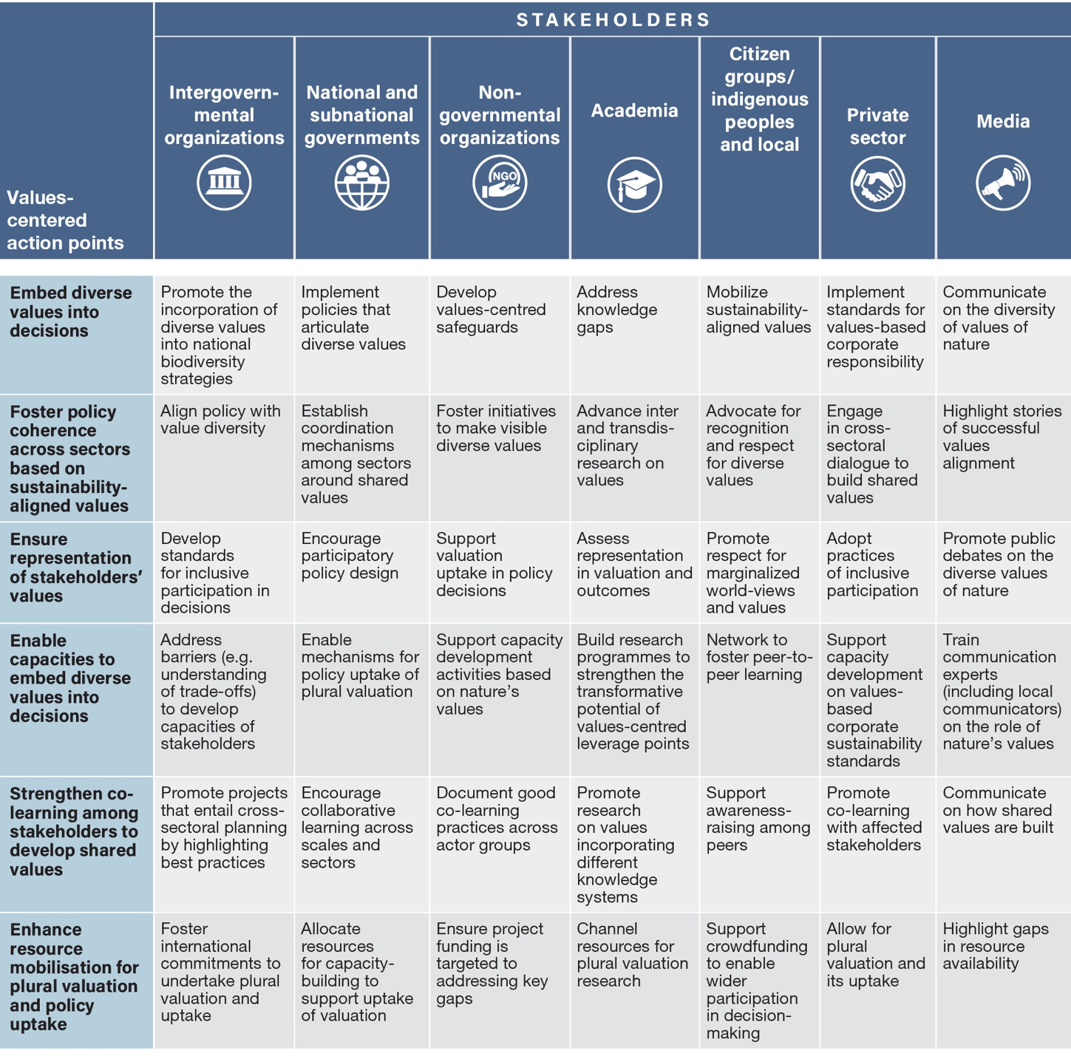

Appendix
Communication of the degree of confidence.
Figure SPM.A1. The four-box model for the qualitative communication of confidence. Confidence increases towards the top-right corner, as suggested by the increasing strength of shading. Source: IPBES (2016). Further details of the approach are documented in the IPBES Guide on the Production of Assessments.
In the methodological assessment regarding the diverse conceptualization of multiple values of nature and its benefits, including biodiversity and ecosystem functions and services, the degree of confidence in each main finding is based on the quantity and quality of evidence and the level of agreement regarding that evidence (figure SPM.A1). The evidence includes data, theory, models and expert judgement.
- Well established: there is a comprehensive meta-analysis or other synthesis or multiple independent studies that agree.
- Established but incomplete: there is general agreement, although only a limited number of studies exist; there is no comprehensive synthesis, and/or the studies that exist address the question imprecisely.
- Unresolved: multiple independent studies exist but their conclusions do not agree.
- Inconclusive: there is limited evidence and a recognition of major knowledge gaps.

Authors are listed with, in parentheses, their country or countries of citizenship, separated by a comma when they have more than one, and, following a slash, their country of affiliation, if different from the country or countries of their citizenship, or their organization if they belong to an international organization. The countries and organizations having nominated the experts are listed on the IPBES website.
SPM: summary for policymakers.
The undertaking of an assessment on transformative change, which will build on the assessment of the diverse values and valuation of nature and other IPBES products, was approved by the Plenary of IPBES at its eighth session, for consideration at its eleventh session.
KM: key message.
IPBES (2019): Global Assessment Report on Biodiversity and Ecosystem Services of the Intergovernmental Science-Policy Platform on Biodiversity and Ecosystem Services. Brondizio, E.S., Settele, J., Díaz, S., Ngo, H.T. (eds). IPBES secretariat, Bonn, Germany, 1144 pages. ISBN: 978-3-947851-20-1.
H. O. Pörtner, R.J. Scholes et al. (2021): IPBES-IPCC Co-Sponsored Workshop Report on Biodiversity and Climate Change; IPBES and IPCC, doi:10.5281/zenodo.4782538.
IPBES (2015): Preliminary Guide Regarding Diverse Conceptualization of Multiple Values of Nature and Its Benefits, Including Biodiversity and Ecosystem Functions and Services (deliverable 3 (d)), annex III to document IPBES/4/INF/13.
United Nations Environment Programme, Mainstreaming the economics of nature: a synthesis of the approach, conclusions and recommendations of TEEB (Nairobi, 2010).
System of Environmental-Economic Accounting 2012: Central Framework (United Nations publication, 2014).
P. Dasgupta, The Economics of Biodiversity: The Dasgupta Review (London, HM Treasury, 2021).
IPBES (2019): Global Assessment Report on Biodiversity and Ecosystem Services of the Intergovernmental Science-Policy Platform on Biodiversity and Ecosystem Services. Brondizio, E.S., Settele, J., Díaz, S., Ngo, H.T. (eds). IPBES secretariat, Bonn, Germany, 1144 pages. ISBN: 978-3-947851-20-1.
The present assessment uses the term “nature-based solutions” as defined by resolution 5/5 of the United Nations Environment Assembly of the United Nations Environment Programme: “actions to protect, conserve, restore, sustainably use and manage natural or modified terrestrial, freshwater, coastal and marine ecosystems, which address social, economic and environmental challenges effectively and adaptively, while simultaneously providing human well-being, ecosystem services and resilience and biodiversity benefits”.
With regards to including diverse values, at one point in the assessment, the catch-all nature of the nature-based solutions concept raises a question mark, since nature-based solutions can vary considerably regarding how much they support biodiversity {6.3.1.1}.
See www.fao.org/3/cb7869en/cb7869en.pdf.
IPBES (2016): Summary for policymakers of the Assessment Report on Pollinators, Pollination and Food Production of the Intergovernmental Science-Policy Platform on Biodiversity and Ecosystem Services. S.G. Potts, V. L. Imperatriz-Fonseca, H. T. Ngo, J. C. Biesmeijer, T. D. Breeze, L. V. Dicks, L. A. Garibaldi, R. Hill, J. Settele, A. J. Vanbergen, M. A. Aizen, S. A. Cunningham, C. Eardley, B. M. Freitas, N. Gallai, P. G. Kevan, A. Kovács-Hostyánszki, P. K. Kwapong, J. Li, X. Li, D. J. Martins, G. Nates-Parra, J. S. Pettis, R. Rader, and B. F. Viana (eds.)., secretariat of the Intergovernmental Science-Policy Platform on Biodiversity and Ecosystem Services, Bonn, Germany. Available at http://doi.org/10.5281/zenodo.2616458.
IPBES (2018): IPBES Guide on the Production of Assessments. Secretariat of the Intergovernmental Science-Policy Platform on Biodiversity and Ecosystem Services, Bonn, Germany. Available at https://ipbes.net/guide-production-assessments.

