UNITED  NATIONS |  |  | 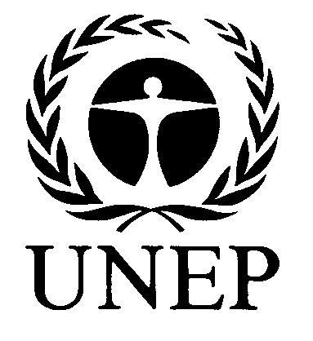 | 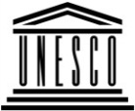 | 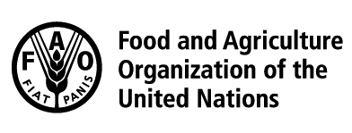 | 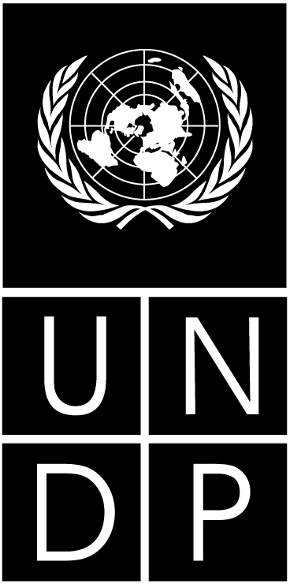 |  | BES
 |  |  |  |  |  |  | IPBES/5/4
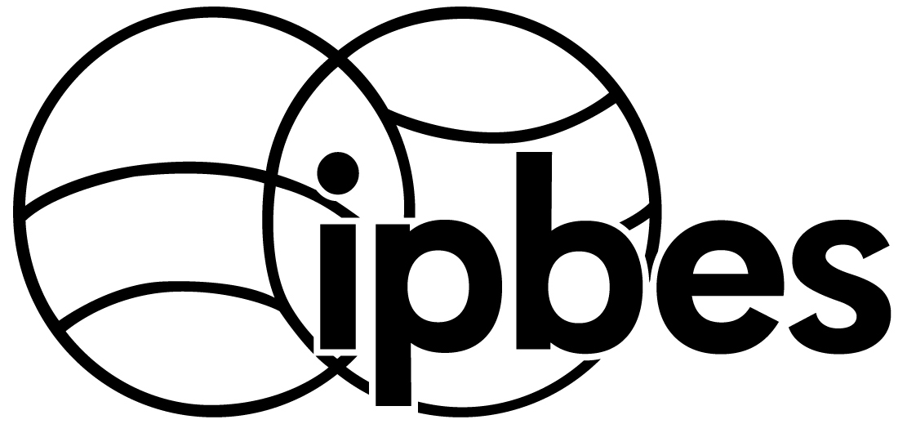 |  | Intergovernmental Science-Policy Platform on Biodiversity and Ecosystem Services |  |  |  |  | Distr.: General  20 December 2016  Original: English
Plenary of the Intergovernmental Science-Policy
Platform on Biodiversity and Ecosystem Services
Fifth session
Bonn, Germany, 7–10 March 2017
Item 6 (b) of the provisional agenda
Work programme of the Platform: indigenous and
local knowledge systems
Indigenous and local knowledge systems (deliverable 1 (c))
Note by the secretariat
Introduction
- The Plenary of the Intergovernmental Science-Policy Platform on Biodiversity and Ecosystem Services (IPBES), in decision IPBES-2/5, requested the Multidisciplinary Expert Panel and the Bureau, with support from the time-bound task force on indigenous and local knowledge, to develop draft procedures for and approaches to working with indigenous and local knowledge systems and, establish a roster and network of experts and a participatory mechanism for working with various knowledge systems.
- In decision IPBES-3/1, the Plenary noted the progress made in the development of draft procedures for and approaches to working with indigenous and local knowledge, and decided to continue to pilot the preliminary guide on approaches to and procedures for working with indigenous and local knowledge in the thematic assessments and in the four regional assessments. It also noted the progress made in the establishment of a roster of experts and a participatory mechanism for working with indigenous and local knowledge systems.
- In decision IPBES-4/3, the Plenary approved the procedures for working with indigenous and local knowledge systems, including holders of and experts in indigenous and local knowledge in IPBES assessment expert groups.
- Furthermore, in decision IPBES-4/1, the Plenary:
  - Took note of the progress made in piloting indigenous and local knowledge dialogue workshops and requested the continued piloting of such workshops in the preparation of assessments, with a view to considering the methodology that had been employed thus far in the organization of the workshops for submission to the Plenary at its fifth session;
  - Took note of the progress to date on the development of a roster of indigenous and local knowledge holders and indigenous and local knowledge experts, and urged the Multidisciplinary Expert Panel, in conjunction with the task force on indigenous and local knowledge systems, to further develop the roster;
  - Took note of the approach to the participatory mechanism for working with indigenous, local and various knowledge systems, and requested the Multidisciplinary Expert Panel, with the support of the task force on indigenous and local knowledge systems, to pilot the mechanism, report on progress made in piloting activities and make recommendations for the further development and implementation of the mechanism to the Plenary at its fifth session;
  - Requested the Multidisciplinary Expert Panel to report to the Plenary at its fifth session on progress made and options for bringing indigenous and local knowledge into Platform products, including, inter alia, processes for addressing prior informed consent, taking into account existing international, regional and national legal and non-legal frameworks, as appropriate; and
  - Requested the indigenous and local knowledge task force and the Multidisciplinary Expert Panel to continue, through an iterative process, to further develop, for consideration by the Plenary at its fifth session, the approaches to incorporating indigenous and local knowledge into the Platform.
I. Work undertaken and progress made in 2016
- In 2016 progress was made on issues related to indigenous and local knowledge as follows:
  - The piloting of indigenous and local knowledge dialogue workshops was continued in the preparation of the regional assessments, including:
    - The launch of calls for submissions of indigenous and local knowledge specifically relevant to the Asia-Pacific and Americas regional assessments and the gathering of case studies from the submissions received;
    - The facilitation of two dialogue workshops, one in Chiang Mai, Thailand
(26–28 June 2016), and one in Sucre (20–22 July 2016); and
    - The compilation of the proceedings of the dialogue workshops, including the case studies presented and discussed during those workshops, for consideration by the assessment expert groups;
  - Further development of approaches to working with indigenous and local knowledge in IPBES, building on the methodology followed to date, and consideration of other options, at the following meetings:
    - Multidisciplinary Expert Panel (Bonn, Germany, 6–10 June and 24–28 October 2016);
    - Task force on indigenous and local knowledge systems (Chiang Mai, Thailand,
20–24 June 2016);
    - First author meeting of the global assessment on biodiversity and ecosystem services (Bonn, Germany, 15–19 August 2016);
    - Joint second author meeting of the regional assessments and the land degradation and restoration assessment (Bonn, Germany, 22–26 August 2016);
  - Further development of the participatory mechanism and roster and their integration into the proposed approach to working with indigenous and local knowledge in IPBES, with some of their structural elements being added to the IPBES website.
- The proposed approach to working with indigenous and local knowledge is set out in the annex to the present note. It is multifaceted, combining different but interrelated ways of working with indigenous and local knowledge that cut across the four functions of IPBES and apply from the local to the global scales. It includes activities undertaken directly or catalysed by IPBES. It is guided by the task force on indigenous and local knowledge systems, with the support of its technical support unit, and will involve a wider community of stakeholders thanks to the participatory mechanism and collaboration with strategic partners.
- Further information on progress achieved since the fourth session of the Plenary is presented in the note by the secretariat on the matter (IPBES/5/INF/4).
II. Suggested actions
- The Plenary may wish to:
  - Approve the proposed approach to working with indigenous and local knowledge and request the Multidisciplinary Expert Panel, with support from the task force on indigenous and local knowledge systems, to implement that approach;
  - Invite indigenous peoples and local communities and their representatives, as well as experts in indigenous and local knowledge, to engage in the activities described in the approach, in particular through the participatory mechanism for working with indigenous and local knowledge systems;
  - Invite Governments, stakeholders, strategic partners and others to support activities that mobilize indigenous and local knowledge where such knowledge is needed but is not readily available to all, and that increase the capacity of indigenous people and local communities to engage in and benefit from the Intergovernmental Science-Policy Platform on Biodiversity and Ecosystem Services;
  - Request the Executive Secretary to make the necessary arrangements for implementing the approach, including the establishment of the participatory mechanism.

Annex
Proposed approach to working with indigenous and local knowledge in the Intergovernmental Science-Policy Platform on Biodiversity and Ecosystem Services
I. Overall framework
- The approach to working with indigenous and local knowledge in the Intergovernmental
Science-Policy Platform on Biodiversity and Ecosystem Services (IPBES) is multifaceted; cuts across the four functions of IPBES; considers various scales, from local to global; and involves activities to be undertaken or catalysed by IPBES (see section II below).
- Indigenous and local knowledge experts selected by IPBES will provide support to the approach, which will, in addition, involve a wide community of stakeholders via the participatory mechanism for working with indigenous, local and various knowledge systems (see section III below).
- The proposed approach is based on a number of overall considerations, definitions and principles, and on the identification of challenges, as described in the following paragraphs.
- In terms of overall considerations regarding the mandate, functions, means and operating principles of IPBES, the approach will:
  - Rely on activities undertaken by IPBES at the global, regional and, where appropriate, subregional levels, using available knowledge, which it will gather, synthesize, review and evaluate. The approach will also promote and catalyse activities that are beyond its mandate, such as the mobilization of knowledge that is not readily available, the generation of new knowledge or capacity-building activities, in collaboration with strategic partners;
  - Rely for its funding on dedicated resources in the trust fund, as well as on in-kind support from, and collaborative activities with, strategic partners;
  - Involve collaboration with relevant initiatives and build on appropriate work, standards and principles that have been developed and agreed on by relevant multilateral agreements and/or other entities. It will use clear, transparent and credible processes for the exchange, sharing and use of data, knowledge, information and technologies from all relevant sources.
- The approach is based on the following definitions of key terms, concepts and categories:
  - Indigenous and local knowledge systems are understood to be dynamic bodies of integrated, holistic, social and ecological knowledge, practices and beliefs pertaining to the relationship of living beings, including people, with one another and with their environment. Indigenous and local knowledge is grounded in territory, is highly diverse and is continuously evolving through the interaction of experiences, innovations and different types of knowledge (written, oral, visual, tacit, practical and scientific). Such knowledge can provide information, methods, theory and practice for sustainable ecosystem management. Indigenous and local knowledge systems have been, and continue to be, empirically tested, applied, contested and validated through different means in different contexts.
  - Maintained and produced in individual and collective ways, indigenous and local knowledge is at the interface between biological and cultural diversity. Manifestations of indigenous and local knowledge are evident in many social and ecological systems. In this context, the approach understands “biocultural” as describing a particular state resulting from the interaction of people and nature at a given time and in a given place and “biocultural diversity” as a dynamic, place-based aspect of nature arising from links and feedback between cultural diversity and biological diversity.
  - The approach does not intend to provide or work with unique definitions of what constitutes “indigenous and local knowledge” or “indigenous peoples and local communities”, as these definitions are often context specific and vary within and across regions.
  - Indigenous and local knowledge holders are understood to be people situated in the collective knowledge systems of indigenous peoples and local communities with knowledge from their own indigenous peoples and local communities; indigenous and local knowledge experts are understood to be people from indigenous peoples and local communities who have knowledge about indigenous and local knowledge and associated issues (they may also be indigenous and local knowledge holders); and experts on indigenous and local knowledge are understood to be people who have knowledge about indigenous and local knowledge and associated issues, not necessarily from indigenous peoples and local communities.
- Involving indigenous and local knowledge in a dialogue with other knowledge systems will bring important new perspectives to IPBES, resulting in a convergence or divergence of ideas and views. This dialogue will need to respect the following general principles:
  - An effective dialogue will require the building of mutual trust and confidence between indigenous and local knowledge holders and natural and social scientists through cultural respect and sensitivity.
  - The approach will need to provide opportunities for dialogue with indigenous peoples and local communities focusing on topics relevant to IPBES, through the development of initiatives by and/or in collaboration with IPBES members and existing networks of indigenous peoples and local communities and of experts on indigenous and local knowledge.
  - The approach should allow time for decision-making through customary and traditional institutions to dialogues at different levels (for example, extended family groups, indigenous peoples who may hold different rights with respect to knowledge) with relevant institutions to identify common goals in the development of IPBES deliverables.
  - The approach should work in culturally appropriate environments, respecting diverse and interactive styles of engagement, using effective tools and strategies to allow inputs from and potential bridges across various knowledge systems.
  - The approach should promote a participatory and empowering dialogue based on
non-discrimination, inclusiveness, affirmative action and recognition of social, cultural, economic and political plurality in the world, seeking free prior informed consent and adhering to relevant agreements, conventions and settlements.
  - The approach should strengthen and enrich the in situ knowledge systems of indigenous peoples and local communities where knowledge is gathered, used, applied, renewed, enhanced, tested, validated, transmitted, shared and governed, as well as the dialogue between knowledge systems as an iterative two-way process. It should deliver policy-relevant knowledge and policy options to indigenous peoples and local communities in meaningful and useful forms.
- The approach seeks to address a broad range of general challenges, including the following:
  - Scale. Scale matters in the definition, collation, compilation and aggregation of knowledge both horizontally (e.g., across local communities) and vertically (scaling knowledge up and down). While most indigenous and local knowledge is inherently local and contextual, IPBES operates at the regional and global levels and critically evaluates policy-relevant knowledge. Mobilizing relevant indigenous and local knowledge, and ensuring validation through the original knowledge system, comprehensiveness and representativeness while avoiding loss of legitimacy, represents a major challenge. Related challenges include representation and participation (addressed in point (b) below) and analytical challenges, as the type and level of complementarity across knowledge systems will vary according to the context, the issue addressed and the desired outcomes.
  - Participation and representation. Meaningful participation and engagement of indigenous peoples and local communities play an important role in working with indigenous and local knowledge. The challenge is to find ways and means that allow for meaningful participation and adequate representation within the existing mandate, rules and procedures, and available resources of IPBES.
  - Formats. Indigenous and local knowledge often exists in written formats other than
peer-reviewed literature, such as grey literature, or in other forms, such as oral, dance, song and visual manifestations, including symbols, documentaries and artwork. Sometimes knowledge holders have not recorded their knowledge in any form, or it has been transmitted in a non-tangible form. The variety of formats and the difficulty of accessing them pose a major challenge. Guidance and methods will be developed for addressing the variety of available formats. Where indigenous and local knowledge is unrecorded or recorded only in non-tangible forms, ways and means of recording that knowledge in tangible products that do not conflict with the IPBES mandate will be considered.
  - Methods and tools. Many of the methods and specific tools needed for this work do not yet exist and will need to be developed by IPBES taking into account all of the above.
- This approach, which is breaking new ground, should be understood as a first step in a long journey, in which indigenous peoples and local communities are key partners.
II. Overall proposed approach to working with indigenous and local knowledge
- The following proposed approach, which cuts across the four functions of IPBES, sets out activities for each of the four functions.
A. Assessments
- Assessing available knowledge forms the backbone of this approach. It includes four phases:
- The first phase, the collaborative definition of problems and goals, is to be realized during the scoping of the assessment, and should result in the development of key questions for the assessment. In general, it is suggested that the following broad groups of questions be considered:
  - What are the contributions of indigenous peoples and local communities in terms of their knowledge, practices and world views to the management and conservation of nature, delivery of nature’s contributions to people and ensuring a good quality of life at the regional and global scales?
  - What are the most important pressures and factors undermining these contributions, as well as affecting the quality of life of present and future generations of indigenous peoples and local communities?
  - What policy responses, measures and processes exist to strengthen and improve the governance of nature and nature’s benefits to people with regard to indigenous peoples and local communities and their knowledge and practices?
- The second phase is about bringing together a wide array of evidence and data from multiple sources of indigenous and local knowledge for the assessment itself, once approved to be undertaken, including:
  - Literature reviews, synthesis reports, geospatial data, and sources of indigenous and local knowledge documented in accessible written form;
  - Recorded, referenceable and accessible indigenous and local knowledge manifested in forms such as song, oral history, dance and the like;
  - Compilation of literature, data and cases from other IPBES assessments and related reports;
  - Compilation of reports and data from international research centres and institutions and relevant regional centres;
  - Compilation of spatially explicit data and geospatial data sources.
- The third phase focuses on appropriately engaging indigenous peoples and local communities in the review of the various drafts of a specific assessment.
- The fourth phase aims at “giving back” knowledge and insights gained through the assessment to indigenous peoples and local communities once the assessment is concluded. Giving back would entail a joint evaluation of the key findings and their implications, including reassessing knowledge gaps and catalysing the generation of new knowledge, as well catalysing capacity-building activities to support the uptake of lessons learned and good practices.
- Important procedural components and activities of these four phases include:
  - Adequate representation of indigenous and local knowledge experts and experts on indigenous and local knowledge in the expert groups scoping and performing the assessment in line with the principles presented above;
  - A series of broad web-based consultations via the participatory mechanism during the first, second and third phases to ensure broad participation by indigenous peoples and local communities, and adequate reflection of their perspectives and of indigenous and local knowledge, in the scoping exercise (first phase); the fine-tuning of questions to be addressed by the assessment and the identification, mobilization and gathering of relevant indigenous and local knowledge where such knowledge exists in recorded, shareable and referenceable form (second phase); and the review of the successive drafts of the assessment (third phase);
  - Three dialogue workshops, one at the scoping stage (first phase) and one during each of the two reviews of the assessment report (third phase) to allow for direct exchanges on the scope and the content of the drafts. These workshops would bring together the indigenous and local knowledge experts of the scoping expert group (first phase) or of the indigenous and local knowledge liaison group (third phase) with a representative selection of experts on and representatives of indigenous peoples and local communities;
  - The synthesis, during the second phase, of the indigenous and local knowledge gathered, using established methods such as the reflection of confidence levels as defined in the guide for assessments (IPBES/5/INF/6), seeking to balance large-scale synthesis and spatial upscaling of literature and geospatial data sources with a rich illustration of cases from different parts of the world portraying the practices, world views, voices and faces of indigenous peoples and local communities. This synthesis would include the description of different understandings resulting from different epistemologies and/or ontologies;
  - The promotion and catalysis of activities to be undertaken by strategic partners, such as local dialogue workshops to fill knowledge gaps when relevant knowledge does not exist in readily available formats (first and second phase), or the building of the capacity of indigenous peoples and local communities to engage in and benefit from IPBES (throughout all four phases). These efforts are part of the knowledge mobilization and capacity-building approach to indigenous and local knowledge (further described in paragraphs 16 and 18 below).
B. Knowledge and data
- The objective of the approach with respect to the work of IPBES on knowledge and data is to:
  - Facilitate, via the IPBES web-based infrastructure, the accessing and management of sources of indigenous and local knowledge, both for internal use in developing assessments and for decision makers and scholars drawing on the work of IPBES to support their own work, in line with relevant standards and conventions;
  - Promote and catalyse the mobilization of indigenous and local knowledge where such knowledge does not exist in readily available formats in ways that reflect the principles of parallel validation or co-production processes, with the support of appropriate partners, focusing on gaps that would emerge during each phase of the assessment; and
  - Reflect appropriately those aspects relevant to indigenous and local knowledge and indigenous peoples and local communities in the list of indicators, classifications of units of analysis and classification of nature’s contributions to people.
C. Policy support tools and methodologies
- IPBES is mandated to identify policy support tools and methodologies, facilitate their use, and promote and catalyse their further development. In this context, the proposed approach would:
  - Identify, describe and facilitate the use of relevant tools and methods to implement the four phases of the proposed approach. Where such tools and methods still need to be developed, IPBES would promote and catalyse their development with appropriate partners;
  - Ensure that policy responses, decision-making instruments and processes relevant to indigenous and local knowledge and indigenous peoples and local communities are being assessed in the respective assessments.
D. Capacity-building
- In line with its mandate, the proposed approach in the context of capacity-building would:
  - Identify, prioritize and build capacity critical to its implementation, within the means available, through, for example, training workshops and webinars on the approaches to and procedures for working with indigenous and local knowledge in assessments or participation in the fellowship programme; and
  - Promote and catalyse the undertaking of capacity-building activities in support of broader capacity-building needs involving, among other mechanisms, strategic partnerships, where such needs go beyond the means of IPBES. In this context, the participatory mechanism could strengthen the ability of indigenous peoples and local communities to take part in, contribute to and profit from IPBES deliverables.
III. Institutional arrangements and the participatory mechanism supporting the implementation of the proposed approach
- In order to implement the proposed approach outlined in section II, IPBES would draw on relevant existing arrangements, which would need to be complemented by the participatory mechanism.
A. Existing arrangements relevant to the implementation of the proposed approach
- The Multidisciplinary Expert Panel will oversee the further development and implementation of this approach. The task force on indigenous and local knowledge systems will provide advice to the Panel and develop specific methodological guidance, as necessary, in close collaboration with the indigenous and local knowledge liaison groups.
- Indigenous and local knowledge liaison groups will be established for each assessment. Such groups will comprise the indigenous and local knowledge experts and experts on indigenous and local knowledge selected for the various chapters of each individual assessment. The groups will be responsible for developing the key questions and topics pertaining to indigenous peoples and local communities to be covered in any assessment, for synthesizing all relevant knowledge, and for ensuring that each assessment adequately reflects the perspectives resulting from different knowledge systems.
- Other task forces and expert groups, such as the task forces on knowledge and data and on capacity-building, as well as the expert groups on values and on policy support tools and methodologies, will also provide support to the implementation of this approach.
- The secretariat, including its technical support unit on indigenous and local knowledge, will provide support for the implementation of this approach.
B. Participatory mechanism for working with indigenous and local knowledge systems
- The objective of the participatory mechanism, as mandated by the Plenary, is to facilitate the effective and meaningful engagement of a self-organizing network of indigenous and local knowledge holders, indigenous and local knowledge experts and their organizations or networks in order to strengthen their ability to contribute to and benefit from IPBES at all scales.
- In line with the rules and procedures of IPBES and in accordance with the universally accepted rights of indigenous peoples and local communities, the participatory mechanism is to achieve this objective by inter alia:
  - Providing a web-based platform to facilitate effective and meaningful engagement of existing networks of indigenous peoples and local communities and relevant experts, and allowing new networks to develop;
  - Promoting, through consultations, a dialogue with different networks, relevant experts and policymakers to mobilize inputs and disseminate results during all four phases of the assessment process, including both web-based consultations and dialogue workshops;
  - Creating opportunities for shared learning and exchange through dedicated discussion forums on the web-based platform or in the context of the contribution to and use of the catalogue of policy support tools and methodologies; and
  - Supporting IPBES, by means of strategic partnerships, in promoting and catalysing activities that build the capacity of indigenous peoples and local communities to engage effectively and meaningfully in IPBES, and that mobilize indigenous and local knowledge in formats accessible to IPBES, when such knowledge is missing.
- The central component of the participatory mechanism would be a web-based platform, managed by the secretariat and hosted on the IPBES website (http://www.ipbes.net/ilk-participatory-mechanism), comprising the following elements:
  - A registry linked to the IPBES stakeholder registry, inclusion in which is mandatory for all actors wishing to participate, including individuals, social organizations, institutions and networks;
  - A roster including all registered individuals or entities as well as all indigenous and local knowledge experts currently or formerly involved in IPBES. This roster would be searchable according to a variety of criteria and publicly available;
  - A repository of relevant resources of indigenous and local knowledge displaying a broad range of relevant sources of information, knowledge and data sets related to indigenous and local knowledge, or links to such information, knowledge and data sets, and thus forming an institutional database to facilitate the mobilization of data and knowledge relevant for gap-filling and dialogue;
  - A display of ongoing activities pertaining to indigenous and local knowledge, including those described in section II above, such as web-based consultations, dialogue workshops, capacity-building activities and activities mobilizing accessible indigenous and local knowledge;
  - A discussion forum creating opportunities for shared learning and exchanges between indigenous and local knowledge systems and other knowledge systems;
  - A place to self-organize for members of the participatory mechanism, including for subgroups that members may seek to establish, such as dedicated groups providing support to specific IPBES assessments.
- The web-based platform would support the dedicated consultations foreseen as part of the four phases:
  - Broad web-based consultations, including opportunities for surveys, discussions and the sharing of relevant knowledge material;
  - Dialogue workshops, three of which would ideally be held for each assessment – the first as part of the scoping process (and in addition to the scoping workshop included in each assessment), and the second and third as part of the process to review the first- and second-order drafts of the assessment. With about 20 participants, each workshop would cost an estimated $50,000.
- IPBES will engage in strategic partnerships to:
  - Ensure the broad reach of and adequate engagement in the online consultation and dialogue workshops;
  - Promote and catalyse the mobilization of indigenous and local knowledge in accessible formats to address gaps identified by appropriate partners; and
  - Promote and catalyse the undertaking of capacity-building activities that strengthen the ability of indigenous peoples and local communities to take part in, contribute to and profit from IPBES deliverables.

IPBES/5/1/Rev.1.
Such as the Permanent Forum on Indigenous Issues and the Working Group on Article 8 (j) of the Convention on Biological Diversity.

