UNITED  NATIONS |  |  | 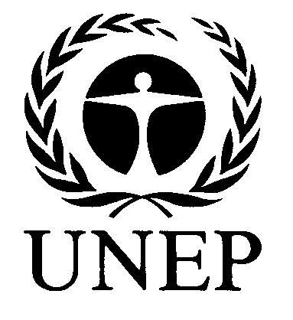 |  | 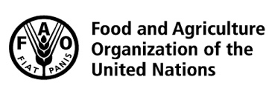 | 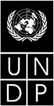 |  | BES
 |  |  |  |  |  |  | IPBES/6/INF/30/Rev.1
 |  | Intergovernmental Science-Policy Platform on Biodiversity and Ecosystem Services |  |  |  |  | Distr.: General  21 February 2018  English only
Plenary of the Intergovernmental Science-Policy
Platform on Biodiversity and Ecosystem Services
Sixth session
Medellin, Colombia, 18–24 March 2018
Item 2 (c) of the provisional agenda*
Organizational matters: election of members of the Multidisciplinary Expert Panel
Compilation of curricula vitae of proposed members of the Multidisciplinary Expert Panel: proposals from Western European and other States
Note by the secretariat
The annex to the present note, which is presented without formal editing, sets out a compilation of the curricula vitae of the candidates proposed for membership of the Multidisciplinary Expert Panel, as submitted by Western European and other States. The curricula vitae have been made available, as received, from https://www.ipbes.net/nominations/mep-2017.
Annex
Compilation of curricula vitae of proposed members of the Multidisciplinary Expert Panel:
proposals from Western European and other States
Nominated by | Name | Affiliation | Expertise | Gender | Link to curriculum vitae
Australia | Donald Anton | Griffith University Law School | International law | Male | https://www.ipbes.net/sites/default/files/anton_cv_nov_2017.pdf
Australia | Kirsten Davies | Macquarie University | Environmental law | Female | https://www.ipbes.net/sites/default/files/dr_kirsten_davies_cv.pdf
Australia | Judith Fisher | Fisher Research Ltd. | Plant ecology | Female | https://www.ipbes.net/sites/default/files/juidth_fisher_brief_cv_29_january_2018.pdf
Australia | Thomas Reuter | University of Melbourne | Anthropology | Male | https://www.ipbes.net/sites/default/files/cv_reuter_2018_short.doc
Australia | Kamaljit Kaur Sangha | Charles Darwin University | Plant ecology | Female | https://www.ipbes.net/sites/default/files/kamal_cv_dec_2016_res_nr_0.docx
Belgium | Nele Witters | Center of Environmental Economics, Hasselt University | Valuation of biodiversity | Female | https://www.ipbes.net/sites/default/files/cv_witters_ipbes_02122017.pdf
Denmark | Carsten Rahbek | Natural History Museum of Denmark, University of Copenhagen | Macroecology | Male | https://www.ipbes.net/sites/default/files/curriculum_vitea_carstenrahbek_dk.pdf
Finland | Heikki Hokkanen | University of Helsinki | Agricultural zoology | Male | https://www.ipbes.net/sites/default/files/hokkanen_cv_2018_1.pdf
Finland | Janne Kotiaho | Department of Biological and Environmental Sciences, University of Jyväskylä | Ecology, evolution, and humanities | Male | https://www.ipbes.net/sites/default/files/20171127_kotiaho_cv_listofpublications.docx
Finland | Tiina Nieminen | Natural Resources Institute Finland, Luke | Forest management | Female | https://www.ipbes.net/sites/default/files/nieminen_tm_cv.pdf
France | Alain Karsenty | Centre de Coopération Internationale en Recherche Agronomique pour le Développement (CIRAD) | Economy, agronomy | Male | https://www.ipbes.net/sites/default/files/cv_ak_english.pdf
France | Esther Katz | Institut de Recherche pour le Développement (IRD)/Muséum National d'Histoire Naturelle (MNHN) | Anthropology, ethnobiology | Female | https://www.ipbes.net/sites/default/files/katz_cv_2017_eng.pdf
France | Sandra Lavorel | Université Grenoble Alpes, | Global change ecology, science-policy | Female | https://www.ipbes.net/sites/default/files/cv_sl_short-en_dec17.pdf
France | Virginie Maris | Centre d'Ecologie Fonctionnelle et Evolutive - Centre National de la Recherche Scientifique  (CEFE - CNRS) | Philosophy | Female | https://www.ipbes.net/sites/default/files/2017-11_v_maris_-_short_cv_in_english.pdf
Netherlands | Esther Turnhout | Forest and Nature Conservation Policy Group, Wageningen University | Politics of environmental knowledge | Female | https://www.ipbes.net/sites/default/files/mini_curriculum_vitae_esther_turnhout.pdf
New Zealand | Philip Seddon | University of Otago | Ecological restoration, pest control | Male | https://www.ipbes.net/sites/default/files/seddon-cv-ipbes_2018.docx
Portugal | Isabel Sousa Pinto | University of Porto | Marine biology | Female | https://www.ipbes.net/sites/default/files/cv_isabel_sousa_pinto_2017_.pdf
Sweden | Marie Stenseke | Department of Economy and Society, University of Gothenburg | Human geography | Female | https://www.ipbes.net/sites/default/files/cv_marie_stenseke_20171107.docx
Switzerland | Markus Fischer | University of Bern | Conservation biology, science-policy interface | Male | https://www.ipbes.net/sites/default/files/cv_markusfischer03122017ipbesmepnomination.pdf

* IPBES/6/1.

