UNITED  NATIONS |  |  |  |  | 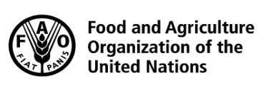 |  |  | BES
 |  |  |  |  |  |  | IPBES/6/INF/19
 |  | Intergovernmental Science-Policy Platform on Biodiversity and Ecosystem Services |  |  |  |  | Distr.: General  8 January 2018  English only
Plenary of the Intergovernmental Science-Policy
Platform on Biodiversity and Ecosystem Services
Sixth session
Medellin, Colombia, 18–24 March 2018
Item 5 of the provisional agenda*
Report of the Executive Secretary on the implementation
of the first work programme for the period 2014–2018
Implementation of the communications and outreach strategy and the stakeholder engagement strategy
Note by the secretariat
- In decision IPBES-3/4, on communications, stakeholder engagement and strategic partnership, the Plenary of the Intergovernmental Science-Policy Platform on Biodiversity and Ecosystem Services (IPBES) took note of the communications and outreach strategy and requested the secretariat, subject to the availability of funds, to undertake the activities described in the initial implementation plan set out in the appendix to the strategy. An update on that implementation was noted by the Plenary in decision IPBES-4/4.
- In decision IPBES-3/4, the Plenary also welcomed the revised draft stakeholder engagement strategy and requested the secretariat to undertake activities to implement it in collaboration with an open-ended network of stakeholders. In decision IPBES-4/4 (section II), the Plenary requested the Executive Secretary to collaborate with the open-ended networks of stakeholders, to undertake the activities set out in the initial implementation plan of the stakeholder engagement strategy and to finalize the institutional arrangements needed to establish such strategic partnerships.
- Subsequent reporting by the secretariat on progress on communications activities and stakeholder engagement, outlined in documents IPBES/5/9, IPBES/5/INF/15 and IPBES/5/INF/16, was noted by the Plenary at its fifth session (IPBES/5/15, section VI H).
- The annex to the present note sets out information on the further implementation of the communications and outreach strategy (part I) and on the implementation of the stakeholder engagement strategy (part II). The annex is presented without formal editing.

Annex
Part I
Implementation of the communications and outreach strategy
I. Day-to-day communication
- Updated visual identity guidelines. Premised on the earlier approval by the Bureau, of updated specifications for the use of the IPBES logo, typography and color palette (see IPBES/5/INF/15), the secretariat, with the support of a professional branding agency, has updated the IPBES visual identity guidelines, which were approved by the Bureau at its 9th meeting. These updated visual identity guidelines are presented, for the information of the Plenary, in appendix I.
- Website. One of the consequences of the budget reductions agreed by the Plenary at its 5th session was the cancellation of the planned comprehensive audit of the IPBES website, which would have reviewed its structure and functionality, to help determine the scope of work in the next phase of website development. The secretariat, has, however, completed a substantial redevelopment of the website – including, among others, its migration to a new, more secure cloud-based server; the creation of significant new functionality in support of IPBES administrative work, policy support tools, communities of practice and stakeholder networks; a much-improved search mechanism; updated content; the streamlining of key IPBES databases for better data collection and analysis and a more intuitive user-interface. The addition to the secretariat of a new G-5 information systems assistant in 2018 will create additional capacity to accelerate and intensify this process of website improvement.
- IPBES acronym. To give effect to the extension by the Bureau of the scope of the IPBES logo use policy to include requests for authorization of the use of the IPBES acronym by third parties in their names, the secretariat has established guidelines on the use of the IPBES acronym in the name of
third-party organizations, reflected for the information of the Plenary in appendix II.
- Videos. Two new IPBES outreach videos have been professionally produced in 2017 – a six-minute video on the IPBES Assessment of Pollinators, Pollination and Food Production, and a four-minute video on the IPBES Assessment of Scenarios and Models of Biodiversity and Ecosystem Services. Both videos have been subtitled in all six of the official United Nations languages, to increase their reach and impact, and both are also available as shorter, stand-alone segments for use on social media platforms. The secretariat is also working with a professional video agency to produce ‘B-roll’ video material to amplify the reach of the five IPBES assessments that are planned to be launched at the sixth session of the Plenary, as well as 16 short video clips for use on social media to further promote the launches and uptake of the assessments. There will also be two further outreach videos produced by mid-2018 – a five-minute video on the IPBES land degradation and restoration assessment and a seven-minute video on the four IPBES regional assessments, to support the regional, subregional and national events to promote uptake of the assessments. Both will be subtitled in all six official United Nations languages and both will also be available as shorter, stand-alone segments for use on social media platforms.
- Multilingual outreach. Although the official working language of IPBES is English, to increase the reach and impact of IPBES’s communications, the secretariat has piloted in 2017 a number of multilingual outreach products and messages in all six official languages of the United Nations. The ‘What is IPBES?’ information brochure, the new outreach videos and the IPBES message ‘primers’ have, for instance, been produced in all six languages, as have a number of official notifications and calls. This commitment to multilingualism in communications and outreach will be continued in 2018, resources permitting.
- Social media. Informed by a comprehensive 12-month integrated digital communication and outreach strategy, IPBES has seen exponential growth from the start of May 2017 in terms of its social media footprint, engagement and influence, and is well on-track to meet and significantly exceed its annual targets. Detailed information about this performance is set out in appendix III.
- Traditional media.
  - All IPBES media contacts have now been consolidated into a central online media database, to facilitate maintenance and ease of use. These have also been greatly expanded by the secretariat in 2017, from just over 1,000 contacts in January to more than 2,800 by December, through new research, close collaboration with key IPBES strategic partners and the assistance of a professional public relations firm.
  - Focusing on the exploration of joint opportunities relating to the planned launch of five new assessments at the sixth session of the IPBES Plenary, collaboration on traditional and social media outreach with IPBES partners and advocates has been widely expanded in 2017. With a concentration on IPBES’s four core United Nations partners, stakeholder networks and key strategic allies, bilateral and multilateral discussions have achieved new levels of agreement on mutual support and promotion – especially with regards to the five assessments planned to be launched at the sixth session of the Plenary and the global assessment of biodiversity and ecosystem services.
  - Access to comprehensive social and traditional media monitoring facilities has been secured by the secretariat, with real-time ‘breaking news’ alerts now in place for immediate action on communications risks and opportunities, daily and weekly summaries of both IPBES-specific mentions and developing news that relates to the IPBES work programme and global, regional and national-level access to online, print and broadcast news in a range of languages.
  - The results of these efforts are already evident. Since the start of 2017, IPBES has been mentioned more than 970 separate times in online news sources, in 26 languages and more than 75 countries – all this in a period when no new assessments have been launched. This equates to an aggregate online potential reach of more than 800 million people, with an advertising value equivalency (online only) in excess of $7.6 million. A single recent Reuters article, about the new IPBES message ‘primers’, was published in at least ten countries by 24 separate news organizations. A recent article by the IPBES Chair, promoting the ongoing IPBES assessments, was published in 24 countries, in the print editions of eight different newspapers and online at more than 23 news sites – with potential online reach of more than 4.6 million people. Regularly updated details of IPBES media coverage can be accessed online at https://goo.gl/k4bF3J
II. Preparations for the launch of assessments in 2018
- Informed by the key learnings from the launch of the first two IPBES assessment reports in 2016, the secretariat, supported by specialist media and public relations professionals (as described in IPBES/5/9), has been working extensively in 2017 to plan, prepare and begin the early implementation of promotional and outreach activities to maximise the reach and impact of the planned launch in March 2018 of the four IPBES regional assessment reports on biodiversity and ecosystem services, as well as the assessment report on land degradation and restoration.
- The specific activities to promote the importance of these five assessment reports, including their key messages and policy options (once approved by the Plenary), to the media and decision makers, have been clustered into three distinct phases – before, during and after the approval of the assessment reports by the Plenary. An overview of the three-phase approach and some of the specific activities planned to be undertaken in each of the three phases was noted by the MEP and Bureau at their ninth meetings, and is presented for the information of the Plenary in appendix IV.
- A central element of the first (‘Pre-Launch’) phase is the set of message ‘primers’ - one each for the four regional assessments, one for the assessment of land degradation and restoration, as well as a sixth general primer with information about all the assessments. To increase their reach and impact, the primers have also been translated into the five other official United Nations languages. The primers are short briefing documents that provide key information about each of the assessments, designed to help decision makers, stakeholders, media and other interested parties understand the scope, scale and significance of the assessments – but not to preview any of the draft key messages. The general primer and the primer on land degradation and restoration are available in all six languages, with the four regional assessment primers available in those languages most relevant to the respective region. The general primer is presented, as an example of these texts, for the information of the Plenary in appendix V. The full set of primers and all of the translated versions can be accessed on and downloaded from the IPBES website at www.ipbes.net/ipbes-6-primers
Part II
Implementation of the stakeholder engagement strategy
- Progress was made in 2017 regarding institutional arrangements necessary to facilitate collaboration on implementation of the stakeholder engagement strategy between the secretariat and open-ended networks of IPBES stakeholders (decision IPBES-4/4). These include, among others, the guidelines on the use of the IPBES acronym in the names of third-party organizations (reflected in appendix II) and the creation, on the IPBES website, of additional architecture to support the hosting and maintenance of the online presence of such networks, their inter-network collaboration, as well as their integration into the newly-established IPBES communities of practice
- As a result of the finalization of these arrangements, the Open-ended Network of IPBES Stakeholders (formerly the IPBES Open-ended Stakeholder Network) has notified the secretariat of its willingness to adopt and abide by the new guidelines, its intention to accept the invitation of the secretariat to host its online presence on the IPBES website and its progress in moving ahead with the formal creation of the Network.
- The phased implementation of the stakeholder engagement strategy (IPBES/5/INF/16) had specified that, in 2017, the roll-out of the third phase would focus on filling the ‘gaps’ identified in the stakeholder needs analysis survey, with specific concentration on underrepresented and unrepresented stakeholder categories. Some of the envisaged elements of the roll-out, such as the “roadshow” elements for members of the MEP and Bureau and selected experts, proved unfeasible in light of the reduced budget agreed by the Plenary at its fifth session. The efforts of the secretariat, with technical in-kind support by the International Union for the Conservation of Nature (IUCN) and a number of interns, have instead focused on data-mining the existing set of IPBES social media ‘followers’ and ‘fans’ to identify prospective organizations and individuals who had not yet engaged as registered IPBES stakeholders and who could be approached to consider such registration and engagement. This process is ongoing.

Appendix I
Updated IPBES visual identity guidelines
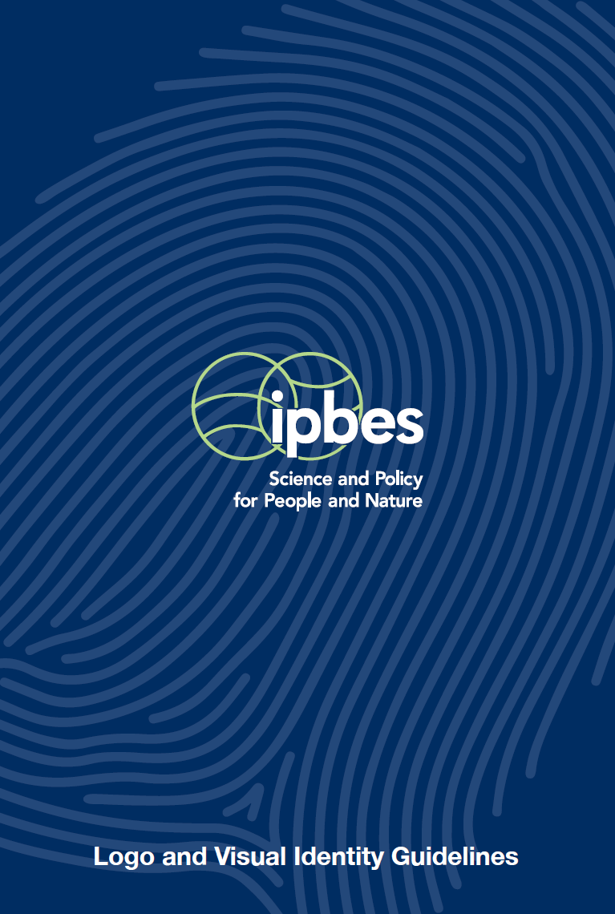
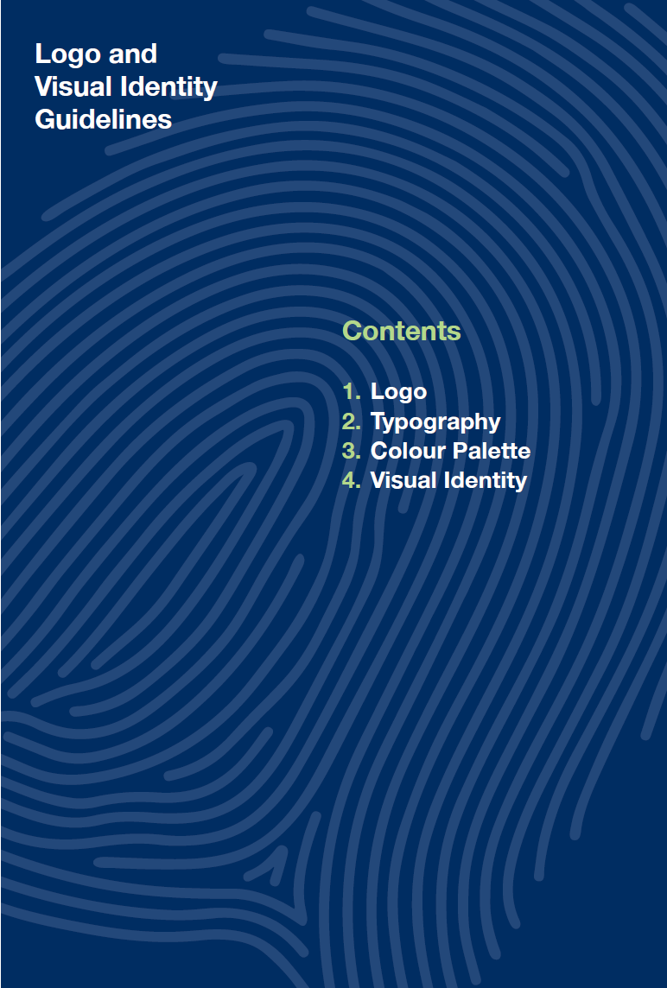
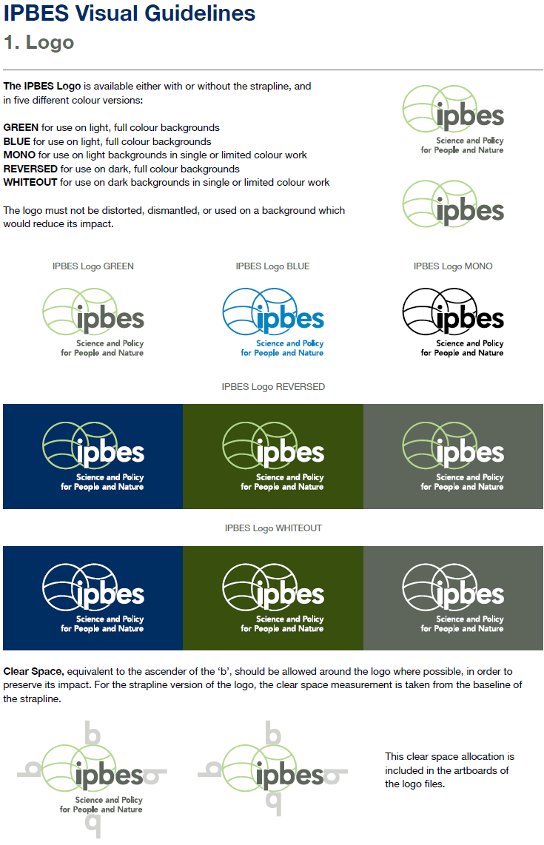
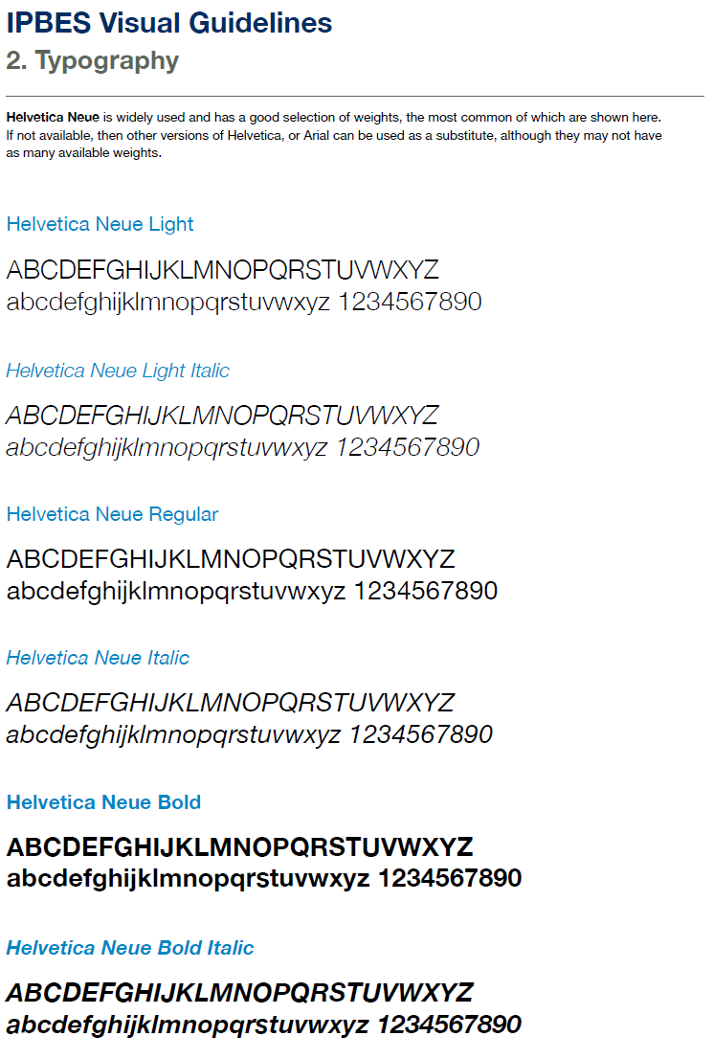
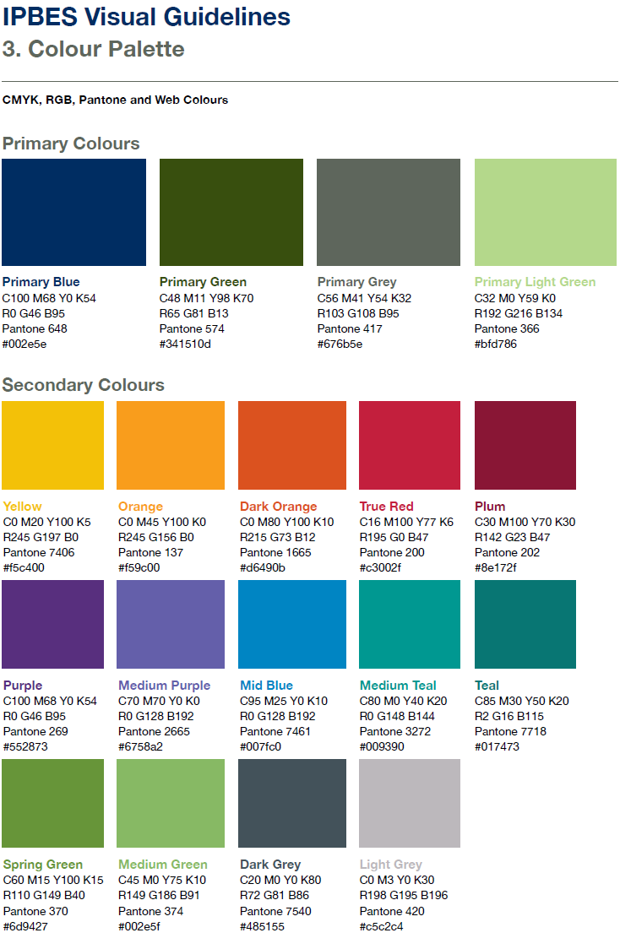
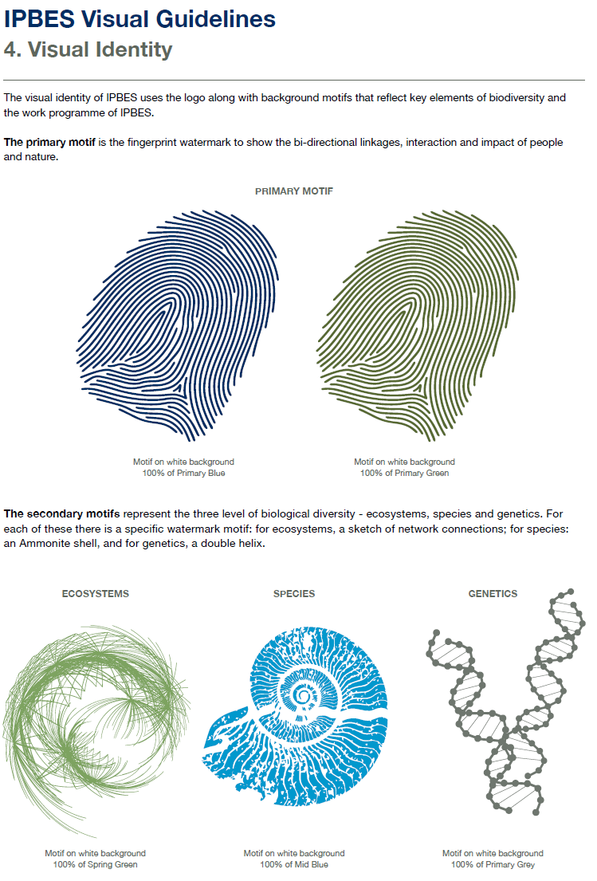
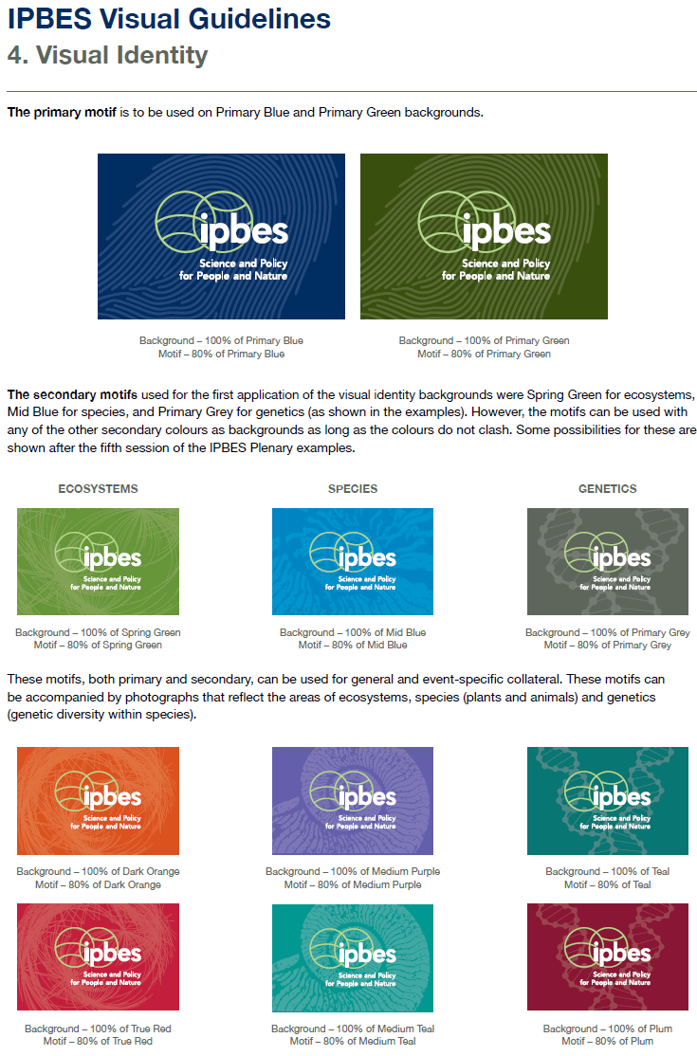
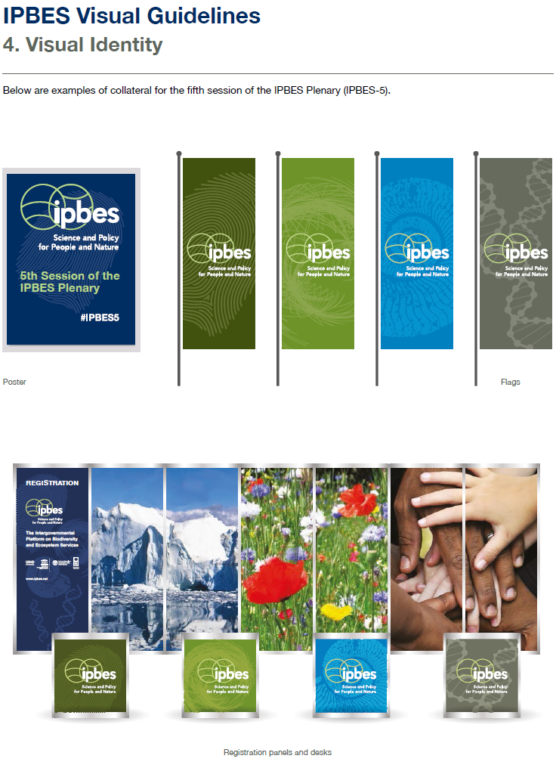
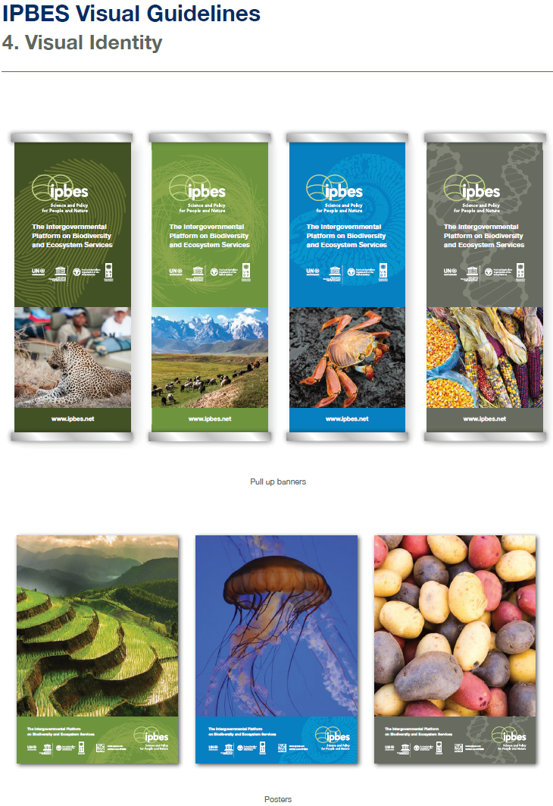
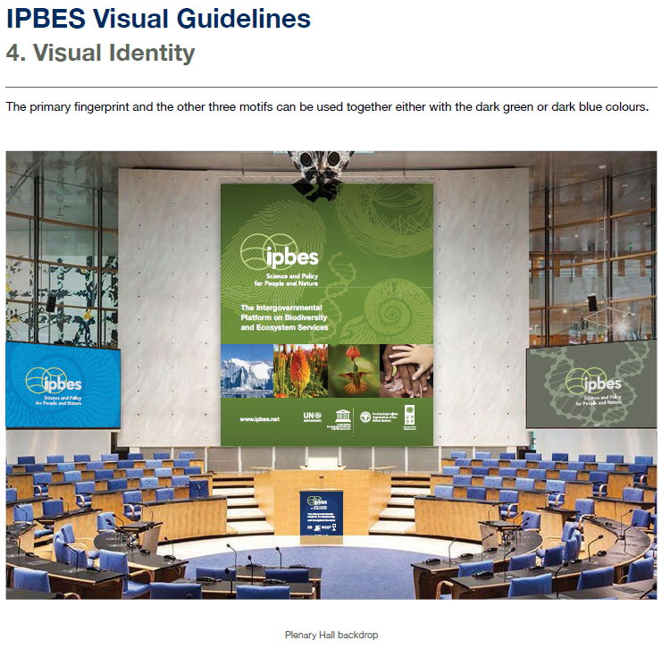

Appendix II
Guidelines on the use of the IPBES acronym in the name of third-party organizations
The acronym “IPBES” stands for “The Intergovernmental Science-Policy Platform on Biodiversity and Ecosystem Services”.
The IPBES acronym is an integral part of the IPBES brand, and will be widely promoted for general use, publicity and interaction by whole IPBES community.
IPBES reserves all rights, however, to the use of its acronym as part of the name/s of any and all third-party organizations, institutions and groups.
Only the IPBES secretariat, acting on behalf of the IPBES Bureau, may grant permission for the IPBES acronym to be used as part of the name/s of any and all third-party organizations, institutions and groups. Such permission may only be given in writing, by the Executive Secretary of IPBES.
Applications for the use of the acronym as part of the name/s of any and all third-party organizations, institutions and groups must be received in writing, and will only be granted by the secretariat, if the organization, institution or group is demonstrably aligned with the mission of IPBES, poses little or no reputational risk to the IPBES brand, and is both able and willing to substantively contribute to the deliverables of the IPBES work programme over an extended period.
Any organization, institution or group wishing to apply for such authorization must agree that they and all their members will act in the best interests of the IPBES brand, specifically that they:
Will not warrant, represent or imply that any product, publication, service or opinion is that of IPBES, unless it is issued by the IPBES secretariat, without alteration, interpretation or elaboration.
Will not enter into any agreements or contracts and will not incur any liabilities on behalf of IPBES.
Will not associate or imply association of IPBES with any other third-parties – especially those which may have a commercial or political purpose. This specifically includes association by visual branding or juxtaposition on all materials, printed, electronic and otherwise.
Will not grant or imply IPBES’s endorsement of any product, publication or service.
Will not bring the IPBES brand into disrepute.
If, at the sole discretion of the IPBES Executive Secretary, any of the above guidelines are breached, authorization for the use of the IPBES acronym as part of the name/s of any and all third-party organizations, institutions and groups can be immediately revoked, by written notice to that party. Any and all resulting costs and/or liabilities will be entirely to the account of the third party.

Appendix III
IPBES social media performance
Social media performance, across all social media platforms, is normally measured in terms (a) numbers of social media ‘followers’ and ‘fans’ (b) ‘reach’ reflected by total impressions/number of times posts and updates are viewed/accessed (c) ‘engagement’ as evidenced by either the average percentage of fans/followers who interact with every post/update or the total number of such interactions (d) ‘conversions’ – the number of times users have completed a desired action/activity (such as clicking through to the IPBES website from social media).
In May 2017, the IPBES secretariat, working with a professional social media firm, began the implementation of a comprehensive 12-month integrated digital communication and outreach strategy. Part of this strategy was the adoption of social media performance targets for the period to May 2018. The performance against these specific targets, to the start of December 2017, is reflected below.
(a) Numbers of social media ‘followers’ and ‘fans’
Facebook
Baseline (May 2017): 1139 fans, 1100 follows
Target (May 2018): 2400 fans (111% increase), 2200 follows (100% increase)
Actual performance (to Dec 2017): 2102 fans (85% increase), 2167 follows (97% increase)
Twitter
Baseline (May 2017): 6393 followers
Target (May 2018): 10,000 followers (56% increase)
Actual performance (to Dec 2017): 8,169 (28% increase)
LinkedIn:
Baseline (May 2017): 0 followers (no IPBES page)
Target (May 2018): 250 followers
Actual performance (to Dec 2017): 194 followers
YouTube:
Baseline (May 2017): 110 subscribers
Target (May 2018): 350 subscribers (219% increase)
Actual performance (to Dec 2017): 210 subscribers (91% increase)
Instagram:
Baseline (May 2017): 72 followers
Target (May 2018): 300 followers (317% increase)
Actual performance (to Dec 2017): 190 followers (164% increase)
(b) ‘Reach’ – total impressions
Facebook
Baseline (May 2017): 25,000/year (300% increase)
Target (May 2018): 100,000/year
Actual performance (to Dec 2017): 230,000/year (820% increase)
Twitter
Baseline (May 2017): 680,000/year = 56,700/month
Target (May 2018): 900,000/year = 75,000/month (32% increase)
Actual performance (to Dec 2017): 1,008,000/year = 84,000/month (47% increase)
LinkedIn:
Baseline (May 2017): 0 (no IPBES page)
Target (May 2018): 20,000
Actual performance (to Dec 2017): 24,060
YouTube:
Baseline (May 2017): 4,474/year = 373/month
Target (May 2018): 10,000/year = 833/month (123% increase)
Actual performance (to Dec 2017): 9,095 (year to date) = 1,300/month (249% increase)
Instagram:
Baseline (May 2017): 0 (no statistics available)
Target (May 2018): 2,000/year
Actual performance (to Dec 2017): 4,600 (year to date)
(c) Engagement
Facebook
Baseline (May 2017): 500 / month
Target (May 2018): 2000 / month (300% increase)
Actual performance (to Dec 2017): 2,219/month (344% increase)
Twitter
Baseline (May 2017): 0.8%
Target (May 2018): 1,5% (88% increase)
Actual performance (to Dec 2017): 1,6 % (100% increase)
LinkedIn:
Baseline (May 2017): 0 (no IPBES page)
Target (May 2018): 1800
Actual performance (to Dec 2017): 558 (year to date)
YouTube:
Baseline (May 2017): 39 likes, 73 shares, 20,575 minutes ‘watch time’ per year
Target (May 2018): 150 likes, 200 shares, 40,000 minutes ‘watch time’ per year
Actual performance (to Dec 2017): 77 likes, 126 shares, 23,493 minutes watch time (year to date)
Instagram:
Baseline (May 2017): 107
Target (May 2018) 300 (180% increase)
Actual performance (to Dec 2017): 492 (360% increase)
(d) ‘Conversions’ (‘Traffic’ to IPBES website from social media sources)
Baseline (May 2017): 5,658/year
Target (May 2018): 7,000/year
Actual performance (to Dec 2017): 2,768 (year to date)
Given that the improvements highlighted above have occurred during a period in which IPBES has not launched any new assessment reports and in which the focus has been on preparations for the planned launches of the assessments at the sixth session of the Plenary, in addition to which the actual performance figures are still a quarter of a year from the specified deadline for the social media targets, it seems more than likely that the targets will be achieved.

Appendix IV
Three-phase approach to outreach on IPBES assessments
Background
IPBES aims to launch five assessment reports in 2018 – four regional assessments of biodiversity and ecosystem services (for Africa, the Americas, Europe and Central Asia and for Asia-Pacific) and an assessment of land degradation and restoration. The planned approval of these reports, is a valuable opportunity to raise awareness of and appreciation for the key messages of the assessments among decision makers, as well as to enhance the credibility and brand of IPBES.
To achieve these aims, a series of communications and outreach activities will be implemented by the secretariat, clustered broadly into three distinct phases: before, during and after the approval of the assessments by the Plenary, targeted for March 2018 at its sixth session (IPBES-6).
Strategic objectives
- Communicate to decision makers, through traditional and social media, as well as through strategic partners and third-party allies and advocates, the importance of and key messages from the five assessments;
- Develop lasting relationships with leading journalists and influencers, globally and regionally, to encourage both advocacy for and coverage of these and future IPBES assessments; and
- Increase the credibility and reputation of IPBES as the authoritative ‘go-to’ source for policy-relevant information about the state of knowledge on biodiversity and ecosystem services.
Overview of activity phases
Phase I (Pre-Launch) – Has already started and will continue to the start of IPBES-6. The purpose of this phase is to build support and awareness among priority audiences so that they promote and support the assessements – without communicating any substance from the draft reports, focusing instead on their scope and importance vis a vis the SDGs, Aichi Biodiversity Targets, the Paris Agreement on climate chnage and major current events/dialogues.
Phase II (Launch) -- Focuses on the media launches and key messages of the assessments, planned to be at IPBES-6, and all related communications activities.
Phase III (Post-Launch) – Begins after the launches and involves regional and subregional events to promote uptake of the assessment reports and to maintain and build on the impact generated from the launches.
Scope/indicative activities per phase
Phase I (“Pre-Launch)
- Compilation of contact lists of key media, influencers and communications hubs – global and region-specific.
- Crafting of message ‘primers’ for each assessment and one for all five as a group – focused on their scope and significance, not the substance of the draft reports.
- Translation of key outreach materials into the six United Nations official languages.
- Initial spokesperson training for 20 official spokespersons – covering each of the assessments and across all six United Nations official languages.
- Targeted media and influencer briefings – not primarily to generate media coverage in this phase but to increase the probability of influential and accurate coverage/promotion once launched.
- Media and influencer ‘save the date’ style notifications and reminders.
- Leveraging IPBES participation in major conferences/summits/events to reinforce/extend the messaging outlined in the primers.
- Ally/advocate development – IPBES strategic and collaborative partners, stakeholders, think-tanks, scientific & environment focused associations/organizations, regional science media centers etc.
- A comprehensive social media campaign, using the primers as the basis for content creation.
- Establishment of traditional and social media monitoring to establish baselines for tracking and review of outreach progress/success.
Phase II (“Launch”)
- Comprehensive spokesperson training for up to 60 official spokespersons – covering each of the assessments and across all six United Nations official languages.
- Finalization and (following Plenary approval) issuing of the strictly embargoes media releases for the approved assessments (including links to high-definition photographs and video “B-roll” material).
- Strictly embargoed media interviews (following Plenary approval of each assessment) for a very limited selection of leading global and regional journalists (embargo to be lifted at the start of the media conferences to launch each approved assessment).
- Two webcast media conferences – one for the launch of the four regional assessments and one for the launch of the land degradation and restoration assessment.
- Ongoing media interviews (global and regional).
- Live and ongoing social media coverage.
- IISD/Earth Negotiations Bulletin reporting.
Phase III (“Post-Launch”)
- Finalization of electronic and printed versions of the laid-out summaries for policymakers (SPMs) for the five assessments in English.
- Finalization of two professional outreach videos – one for the land degradation and restoration assessment (five minutes in length) and one for the four regional assessments (seven minutes with separate three-minute versions for each of the four regions).
- Finalization of all other electronic and printed outreach material and related marketing collateral for the five assessments.
- Additional media/spokesperson training/refresher courses as needed.
- Events hosted by members, strategic partners, stakeholders, allies and advocates in each of the four regions to promote the uptake of the assessments, with support where feasible from as many of the assessment co-chairs, CLAs, authors, MEP and Bureau from that region, as possible. These events to be implemented as part of the rolling plan on capacity building, with support from the IPBES communications team.
- Ongoing events by individual authors (at their own institutions and at other events) to promote/build momentum.
- Leveraging IPBES participation in major global and regional development events/summits.
- Ongoing articles and letters (science and mainstream journals and media) by authors to build on the assessments.
- Summary report on campaign highlights, lessons learned and analysis of coverage.
- Ongoing social and traditional media campaign to highlight key impacts of the five assessments on policy and decision making.

Appendix V

Phase 1 message ‘primers’ - example
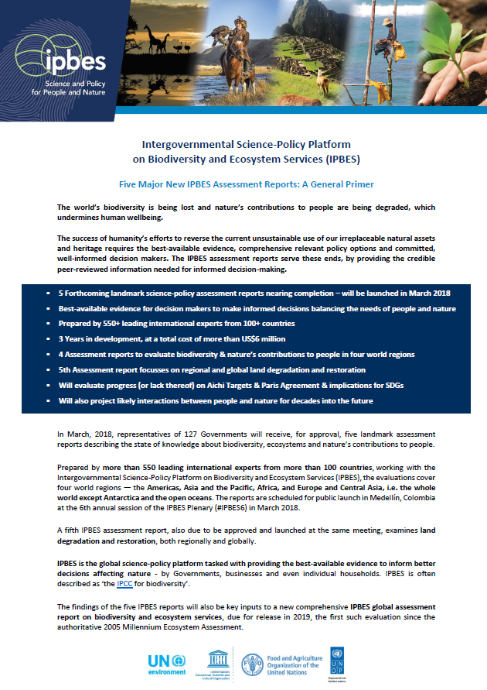

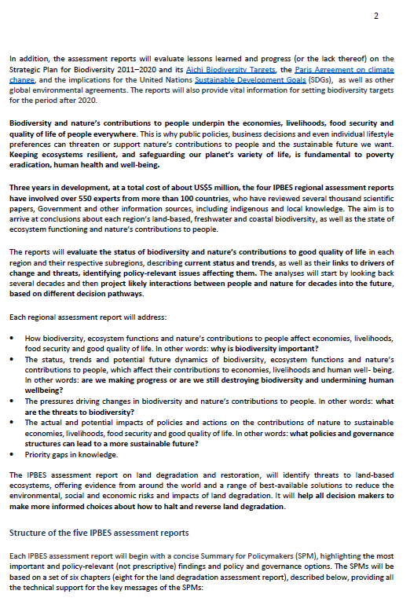
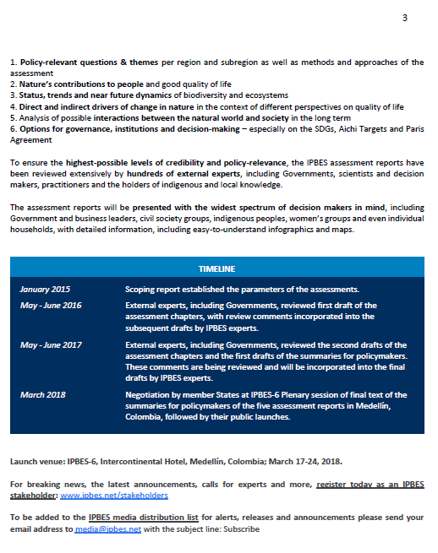
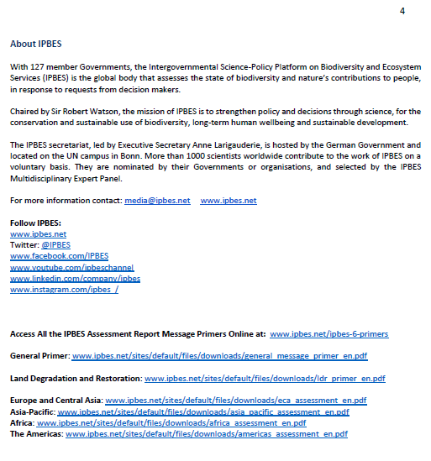

* IPBES/6/1.
Not exhaustive – and resource dependent.

