UNITED
NATIONS

IPBES/10/INF/12

 | Intergovernmental Science-Policy  Platform on Biodiversity and  Ecosystem Services | Distr.: General  5 July 2023  English only

Plenary of the Intergovernmental Science-Policy
Platform on Biodiversity and Ecosystem Services
Tenth session
Bonn, Germany, 28 August–2 September 2023
Item 8 of the provisional agenda*
Building capacity, strengthening knowledge foundations and supporting policy
Information on advanced work on policy instruments, policy support tools and methodologies
Note by the secretariat
- One of the four functions of the Intergovernmental Science-Policy Platform on Biodiversity and Ecosystem Services (IPBES) set out in its founding resolution is to support “policy formulation and implementation by identifying policy-relevant tools and methodologies, such as those arising from assessments, to enable decision makers to gain access to those tools and methodologies and, where necessary, to promote and catalyse their further development”.
- In decision IPBES-7/1, the Plenary adopted the rolling work programme of IPBES for the period up to 2030, which included objective 4 (a), on advanced work on policy instruments, policy support tools and methodologies. This objective focuses on supporting the use of policy instruments, policy support tools and methodologies in the implementation of the programme of work relevant for biodiversity conservation, restoration and sustainable use, as well as the provision of ecosystem functions and services in the conduct of the assessments, and in enabling the uptake of the findings of the assessments in decision-making. Further, the objective focuses on promoting and catalysing the further development of policy instruments and policy support tools to fill gaps identified in assessments and related capacity-building activities.
- In section V of that decision, the Plenary established a task force on policy tools and methodologies to implement objective 4 (a) of the rolling working programme of IPBES up to 2030, in accordance with the terms of reference set out in annex II to the decision, and requested the Bureau and the Multidisciplinary Expert Panel, through the IPBES secretariat, to constitute the task force in accordance with those terms of reference. The Plenary decided to review the mandate and terms of reference of the task force at its tenth session.
- The terms of reference of the task force on policy tools and methodologies include:
  - Overseeing the development of content for the IPBES policy support gateway and support for the use of the gateway by Governments and stakeholders, and ensuring that policy instruments, policy support tools and methodologies identified in IPBES assessments are featured on the gateway and accessible to decision makers;
  - Catalysing the further development of policy instruments, support tools and good practices to fill gaps identified in IPBES assessments;
  - Supporting the use of policy instruments, policy support tools and methodologies in the implementation of the work programme relevant to biodiversity conservation, restoration and sustainable use, as well as the provision of ecosystem functions and services in the conduct of the assessments, and in enabling the uptake of the findings of the assessments in decision-making.
- Also in decision IPBES-7/1, the Plenary requested the task force to develop specific deliverables for each of the priority topics set out in paragraph 8 of the rolling work programme up to 2030, for consideration by the Plenary at its eighth session. In decision IPBES-8/1, the Plenary welcomed the progress made by the task force in the development of objective 4 (a) and the three initial topics of the work programme and decided to consider those deliverables at its ninth session. In decision IPBES-9/1, the Plenary welcomed the deliverables supporting objective 4 (a) and supporting the three initial topics of the IPBES rolling work programme up to 2030 set out in annex V to that decision, and reproduced below:
  - Promoting and supporting the use of findings of IPBES products in decision-making;
  - Strengthening the policy relevance of IPBES assessments;
  - Supporting authors of policy chapters in IPBES assessment reports.
- Finally, the general terms of reference of the task forces, set out in annex II to decision IPBES-7/1, stipulate that each task force will, among other activities, provide a regular progress report and, in consultation with the Multidisciplinary Expert Panel and the Bureau, develop and update a workplan that sets out clear milestones and deliverables with regard to the relevant topics and objectives of the rolling work programme up to 2030 for periodic consideration by the Plenary. In decision IPBES-8/1, the Plenary approved a workplan for the task force on policy tools and methodologies for the intersessional period 2021–2022, set out in annex VI to that decision, and in decision IPBES-9/1, the Plenary approved the workplan of the task force for the intersessional period 2022–2023. The work plan is set out in annex V to the decision.
- An overview of the activities carried out by the task force since the ninth session of the Plenary is set out in the report of the Executive Secretary on progress in the implementation of the rolling work programme up to 2030 (IPBES/10/4).
- The annex to the present document provides further information on activities carried out by the task force in implementing its workplan (sections I, II and III and appendix). Section IV sets out additional information on the proposed workplan for the task force for the intersessional period
2023–2024, presented in document IPBES/10/8. Sections V and VI contain draft workplans for the implementation of work programme objective 4 (a) for the intersessional periods 2024–2025 and 2025–2026. The annex and its appendix are presented without formal editing.

Annex*
Information on work related to policy instruments, policy support tools and methodologies
I. Membership of the task force
- At their 13th meetings, the Multidisciplinary Expert Panel and Bureau selected the members of the task force on policy tools and methodologies, in line with the terms of reference set out in annex II to decision IPBES-7/1. The Multidisciplinary Expert Panel and Bureau also selected liaison experts from each assessment as members or alternate members of the task force, to enhance connections between the work of the task force and the on-going assessments.
- The task force is currently composed of the following members:
Name | Country | Function
Vinod Bihari Mathur | India | Task force co-chair, Bureau member
David bin Magintan | Malaysia | Member of the Multidisciplinary Expert Panel
Milan Mataruga | Bosnia and Herzegovina | Member of the Multidisciplinary Expert Panel
Mialy Andriamahefazafy | Madagascar | Expert
Senka Barudanovic | Bosnia and Herzegovina | Expert
Xu Jing | China | Expert
Ryo Kohsaka | Japan | Expert
Juana Mariño | Colombia | Expert
Melodie McGeoch | Australia / South Africa | Liaison expert from the invasive alien species assessment
Trine Setsaas | Norway | Expert
Gemedo Dalle Tussie | Ethiopia | Expert
María Elena Zaccagnini | Argentina | Expert
- A representative of the Food and Agriculture Organization of the United Nations (FAO) participated in the work of the task force as resource person.
- The United Nations Environment Programme World Conservation Monitoring Centre (UNEP-WCMC), which had provided technical support to the expert group on policy support during the first work programme of IPBES, was selected by the Bureau at its 13th meeting to continue providing technical support to the task force under the 2030 rolling work programme until the tenth session of the Plenary.
II. Meetings of the task force on policy tools and methodologies
- The fourth meeting of the task force on policy tools and methodologies was held from 31 October to 1 November 2022. The full report of the task force meeting is set out in the appendix to this document.
- The main objective of the meeting was to discuss next steps in the implementation of the deliverables of objective 4 (a) of the IPBES rolling work programme up to 2030, which were welcomed by the Plenary in decision IPBES-9/1:
  - Promoting and supporting the use of findings of IPBES products in decision-making;
  - Strengthening the policy relevance of IPBES assessments;
  - Supporting authors of policy chapters in IPBES assessment reports.
- In particular, the meeting aimed to kickstart and continue implementing the following activities planned for 2022 and early 2023, as specified in the workplan of the task force for the intersessional period 2022 – 2023:
  - Convening up to four dialogue workshops with actors at the science-policy interface to promote the use of findings of completed thematic, regional and global IPBES assessments in decision-making, including engagement with existing platforms and networks;
  - Identifying entry points and potential modalities for increasing the use of IPBES products by intergovernmental processes at the global, regional and subregional levels within their mandates, as well as potential barriers that may hinder engagement;
  - Creating fact sheets for the Thematic Assessment Report on the Sustainable Use of Wild Species and the Methodological Assessment Report on the Multiple Values of Nature and a draft fact sheet for the invasive alien species assessment, in order to improve the communication and uptake of these IPBES assessments. These would be produced in collaboration with the IPBES communications team, and would target user groups which may include policymakers, Indigenous Peoples and local communities, and businesses and the general public;
  - Peer reviewing by task force members of the first drafts of the chapters of the nexus and transformative change assessment reports and promoting wider engagement of the policy and practitioner community in the peer review;
  - Convening and/or contributing to webinars for authors of the nexus and transformative change assessment reports based on the methodological guidance on how to assess policy instruments and facilitate the use of policy support tools and methodologies through IPBES assessments;
  - Ensuring that supporting materials are ready for use by the authors of the business and biodiversity assessment report.
- The meeting also provided a space to identify lessons learned from the work of the task force relating to the implementation of objective 4 (a) between IPBES 7 and IPBES 10.
- In preparation for IPBES 10, when the mandate and terms of reference for the task force on policy tools and methodologies will be reviewed, the task force convened a discussion regarding ideas that could inform the development, by the Bureau and the Multidisciplinary Expert Panel, of future terms of reference and consider lessons learned from the task force’s work since IPBES 7. The discussion also included brainstorming activities to inform the workplans for the period between IPBES 10 and IPBES 13.
III. Report on progress in the implementation of objective 4 (a): advanced work on policy instruments, policy support tools and methodologies
A. Promoting and supporting the use of IPBES products in decision-making
- Dialogue workshops to promote the use of IPBES products in policymaking: The task force has delivered its fourth and fifth online dialogue workshops to promote the use of IPBES products in policymaking, for Western Europe and Other States (13 March 2023) and Eastern Europe (17 March 2023). The reports of both dialogue workshops are available on the IPBES website, at https://ipbes.net/events/dialogue-workshop-promote-use-ipbes-products-policymaking-western-europe-and-other-states and https://ipbes.net/events/dialogue-workshop-promote-use-ipbes-products-policymaking-eastern-europe, respectively. In addition, the task force also convened jointly with the task forces on knowledge and data and capacity-building, two dialogue workshops – one for Africa (13 June 2023) and one for Asia-Pacific (20 June 2023). Further information is set out in document IPBES/10/INF/11. Dialogue workshops were organized drawing on the lessons learned from those carried out for the Latin America and Caribbean region (3 May 2022), and the Asia and the Pacific region (19 April 2022), based on the piloting of this concept for the African region (18 March 2021).
- Strengthening the IPBES impact tracking database (TRACK) and promoting its use: Participants of the online dialogue workshops held in 2023 for Western Europe and Other States, Eastern Europe, Africa and Asia-Pacific were invited to provide contributions to the TRACK database, focusing on but not limited to any examples shared during the dialogue workshops.
- Exploring opportunities and potential modalities for increasing the use of IPBES products by intergovernmental processes: The task force at its fourth meeting decided to incorporate reference to relevant intergovernmental processes in their external review comments for the drafts of the nexus and transformative change assessments.
- Developing factsheets for the Thematic Assessment Report on the Sustainable Use of Wild Species and the Methodological Assessment Report on the Diverse Values and Valuation of Nature: The Plenary, at IPBES 9, requested the creation of fact sheets for the Thematic Assessment Report on the Sustainable Use of Wild Species and the Methodological Assessment Report on the Diverse Values and Valuation of Nature, targeted to user groups that may include policymakers, indigenous peoples and local communities, businesses and the general public. The Plenary also requested that the task force on policy tools and methodologies report back on the process followed to develop the fact sheets and provide advice on the preparation of fact sheets for future assessments. The following steps were undertaken:
  - The task force, in collaboration with the technical support units for and co-chairs of both assessments, developed draft fact sheets for the Thematic Assessment Report on the Sustainable Use of Wild Species and the Methodological Assessment Report on the Diverse Values and Valuation of Nature. The fact sheets were solely based on text and figures from the summaries for policymakers of these assessments. A key principle for development of the fact sheets was to ensure traceability to the information in the assessment report and to use the language of the report. As this was the first time that fact sheets were prepared, it was decided to focus on one general fact sheet for each assessment, targeted to policymakers. For future assessments, such as for the invasive alien species assessment, it is suggested to prepare more than one fact sheet (see (d) and (e) below);
  - The drafts of the fact sheets were made available for review by Governments between 4 May and 7 June 2023. The review was aimed at gathering inputs on the structure and format of the fact sheets. Comments were received from 11 Governments. Overall, the feedback relating to structure and format, and to the use of figures and graphics was positive;
  - The fact sheets were finalized in line with the comments received and will be made available on the IPBES website at: https://www.ipbes.net/sustainable-use-assessment and at https://www.ipbes.net/the-values-assessment;
  - The task force, in collaboration with the technical support unit for and co-chairs of the invasive alien species assessment, prepared three factsheets. These factsheets focused on invasive alien species and islands; policy options, and data availability for trends in invasive alien species. The development of the draft fact sheets took into account the comments received during the external review of the fact sheets on the Values and Sustainable Use Assessment Reports. The fact sheets will be updated and finalized, once the summary for policymakers of the assessment has been approved;
  - Going forward it is suggested to use a similar approach: For the nexus and transformative change assessments, this could include fact sheets on each one of the nexus elements for the nexus assessment, and a focus based on user groups for the transformative change assessment.
B. Strengthening the policy relevance of IPBES assessments
- Peer review by task force members of the first draft of the chapters of the nexus and transformative change assessment reports and promoting wider engagement of the policy and practitioner community in the peer review: Members of the task force on policy tools and methodologies reviewed the first drafts of the nexus and the transformative change assessments. The technical support unit collected the review comments and submitted these to the secretariat on behalf of the task force members.
C. Supporting authors of policy chapters in IPBES assessments
- With a view to enhancing the policy relevance of IPBES assessments, presentations relating to the work of the task force on policy tools and methodologies were made at the author meetings of the transformative change and nexus assessments.
IV. Additional information on the workplan for the implementation of work programme objective 4 (a) for the intersessional period 2023–2024
- In decision IPBES-7/1, the Plenary decided to review the mandate and terms of reference of the task force at its tenth session. Revised terms of reference for the task force are presented in document IPBES/10/8 for consideration by the Plenary. In the same document, a workplan for the implementation of objective 4 (a) of the IPBES rolling work programme up to 2030 is presented together with workplans for objectives 2, 3 (a,i – data); 3 (a,ii – knowledge generation); 3 (b) and 4 (b). The workplans, which are presented for consideration by the Plenary, cover the period between IPBES 10 and IPBES 11 (intersessional period 2023-2024). Figure 1 presents the institutional structure proposed for the implementation of these workplans.
Figure 1
Illustration of the change proposed in bodies responsible for the implementation of objectives 2, 3 and 4 of the IPBES rolling work programme up to 2030. Bolded text and orange arrows indicate a change in responsible body.
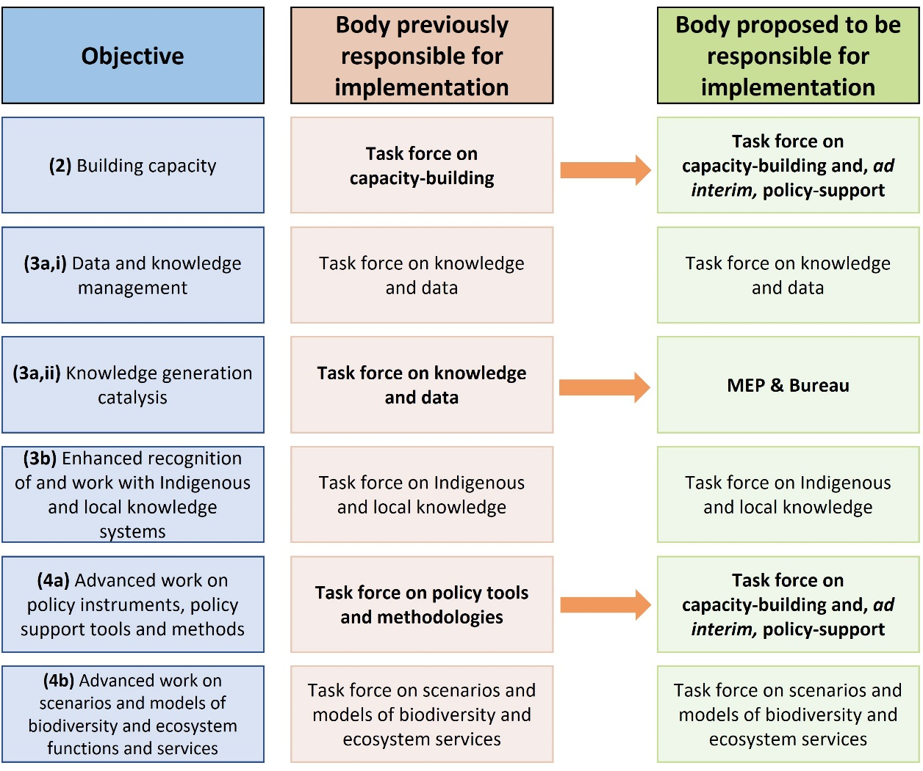
- Draft workplans for the implementation of objective 4 (a), covering the intersessional period between IPBES 11 and IPBES 12 (intersessional period 2024-2025) and between IPBES 12 and IPBES 13 (intersessional period 2025-2026) are presented in sections V and VI below. Figure 2 illustrates schematically the interactions of the task force with IPBES assessment processes, as reflected in the activities presented as part of the workplans to implement objective 4 (a) of the IPBES rolling work programme. The planned activities provide input into assessment processes at several stages. At the commencement of an IPBES assessment, the task force is responsible for distributing the call for authors and fellows to networks of individuals with practical experience in policy processes. Once assessment experts have been selected, the task force provides methodological guidance and available resources to them. The task force reviews the draft text as part of the external review process. Once an IPBES assessment has been approved/accepted by the Plenary, the task force holds dialogues to enhance the use of the assessment findings in decision-making. For all new IPBES assessments, the task force will continue to engage with the assessment process in this manner.

Figure 2
Interaction of the task force implementing the work plan for objective 4 (a) with the assessment process. The standard process for the production of an IPBES assessment is shown along the multi-coloured horizontal arrow, with activities to implement objective 4 (a) shown in pink lines and arrows. The dotted line for scoping indicates that this process is not carried out for every assessment.
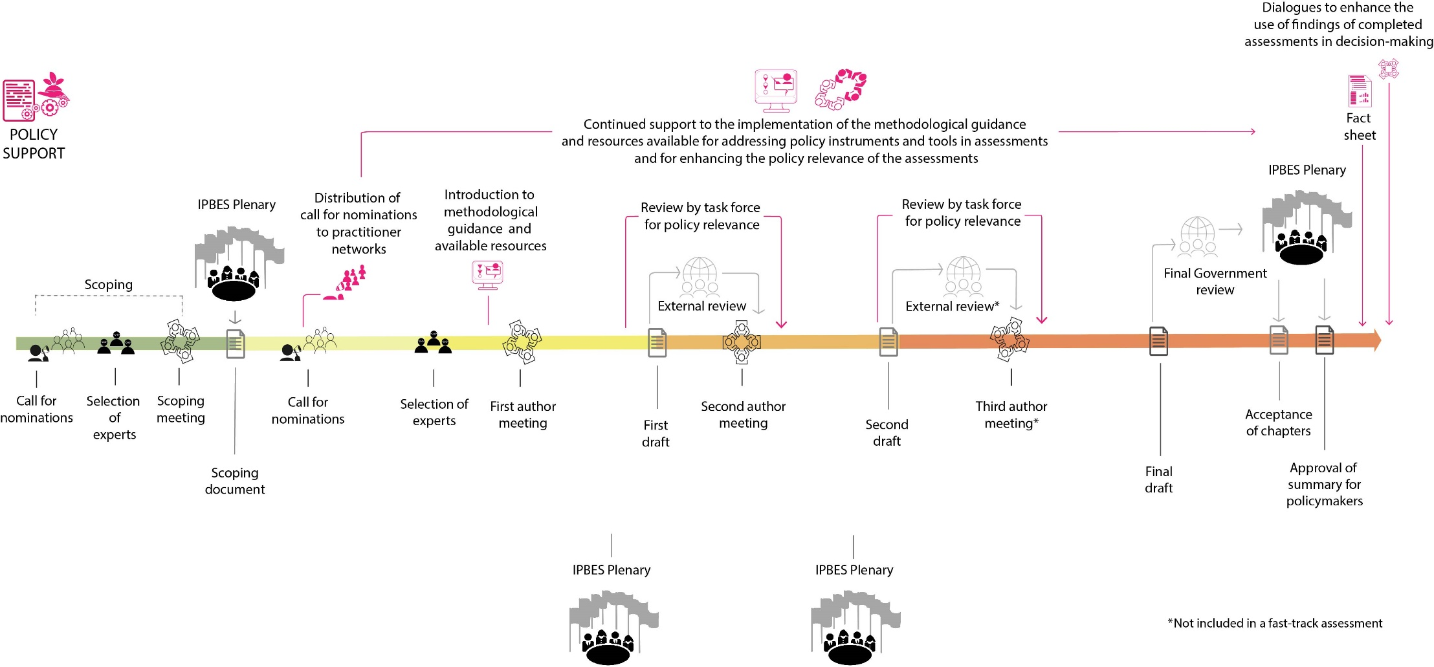

V. Draft workplan for the intersessional period 2024-2025 (for information)
- Activities to increase the policy relevance of IPBES assessments would include:
  - The provision of support to assessment experts with a view to increasing the policy relevance of IPBES assessments, including starting to update the “Guidance on how to assess policy instruments and facilitate the use of policy support tools and methodologies in IPBES assessments”, in order to address lessons learned from its use, where required;
  - Online dialogues with national focal points, with the objective to increase the policy-relevance of the assessments, in the context of the external review of the summary for policymakers of the business and biodiversity assessment and the external review of any new assessments (as part of the online dialogues included in the draft work plan for work programme objective 2, building capacity);
  - Fostering the participation of policy practitioners in IPBES assessments through the dialogue workshops with stakeholders being organized for ongoing assessments (included in the draft work plan for work programme objective 2, building capacity).
- Activities to promote and support the use of IPBES products in decision-making would include:
  - The preparation of fact sheets for the business and biodiversity assessment, once completed, targeted to specific sectors, to be coordinated by the secretariat (first quarter 2026);
  - An in-person dialogue meeting with new IPBES members and observer States to further enhance the capacity of Governments to use completed IPBES assessments, and other IPBES work, in policy- and decision-making (as part of the workshop included in the draft work plan for work programme objective 2, building capacity);
  - Strengthening the role of national and (sub)regional science-policy platforms, networks and assessments for biodiversity and ecosystem services in promoting the use of IPBES deliverables in policy- and decision-making and in enhancing their policy-relevance (as part of the online dialogue workshop included in the draft work plan for work programme objective 2, building capacity);
  - Regional online dialogue meetings with actors at the science-policy interface, including IPBES national focal points and focal points of other relevant biodiversity-related multilateral environmental agreements, to promote the use of completed IPBES assessment reports in policy- and decision-making through the sharing of experiences;
  - Encouraging the addition of examples of the successful use of completed IPBES assessments in policy- and decision-making to the IPBES impact-tracking database (TRACK).
- Activities to ensure the effectiveness of the implementation of the workplan include the monitoring of a set of relevant indicators for measuring the effectiveness of the workplan.
VI. Draft Workplan for the intersessional period 2025-2026 (for information)
- Activities to increase the policy relevance of IPBES assessments would include:
  - The provision of support to assessment experts with a view to increasing the policy relevance of IPBES assessments, including finalizing the updating of the “Guidance on how to assess policy instruments and facilitate the use of policy support tools and methodologies in IPBES assessments”, to address lessons learned from its use, where required;
  - Online dialogues with national focal points, with the objective to increase the policy-relevance of the assessments, in the context of the external review of any new assessments (as part of the workshop included in the draft work plan for work programme objective 2, building capacity);
  - Fostering the participation of practitioners in IPBES assessments through the dialogue workshops with stakeholders being organized for ongoing assessments (as part of the workshops included in the draft work plan for work programme objective 2, building capacity).
- Activities to promote and support the use of IPBES products in decision-making will include:
  - The preparation of fact sheets for any new assessments to be finalized in 2026, once completed, targeted to specific sectors, to be coordinated by the secretariat (second half of 2026);
  - An in-person dialogue meeting with national focal points to further enhance the capacity of Governments to use completed IPBES assessments, and other IPBES work, in policy- and decision-making (as part of the workshop included in the draft work plan for work programme objective 2, building capacity);
  - Strengthening the role of national and (sub)regional science-policy platforms, networks and assessments for biodiversity and ecosystem services in promoting the use of IPBES deliverables in policy- and decision-making and in enhancing their policy-relevance (as part of the online dialogue workshop included in the draft work plan for work programme objective 2, building capacity);
  - Regional online dialogue meetings, with actors at the science-policy interface, including IPBES national focal points and focal points of other relevant biodiversity-related multilateral environmental agreements, to promote the use of completed IPBES assessment reports in policy- and decision-making through the sharing of experiences;
  - Encouraging the addition of examples of the successful use of completed IPBES assessments in policy- and decision-making to the IPBES impact-tracking database (TRACK);
  - Conducting a third edition of the “survey on the use of IPBES assessments in policymaking at national and subnational levels” to gather information relating to new IPBES assessments (second quarter 2026).
- Activities to ensure the effectiveness of the implementation of the workplan include the monitoring of a set of relevant indicators for measuring the effectiveness of the workplan.

Appendix I
Report of the IPBES task force on policy tools and methodologies on its 4th meeting under the 2030 IPBES rolling work programme
Introduction
- The fourth meeting of the task force on policy tools and methodologies was organized as an online meeting and took place on 31 October and 1 November 2022.
I. Opening of the meeting and agenda
- David bin Magintan, member of the Multidisciplinary Expert Panel and of the management committee for the work of the task force on policy tools and methodologies, opened the meeting on 31 October 2022.
- The task force adopted the agenda for the meeting, including the different sessions, as presented (see annex I to the appendix). All discussions took place in plenary sessions.
II. Objectives of the meeting
- The main objective of the meeting was to continue the implementation of objective 4 (a) of the IPBES rolling work programme up to 2030, relating to advancing the work on policy instruments, policy support tools and methodologies. The meeting of the task force focused on the following deliverables included in the workplan of the task force for the intersessional period 2022–2023, approved by the Plenary at its ninth session in July 2022:
  - Promotion of and support to the use of findings of IPBES assessments in decision-making;
  - Increasing the policy relevance of IPBES assessments; and
  - Supporting the authors of policy chapters in IPBES assessments.
- In particular, the meeting aimed to kickstart and continue the process of implementing the following activities planned for 2022 and early 2023, as specified in the workplan of the task force:
  - Convening up to four dialogue workshops with actors at the science-policy interface to promote the use of findings of completed thematic, regional and global IPBES assessments in decision-making, including engagement with existing platforms and networks;
  - Identifying entry points and potential modalities for increasing the use of IPBES products by intergovernmental processes at the global, regional and subregional levels within their mandates, as well as potential barriers that may hinder engagement;
  - In order to improve the communication and uptake of IPBES assessments and in collaboration with the IPBES communications team, creating fact sheets for the Thematic Assessment Report on the Sustainable Use of Wild Species and the Methodological Assessment Report on the Multiple Values of Nature and a draft fact sheet for the invasive alien species assessment, targeted to user groups that may include policymakers, indigenous peoples and local communities, businesses and the general public;
  - Peer review by task force members of the first order drafts of the chapters of the nexus and transformative change assessment reports and the promotion of wider engagement of the policy and practitioner community in the peer review;
  - Convening and/or contributing to webinars for authors of the nexus and transformative change assessment reports based on the methodological guidance on how to assess policy instruments and facilitate the use of policy support tools and methodologies through IPBES assessments;
  - Ensuring that supporting materials are ready for use by the authors of the business and biodiversity assessment report.
- The meeting also provided a space to identify lessons learned from the work of the task force relating to the implementation of objective 4 (a) between IPBES 7 and IPBES 10.
III. Summary of general discussions and presentations
A. Promotion of and support to the use of IPBES assessment findings in decision-making
1. Strategic planning of upcoming dialogue workshops
- The technical support unit for policy tools and methodologies (TSU) presented a summary of the two dialogue workshops that took place in 2022 for the Asia Pacific region and the Latin America and the Caribbean region, including feedback from the evaluation surveys of the workshops. Plans to convene two more dialogue workshops for early 2023 to promote the use of IPBES products in decision making were also presented. Upcoming dialogue workshops will be convened for Western Europe and Other States (tentatively planned for February 2023) and for the Eastern European region (tentatively planned for March/April 2023).
- Several lessons learned and recommendations were identified from the previous dialogue workshops to improve planning and organization of future workshops. These lessons learned include the following:
  - Improve the reach and potential impact of the dialogue workshops. This could be done through:
    - Increasing the attendance of practitioners at the dialogue workshop meetings and encouraging their involvement in IPBES work in practical ways;
    - Continuing to invite regional organizations given the fact that in some regions they play an important role in supporting the implementation of international and national policies;
  - Provide further concrete examples of how IPBES products have been used in decision-making, and what their impact has been. This could be done through:
    - Asking participants to think of examples of IPBES products that had an impact on decision-making prior to the start of the workshop;
    - Showcasing how IPBES members and other countries have integrated IPBES products into their own policy instruments at national or sub-national levels;
  - Further improve opportunity for dialogue and contributions from participants during the interactive discussion sections of the workshop. This could be done through:
    - Creating more breakout rooms to allow for increased exchange of experiences between member countries;
    - Reducing the time allocated for presentations to provide increased time for discussion and sharing of experiences;
  - Envisage ways of having IPBES documents translated into local languages. The language barrier can present a hurdle to increasing the involvement of practitioners at the national government level or for regional administrations;
  - Focus the presentation of the main findings of IPBES assessments at the start of the dialogue workshop on the region in question.
- Building on the lessons learned from past dialogue workshops, the task force made the following recommendations for the work going forward:
  - Consider conducting another dialogue workshop for the Africa region given the fact that the first one was a pilot dialogue workshop and subsequent regional workshops have seen greater participation;
  - Reflect on the possibility of having smaller subregional dialogue workshops to further encourage the use of IPBES assessments by more easily identifying common issues of interest.
2. Entry points and potential modalities for increasing the use of IPBES products by intergovernmental processes
- An overview of the work conducted and planned to increase the use of IPBES products in intergovernmental processes was presented to the task force for their input. One suggestion was to provide support to IPBES assessment experts who intend to refer to intergovernmental processes in IPBES assessments. As agreed at the third meeting of the task force, the task force initiated the development of two draft annotated outlines to map key intergovernmental processes and international treaties, including multilateral environmental agreements (MEAs), of relevance to the nexus and transformative change assessments. A preliminary version of the two draft documents was presented to the task force for their consideration. In particular, the task force was asked to consider the type of information that they think should be considered by authors of these two assessments and the way in which to present this information in a manner that is useful to the authors.
- As the scope of the nexus and transformative change assessments is very broad, a large number and wide range of intergovernmental processes is potentially relevant to them. It is therefore difficult to compile all the information regarding key intergovernmental processes in a manner that would be useful for the experts. As a result, it was agreed that the task force would not continue to work on entry points and potential modalities for increasing the use of IPBES products by intergovernmental processes. Instead, once the draft chapters of the nexus and transformative change assessments are available for external review, task force members will participate in the review in order to make sure that relevant intergovernmental processes are adequately captured. The task force will provide specific guidance in terms of which additional processes should be considered, the reasons for including these and what specific mandates should be considered by the assessment experts in relation to these processes.
- Several suggestions were made to increase the use of IPBES products in intergovernmental processes, including the following:
  - Focusing on provision of inputs during the external review period: Rather than the task force creating a particular document, the task force members should aim to share their inputs with respect to intergovernmental processes during the external review of draft chapters of the assessment reports. Through the feedback, opportunities to enhance complementarity between transformative change and nexus assessments will be explored;
  - International processes: While the focus of the work of the task force has so far been on identification and consideration of intergovernmental processes, the diverse scope of IPBES assessments (e.g., business and biodiversity assessment) may require that in some cases there might be a need to consider international processes more broadly (i.e., beyond those of intergovernmental nature);
  - Reaching out to the secretariats of intergovernmental processes: Liaising with the secretariats of relevant intergovernmental processes during the assessment process and upon its completion, could be another way of ensuring the policy reach of IPBES assessments. MEAs could potentially use the assessment in their work and be involved in the assessment process during the review periods or once assessments are finalised. The IPBES secretariat has already begun reaching out to a number of MEAs that are relevant to the nexus and transformative change assessment and hope to build these relationships over the coming years. The task force may want to support this work by identifying intergovernmental processes that would be relevant for upcoming IPBES assessments such as the business and biodiversity assessment.
3. Fact sheets for the Sustainable Use of Wild Species Assessment and the Multiple Values of Nature Assessment and a draft fact sheet for the invasive alien species assessment
- A summary of the work undertaken to create fact sheets for the Thematic Assessment Report on the Sustainable Use of Wild Species and the Methodological Assessment report on the Diverse Values and Valuation of Nature, and to create a draft fact sheet for the invasive alien species assessment was presented during the meeting. The information presented included the timeline for the development of the fact sheets as well as next steps for the work relating to their development, including the preparation of a draft of the fact sheets for the completed assessments in the end of November 2022. The respective assessment teams would draft the fact sheets and make sure that their content reflected the text in the summaries for policymakers approved by the Plenary.
- Members of the task force will have the opportunity to review the draft factsheets before they are finalized and to provide feedback on the way in which information is being presented.
B. Increasing the policy relevance of IPBES assessments
1. Strengthen the policy relevance of IPBES assessments by promoting wider engagement of the policy and practitioner community
- This session provided a space to discuss progress in implementing the strategy to further increase the involvement of individuals with practical policy experience in the assessment process that the task force had developed.
- A member of the IPBES secretariat provided an overview of how the secretariat has sought to engage practitioners with the nexus and transformative change assessments.
- The discussion with task force members built on the update provided by the IPBES secretariat, and covered how to identify individuals with practical policy experience, improve the identification of knowledge and experience gaps in assessment teams and encourage participation of individuals from task force member’s own networks. Several suggestions were made, including the following:
  - It was suggested that practitioners should be involved in the entire lifecycle of the assessment writing process rather than only during the external review. This could be achieved by selecting more practitioners as part of the assessment expert teams. The business and biodiversity assessment process attempts to involve more practitioners. The application process provides the option for practitioners, who may not have peer reviewed publications, to provide grey literature or internal reports as part of their application;
  - A suggestion was made to consider developing a framework to improve outreach to practitioners in a more organized and systematic way. A mapping process at the level of international organizations and research organizations with policy departments that comprise individuals who are both experts and policy practitioners could potentially help with this;
  - Task force members could personally forwarding notifications on external reviews of assessments to people in their own networks who have policy expertise and who are relevant to the IPBES process but who may not yet be involved was highlighted as far more effective than relying on automated mailing lists;
- Given that several task force members participate in some capacity in the transformative change assessment, it was suggested that the task force organize, in collaboration with the TSU for the assessment, a webinar to discuss policy relevance of the assessment.
C. Support the authors of policy chapter in IPBES assessments
- The task force reviewed the orientation packs that assessment experts receive at the start of an assessment, and discussed whether any changes needed to be made to the two-page guidance document related to work of the task force on policy tools and methodologies (see annex III to this appendix). The revised pack would be provided to the business and biodiversity assessment experts in early 2023. The task force provided the following suggestions:
  - It was pointed out that some IPBES assessments use definitions of the concept of governance that differ from the one included in the IPBES glossary of terms. It is suggested to improve the use of the glossary and of agreed upon definitions;
  - The importance of threading policy coherence throughout IPBES assessment chapters, rather than only focusing on policy in the chapter dedicated to policy options, was also underlined.
- It was decided that the TSU would review the scoping document of the business and biodiversity assessment and propose further additions to the guidance document, where necessary, for approval by the task force.
D. Initiating the development of revised terms of reference and draft future workplans for the task force
- In preparation for IPBES 10, when the mandate and terms of reference for the task force on policy tools and methodologies will be reviewed, the task force convened a discussion regarding ideas that could inform the development of future terms of reference by the Bureau and the MEP, considering lessons learned since IPBES 7. The discussion addressed lessons learned from the task force’s work since IPBES 7 and included brainstorming activities to inform the workplans for the period between IPBES 10 and IPBES 13. The contributions of the task force members to the discussion were recorded through the use of an online whiteboard tool, Miro, and can be found in annex IV to this appendix.
- The discussion on lessons learned during the current term of office of the task force on policy tools and methodologies covered many topics, and included lessons learned for specific activities undertaken as well as reflections on the purpose and effectiveness of the task force itself.
  - Specific lessons learned from activities carried out
    - Overall, the task force acknowledged that it was successful in implementing its mandate and workplans, considering the challenges posed by the COVID-19 pandemic;
    - There was a shared view that the dialogue workshops organized by the task force have proven a useful activity to better understand how IPBES products are being used, facilitate the exchange of experiences among IPBES members and promote the use of IPBES products;
    - Task force members highlighted the importance of continuing to target the dialogue workshops to the respective regions;
    - Involving IPBES national focal points in the dialogue workshops and working with them to involve representatives from other sectors of relevance to the work of IPBES was emphasized as particularly important. Task force members also suggested to involve more practitioners in the dialogue workshops;.
    - Adjusting the format and modality of work to the changing circumstances presented by the COVID-19 pandemic through holding online dialogue workshops showed commendable adaptability;
    - It was suggested to extend the support, which the task force currently provides to assessment chapters addressing policy options, to all chapters of an assessment. IPBES assessments in their entirety are intended to inform policymakers.
  - Challenges and lessons learned for the mandate, scope and operations of the task force in general
    - Some task force members expressed the need to clarify the expectations from IPBES members regarding the realisation of the IPBES policy support function. Development of workplans for work programme objective 4 (a) and implementation of its activities would benefit from more clarity regarding the outcomes expected to result from the implementation of the policy support function;
    - Task force members expressed the need for policy support to be innovative, while continuing to be policy relevant but not prescriptive;
    - Task force members emphasized that being policy relevant but not prescriptive remains a challenge for the work of IPBES. This is an area on which further work could be done;
    - The task force should continue having a focus on the use of IPBES products in decision-making. To pursue this focus, continued consideration of the audience for the work of the task force and how to respond to its needs is required;
    - Regarding the operations of the task force, it was suggested that the task force should meet twice a year to increase engagement of task force members and their contributions to the work of IPBES.
- The second part of the discussion revolved around brainstorming activities for future workplans for the intersessional periods between IPBES 10 and IPBES 13. The discussion was organized around the current three deliverables of the task force. Some of the recommendations include:
  - Promotion of and support for the use of IPBES products in decision-making
    - Continue convening dialogue workshops after IPBES 10, which engage sectors beyond the environment sector;
    - Develop fact sheets for future assessment reports;
    - Conduct future editions of the survey on the use of IPBES assessments in decision-making;
  - Increase the policy relevance of IPBES assessments
    - Continue providing written inputs as part of the external review of draft chapters and draft summaries for policymakers of IPBES assessment reports ;
    - Assess the implementation of the strategy to include individuals with experience in policy processes in IPBES assessments;
  - Support the authors of policy chapters in IPBES assessments
    - Provide a presentation on the methodological guidance and more broadly on the work of the task force at the introductory meeting for authors of new IPBES assessments and/or at the first author meetings;
    - Provide a short video as part of the orientation packs for new assessment authors to present the methodological guidance on assessing policy tools;
    - Update the methodological guidance based on lessons learned from its use and from the work of the task force and further communicate and support its use by assessment authors.
IV. Closing session
- The meeting was closed by the technical support unit for policy support tools and methodologies and it was reiterated that the next steps would include consultation with the task force members for input into the documents discussed.

Annex I to the appendix: Agenda of the 4th meeting of the task force on policy tools and methodologies under the 2030 IPBES rolling work programme
Objectives
The main objective of the meeting is to continue the implementation of objective 4 (a) of the IPBES rolling work programme up to 2030, relating to advanced work on policy instruments, policy support tools and methodologies. In particular, the implementation of key activities identified in the workplan of the task force on policy tools and methodologies for the intersessional period 2022−2023, as approved by the Plenary at IPBES 9 in July 2022, will be discussed. The meeting will also provide an opportunity to identify experiences and lessons learned of the task force’s work since IPBES 7. This meeting will kickstart or continue the process of implementation of the following activities planned for 2022–2023:
- Convening up to four dialogue workshops for actors at the science-policy interface in order to share experiences and better understand and promote the use of completed IPBES assessment reports and other IPBES products in decision-making processes;
- Providing further support to strengthen the IPBES impact tracking database (TRACK) and promote its use;
- Identify entry points and potential modalities for increasing the use of IPBES products by intergovernmental processes at the global, regional, and subregional levels within their mandates, as well as potential barriers that may hinder engagement;
- In order to improve the communication and uptake of IPBES assessments, creating, with the IPBES communications team, fact sheets for the Sustainable Use of Wild Species Assessment and the Multiple Values of Nature Assessment and a draft fact sheet for the invasive alien species assessment, targeted to user groups that may include policymakers, indigenous peoples and local communities, businesses and the general public. Like all communication products, fact sheets will not be made public until summaries for policymakers are approved and will provide a link to the underlying summary and assessment. At the tenth session of the Plenary, the task force will report on the process used to develop the fact sheets and will provide advice on the preparation of versions for additional user groups, with a view to planning the development of future fact sheets and assessing their impact, while taking into consideration additional suggestions by IPBES members;
- Activities to strengthen the policy relevance of IPBES assessments will include peer review by task force members of the first order draft of the chapters of the nexus and transformative change assessment reports and by promoting wider engagement of the policy and practitioner community in the peer review; and
- Activities to support authors of policy chapters in IPBES assessment reports will include ensuring that supporting materials are ready for use by the authors of the business and biodiversity assessment report.
31 October 2022, 12:30 (CET)
Time (minutes) | Agenda Item
12:15 – 12:30  15 mins | Join the meeting: 05:15 Colombia / 12:15 Germany / 19:15 Japan
12:30 – 12:45  15 mins | - Opening of the meeting  - Welcome by David bin Magintan, Member of the management committee of the task force  - Round of introductions
12:45 – 13:05  20 mins | - Orientation and reflections  - Outcomes of IPBES 9: Overview of approved workplan for the task force on policy tools and methodologies until IPBES 10  - Update on the activities carried out during the first half of 2022  - Objectives of the meeting and proposed organization of work
13:05 – 13:45  40 mins | - Strategic planning of upcoming dialogue workshops  - Discussion on lessons learned during the previous online dialogue workshops in the Asia-Pacific region and the Latin America and the Caribbean region and any recommendations  - Discussion and identification of plans for convening workshops in the Western Europe and Other States region and the Eastern Europe region
13:45 – 13:50  5 mins | Break
13:50 – 14:35  45 mins | - Strengthen the policy relevance of IPBES assessments by promoting wider engagement of the policy and practitioner community in the peer review  - Presentation of approach to involving practitioners in the external review of the nexus and transformative change assessments
14:35 – 15:05  30 mins | - Support to authors of policy chapters in IPBES assessment reports  - Recap on the existing supporting materials for authors  - Review the business and biodiversity scoping document to identify additional support/ materials which might be needed
15:05 – 15:15  10 mins | - Wrap up and details for the next day
1 November 2022, 12:30 (CET)
Time (minutes) | Agenda Item
12:15 – 12:30  15 mins | Join the meeting: 05:15 Colombia / 12:15 Germany / 19:15 Japan
12:30 – 12:40  10 mins | - Recap of previous day and plans for the day
12:40 – 13:25  45 mins | - Entry points for increasing the use of IPBES products by intergovernmental process  - Presentation of the draft annotated outline which highlights potential entry points for increasing the use of IPBES products by intergovernmental processes at the global, regional, and subregional levels within their mandates, as well as potential barriers that may hinder engagement  - Discussion: Review the annotated outlines, identify potential entry points and discuss next steps for this activity
13:25 – 13:55  30 mins | - Fact sheets for the Sustainable Use of Wild species Assessment and the Multiple Values of Nature Assessment  - Presentation to outline the steps taken and plans to develop the fact sheets with the assessment TSUs
13:55 – 14:00  5 mins | Break
14:00 – 15:00  60 mins | - Develop a revised terms of reference and draft future workplans for the task force  - Gather lessons learned during the current period of the task force on policy support tools and methodologies  - Share views and reflections for future potential task force such as the ideal profile of members, for example, preferred experiences or fields of expertise.  - Discuss specific actions for the task force workplans up to IPBES 13  - Period IPBES 10 – 11 (mid-2023 to end 2024)  - Period IPBES 11 – 12 (end 2024 to end 2025)  - Period IPBES 12 – 13 (end 2025 to end 2026)
15:00 – 15:15  15 mins | - Closing of the meeting  - Summary of action points and next steps  - Closure of the meeting

Annex II to the appendix: List of participants
MEMBERS OF THE TASK FORCE
David Magintan | Member of the MEP, Malaysia
Milan Mataruga | Member of MEP, Bosnia and Herzegovina
Gemedo Dalle Tussie | Task force on policy tools and methodologies, Ethiopia
Juana Marino | Task force on policy tools and methodologies, Colombia
Mialy Andriamahefazafy | Task force on policy tools and methodologies, Madagascar
Ryo Kohsaka | Task force on policy tools and methodologies, Japan
RESOURCE PERSONS
Dan Leskien | Food and Agriculture Organization of the United Nations
SECRETARIAT
Secretariat based in Bonn
Bonnie Myers | Programme Management Officer
Satomi Yoshino | Programme Management Officer
Simone Schiele | Head of Work Programme
Technical support unit
Daniela Guarás | Technical support unit for the policy tools and methodologies task force
Sebastien Kaye | Technical support unit for the policy tools and methodologies task force
Laura Mack | Technical support unit for the policy tools and methodologies task force
Other technical support units
Aidin Niamir | Technical support unit for the knowledge and data task force
Renske Gudde | Technical support unit for the knowledge and data task force
Ingunn Storro | Technical support unit for the capacity building task force
Naoki Amako | Technical support unit on invasive alien species assessment
Machteld Schoolenberg | Technical support unit for the task force on scenarios and models

Annex III to the appendix: Supporting materials for the orientation packs for authors of IPBES assessments
IPBES POLICY SUPPORT IN THE CONTEXT OF THE ASSESSMENT PROCESS
Policy support is one of the four functions of IPBES set out in its founding resolution. In this regard, IPBES is to support “policy formulation and implementation by identifying policy-relevant tools and methodologies, such as those arising from assessments, to enable decision makers to gain access to those tools and methodologies and, where necessary, to promote and catalyse their further development” (UNEP/IPBES.MI/2/9, annex I).
In line with this function, the IPBES rolling work programme up to 2030 includes “supporting policy” as one of its six objectives to identify and promote the development and use of policy instruments, policy support tools and methodologies in the field of biodiversity and ecosystem functions and services (Decision IPBES-7/1).
TASK FORCE ON POLICY TOOLS AND METHODOLOGIES
Established at IPBES 7 to support the implementation of objective 4 (a) of the new rolling work programme up to 2030: “advanced work on policy instruments, policy support tools and methodologies”, the task force on policy support tools and methodologies undertakes the following:
- Supports the use of policy instruments, policy support tools and methodologies in the implementation of the work programme in the conduct of the assessments, and in enabling the uptake of the findings of the assessments in decision-making;
- Catalyses the further development of policy instruments, support tools and good practices to fill gaps identified in IPBES assessments;
The task force is supported by a technical support unit (TSU) based at the UN Environment Programme World Conservation Monitoring Centre (UNEP-WCMC) in Cambridge, United Kingdom. The TSU currently consists of Claire Brown, Daniela Guarás and Sebastien Kaye.
The task force, with the support of the TSU, supports the authors of policy chapters mainly by:
- Developing guidance on how to assess policy instruments and facilitating the use of policy support tools and methodologies through IPBES assessments;
- Providing on-demand support to authors of the chapters dealing with policy options/responses in the application of the guidance; and
- Participating in the peer-review of draft scoping documents, draft chapters and summaries for policymakers of ongoing assessments to increase their policy relevance.

RESOURCES
The following resources may be useful for authors of IPBES assessments, in particular those dedicated to the chapter(s) focusing on governance and policy options and responses:
Resources
Guidance for assessing policy instruments and facilitating the use of policy support tools and methodologies through IPBES assessments  - This guidance constitutes Module D of the IPBES Guide on the production of assessments.  - This guidance is aimed at IPBES assessment authors, in particular those selected to assess policy instruments and to facilitate the use of policy support tools and methodologies through the assessment. It may also support authors in coordinating the development of key themes and narratives across chapters and the development of the summary for policymakers.  - The guidance is a living document and will be updated based on the ongoing work of IPBES. Users should ensure they are using the latest version. Feedback by users can be provided to the relevant technical support unit and the IPBES secretariat. | 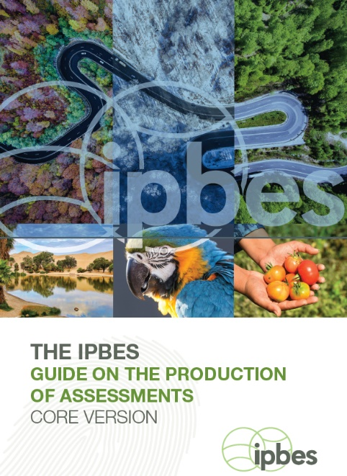
IPBES Policy Support Gateway  - Contains information regarding a range of policy instruments and policy support tools and methodologies linked to assessments, case studies, capacity-building opportunities and resources, and communities of practice.  - This gateway can support authors to assess the usability of policy support tools and methodologies in their specific assessment contexts, including resources required and types of outputs that can be obtained, and thus help to identify gaps in tools and methodologies (IPBES/3/INF/8).  - It is no longer being updated. | 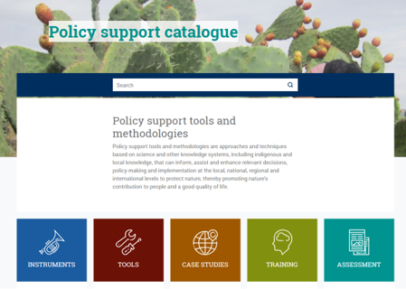  Available at: https://ipbes.net/policy-support
IPBES Core Glossary  Policy support tools and policy instruments are commonly misunderstood and used interchangeably. It is important to understand the differences. Definitions of key terms and concepts can be found in the IPBES glossary https://ipbes.net/glossary | 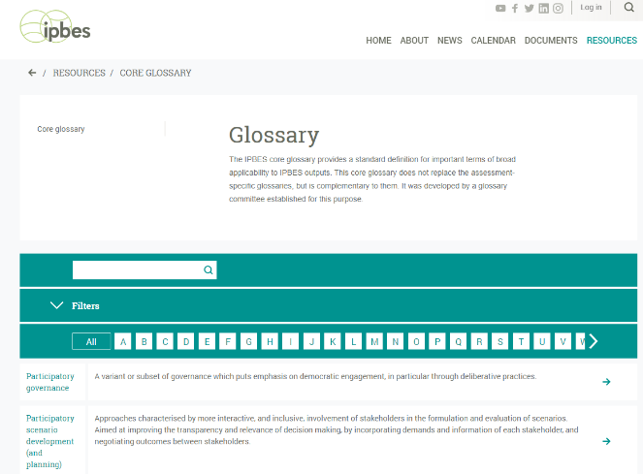

ACHIEVING COHERENCE ACROSS CHAPTERS
- Most policy analysis is expected to occur within the chapter focusing on governance and policy instruments.
- However, policy instruments are likely to be addressed in other chapters, too, for example, the chapter on drivers. The location of the analysis will be dependent on the scope of the assessment and the chapter structure.
- Authors are encouraged to refer to the scoping document and other chapters in the assessment at any point during the assessment process to ensure consistency around the assessment of policy instruments.
FURTHER SUPPORT
For further support and guidance on policy support tools and methodologies, please contact the TSU at: ipbes.tsu.policysupport@unep-wcmc.org

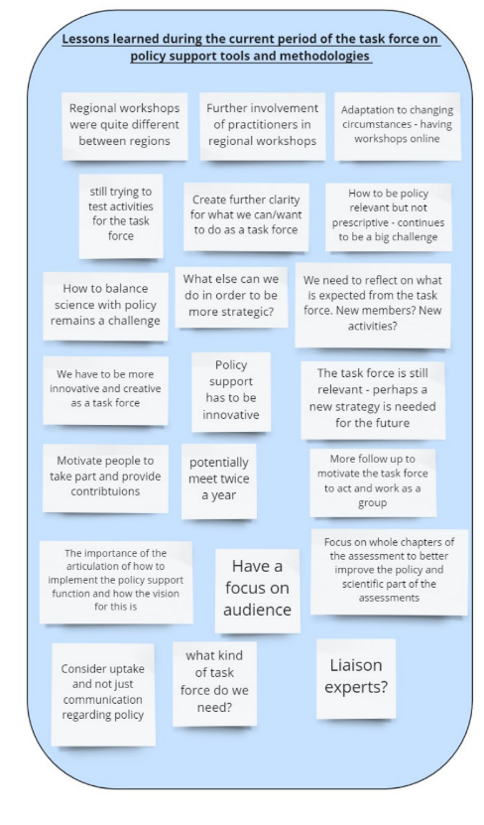
Annex IV to the appendix: Miro board

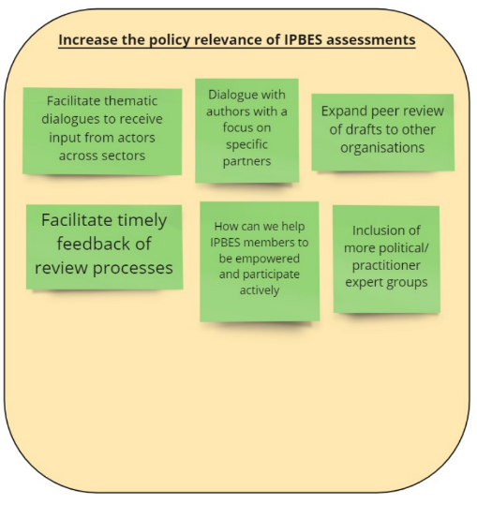
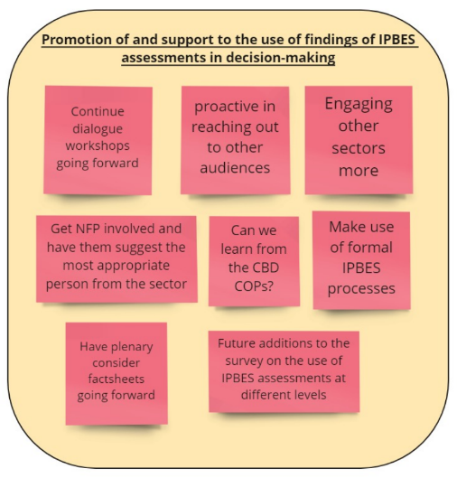
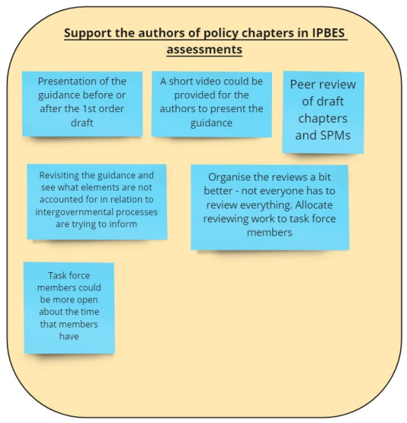

* IPBES/10/1.
UNEP/IPBES.MI/2/9, annex I, sect. I, para. 1 (d).
* The annex has not been formally edited.
Subject to the initiation of new assessments by the Plenary.
Subject to the initiation of new assessments by the Plenary.
Subject to the initiation of new assessments by the Plenary.

